ROAD SIGN

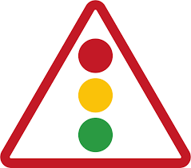 🔴 Red – Stop. Vehicles must come to a complete halt and cannot move forward.
🟡 Yellow (Amber) – Prepare to stop. It signals that the light is about to turn red. If you're close to the intersection, you may pass with caution; otherwise, stop.
🟢 Green – Go. Vehicles may proceed through the intersection or continue moving.

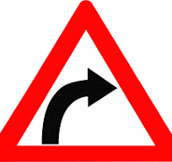 A Right Curve sign warns drivers that the road bends to the right ahead. Drivers must slow down, steer carefully, and stay in their lane to avoid skidding or accidents. This sign promotes safe turning especially on highways or blind curves.

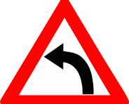 A Left Curve sign warns that the road bends to the left ahead. Drivers should reduce speed, stay in their lane, and navigate the curve cautiously to avoid accidents. It ensures safe and smooth turning, especially on sharp or blind curves.

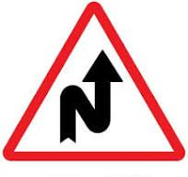 A Right Zigzag Bend sign warns that there are multiple sharp curves to the right ahead, usually in quick succession.Drivers must slow down, stay alert, and steer carefully through the winding road.This sign helps prevent accidents on dangerous or winding sections of the road.

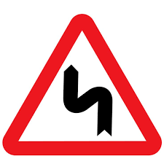 A Left Zigzag Bend sign indicates that there are multiple sharp curves to the left ahead, one after another.Drivers must reduce speed, stay focused, and maneuver carefully to maintain control of the vehicle.This sign is essential for warning drivers of winding or hazardous roads.
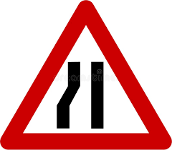 A Narrow Road Left sign warns that the left side of the road narrows ahead.Drivers should slow down, stay centered, and be ready to yield if needed. This helps ensure safe passing in areas with limited space on the left side.
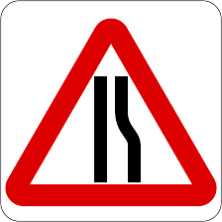 A Narrow Road Right sign warns that the right side of the road becomes narrower ahead.
Drivers must reduce speed, stay in lane, and be cautious when passing other vehicles. It ensures safe driving in areas with limited road width on the right side.
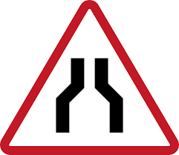 A Narrow Road sign warns that the entire road becomes narrower ahead, leaving less space for vehicles to pass.Drivers must slow down, stay alert, and be prepared to yield when necessary.
This sign helps prevent collisions on roads with limited width.
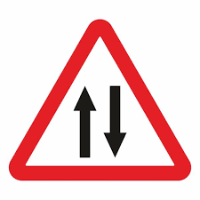 A Two-Way Traffic sign warns drivers that the road ahead carries traffic in both directions.
Drivers must stay on the correct side, be alert for oncoming vehicles, and avoid overtaking unless safe.
This sign is crucial for preventing head-on collisions.
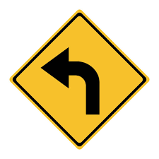A Left Turn sign indicates that vehicles must or may turn left ahead.It guides drivers on the correct direction at intersections or junctions.Drivers should signal early, check for pedestrians and oncoming traffic, and turn safely.
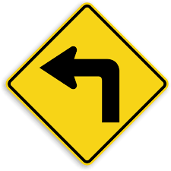A Right Turn sign indicates that vehicles must or may turn right ahead.It provides clear direction at intersections or curves in the road.Drivers should signal properly, slow down, and turn with caution, checking for pedestrians and other vehicles.

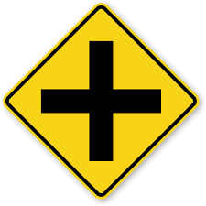A Crossroad sign warns that there is an intersection ahead where another road crosses the current road.Drivers must slow down, watch for crossing traffic, and be ready to yield or stop.
This sign promotes safe driving through intersections and helps prevent collisions.
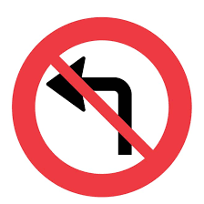A No Left Turn sign means that vehicles are not allowed to make a left turn at the intersection or junction. It is used to prevent traffic congestion, avoid accidents, or improve traffic flow. Disobeying this sign is a traffic violation and may result in fines or penalties.
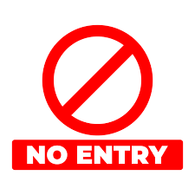A No Entry sign indicates that vehicles are strictly prohibited from entering a particular road or lane. It is placed at one-way streets, restricted areas, or exit-only lanes. Entering despite this sign is a serious traffic violation and may cause head-on collisions.
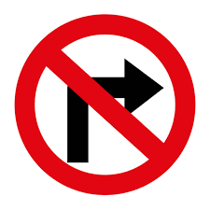A No Right Turn sign means that vehicles are not allowed to turn right at the upcoming intersection or junction.It is used to manage traffic flow, avoid conflict with oncoming vehicles, and enhance safety. Violating this sign is a traffic offense and may result in fines or accidents.
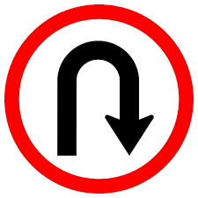A U-Turn sign indicates that making a U-turn is allowed or required at a certain point in the road. It guides drivers where it is safe and legal to reverse direction. Drivers must signal properly, check for oncoming traffic, and turn cautiously.
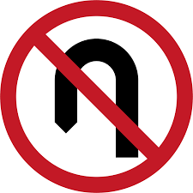A No U-Turn sign means that drivers are not allowed to make a U-turn at the indicated area.It is placed to avoid traffic disruption, prevent collisions, and maintain smooth flow.
Making a U-turn despite this sign is a traffic violation and may result in penalties.

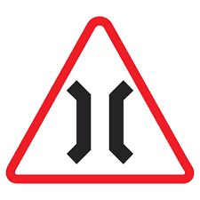A Narrow Bridge sign warns that the bridge ahead has limited width, allowing only one vehicle at a time or reduced space for passing.Drivers must slow down, approach with caution, and be ready to yield to oncoming traffic if necessary.This sign helps prevent accidents on constricted or one-lane bridges
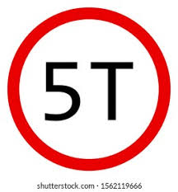A Load Limit sign indicates the maximum weight a vehicle can carry or pass through a specific road, bridge, or area (e.g., 5 tons).It helps prevent damage to infrastructure and ensures safe travel.Exceeding the limit is a traffic violation and can lead to fines, structural damage, or accidents.
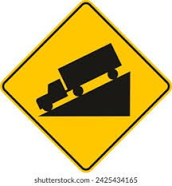A Steep Hill sign warns that the road ahead has a sharp incline (uphill) or decline (downhill).Drivers must adjust speed, use lower gears, and be prepared for reduced control.This sign helps ensure safe driving on sloped terrain, especially for heavy vehicles.
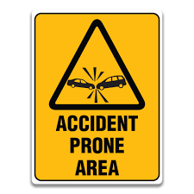An Accident-Prone Area sign warns that the road ahead has a high risk of accidents due to sharp curves, poor visibility, frequent collisions, or other hazards.Drivers must slow down, stay alert, and exercise extra caution.This sign helps reduce the chance of crashes in dangerous zones.
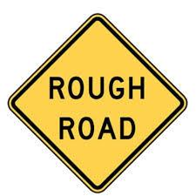A Rough Road sign warns that the road surface ahead is uneven, damaged, or under poor condition.Drivers should slow down, maintain control, and be cautious to avoid vehicle damage or loss of traction. This sign ensures safe driving through bumpy or unpaved roads.

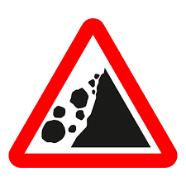A Landslide Area sign warns that the road ahead is prone to falling rocks or landslides, especially during rain or after earthquakes.Drivers must slow down, stay alert, and avoid stopping in marked areas.This sign promotes safety in mountainous or hazardous zones.

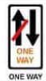 A One Way sign means vehicles are only allowed to travel in one direction on that road.It helps avoid collisions and keeps traffic flowing smoothly. Driving against it is dangerous and a traffic violation.
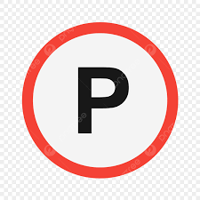 A Parking sign indicates that vehicles are allowed to park in the designated area.Drivers must follow specific parking rules such as time limits or vehicle types (if posted). Proper parking ensures smooth traffic flow and avoids penalties or towing.

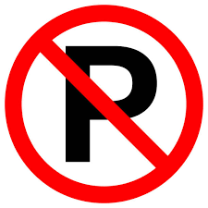 A No Parking sign means that vehicles are not allowed to park in the marked area.
Stopping briefly may be allowed (e.g., for drop-off), but leaving the vehicle unattended is prohibited.
Violating this sign may result in fines, towing, or traffic obstruction.

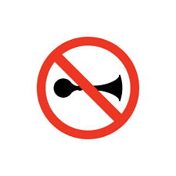
A No Horn sign indicates that honking is prohibited in the area, usually near schools, hospitals, or quiet zones. It helps maintain peace and minimize noise pollution. Unnecessary honking in these areas is a traffic violation and may lead to penalties.
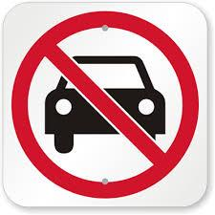 A No Automobiles sign means that cars and other motor vehicles are not allowed to enter or pass through the area.It is often used in pedestrian zones, bike lanes, or restricted roads.
Violating this sign may lead to penalties and safety risks
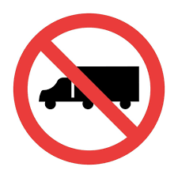 A No Trucks sign means that trucks or heavy vehicles are not allowed to enter or pass through the area. This is usually placed in narrow roads, residential areas, or weight-restricted zones.
Violating this restriction may result in fines, vehicle damage, or traffic congestion.

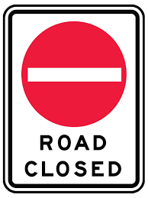 A Road Closed sign means that the road is not accessible to any vehicles or pedestrians due to construction, accidents, flooding, or other hazards. Drivers must not enter and should follow alternate routes or detour signs. Ignoring this sign can lead to dangerous situations and legal penalties.

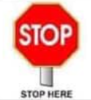 The Stop sign tells drivers to come to a complete stop at a specific point, usually before a pedestrian lane or intersection. It ensures safety and gives right of way to other vehicles or pedestrians. Failing to stop is a traffic violation.

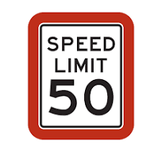 A Speed Limit sign indicates the maximum speed a driver is legally allowed to travel on a specific road.It helps prevent accidents, ensures safe driving, and is enforced by law. Driving faster than the limit is a traffic violation and can result in penalties.
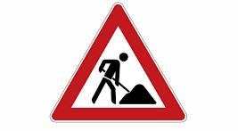
A Construction Zone sign warns drivers that there is ongoing road work or maintenance ahead. Drivers must slow down, follow signs, and be extra cautious for workers and equipment.
Speeding or reckless driving in this area is a serious traffic violation.

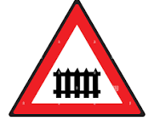 A Railway Crossing sign warns that a train track crosses the road ahead. Drivers must slow down, look both ways, and stop if a train is coming. Crossing while a train is approaching is extremely dangerous and against the law.
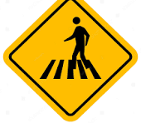 A Zebra Crossing sign marks a pedestrian crosswalk with white stripes on the road.
Drivers must slow down and give way to pedestrians crossing.Failing to yield is a traffic violation and can endanger lives.

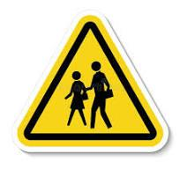A School Ahead sign warns drivers that there is a school zone nearby where children may be crossing. Drivers must slow down, stay alert, and follow the reduced speed limit.
Extra caution is required to ensure student safety.

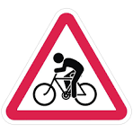 A Cycle Zone sign indicates that the road or lane is designated for bicycles. Motorists must share the road, slow down, and give way to cyclists. Driving carelessly in a cycle zone is a traffic violation and may endanger cyclists.

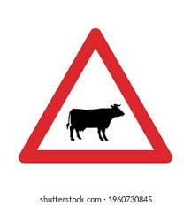An Animal Zone sign warns that animals may cross or roam in the area, such as livestock or wildlife.Drivers should slow down, stay alert, and be ready to stop if necessary. This sign helps prevent accidents involving animals and protects both drivers and animals.
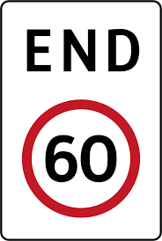 An End of Speed Limit sign indicates that the previous speed restriction is no longer in effect.Drivers may now follow the default speed limits set for the type of road or area, but must still drive responsibly and safely.It reminds drivers to adjust speed based on road, traffic, and weather conditions.
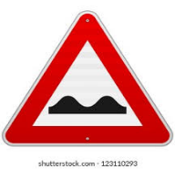A Bumps sign warns drivers that there are raised areas on the road ahead (like speed bumps or humps).Drivers must slow down to avoid vehicle damage and ensure passenger comfort.This sign is usually placed near schools, intersections, or pedestrian zones to enforce slower driving.
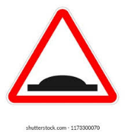A Bumps sign warns that the road ahead has multiple raised sections or uneven surfaces, such as speed bumps or humps.Drivers must reduce speed to avoid discomfort, protect their vehicles, and ensure safety especially in school zones, residential areas, or crosswalks.This sign encourages controlled and careful driving.

