|  |  |
| --- | --- |
| My little segway  Project Report | 제출정보  교 과 목 : 임베디드 시스템 설계  담당교수 : 임 성 수 교수님  학 과 : 컴퓨터 공학부  제 출 일 : 2015. 12. 14  제출인  20133242 이두나 |

my Little Segway

# Project description

The Segway is a two-wheeled, self-balancing, battery-powered electric vehicle used as a convenient way to travel around towns and cities. In this project, I made it small. However, if you use the better motor you can make the real Segway possible to ride.

By following this project you will learn how to access 6-axis motion sensor, motor control, PID control and basic automatic control theorem.

# System Overvie

1. Design View

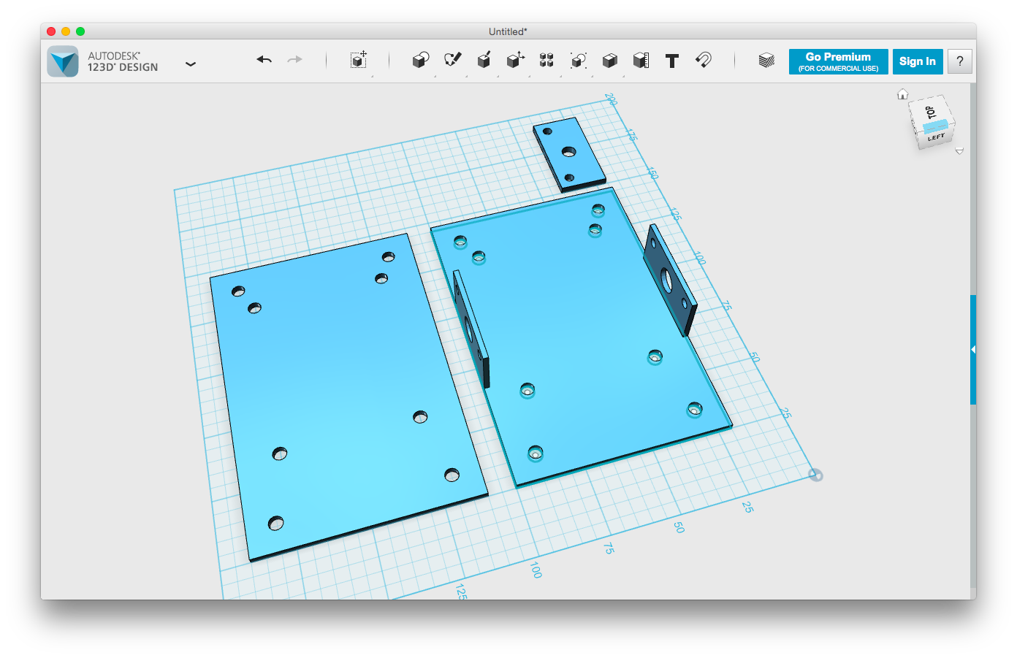

1. Schematic Design

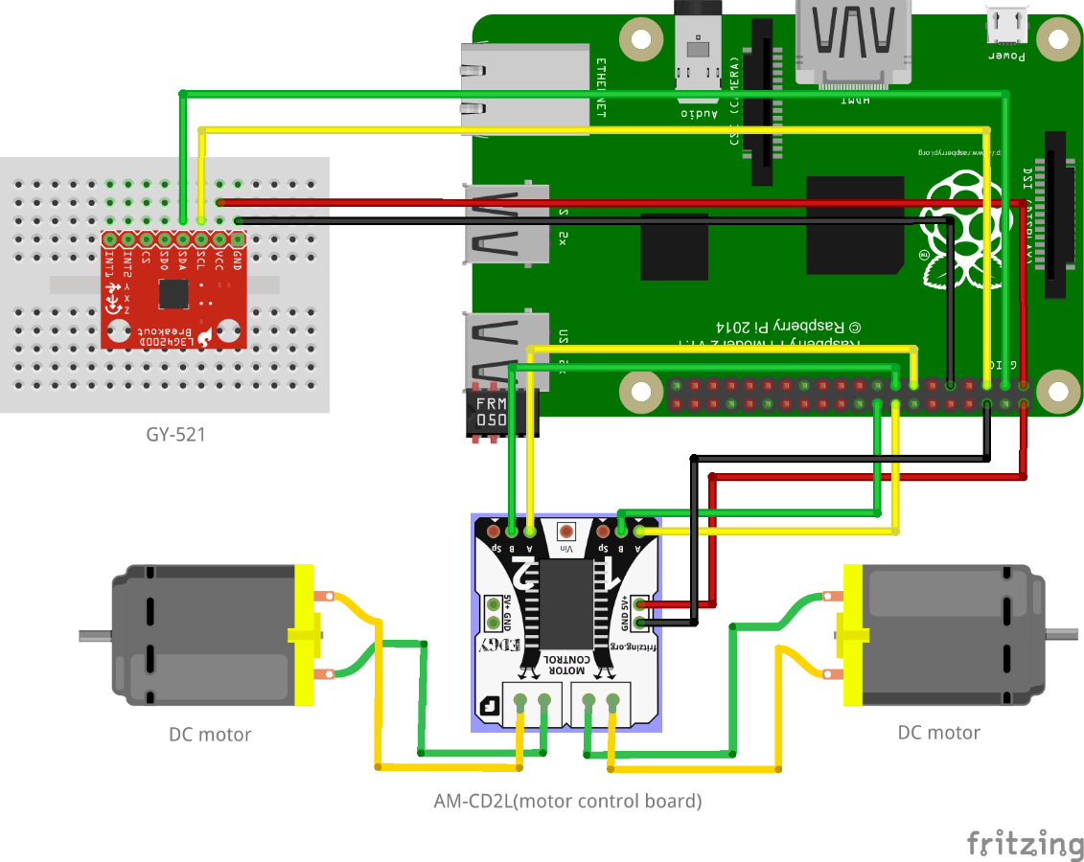

1. Basics Software

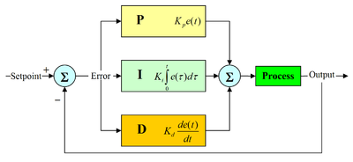

# environment

1. OS : Raspbian
2. Tool : 123D design(3D design program), Cura(slicer program), Friaing(for schematic Design), vim
3. SW packages : wiringPi, pwm

# source code

**<motors.c>**

#include <stdio.h>

#include <stdlib.h>

#include <wiringPi.h>

#include <softPwm.h>

#define RANGE 100

#define INITIAL_VALUE 0

void init_motors()

{

wiringPiSetup();

// initialize left motor (wiring pin 2 & 3)

softPwmCreate(2, INITIAL_VALUE, RANGE);

softPwmCreate(3, INITIAL_VALUE, RANGE);

// initialize right motor (wiring pin 4 & 5)

softPwmCreate(4, INITIAL_VALUE, RANGE);

softPwmCreate(5, INITIAL_VALUE, RANGE);

}

void stop_motors()

{

pinMode(2, OUTPUT);

pinMode(3, OUTPUT);

digitalWrite(2, LOW);

digitalWrite(3, LOW);

pinMode(4, OUTPUT);

pinMode(5, OUTPUT);

digitalWrite(4, LOW);

digitalWrite(5, LOW);

// printf("motor stopped!!\n");

// exit(1);

}

double left_speed;

double right_speed;

void motors(double speed, double left_offset, double right_offset)

{

// to come to me, drive pin 3&5 to some power

// to away from me, drive pin 2&4 to some power

// 2:LM-, 3:LCE

// 4:RM-, 5:RCE

// put M+ high & M- low will come to me

// put M+ low & M- High will away from me

left_speed = speed + left_offset;

right_speed = speed + right_offset;

// left motor

if (left_speed < 0) {

softPwmWrite(2, (int) -left_speed);

softPwmWrite(3, 0);

}

else

if (left_speed > 0) {

softPwmWrite(3, (int) left_speed);

softPwmWrite(2, 0);

}

// right motor

if (right_speed < 0) {

softPwmWrite(5, (int) -right_speed);

softPwmWrite(4, 0);

}

else

if (right_speed > 0) {

softPwmWrite(4, (int) right_speed);

softPwmWrite(5, 0);

}

}

**<mySegway.c>**

#include <wiringPiI2C.h>

#include <stdio.h>

#include <stdlib.h>

#include <math.h>

#include <sys/time.h>

// PID parameters

double Kp = 2.5; // 2.5

double Ki = 0.8; // 1.0

double Kd = 8.0; // 8.0

double K = 1.9*1.12;

// Complimentary Filter parameters

double K0 = (double) 0.98;

double K1 = (double) 0.02;

int fd;

int acclX, acclY, acclZ;

int gyroX, gyroY, gyroZ;

double accl_scaled_x, accl_scaled_y, accl_scaled_z;

double gyro_scaled_x, gyro_scaled_y, gyro_scaled_z;

double gyro_offset_x, gyro_offset_y;

double gyro_total_x, gyro_total_y;

double gyro_x_delta, gyro_y_delta;

double rotation_x, rotation_y;

double last_x, last_y;

struct timeval tv, tv2;

unsigned long long timer, t;

double deltaT;

int read_word_2c(int addr)

{

int val;

val = wiringPiI2CReadReg8(fd, addr);

val = val << 8;

val += wiringPiI2CReadReg8(fd, addr+1);

if (val >= 0x8000)

val = -(65536 - val);

return val;

}

double dist(double a, double b)

{

return sqrt((a*a) + (b*b));

}

double get_y_rotation(double x, double y, double z)

{

double radians;

radians = atan2(x, dist(y, z));

return -(radians * (180.0 / M_PI));

}

double get_x_rotation(double x, double y, double z)

{

double radians;

radians = atan2(y, dist(x, z));

return (radians * (180.0 / M_PI));

}

void read_all()

{

acclX = read_word_2c(0x3B);

acclY = read_word_2c(0x3D);

acclZ = read_word_2c(0x3F);

accl_scaled_x = acclX / 16384.0;

accl_scaled_y = acclY / 16384.0;

accl_scaled_z = acclZ / 16384.0;

gyroX = read_word_2c(0x43);

gyroY = read_word_2c(0x45);

gyroZ = read_word_2c(0x47);

gyro_scaled_x = gyroX / 131.0;

gyro_scaled_y = gyroY / 131.0;

gyro_scaled_z = gyroZ / 131.0;

}

unsigned long long getTimestamp()

{

gettimeofday(&tv, NULL);

return (unsigned long long) tv.tv_sec * 1000000 + tv.tv_usec;

}

double constrain(double v, double min_v, double max_v)

{

if (v <= min_v)

return (double)min_v;

else if (v >= max_v)

return (double)max_v;

else

return (double)v;

}

double GUARD_GAIN = 100.0;

double error, last_error, integrated_error;

double pTerm, iTerm, dTerm;

double angle;

double angle_offset = 2.0; //1.5

double speed;

void pid()

{

error = last_y - angle_offset;

pTerm = Kp * error;

integrated_error = 0.95*integrated_error + error;

iTerm = Ki * integrated_error;

dTerm = Kd * (error - last_error);

last_error = error;

speed = constrain(K*(pTerm + iTerm + dTerm), -GUARD_GAIN, GUARD_GAIN);

}

int main()

{

init_motors();

delay(200);

fd = wiringPiI2CSetup (0x68);

wiringPiI2CWriteReg8 (fd,0x6B,0x00);//disable sleep mode

// printf("set 0x6B=%X\n",wiringPiI2CReadReg8 (fd,0x6B));

timer = getTimestamp();

deltaT = (double) (getTimestamp() - timer)/1000000.0;

read_all();

last_x = get_x_rotation(accl_scaled_x, accl_scaled_y, accl_scaled_z);

last_y = get_y_rotation(accl_scaled_x, accl_scaled_y, accl_scaled_z);

gyro_offset_x = gyro_scaled_x;

gyro_offset_y = gyro_scaled_y;

gyro_total_x = last_x - gyro_offset_x;

gyro_total_y = last_y - gyro_offset_y;

while(1) {

t = getTimestamp();

deltaT = (double) (t - timer)/1000000.0;

timer = t;

read_all();

gyro_scaled_x -= gyro_offset_x;

gyro_scaled_y -= gyro_offset_y;

gyro_x_delta = (gyro_scaled_x * deltaT);

gyro_y_delta = (gyro_scaled_y * deltaT);

gyro_total_x += gyro_x_delta;

gyro_total_y += gyro_y_delta;

rotation_x = get_x_rotation(accl_scaled_x, accl_scaled_y, accl_scaled_z);

rotation_y = get_y_rotation(accl_scaled_x, accl_scaled_y, accl_scaled_z);

// printf("[BEFORE] gyro_scaled_y=%f, deltaT=%lf, rotation_y=%f, last_y= %f\n", (double)gyro_scaled_y, (double)deltaT, (double)rotation_y, (double) last_y);

// printf("[1st part] = %f\n", (double) K0*(last_y + gyro_y_delta));

// printf("[2nd part] = %f\n", (double) K1*rotation_y);

last_x = K0 * (last_x + gyro_x_delta) + (K1 * rotation_x);

last_y = K0 * (last_y + gyro_y_delta) + (K1 * rotation_y);

// printf("[AFTER] gyro_scaled_y=%f, deltaT=%lf, rotation_y=%f, last_y=%f\n", (double)gyro_scaled_y, (double)deltaT, (double)rotation_y, (double) last_y);

if (last_y < -60.0 || last_y > 60.0)

stop_motors();

pid();

printf("%lf\t%lf\t%lf\t%lf\t%lf\n", error, speed, pTerm, iTerm, dTerm);

motors(speed, 0.0, 0.0);

delay(10);

}

stop_motors();

return 0;

}