# Beat Chart

# 

# 

# 

# 

# 

# 

# Level: 1

Name: Maze 1

**TOD:** Night

**Story:** The player makes his way through the maze and must fight the boss at the end.

**Progression:** The player is taught how to move through the game and how to fight.

**Est. play time:** 10 mins

**Colour map:** TBD

**Enemies:** TBD

**Mechanics:** Treasure chest, healing pickups

**Hazards:** Traps

**Power-ups:** Strength power up, speed up

**Abilities:** TBD

**Music Track:** TBD

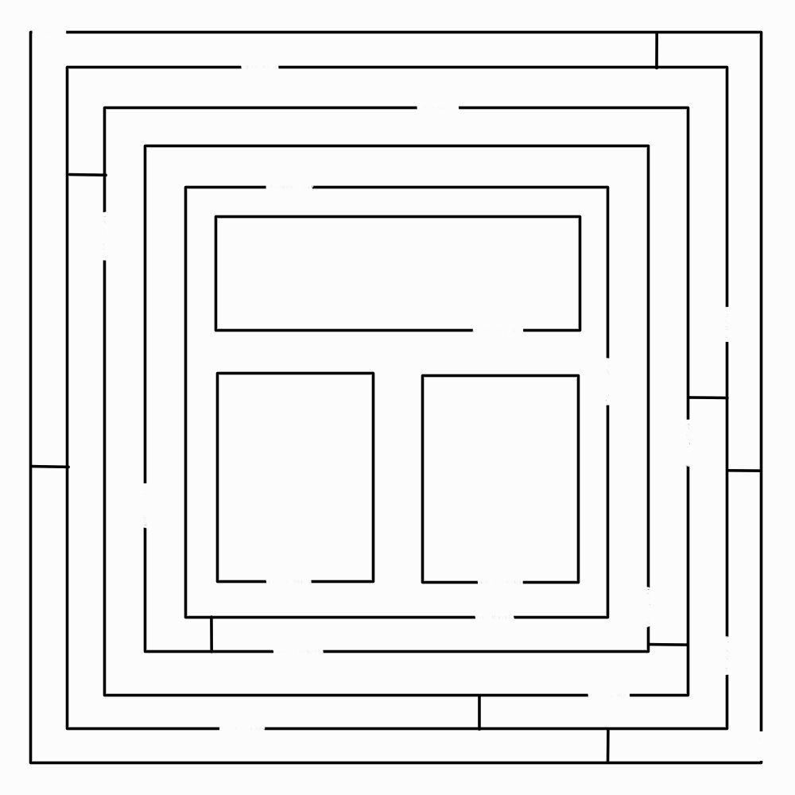

**Level:** 2

**Name:** Maze 2

**TOD:** Night

**Story:** The player is introduced to the Spirits and must fight them off while completing the Maze.

**Progression:** The player learns about puzzles.

**Est. play time:** 10 mins

**Colour Map:** TBD

**Enemies:** Spirits

**Mechanics:** Treasure chest, healing pickups, buttons, sliding door

**Hazards:** Traps

**Power-ups:**  Strength, speed

**Abilities:** TBD

**Music Track:** TBD

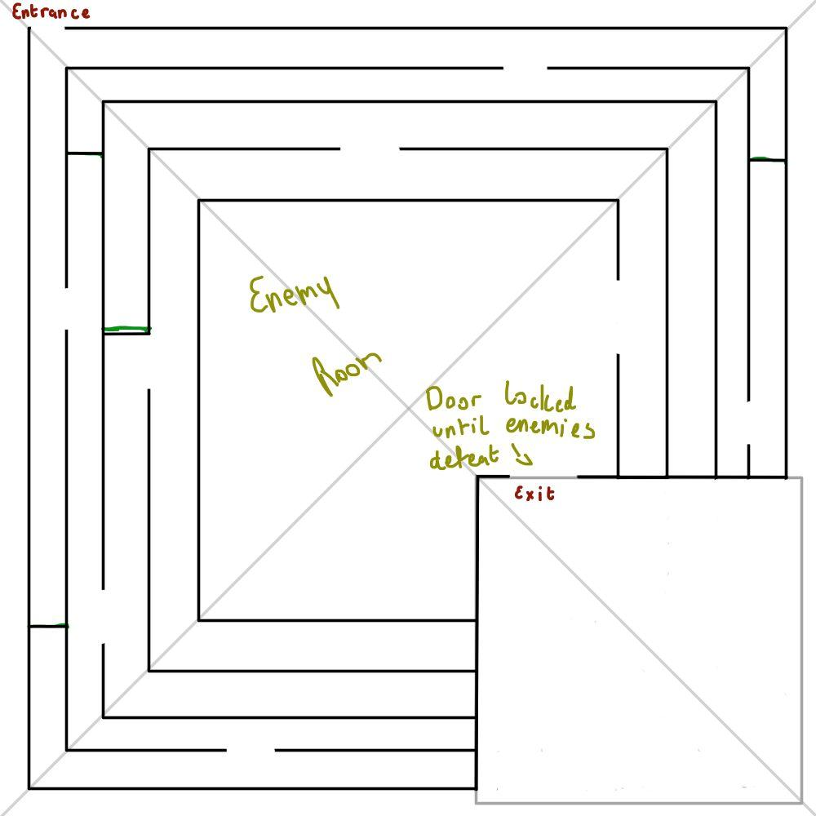

**Level:** 3

**Name:** Maze 3

**TOD:** Night

**Story:** The player continues through the maze, meeting other warriors who were sent into the maze, some are friendly, but most aren’t.

**Progression:** The player is introduced to companions and a new enemy, The Warrior

**Est. play time:** 13 min

**Colour Map:** TBD

**Enemies:** Spirit, Warrior

**Mechanics:** Treasure chest, healing pickups, buttons, sliding doors, companions

**Hazards:** Traps

**Power-ups:**  Strength, speed

**Abilities:** TBD

**Music Track:** TBD

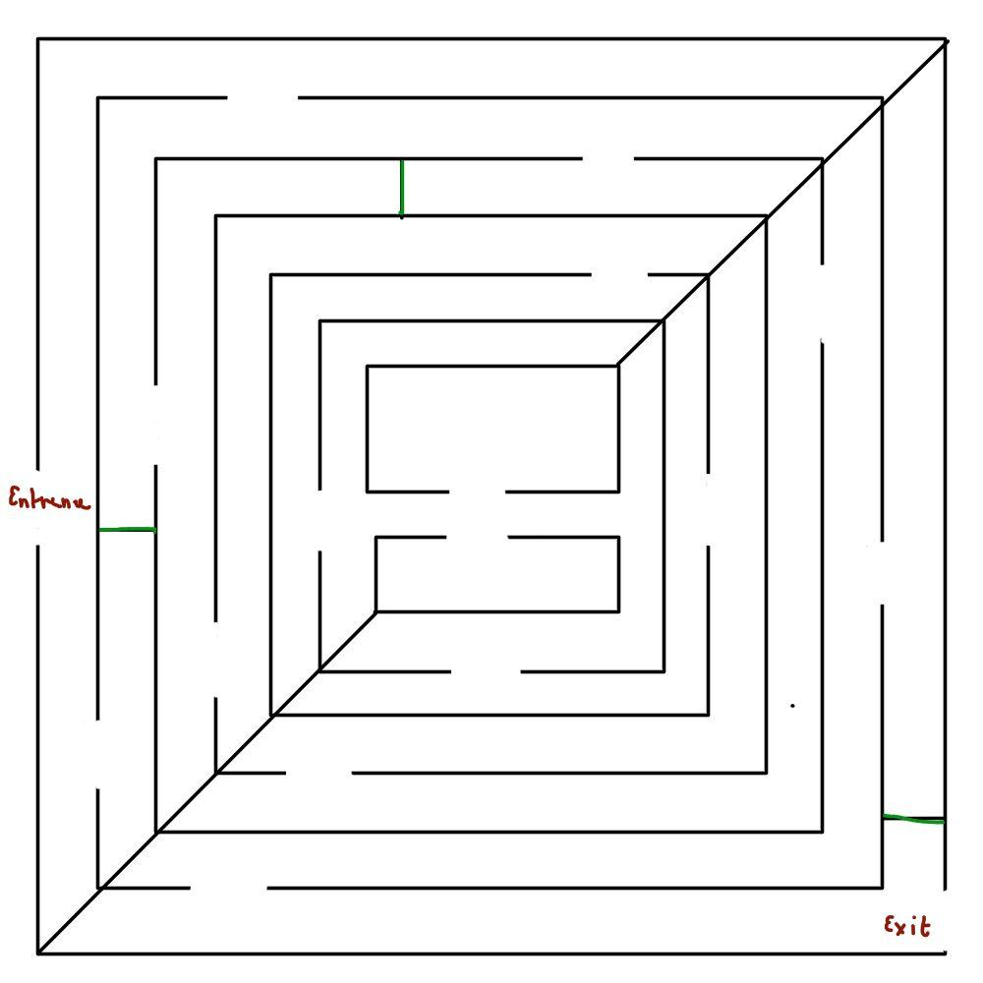

**Level:** 4

**Name:** Maze 4

**TOD:** Night

**Story:** The player continues through the mazes, meeting one of the gods and being given a helpful item.

**Progression:** The player is introduced to one of the other gods, earning a new helpful item.

**Est. play time:** 15 min

**Colour Map:** TBD

**Enemies:** Spirit, Warrior

**Mechanics:** Treasure chest, healing pickups, companions, Devine Plinth

**Hazards:** Traps

**Power-ups:** Strength, speed

**Abilities:** TBD

**Music Track:** TBD

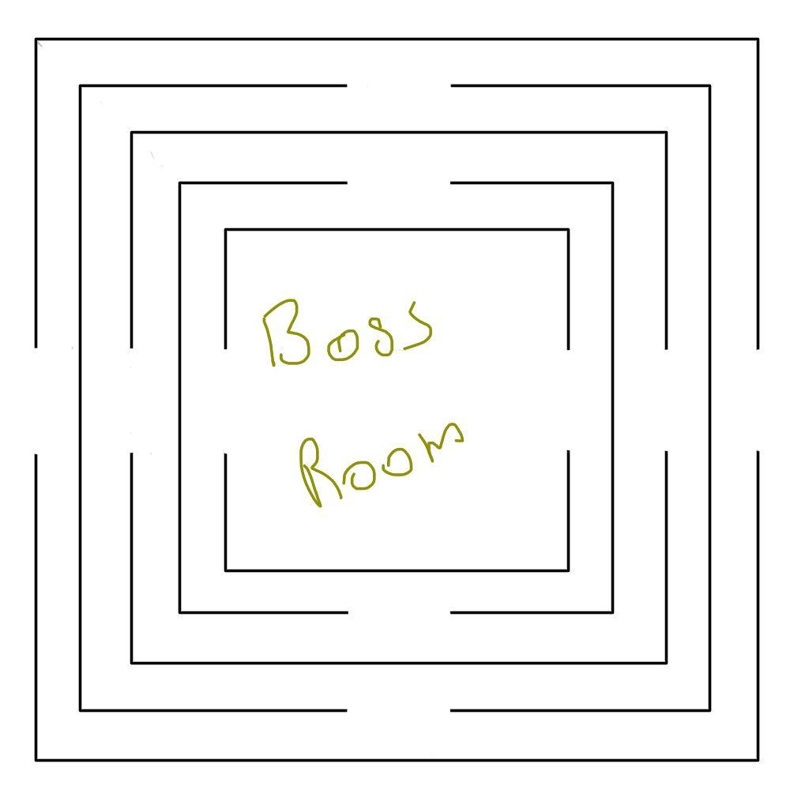

**Level:** 5

**Name:** Maze 5

**TOD:** Night

**Story:** The player enters a large ‘maze’ that is more of a colosseum, where they must fight a very strong boss.

**Progression:** The player encounters a strong boss, and must use his companions and new weapons and items.

**Est. play time:** 15 min

**Colour Map:** TBD

**Enemies:** Boss Enemy(TBD)

**Mechanics:** Healing pickups

**Hazards:** N/A

**Power-ups:** Strength, speed

**Abilities:** N/A

**Music Track:** TBD