PCB-A — the sensor board
Everything that needs a hose, plus the I²C mux, the air sensor and the fan interface, on one board under the ESP32. Drawn to be entered in Proteus (or any EDA tool).
- pcb_a_schematic.svg — the schematic, net-label style: pins with the same net name are connected.
- pcb_a_netlist.md — every net and every pin, for checking the layout against.
Both are generated by cad/schematic.py from one parts table, so they can't disagree. Change the table and re-run it rather than editing either file.
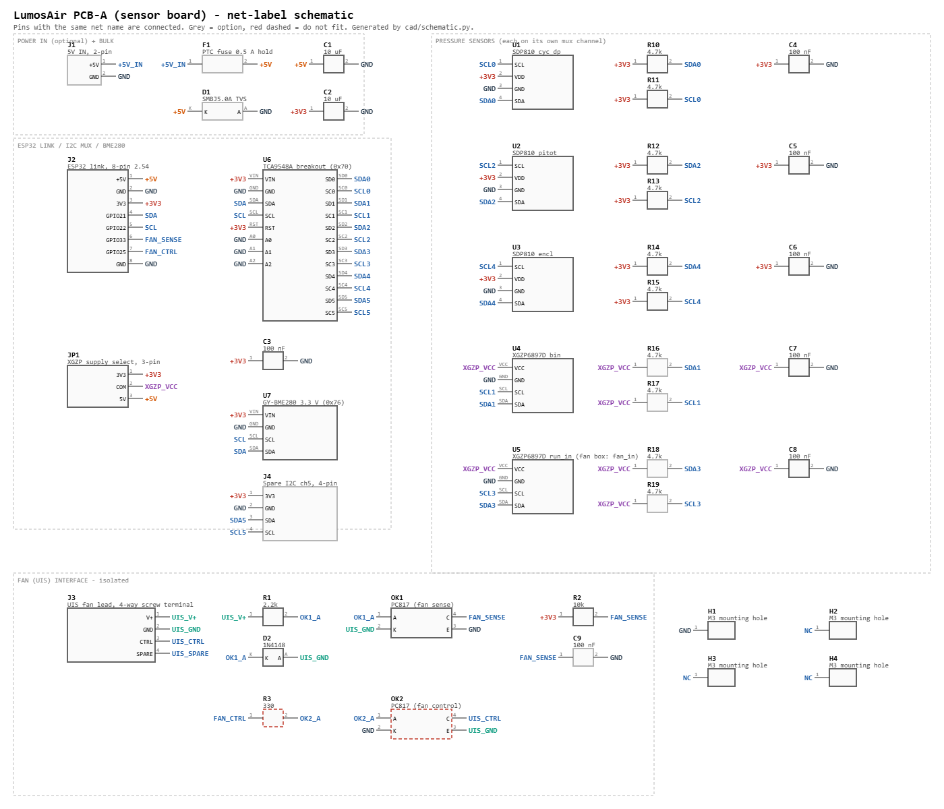

Blocks
Block | Parts | What it does
Link to the ESP32 | J2 (8-pin) | +5V, GND, 3V3, SDA (GPIO21), SCL (GPIO22), FAN_SENSE (GPIO33), FAN_CTRL (GPIO25)
I²C mux | U6 TCA9548A breakout, C3 | The pressure sensors share addresses (SDP810 = 0x25, XGZP = 0x6D), so each gets its own channel. A0–A2 low = 0x70.
Pressure | U1–U3 SDP810, U4–U5 XGZP6897D, R10–R19, C4–C8 | One sensor per channel, pull-ups per channel, 100 nF at every sensor.
Air | U7 GY-BME280 | On the main bus (0x76), not behind the mux. Density correction for CFM.
XGZP supply | JP1 | See below — the one thing to set when the sensors arrive.
Fan sense | J3, R1, D2, OK1, R2, C9 | The fan lead's own rail lights OK1, which pulls FAN_SENSE low: "this is the fan box" (DESIGN 6a, step 1). Fully isolated.
Fan control | R3, OK2 — do not fit | Footprints only, until the UIS pinout and signalling are verified. FAN_OUTPUT_ENABLED stays False.
5 V input | J1, F1, D1, C1 | Only if power comes in on the 2-wire USB-C socket rather than through the ESP32 board's own USB port. The TVS clamps and the PTC trips if the 10 V fan lead is ever plugged into the power socket.

Channel map — identical on both boxes
Mux ch | Part | Laser box | Fan box
0 | U1 SDP810 | cyc_dp | —
1 | U4 XGZP | bin | —
2 | U2 SDP810 | pitot | —
3 | U5 XGZP | run_in | fan_in
4 | U3 SDP810 | encl | —
5 | J4 (spare) | — | —
Because both boards are the same, the fan box's fan_in has to sit on one of the two XGZP positions; it takes the RUN one, channel 3. config_fan.py still says channel 0 from the bench days — change it to "mux": 3 when the sensors go in.

Things to confirm before ordering boards
- XGZP6897D supply voltage. The standard part is 5 V; the 3.3 V version has 33 in its part number. Read the marking on the sensor when it arrives, then set JP1: 1-2 for 3.3 V, 2-3 for 5 V. JP1 also sets the pull-up voltage on the XGZP channels; the TCA9548A passes each channel through at its own voltage, so the ESP32 still only sees 3.3 V. If the module already has pull-ups, leave R16–R19 off.
- XGZP pressure range. The firmware assumes the ±1 kPa part (k = 4096). The range is in the part number (001KPD… = 1 kPa). A different range needs a different k.
- Module footprints. U4/U5 (XGZP modules), U6 (TCA9548A) and U7 (BME280) are breakouts; take the pin order and spacing from the boards you have, not from a library.
- SDP810 orientation. Pin 1 is SCL, and Sensirion's table is drawn from the bottom. Mirror-check the footprint — this is the classic way to reverse a part.
- UIS wiring. J3's four terminals are functions (V+, GND, CTRL, spare), not UIS contact numbers. Meter the fan lead first, then land each wire on its function. Keep UIS_GND copper apart from board GND; the optocouplers are the only bridge.

Why these values
- R1 2.2 k: about 4 mA through OK1's LED from a 10 V rail, still enough at 5 V. D2 stops the LED being reverse-biased if the rail turns out to be the other way round.
- R2 10 k: GPIO33 has an internal pull-up, but an external one is predictable. With a PC817 (CTR ≥ 50 %) the 4 mA LED current sinks far more than the 0.33 mA R2 passes.
- R3 330 Ω: about 6 mA from a GPIO, well inside its limit.
- 4.7 k pull-ups per channel: the SDP810 has none of its own, and each mux channel is a separate bus.
- 3V3 for the SDP810s: they run from 2.7 to 5.5 V; 3.3 V keeps them on the ESP32's logic level with no translation.

Firmware that follows from this board
- fan_in on channel 3 in config_fan.py (above).
- A FAN_SENSE_PIN = 33 setting and the "which box am I" logic that reads it. Not written yet — it waits for a board to test on.

Mounting the display
The SWIFT-LCD-20 has only two holes, both on the connector edge (30 mm apart, 2.5 mm in from the edge — maker's dimension drawing). Nothing holds the other edge.
Recommended: hang it from the lid. Two nylon screws through the clear lid into two standoffs, into the display's holes, glass facing up against the lid. A strip of 1–2 mm foam tape between the far edge of the display board and the lid keeps it parallel.
- It reads best: no gap for parallax or reflections between the glass and the lid.
- It takes the display out of the stack, so PCB-A and the ESP32 board have the full height of the box.
- The six-wire lead has to reach when the lid is open; the supplied pigtail is long enough if it runs along a wall.
- Seal the two lid holes with nylon screws and rubber washers.
Alternative: a printed cradle screwed to the ESP32 board's mounting holes, with a ledge under the far edge of the display. Better if the lid comes off often; more height used inside the box.
Measure the hole diameter on your display before buying screws (the maker calls it "LEGO compatible", which may mean Ø4.8 mm rather than M2.5/M3).

