**ExxonMobil Chemical Company**

**Recipe Toolkit**

**Database Manager Guide**

**Version 1.0**

**Nov 24, 2014**

**Prepared by:**

**ILS Automation Inc.**

REVISION HISTORY

|  |  |  |  |
| --- | --- | --- | --- |
| **Revision** | **Date** | **Initial** | **Description** |
| 0.1 | Sept 2, 2014 | CC | First Draft |
| 0.2 | Oct 1, 2014 | PH | Updated screen shots and overall structure |
| 1.0 | Oct 28, 2014 | PH | Updated for initial release |

REFERENCES

|  |  |
| --- | --- |
| **Title** | **Version** |
| ExxonMobil Chemical Company, Recipe Toolkit, Functional Requirement Specification | 0.1 May, 2104 |

**Table Of Contents**

1. Introduction 5

2. Contact Engineer Interface 5

2.1 Overview 5

2.2 Launching 5

2.3 Main Menu 8

2.4 Recipe Database / Unit Map 9

2.5 Grade Master Screen 10

2.5.1 Creating a New Grade 11

2.5.2 Creating a new Version of a Recipe for an Existing Grade 12

2.6 Grade Detail Screen 13

2.7 Value Definition Screen 14

2.8 SQC Limits 15

2.9 Adhoc Tables 16

3. Recipe Database Schema 17

4. Migration 17

4.1 Initial import 18

4.2 Configure Database Connections in Ignition 18

4.3 Create Database Tables 18

4.4 Conversion 18

4.4.1 Verify Successful Import 19

# Introduction

The Recipe Toolkit is a platform to transfer or download product or process specific data within a SQL database to process automation/information systems. In particular, these include the DCS and ExxonMobil Toolkit system implemented in Ignition. The two main users of the system are a contact engineer who is responsible for specifying the recipe data within the database and console operator responsible for the review and transfer data from the database to the DCS or Ignition. This guide covers the application for the contact engineer.

The Database Manager Application replaces a legacy application written in Visual Basic called *dBManagerPlus* (Refer to the ExxonMobil document dbManagerPlus.doc for details). The prior application utilized a database schema written for Microsoft Access. The prior schema has been updated into a more traditional relational design for use with Microsoft SQL Server. A migration utility is provided.

# Contact Engineer Interface

This section provides a description of the contact engineer interface for configuring the recipe database. The application is delivered in a stand-alone Ignition project named *dbmanager.proj*.

## Overview

The Recipe Toolkit Database Manager is an editor for the Recipe database. The database design follows a standard master-detail pattern. The editor allows access to both master and detail record types and enforces full relational integrity.

## Launching

The application is launched from the gateway home page, Figure 1, or from the client launcher, Figure 2. A desktop shortcut may also be configured.

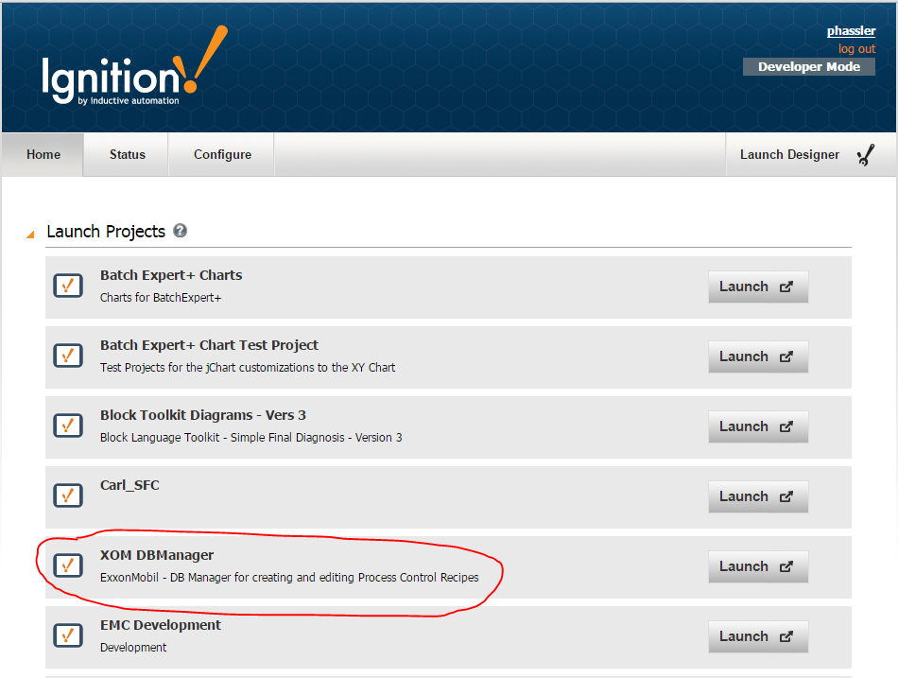

Figure 1 - Launching client from the Gateway Web Page

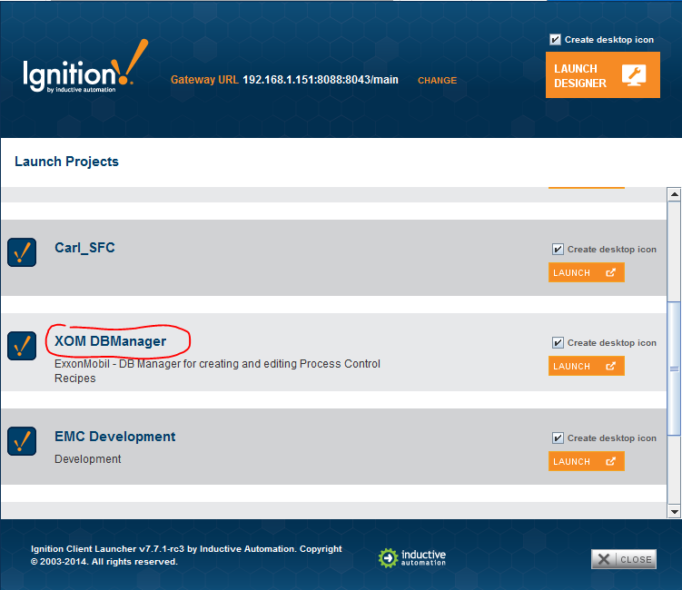

Figure 2 - Launching the Client from the Client Launcher

Once a connection is made, the login is displayed, a valid username and password is required.

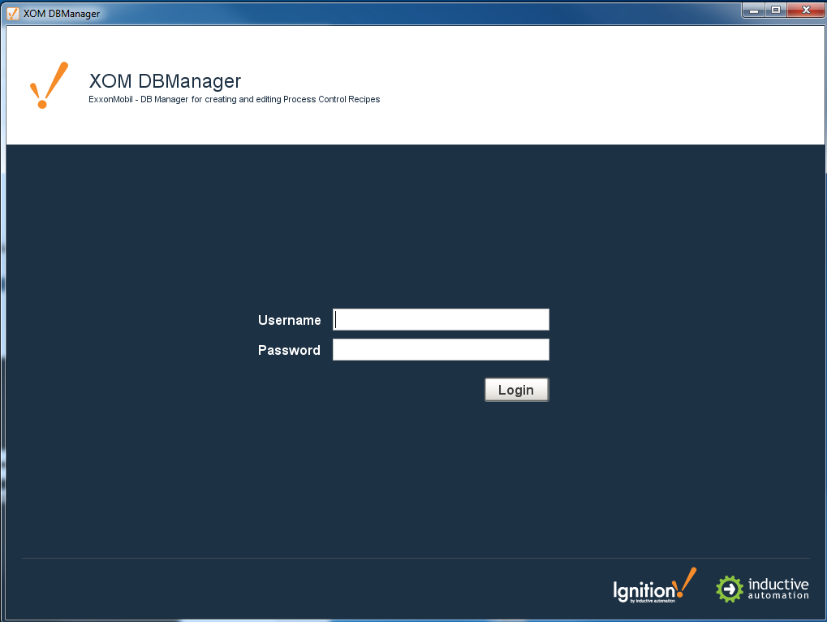

Figure 3 - DB Manager Login Screen

## Main Menu

The navigation within the application is provided by a main drop down menu. The View and Tools menus are custom for the *DBManager* application. The Command, Windows, and Help menu are standard Ignition menus for logging out, closing windows, and accessing help. The common *DBManager* screens are all accessed from the View menu. The Migration utility from the old MS Access style tables is accessed from the Tools menu.

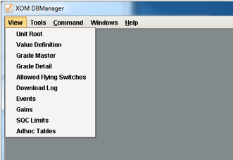

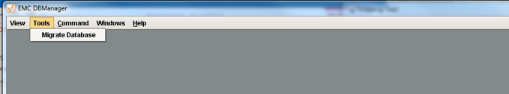

Figure 4 - Main Menu

## Recipe Database / Unit Map

The DB Manager application can access multiple recipe databases. The Unit Map is used to define the recipe databases available from this gateway. The screen is shown below.

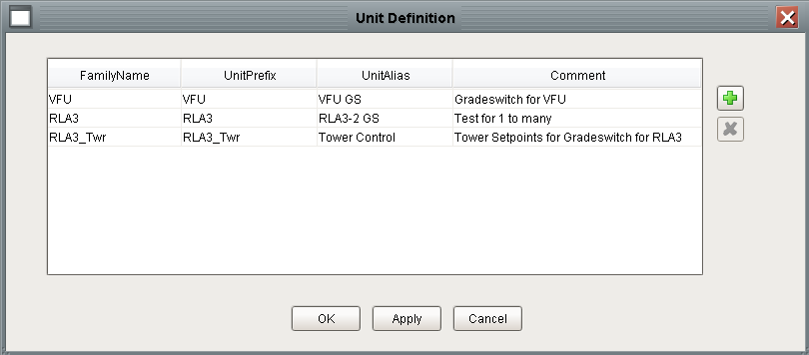

Figure 5 - Unit Root Screen

## Grade Master Screen

The Grade Master screen is used to view all of the grades in the recipe database. The grades can be filtered by unit and version. All of the screens used in the application use the Power Table widget which allows columns to be resized, sorted, and hidden.

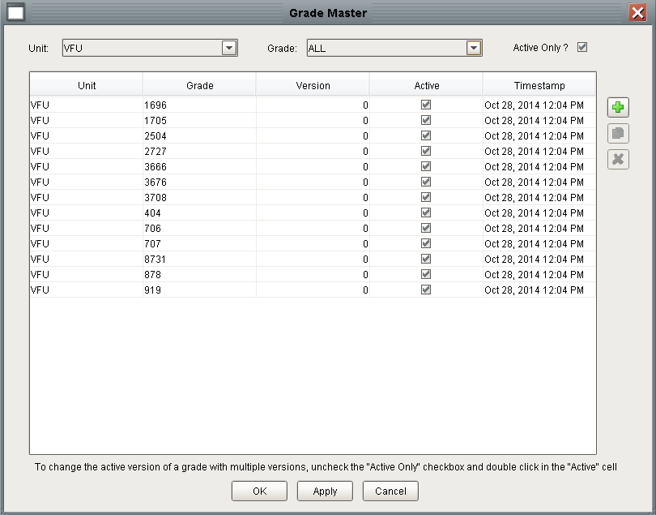

Figure 6 - Grade Master Screen

### Creating a New Grade

A new grade can be created by pressing the top button to the right of the table. It will post a popup dialog where a new grade number may be entered.

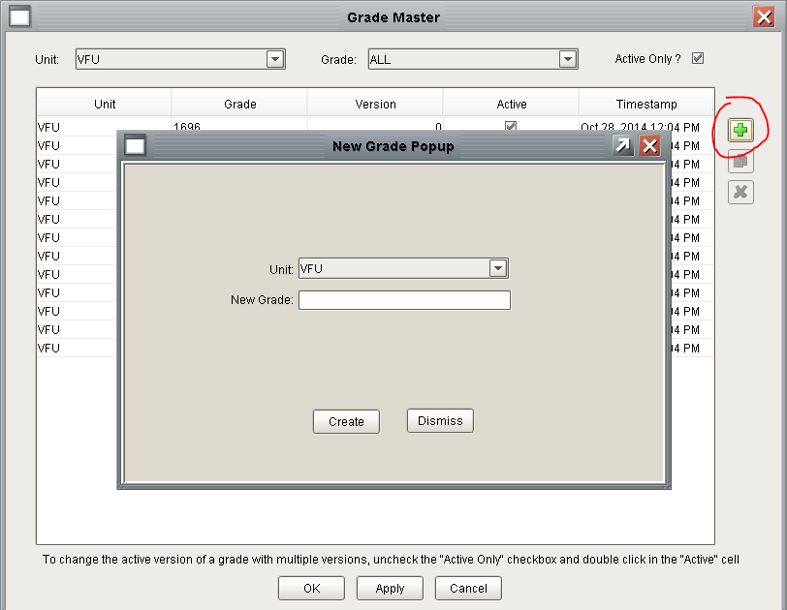

Figure 7 - Creating a New Grade

### Creating a new Version of a Recipe for an Existing Grade

A new version of an existing recipe can be created by selecting an existing grade and pressing the middle button to the right of the table. The button is only enabled when a row is selected.

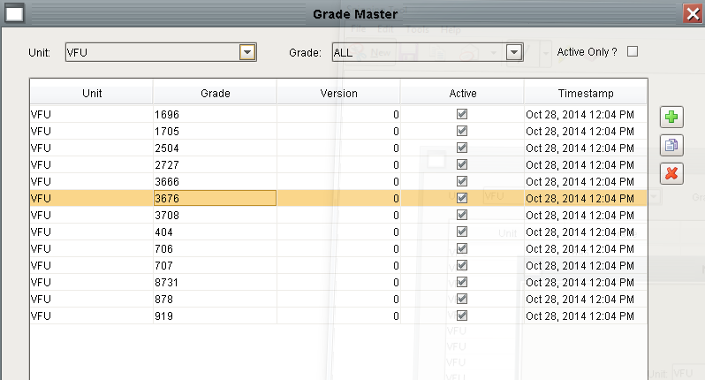

Figure 8 - Creating a New Recipe Version

The version field will automatically be incremented for the new version. The original version will remain the active version.

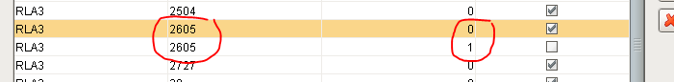

Figure 9 - New Version Showing Auto-Increment

## Grade Detail Screen

The Grade Detail screen is used edit the recommended value and the optional low and high limits.

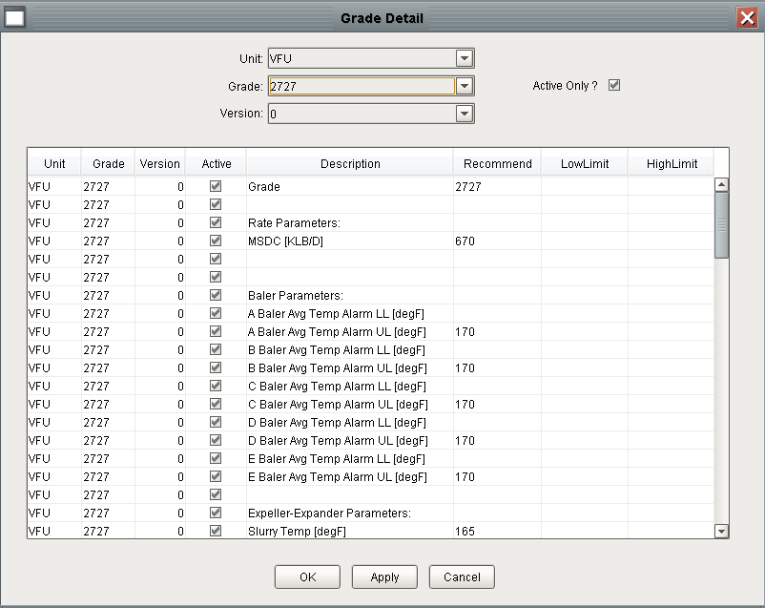

Figure 10 - Grade Detail Screen

## Value Definition Screen

The Value Definition screen is used to define the structure of the recipe for a unit. The underlying concept here is that all of the recipes for a unit have the same structure. All of the recipes Grade Master screen is used to view all of the grades in the recipe database.

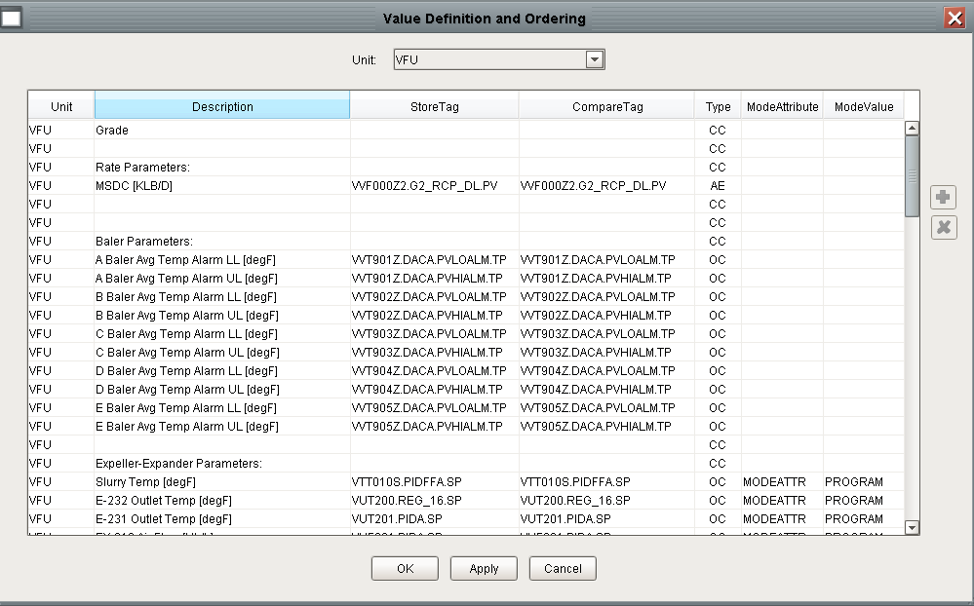

Figure 11 - Value Definition Screen

## SQC Limits

The SQC Limit screen is used to configure the SQC limits. Not all recipe installations utilize the SQC Limit capability.

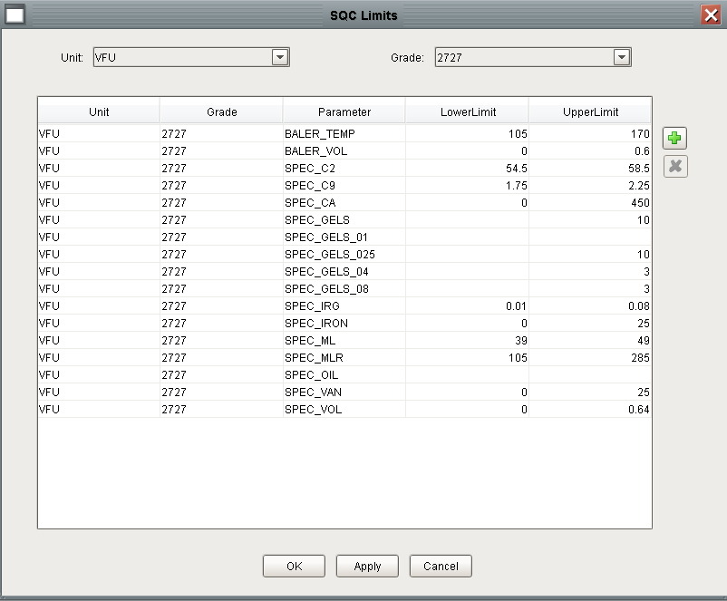

Figure 12 SQC Limit Screen

## Adhoc Tables

The DBManager application has made allowances for spontaneous creation of new data structures that are required for new control strategies. By following simple database table guidelines the user interface shown below to maintain the data without any modifications to the DB manager application.

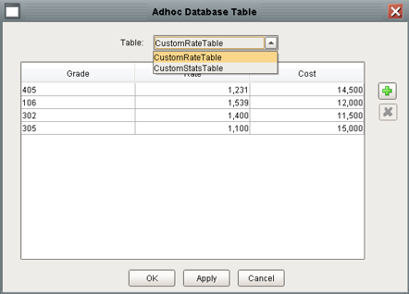

Figure 13 - Adhoc Table User Interface

The following steps describe how to create tables that will work within the Ad-Hoc user interface:

1. Manually create the table using the SQL Server Management Studio in the XOM database. The first column of the table MUST be Id and it must have a system generated key.

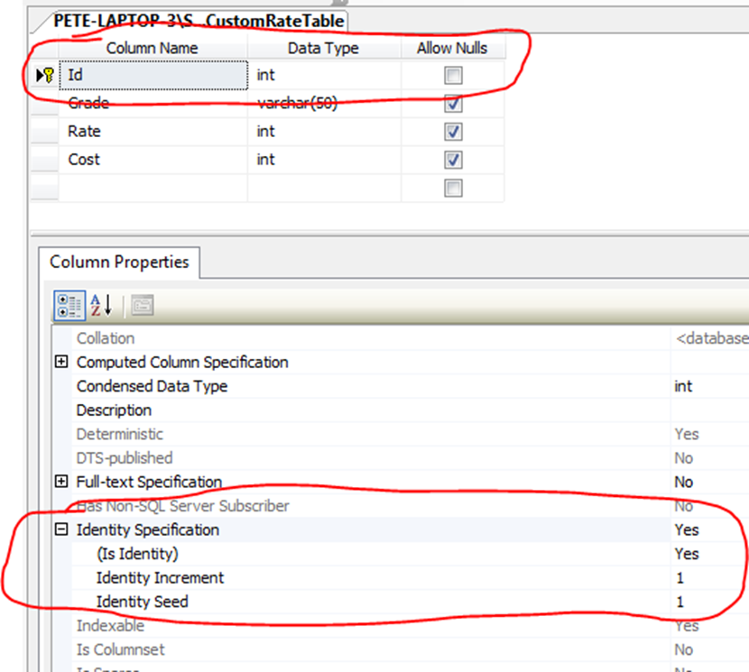

Figure 14 - Adhoc Table Design Considerations

1. Insert the name of the table into RtAdhocCatalog

# Recipe Database Schema

Refer to the XOM Database Design specification for complete details on the database schema.

# Migration

This section outlines the steps necessary to migrate the existing MS Access database tables into the form necessary for the Ignition-based recipe toolkit.

## Initial import

Using the SQL Server Management Studio, create a new database instance. This is a temporary instance used only for migration. For example, call it “AccessFormatGLineRecipe” (for the “GLine”). Then using the studio,

* right-click on the new database, select “Tasks->Import Data”
* in the dialog that appears, select “Microsoft Access as the “Data Source”
* browse to the file system location of the legacy MSAccess-format files
* proceed with the Import Wizard, copying into the target (“AccessFormatRecipe”) database

The newly created instance serves as the basis for further migration steps.

## Configure Database Connections in Ignition

Using the Ignition gateway webpage, create database connections for each database created in step 4.1.

## Create Database Tables

Using the SQL Server Management Studio, create tables for the DBManager project by executing the createRecipe.sql script. It will create a number of tables all prefixed by Rt.

## Configure Common Tables

* There must be at least one row in the TkPost table.
* The interfaces defined in table x of the old data must be mapped to interfaces in the new system contained in the TkWriteLocation table.

## Conversion

Using the DbManager application, open the database conversion screen by selecting Tools->Migrate Database. The utility queries the old databases and writes SQL commands to insert the data into the new database tables.

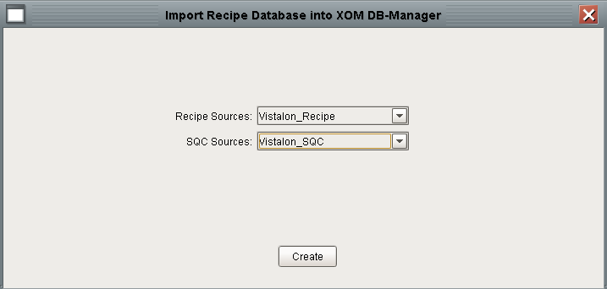

* select the “Recipe Sources” database connection corresponding the “initial import” in the previous step.
* select the “SQC Sources” database connection if there was an SQC database imported in the previous step.
* press “Create”

DbManager will insert the data from the imported databases into the final XOM database. There are no intermediate files. To debug / view the results of the import select Diagnostics from the Help menu.

### Verify Successful Import

Verify the successful import of data by viewing the data in SQL*Server or by launching the DBManager project and viewing the recipes by following the steps described in section 2.