Encoder loss detection is a combination of hardware and fundamental system set up pointers and plc code.
HARDWARE
Firstly the hardware must be modified to physically detect encoder loss. This is done with resistor packs in the ACC28e2 series cards and for the stepper systems is described in the manual as follows …
- Resistor Pack Configuration
- Differential or Single-Ended Encoder Selection
The differential input signal pairs to the PMAC have user-configurable pull-up/pull-down resistor networks to permit the acceptance of either single-ended or differential signals in one setting, or the detection of lost differential signals in another setting.
- The ‘+’ inputs of each differential pair each have a hard-wired 1 kΩ pull-up resistor to +5V. This cannot be changed.
- • • The ‘-’ inputs of each differential pair each have a hard-wired 2.2 kΩ resistor to +5V; also each has another 2.2 kΩ resistor as part of a socketed resistor pack that can be configured as a pull-up resistor to +5V, or a pull-down resistor to GND.

If this socketed resistor is configured as a pull-down resistor (the default configuration), the combination of pull-up and pull-down resistors on this line acts as a voltage divider, holding the line at +2.5V in the absence of an external signal. This configuration is required for single-ended inputs using the ‘+’ lines alone; it is desirable for unconnected inputs to prevent the pick-up of spurious noise; it is permissible for differential line-driver inputs.
If this socketed resistor is configured as a pull-up resistor (by reversing the SIP pack in the socket), the two parallel 2.2 kΩ resistors act as a single 1.1 kΩ pull-up resistor, holding the line at +5V in the absence of an external signal. This configuration is required if encoder-loss detection is desired; it is required if complementary open-collector drivers are used; it is permissible for differential line-driver inputs even without encoder loss detection.
ACC24E2S Stepper card:
If Pin 1 of the resistor pack (marked by a dot on the pack) matches Pin 1 of the white square solder pin on the front side of the board), then the pack is configured resistors. If the pack is reversed in the socket, it is configured as a bank of pull-up, encoder loss.
The following table lists the pull-up/pull-down resistor pack for each input device:
Device | Resistor Pack | Pack Size
Encoder 1 | RP19 | 6-pin
Encoder 2 | RP21 | 6-pin
Encoder 3 | RP27 | 6-pin
Encoder 4 | RP29 | 6-pin

ACC24E2A Analogue "servo" card:

If Pin 1 of the resistor pack (marked by a dot on the pack) matches Pin 1 of the socket (marked by a wide white square solder pin on the front side of the board), then the pack is configured as a bank of pull-down resistors. If the pack is reversed in the socket, it is configured as pull-up, Encoder Loss Protection.
The following table lists the pull-up/pull-down resistor pack for each input device:
Device | Resistor Pack | Pack Size
Encoder 1 | RP22 | 6-pin
Encoder 2 | RP24 | 6-pin
Encoder 3 | RP22 | 6-pin
Encoder 4 | RP24 | 6-pin
You may notice from the table that Encoders 3 and 4 respectively have the same resistor pack number as 1 and 2. This is because the 4 axis card comprises of one 2 axis card with another 2 axis “piggy-back” card screwed to it. The “piggy-back” board will need to be removed in order to gain access to the first packs.

Unscrew the 4x crosshead screws on the mounting pillars, then carefully ease the top PCB away from the motherboard (their adjoining plug/socket is in the centre of the PCB.).

Termination Resistors
The Acc-24E2S provides sockets for termination resistors on differential input pairs coming into the board. As shipped, there are no resistor packs in these sockets. If these signals are brought long distances into the Acc-24E2A board and ringing at signal transitions is a problem, SIP resistor packs may be mounted in these sockets to reduce or eliminate the ringing.
All termination resistor packs have independent resistors (no common connection) with each resistor using two adjacent pins.

Nominal termination resistor value for this type of application is 120R. A single 0.5w 120R doubled over will fit the sip socket. 3 of these would be needed for each encoder.

BITS Needed
To use encoder loss detection we need to map the status word from the accessory card as a 16 bit digital input, then we can look at the required bit ( taking into account bit shifting that takes place across the ring during transfers) to check for encoder loss. This bit is non-latching so although we can read it using an M-variable substitution, to be really useful we would also latch it with a p variable so it can be held until acknowledged

DATA Transfers

MS{anynode},MI21-MI68 Data Transfer Source and Destination Address
Range: $000000000000 - $FFFFFFFFFFFF
Units: Double 16-Axis MACRO Station Addresses
Default: 0
These MI-variables each specify a data transfer (copying) operation that will occur on the 16-Axis
MACRO Station at a rate specified by Station Variable MI19, and enabled by Station variable MI20.
Each variable specifies the address from which the data will be copied (read), and the address to which
the data will be copied (written). These variables are 48-bit values, usually specified as 12 hexadecimal
digits.
The first 24 bits (6 hex digits) specify the address of the register on the 16-Axis MACRO Station from
which the data is to be copied; the second 24 bits (six hex digits) specify the address on the 16-Axis
MACRO Station to which the data is to be copied. In each set of six hex digits, the last four hex digits
specify the actual address. The first two digits (eight bits) specify what portion of the address is to be
used.
The following diagram shows what each digit represents:
Hex Digit # 1 2 = From Register Format Code

Hex Digit # 3 4 5 6 = From Register Address

Hex Digit # 7 8 = To Register Format Code

Hex Digit # 9 10 11 12 = To Register Address

The following table shows the 2-digit hex format codes and the portions of the address that each one
Selects:

Code X or Y Bit Width Bit Range Notes
$40 Y 8 0-7
$48 Y 8 8-15
$50 Y 8 16-23
$54 Y 12 0-11 Lower 12-bit ADC registers
$60 Y 12 12-23 Upper 12-bit ADC registers
$64 Y 16 0-15
$6C Y 16 8-23 16-bit MACRO Servo Node Registers
$78 Y 24 0-23 24-bit MACRO Servo Node Registers
$7E NA NA NA Use the MM variable definition for the
decode of the variable and address and the
address being the MM variable number.
$B0 X 8 0-7
$B8 X 8 8-15
$C0 X 8 16-23
$C4 X 12 0-11
$D0 X 12 12-23
$D4 X 16 0-15
$DC X 16 8-23 16-bit MACRO I/O Node Registers
$E8 X 24 0-23 24-bit MACRO I/O Node Registers
.

Data from an accessory card is put onto the macro ring using one set of MSnode,I variables, and the transfer of this data across the macro link and how it is read by the host pmac ultralight is governed by another set of I variables.
First we need to transfer data from the accessory cards onto the macro ring. Normally this is done automatically at power on for standard servo control axes, but for i/o or axes with mixed sources ( eg encoder feedback via analogue or digital i/o) then it becomes more problematical.
MS0,I19 sets up the data transfer rate in servo cycles ( we have it set to 4 in MX). If set to ZERO it will disable 16 bit data transfers.

The following examples were taken from the original set up of the i02 optics hutch. This is unusual in that it has analogue i/o transfers as well as the encoder loss transfers , but in the event we have non-micromech rack set up to consider then this shows how it can be achieved. The standard settings for a micromech UMAC MACRO are appended at the end of this document.
MS0,i20=4
MS0,I20=$1FFFE3F sets up which of 48 possible transfer lines(I21-I68) will be used
MS0,I21=$6C8800DCC0A1 transfers data from accessory card location 8800 ( an analogue card 1, input 1 of 4) using method 6C ( upper 16 of 24 bits as servo node register Y) to location C0A1 using method DC ( this moves as an i/o transfer into the first of 3 16 bit transfer addresses for node 2.)
MS0,i22=$6C8801DCC0A2 likewise moves ana card1 input 2 to the second address for i/o node2
….
MS0,i26=$6c8841DCC0A7 likewise moves ana card 2 input 2 to the third of three 16 bit addresses for node3
MS0,i27 to MS0,i29 are not activated ( see I20 above)
MS0,i30=$6488C8DCCC0A9 is the first encoder loss detection bit. Manual states that for the motor at base address $8000 ( ie servo ic 0) encoder loss bit is at Y:$88C8,5 and transfer type64 is just a straight 16 bit transfer. C0A9 is the first 16 bit transfer address for node 6, And transfer type DC shifts it to the upper 16 bits of a 24 bit word so our enc loss bit is now 13.

MS0,i31=$6488C9DCC0AA is our second encoder loss bit. C0AA points at i/o node 6s second 16 bit transfer channel. In mx we seem to jump from the second of three tx in i/o node 6 up to i/o node 18 where we continue to use three per node up to i/o node 26

MS0,i43=$6498CEDCC0F1 likewise transfers enc loss bit for motor 15 ($98CE) to the upper 16 bits of the first tx address of node26.
.
The source addresses are to be found in the reference for the hardware and the destination addresses are to be found in the 16axis macro cpu documentation (see end of this document.)

MS0,i975 = $cc this enables i/o transfers. Similar to i996 it is bit mapped to the i/o nodes 2,3,6 etc , and so should only contain 4,8 or c in each location
MS0,i996; MS16,i996, MS32,i996 and MS48,i996 control what nodes the MACRO card will transfer, with bit 15 set to enable macro ring transfer to the next set of 8. 4 hex digits control the individual node transfers and nodes0, 16,32 and 48 will be preceded by 0f, 1f, 2f and 3f respectively.
Ii6841; i6891; 6941; i6991 are the equivalent bits on the pmac side and normally have the same values as the corresponding ms(anynode) i996.
USING THE DATA
Now to access the bit in turbo pmac we need to know where the registers are for turbo pmac2 to find these 16 bit registers. The following is the start of the address list from turbo pmac SRM
Knowing the address we can then use an M variable substitution to look for the encoder loss bit. Be careful not to use either a variable already chosen by another user, and try to avoid the standard M variable substitution numbers to avoid problems later on if either the standard definitions or the user definitions are reloaded. Eg OD OH in MX2 uses M184 as encoder loss bit which is not defined, but then they use M189 to remap it into DPRAM which has a standard definition.
In UMAC macro systems which have a mixture of I/O cards we need to be very careful not to overwrite destinations addresses or confuse data types. It is recommended that a chart is prepared for each subsystem detailing each card, its bit settings its address and also the data types that will be written and to which of the MS nodes it will be transferred from.

Turbo PMAC/PMAC2 Software Reference
560 Turbo PMAC Memory and I/O Map
Turbo PMAC2 MACRO Node Registers
MACRO IC# 0 1 2 3
Address $07842x $07942x $07A42x $07B42x
Y:$07x420 MACRO Node 0 24-bit command(write) and feedback (read) register
X:$07x420 MACRO Node 2 24-bit command(write) and feedback (read) register
Y:$07x421 MACRO Node 0 first 16-bit command(write) and feedback (read) register
(bits 8-23; bits 0-7 not used)
X:$07x421 MACRO Node 2 first 16-bit command(write) and feedback (read) register
(bits 8-23; bits 0-7 not used)
Y:$07x422 MACRO Node 0 first 16-bit command(write) and feedback (read) register
(bits 8-23; bits 0-7 not used)
X:$07x422 MACRO Node 2 second 16-bit command(write) and feedback (read) register
(bits 8-23; bits 0-7 not used)
Y:$07x423 MACRO Node 0 third 16-bit command(write) and feedback (read) register
(bits 8-23; bits 0-7 not used)
X:$07x423 MACRO Node 2 third 16-bit command(write) and feedback (read) register
(bits 8-23; bits 0-7 not used)
Y:$07x424 MACRO Node 1 24-bit command(write) and feedback (read) register
X:$07x424 MACRO Node 3 24-bit command(write) and feedback (read) register

M184->X:$78429,13 bit 13 of node6 first 16 bit register as enc loss for axis1
M284->X:$7842A,13 for node 6 second 16 bit register as enc loss for axis2
PLC CODE
We can now use Mx84 in a plc to test for enc loss bit, then use a.n.other variable to latch it eg P184. We must do this since the bit itself is not latched in hardware, and if we want to test for encoder over speed we need to capture the loss within a few milliseconds. ( The Rennishaw RG24 and RGH interpolators do not have a separate encoder loss output channel but instead warn of over-speed or other faults by momentarily forcing all the channels high ( an illegal state which is itself the same condition that will be mimicked by the encoder loss resistor settings)
If we use a short fast plc to test for Mx84 and latch with Px84 then we can use the Px84 variable in a supervisory PLC which may be running much slower to bring affected axes to a halt
If M184 = 1 and P184=0
P184=1
endif
If M284=1 and P284=0
P284=1
endif
Later on we can then use P184 to KILL motion and de-energise. Assuming we know axis 1 is I coordinate system 3 for example we could do something like the following

If P184=1 and P185=0 ; using p185 as a latch to prevent multiple abort and kill commands
P185=1
command”&3A” ; abort motion in current coordinate system
command”#1K #2k #3k #4k #5k #6k” ; kill all 6 motors in the CS, this will disable all output and should prevent runaway
endif
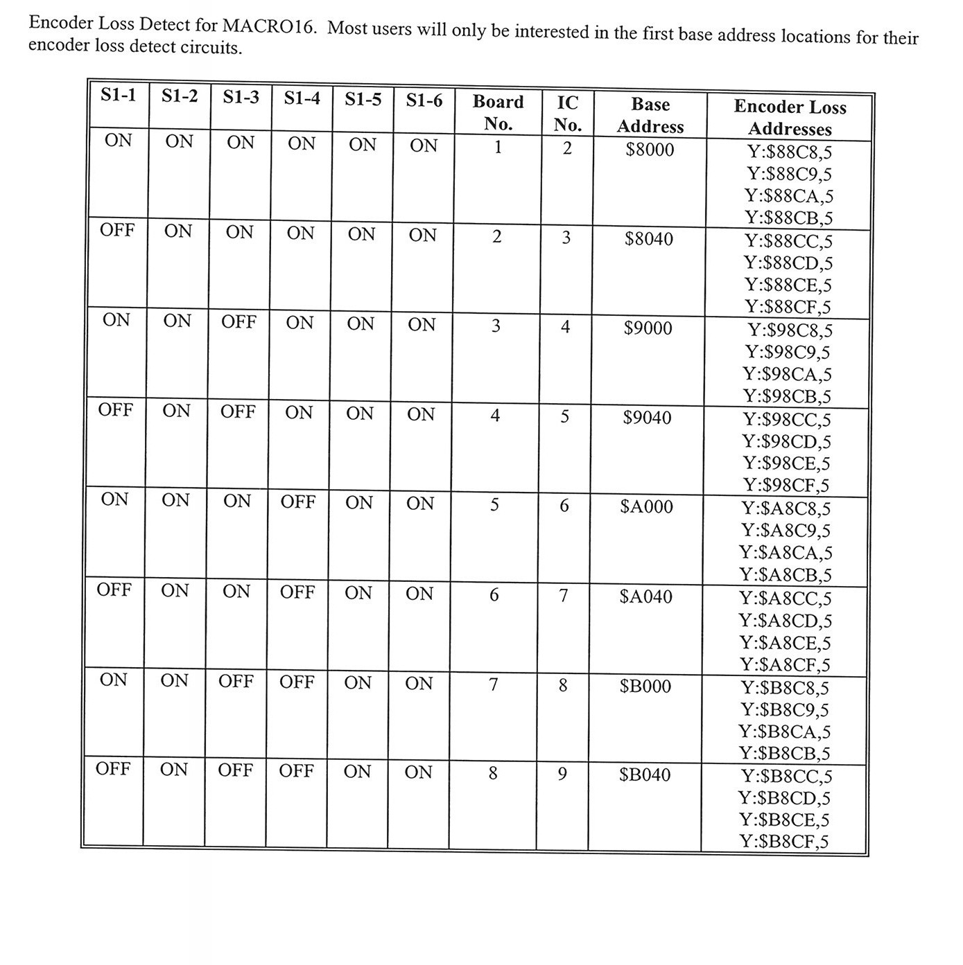
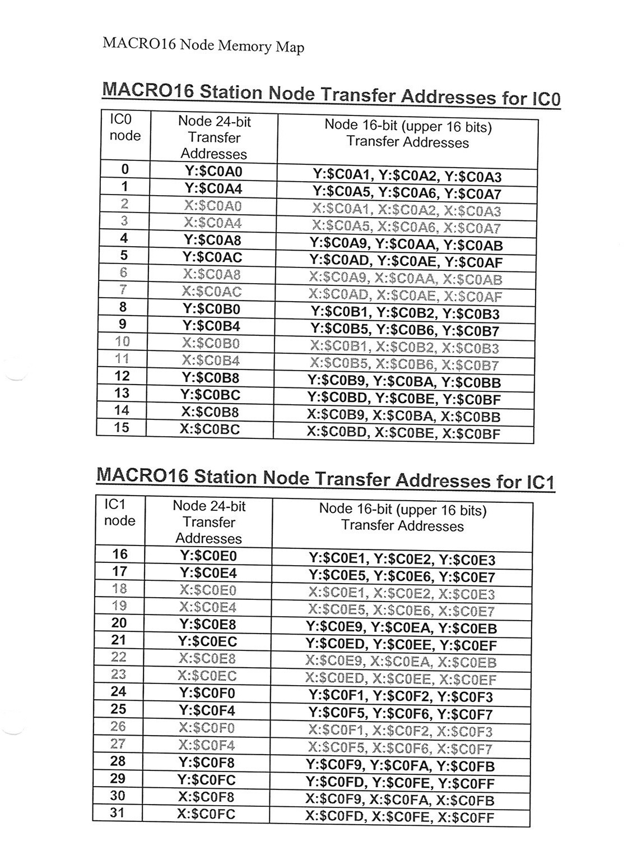
Of course recovering from the fault now prevents a problem, and we must at recovery remember to reset p184 and p185 , but only if M184 itself is reset.
Another technique would be to set ixx11=1, effectively giving a fatal following error of 1/16 count and this will kill the affected motor. If ixx24 is set to $240001 then all other motors in the same coordinate system will also be killed.. Determining which axis killed the system would simply mean finding which axis had its xx11 set to 1. WARNING this method will not stop an open loop move #nnO-5 for instance, whereas a #nnK will stop all motion types once coordinate system motion is aborted with &nA.

EDM Implementation
The status of the bits needs to be GUI displayed somewhere appropriate on the screen. An Acknowledgement or Reset button will be needed, possibly per axis. Careful consideration is needed as to what is acknowledged. (i.e. assuming the fault is cleared, will the button clear the fault colour, enable the axis, enable the amplifiers etc…?) In practice this will depend on whether this is a single or co-ordinate system, in vacuum, piezo etc.

TESTING
1. Manually change the “bit” to see your EDM change.
2. Change the “bit” back again and check to see that the EDM stays latched, if not quiz the latching bit.
3. Unplug the encoder, see the EDM change. Plug the encoder back in. EDM should stay latched. RESET or ACK.
4. Again, unplug the encoder. This time try to RESET or ACK the fault with the encoder still disconnected. Check that you get the desired effect.
5. For optical encoders, (Renishaw RGx xxx, SIGMA, etc) Repeat 3, and 4, above, this time leave the encoder plugged in. Slide a piece of paper under the readhead (LED Should turn RED on encoder/interpolator). Check that the EDM responds appropriately.

Standard definitions for Micromech UMAC MACRO stations.

;;Memory locations for encoder loss bit
;;These addresses work for micromech racks, OD racks need different ones
;ms0,i21 = $6488C8DCC0A1
;ms0,i22 = $6488C9DCC0A2
;ms0,i23 = $6488CADCC0A3
;ms0,i24 = $6488CBDCC0A5
;ms0,i25 = $6488CCDCC0A6
;ms0,i26 = $6488CDDCC0A7
;ms0,i27 = $6488CEDCC0A9
;ms0,i28 = $6488CFDCC0AA
;ms0,i29 = $6498C8DCC0AB
;ms0,i30 = $6498C9DCC0AD
;ms0,i31 = $6498CADCC0AE
;ms0,i32 = $6498CBDCC0AF
;ms0,i33 = $6498CCDCC0B1
;ms0,i34 = $6498CDDCC0B2
;ms0,i35 = $6498CEDCC0B3
;ms0,i36 = $6498CFDCC0B5
;ms32,i21 = $6488C8DCC0A1
;ms32,i22 = $6488C9DCC0A2
;ms32,i23 = $6488CADCC0A3
;ms32,i24 = $6488CBDCC0A5
;ms32,i25 = $6488CCDCC0A6
;ms32,i26 = $6488CDDCC0A7
;ms32,i27 = $6488CEDCC0A9
;ms32,i28 = $6488CFDCC0AA
;ms32,i29 = $6498C8DCC0AB
;ms32,i30 = $6498C9DCC0AD
;ms32,i31 = $6498CADCC0AE
;ms32,i32 = $6498CBDCC0AF
;ms32,i33 = $6498CCDCC0B1
;ms32,i34 = $6498CDDCC0B2
;ms32,i35 = $6498CEDCC0B3
;ms32,i36 = $6498CFDCC0B5
;;Configure MACRO station node enable i variables
;ms0,i996 = $FBFFF
;ms32,i996 = $2FBFFF
;;Configure IO, enable all nodes
;ms0,i975 = $CCC
;ms32,i975 = $CCC
;;Macro IC0 and IC2 Node Activate Control
;i6841 = $FFFFF
;i6941 = $2FFFFF

Set up the M-variable definitions to point to
; the encoder loss memory locations
m184->X:$78421,13
m284->X:$78422,13
m384->X:$78423,13
m484->X:$78425,13
m584->X:$78426,13
m684->X:$78427,13
m784->X:$78429,13
m884->X:$7842A,13
m984->X:$7842B,13
m1084->X:$7842D,13
m1184->X:$7842E,13
m1284->X:$7842F,13
m1384->X:$78431,13
m1484->X:$78432,13
m1584->X:$78433,13
m1684->X:$78435,13
m1784->X:$7A421,13
m1884->X:$7A422,13
m1984->X:$7A423,13
m2084->X:$7A425,13
m2184->X:$7A426,13
m2284->X:$7A427,13
m2384->X:$7A429,13
m2484->X:$7A42A,13
m2584->X:$7A42B,13
m2684->X:$7A42D,13
m2784->X:$7A42E,13
m2884->X:$7A42F,13
m2984->X:$7A431,13
m3084->X:$7A432,13
m3184->X:$7A433,13
m3284->X:$7A435,13

