**<COMP_HW3>**

2015-18634

Hyunjong Lee

1. **Problem 1**

Method Overloading is the feature that allows a class to make two or more methods with same name when their argument lists are different. I implement three ‘bark’ methods. First, bark() with no argument print “barking!”. Second, bark(String a) method prints “a barking”. I used ‘+’ to concatenate string a and “ barking”. Last, bark(int n, String b) method prints “n b barking”.

If I write bark() in main function, the first bark method would be called. If I write bark(“dog”) in main function, the second bark method would be called and print “dog barking”. If I write bark(2, “dog”) in main function, the third bark method would be called and print “2 dog barking”.

* Execution Result

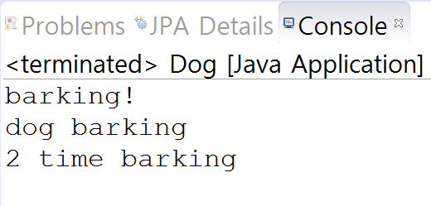

1. **Problem 2**

I used list to implement stack class. In stack class, I make list of string in field and integer value “top” that is indicating last index of the list. If list is empty, top is -1. When I push element to stack, add the element to list and increase top as 1. When I pop element, check if list is empty. Then, return list[top] value and remove it.

I used “+”, “ “(space), and “-“ to delimiter. I added ‘true’ to argument in StringTokenizer constructor, which is also return delimiter. I make boolean variance that indicate token is appeared after “+”. If token is “-“, pop element from token. If token is not delimiters and the Boolean variance is true (token is appeared after “+”), push it to stack.

* Execution Result

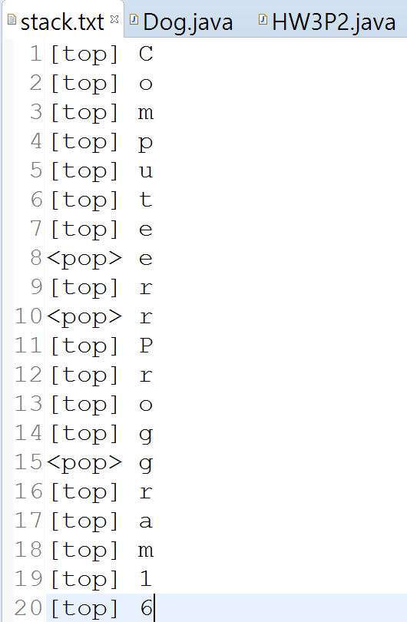

1. **Problem 3**

I make ‘Array’ class that has integer value in field. The value is initialized by constructor argument. I made two arrays of ‘Array’ object(Array[]) whose i-th value is initialized with Array(i) (i=0, 1, … , 9). This two arrays have same value but ‘Arrays.equals()’ returns false. Because it compare reference of each element. Since I make new ‘Array’ class instance for element of both arrays, reference of each element is different.

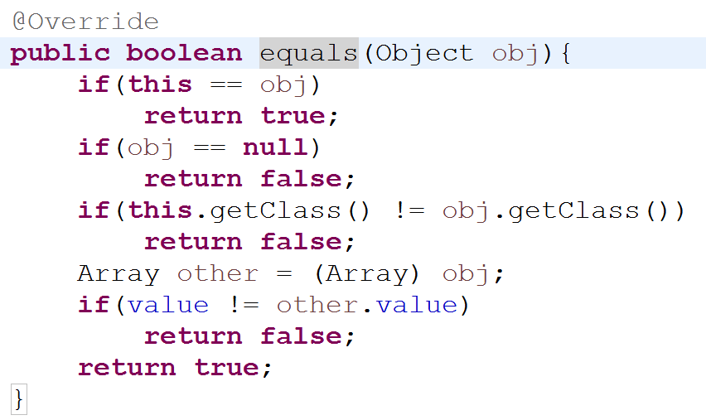

So I write ‘equals(Object obj)’ method overriding from Object class in Array class. If two ‘Array’ class object has same integer value, it would return true. (I checked if obj has same class and same integer value with this ‘Array’ class object or not.) Then, Arrays.equals() returns true.

* Execution Result

1. Before implementing ‘equals()’ method in ‘Array’ class

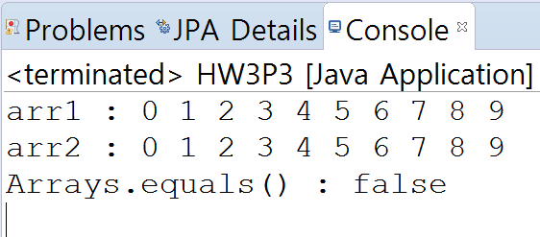

1. After implementing ‘equals()’ method in ‘Array’ class

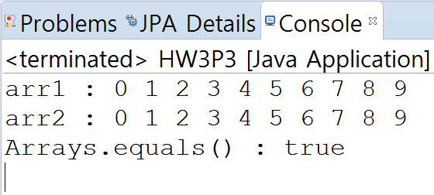

1. **Problem 4**

I imported java.util.Random class. I make Random class instance and use nextInt(int boundary) to generate random number between 0 and boundary. Since the ASCII code of letter(=alphabet) is between 65 and 122 except 91 – 96, I generate random number between 0 and 57(using nextInt(57)) and add 65 until it is not 91 – 96. Then, substitute it to character variable.

I used switch-case to check the letter is vowel or consonant. By using switch-case, check the letter is ‘a’, ‘e’, ‘i’, ‘o’, ‘u’, ‘A’, ‘E’, ‘I’, ‘O’, ‘U’.

* Execution Result

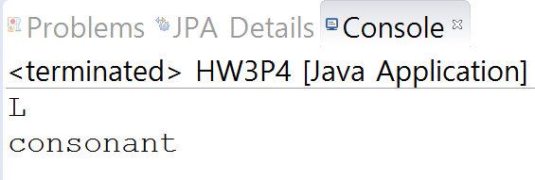 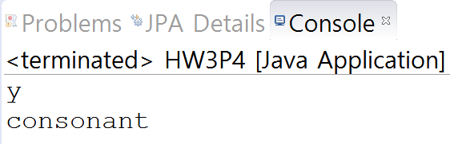

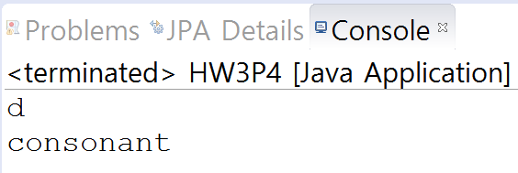 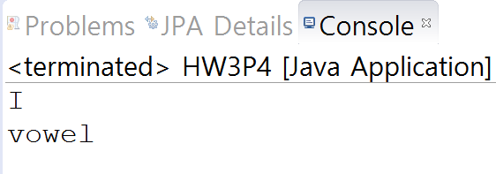

1. **Problem 5**

I use dynamic programming to calculate Fibonacci sequence. ‘printFibo(int n)’ is method printing n Fibonacci numbers from the beginning. In this method, I create integer array with length n. I initialize first two elements as 1. Then, calculate each number (from the third on) by add the previous two.

* Execution Result

