Login模块的度量

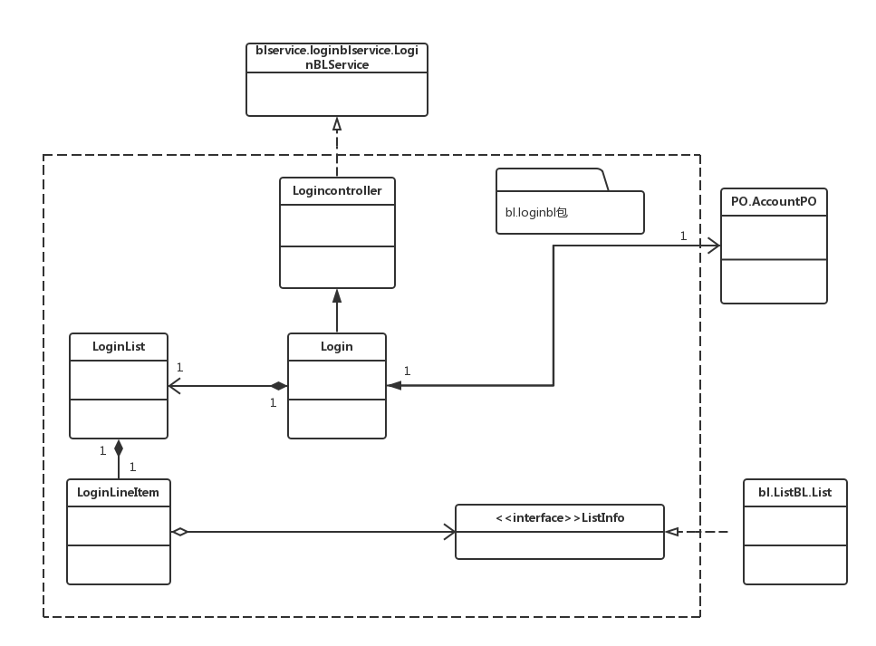

|  |  |  |
| --- | --- | --- |
| 类名 | CBO | DAC |
| Login | 3 | 1 |
| 调用其他类2  被其他类调1 | AccountPO |

|  |  |  |
| --- | --- | --- |
| 类名 | NOC | DIT |
| Login | 0 | 0 |
| Loginlist | 0 | 0 |
| LoginController | 0 | 1 |
| LoginLineItem | 0 | 1 |
| AccountPO | 0 | 0 |

Review模块的度量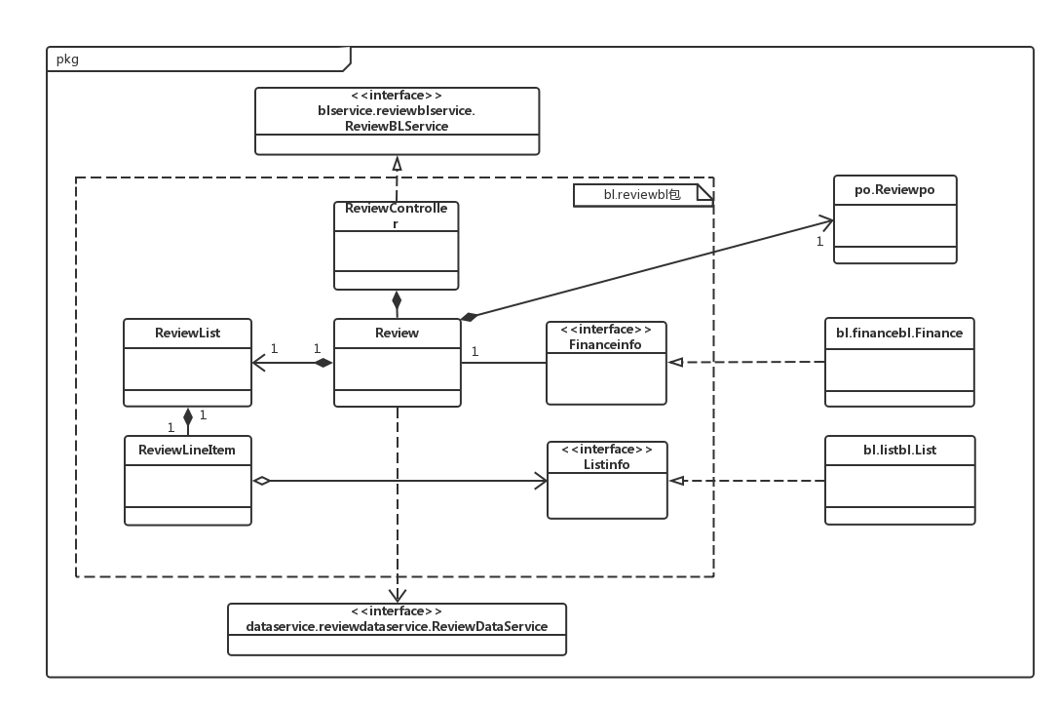

|  |  |  |
| --- | --- | --- |
| 类名 | CBO | DAC |
| Review | 5 | 2 |
| 调用其他类4  被其他类调1 | ReviewPO  Financeinfo |

|  |  |  |
| --- | --- | --- |
| 类名 | NOC | DIT |
| Review | 0 | 0 |
| ReviewController | 0 | 1 |
| ReviewList | 0 | 0 |
| ReviewLineItem | 0 | 1 |
| ReviewPO | 0 | 0 |

wareHouse的度量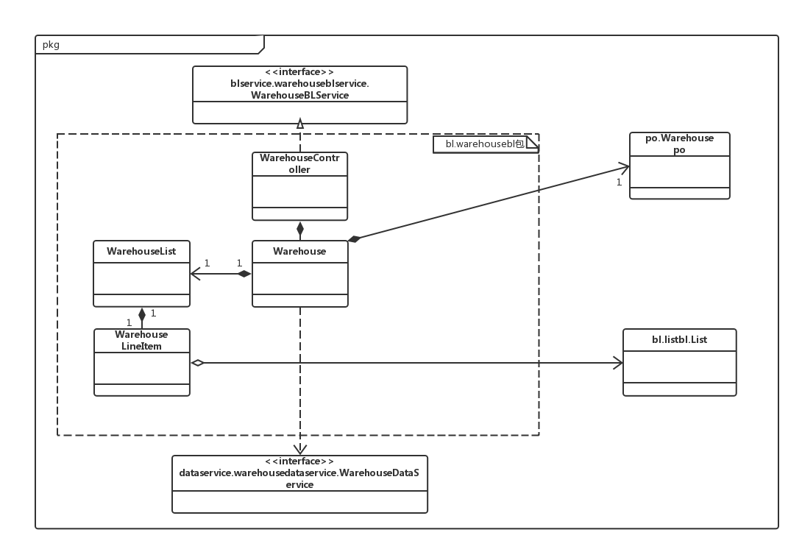

|  |  |  |
| --- | --- | --- |
| 类名 | CBO | DAC |
| WareHouse | 4 | 1 |
| 调用其他类3  被其他类调1 | WareHousePO |

|  |  |  |
| --- | --- | --- |
| 类名 | NOC | DIT |
| WareHouse | 0 | 0 |
| WarehouseList | 0 | 0 |
| Warehousecontroller | 0 | 1 |
| Warehousepo | 0 | 0 |
| WareHouseLineItem | 0 | 1 |

Trans模块的度量

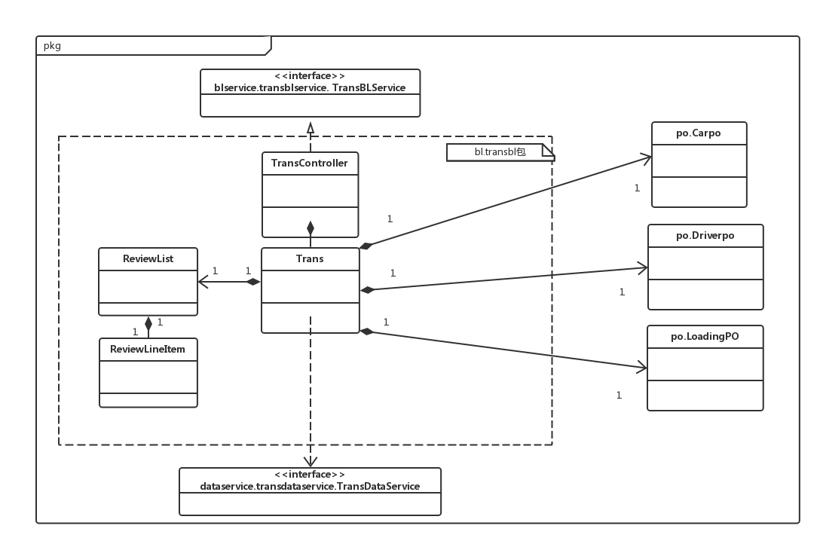

|  |  |  |
| --- | --- | --- |
| 类名 | CBO | DAC |
| Trans | 5 | 3 |
| 调用其他类4  被其他类调1 | CarPO  DriverPO  LoadingPO |

|  |  |  |
| --- | --- | --- |
| 类名 | NOC | DIT |
| Trans | 0 | 0 |
| TransList | 0 | 0 |
| Transcontroller | 0 | 1 |
| Carpo | 0 | 0 |
| Driverpo | 0 | 0 |
| Loadingpo | 0 | 0 |
| TransLineItem | 0 | 1 |

List模块的度量

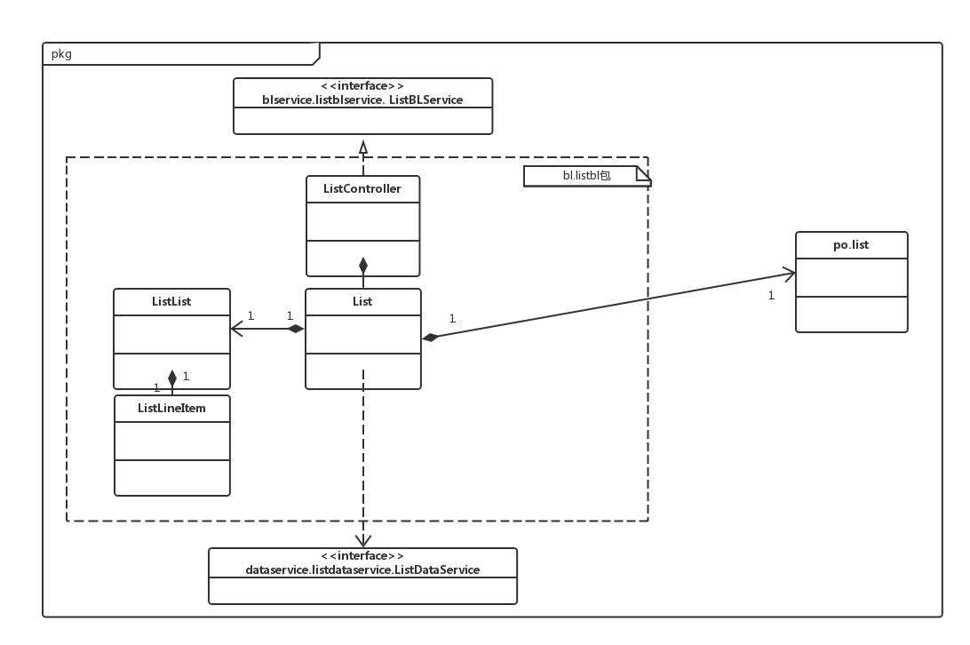

|  |  |  |
| --- | --- | --- |
| 类名 | CBO | DAC |
| List | 4 | 1 |
| 调用其他类3  被其他类调1 | PO.list |

|  |  |  |
| --- | --- | --- |
| 类名 | NOC | DIT |
| List | 0 | 0 |
| ListList | 0 | 0 |
| Listcontroller | 0 | 1 |
| Po.List | 0 | 0 |
| listLineItem | 0 | 1 |

Inquire模块的度量

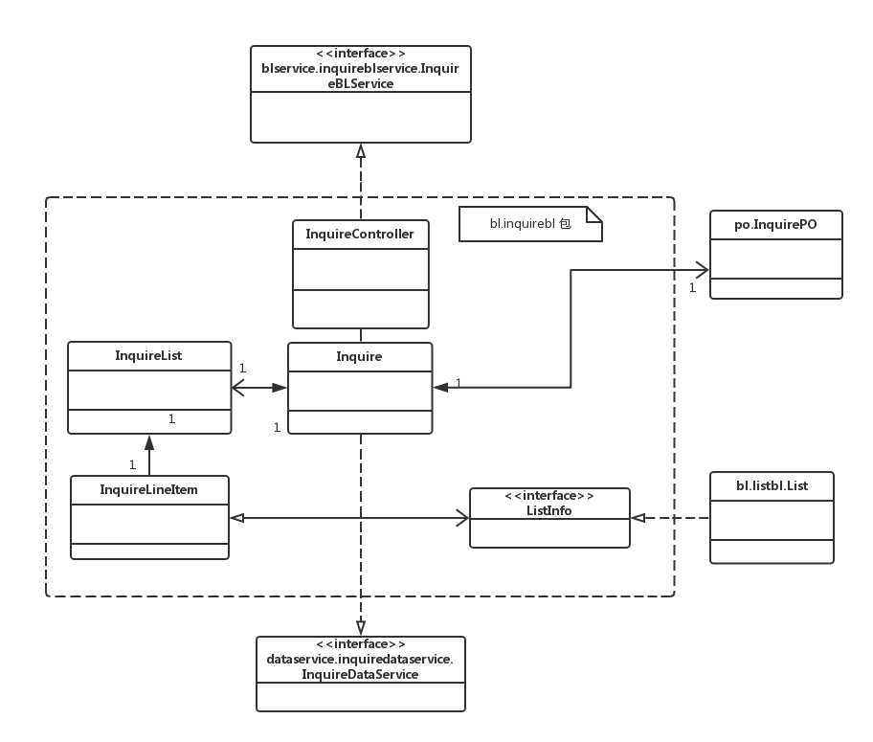

|  |  |  |
| --- | --- | --- |
| 类名 | CBO | DAC |
| Inquire | 4 | 1 |
| 调用其他类3  被其他类调1 | InquirePO |

|  |  |  |
| --- | --- | --- |
| 类名 | NOC | DIT |
| Inquire | 0 | 0 |
| InquireList | 0 | 0 |
| Inquirecontroller | 0 | 1 |
| InquirePO | 0 | 0 |
| InquireLineItem | 0 | 1 |

Finance模块的度量

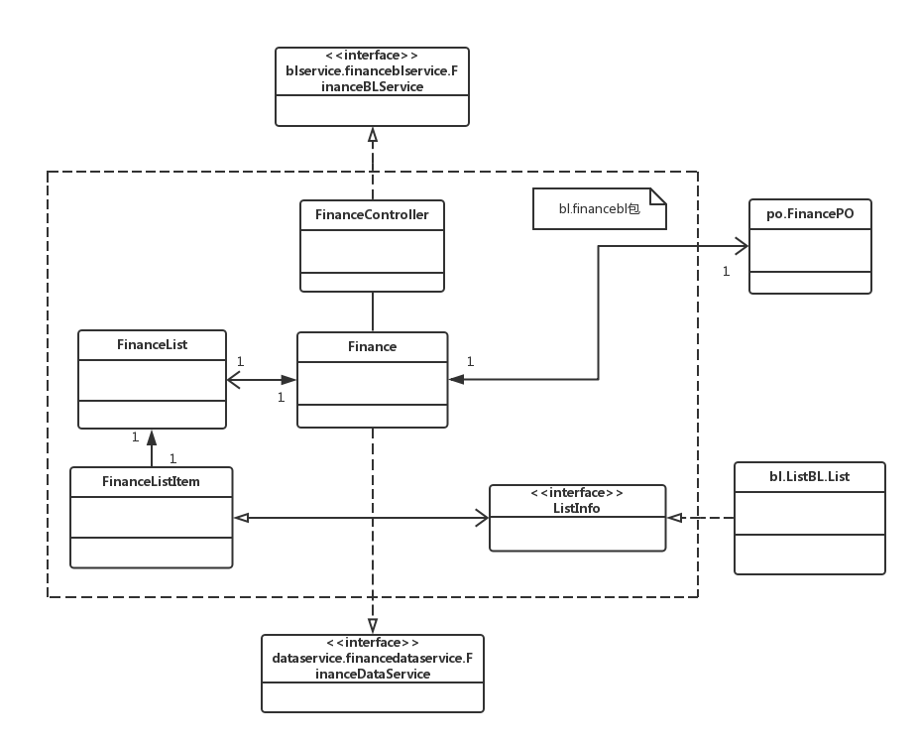

|  |  |  |
| --- | --- | --- |
| 类名 | CBO | DAC |
| Finance | 4 | 1 |
| 调用其他类3  被其他类调1 | FinancePO |

|  |  |  |
| --- | --- | --- |
| 类名 | NOC | DIT |
| Finance | 0 | 0 |
| FinanceList | 0 | 0 |
| Financecontroller | 0 | 1 |
| FinancePO | 0 | 0 |
| FinanceLineItem | 0 | 1 |

Account模块的度量

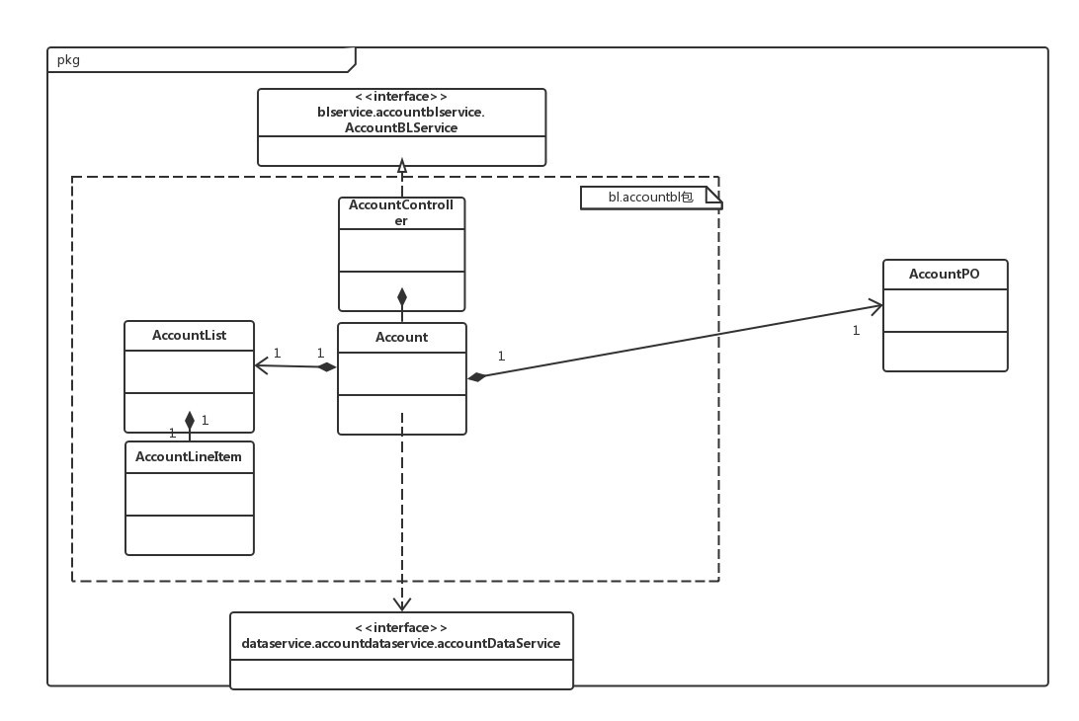

|  |  |  |
| --- | --- | --- |
| 类名 | CBO | DAC |
| Account | 4 | 1 |
| 调用其他类3  被其他类调1 | AccountPO |

|  |  |  |
| --- | --- | --- |
| 类名 | NOC | DIT |
| Account | 0 | 0 |
| AccountList | 0 | 0 |
| Accountcontroller | 0 | 1 |
| AccountPO | 0 | 0 |
| AccountLineItem | 0 | 1 |