Iodine_Liquid_Milk

Lee Kennedy

29 February 2016

## Iodine in MG Liquid Milks

MG have had high iodine results in powdered milks from the Koroit area and are investigating the milk sources.

The intent of this investigation is to look at the results they are extracting for liquid milks, to see the ranges present and to compare the results to other liquid milk samples. Overall there are not many liquid milk samples.

## Histograms

LIQ_MILK samples come from a number of clients, none MG.

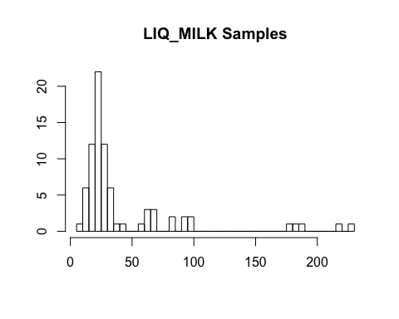

MG's recent survey of raw milks (LIQM_RAW) 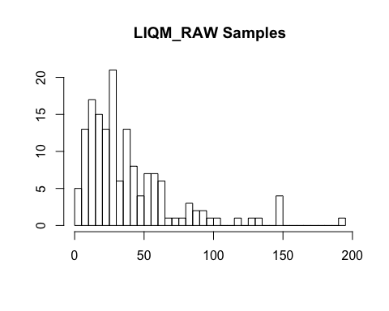

The two histograms can be overlaid:

