Control Chart Review - LACT02

15 January 2015

## [1] "Test Code : LACT02"

The recent control samples with this test have been:

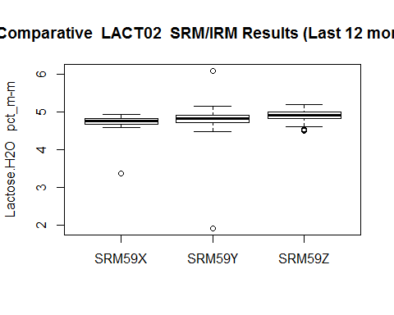

The most recent control chart (minus any outliers (shown in red) is:

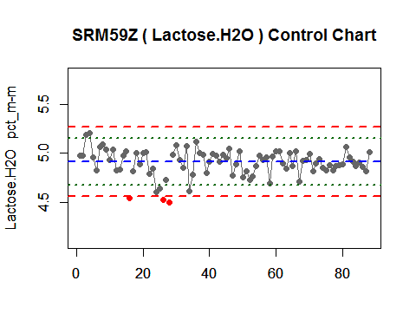

The histogram of the data points is:

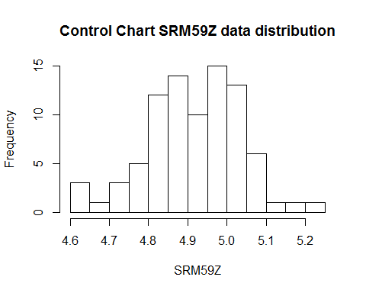

**Review** 1. Is it skewed? 2. Is it normal shaped? .

The general statistics for the data are:

## vars n mean sd median trimmed mad min max range skew kurtosis  
## 1 1 85 4.92 0.12 4.93 4.92 0.12 4.61 5.21 0.6 -0.29 0.08  
## se  
## 1 0.01

The values for the control lines used in the chart are:

## Labels V2  
## 1 UCL 5.274  
## 2 UWL 5.155  
## 3 Centre 4.916  
## 4 LWL 4.678  
## 5 LCL 4.559  
## 6 MU +/- 0.238

The results obtained by each operator are:

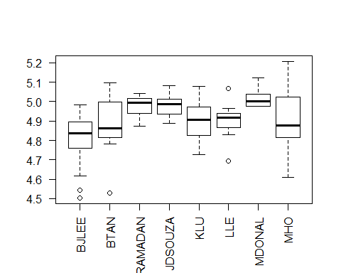

Number of control samples run by each operator:

##   
## BJLEE BTAN HRAMADAN JDSOUZA KLU LLE MDONAL MHO   
## 20 14 9 9 8 7 8 13