Control Chart Review

26 June, 2015

### Test Code : LACT02

The recent control samples with this test have been:

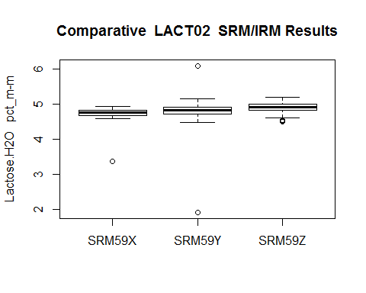

The following is the most recent control chart (control lines caluclated after omitting any outliers (shown in red)).

This chart uses up to the 70 most recent data points (less if there are not that many points available) and sets the control lines using the first 20 of them. If present, green points represent 'one side of the mean' trending error and yellow points represent a 'seven point' increasing or decreasing trend.

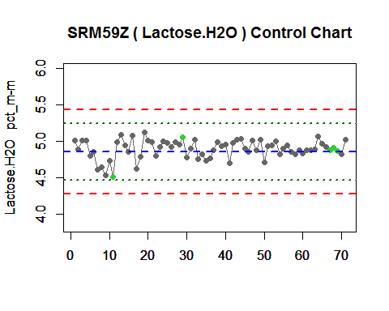

The histogram of the data points. Red line = mean:

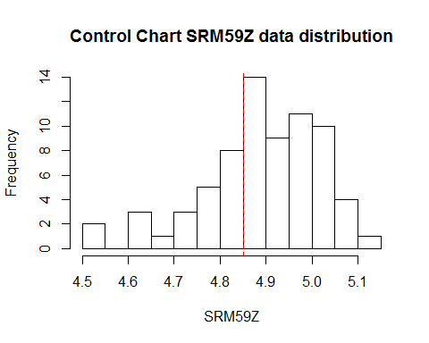

The general statistics for the data are:

## vars n mean sd median trimmed mad min max range skew kurtosis se  
## 1 1 20 4.85 0.19 4.87 4.86 0.2 4.5 5.12 0.62 -0.37 -1.28 0.04

The values for the control lines used in the chart are:

## Labels V2  
## 1 UCL 5.431  
## 2 UWL 5.237  
## 3 Centre 4.851  
## 4 LWL 4.465  
## 5 LCL 4.272  
## 6 MU +/- 0.386

The results obtained by each operator. Blue line = mean:

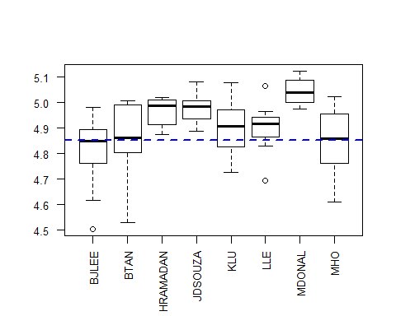

Number of control samples run by each operator:

##   
## BJLEE BTAN HRAMADAN JDSOUZA KLU LLE MDONAL MHO   
## 16 10 8 7 8 7 4 11