R Notebook

### Area of investigation

This report is specifically looking at CHROM_2.

## ── Attaching packages ─────────────────────────────────────────────────────────────────────────────────────────────── tidyverse 1.2.1 ──

## ✔ ggplot2 3.0.0 ✔ purrr 0.2.4  
## ✔ tibble 1.4.2 ✔ dplyr 0.7.4  
## ✔ tidyr 0.8.1 ✔ stringr 1.3.1  
## ✔ readr 1.1.1 ✔ forcats 0.3.0

## ── Conflicts ────────────────────────────────────────────────────────────────────────────────────────────────── tidyverse_conflicts() ──  
## ✖ dplyr::filter() masks stats::filter()  
## ✖ dplyr::lag() masks stats::lag()

##   
## Attaching package: 'lubridate'

## The following object is masked from 'package:base':  
##   
## date

Possible other areas are CHROM_1, WET_CHEM, PHYSICAL, CHROM_2, CHROM_3, GRAVIMTRIC, NA, METALS, CH_COUNCIL, INNOVATION, COMPOSITN, CALC, SAMP_PREP, GENERAL

hist(new_set2$STARTED,  
 breaks = 240)

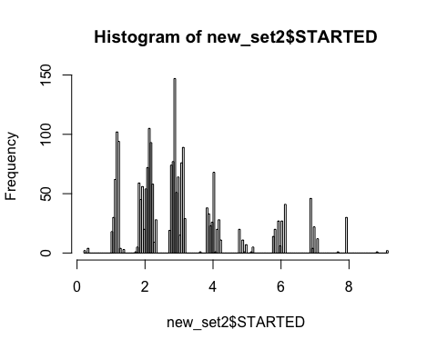

hist(new_set2$RELEASED,  
 breaks = 240)

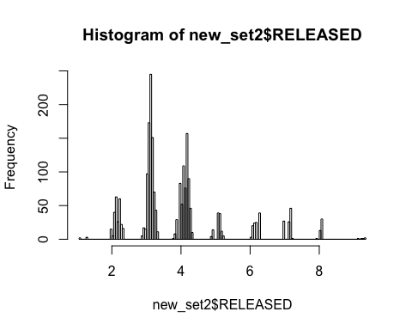

hist(new_set2$REVIEWED,  
 breaks = 240)

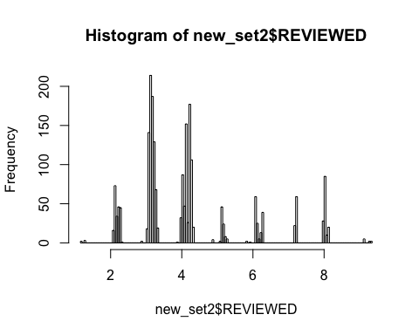

new_set2 <- na.omit(new_set2)  
  
summary.set <- new_set2 %>%  
 group_by(ANALYSIS) %>%  
 summarise(n = n(),   
 ave.start = round(mean(STARTED),2),   
 `95.pct.started` = round(quantile(STARTED, 0.95),2),  
 `95.pct.test.TAT` = round(quantile(RELEASED,0.95),2),  
 `95.pct.project.TAT` = round(quantile(REVIEWED,0.95),2))  
   
summary.set

## # A tibble: 1 x 6  
## ANALYSIS n ave.start `95.pct.started` `95.pct.test.TAT`  
## <chr> <int> <dbl> <dbl> <dbl>  
## 1 AFLA090615 2112 3.02 6.88 7.13  
## # ... with 1 more variable: `95.pct.project.TAT` <dbl>