Validation Report

Lee Kennedy

28 February 2016

## R Markdown

This is an R Markdown document. Markdown is a simple formatting syntax for authoring HTML, PDF, and MS Word documents. For more details on using R Markdown see <http://rmarkdown.rstudio.com>.

When you click the **Knit** button a document will be generated that includes both content as well as the output of any embedded R code chunks within the document. You can embed an R code chunk like this:

## Including Plots

You can also embed plots, for example:

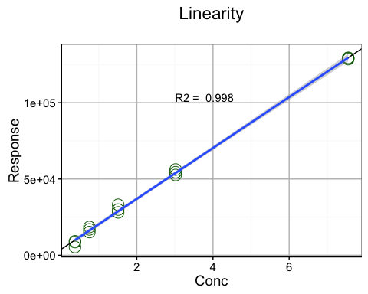

Note that the echo = FALSE parameter was added to the code chunk to prevent printing of the R code that generated the plot.

lin2

## term estimate std.error statistic p.value  
## 1 (Intercept) 3661.333 776.0161 4.718115 4.018638e-04  
## 2 linearity$A 16665.607 208.7219 79.846009 6.959816e-19

R2

## [1] 0.9979651

# 95% CI for co-efficients-----------------------------------------  
coefficients(lin) # model coefficients

## (Intercept) linearity$A   
## 3661.333 16665.607

confint(lin, level=0.95) # CIs for model parameters

## 2.5 % 97.5 %  
## (Intercept) 1984.852 5337.814  
## linearity$A 16214.691 17116.523

CI_curve <- confint(lin, level=0.95)

xxx

# LOD-LOR-----------------------------------------------------------  
LOR <- Validation.Workbook.LOD.LOR  
#LOR <- LOR[,1:2]  
  
  
colnames(LOR)[1] <- "Test"  
colnames(LOR)[2] <- "Result"  
  
LOR <- na.omit(LOR)  
  
limit_d <- 3*sd(LOR$Result)  
limit_r <- 10*sd(LOR$Result)  
  
print(limit_d)

## [1] 1751.834

print(limit_r)

## [1] 5839.445

xxxx

Boxplot of data:

boxplot(Input,  
 frame = TRUE,  
 cex.axis = 1.5,  
 cex.main = 2,  
 outpch=16,  
 outcol = "red")

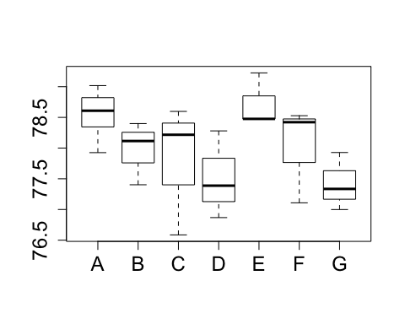

xxxx

#convert to a two element stack  
xs <- na.omit(stack(Input))  
  
# Run ANOVA  
anova1 <- aov(values ~ ind, data = xs)  
  
#Review results  
summary(anova1)

## Df Sum Sq Mean Sq F value Pr(>F)   
## ind 6 5.376 0.896 2.339 0.0758 .  
## Residuals 18 6.895 0.383   
## ---  
## Signif. codes: 0 '***' 0.001 '**' 0.01 '*' 0.05 '.' 0.1 ' ' 1

#Check for significant differences  
TukeyHSD(anova1)

## Tukey multiple comparisons of means  
## 95% family-wise confidence level  
##   
## Fit: aov(formula = values ~ ind, data = xs)  
##   
## $ind  
## diff lwr upr p adj  
## B-A -0.58248102 -1.9937312 0.8287691 0.8131109  
## C-A -0.75476854 -2.1660187 0.6564816 0.5839703  
## D-A -1.04286028 -2.4541104 0.3683899 0.2377208  
## E-A 0.16976570 -1.2414844 1.5810159 0.9996001  
## F-A -0.53565765 -1.9469078 0.8755925 0.8633477  
## G-A -1.13421288 -2.5454630 0.2770373 0.1668098  
## C-B -0.17228751 -1.8421012 1.4975262 0.9998351  
## D-B -0.46037925 -2.1301930 1.2094344 0.9659449  
## E-B 0.75224673 -0.9175670 2.4220604 0.7477323  
## F-B 0.04682338 -1.6229903 1.7166371 0.9999999  
## G-B -0.55173186 -2.2215456 1.1180818 0.9225721  
## D-C -0.28809174 -1.9579054 1.3817220 0.9969664  
## E-C 0.92453424 -0.7452795 2.5943479 0.5465600  
## F-C 0.21911089 -1.4507028 1.8889246 0.9993429  
## G-C -0.37944435 -2.0492580 1.2903693 0.9869088  
## E-D 1.21262598 -0.4571877 2.8824397 0.2540694  
## F-D 0.50720263 -1.1626111 2.1770163 0.9466080  
## G-D -0.09135260 -1.7611663 1.5784611 0.9999961  
## F-E -0.70542335 -2.3752370 0.9643903 0.7970355  
## G-E -1.30397859 -2.9737923 0.3658351 0.1895311  
## G-F -0.59855524 -2.2683689 1.0712585 0.8911232

#Repeatability & Interim Precision  
mean.sqr <- summary(anova1)[1][[1]][[3]]  
ncount <- as.numeric(length(anova1$effects))/as.numeric(length(anova1$coefficients))  
sdr <- sqrt(mean.sqr[2])  
interim <- sqrt((mean.sqr[1]-mean.sqr[2])/ncount)  
sdR <- sqrt(sdr^2 + interim^2)  
sdr

## [1] 0.6189002

sdR

## [1] 0.7257161

xxx

## null device   
## 1

xxxx

plot_anova = ggplot(xs, aes(x=ind, y=values)) +  
 geom_point(size=5, shape = 21, colour = "black", fill = "cornflowerblue") +  
 geom_hline(aes(yintercept=Mean),lty=5, col = "blue") +  
 geom_hline(aes(yintercept=UCL),lty=5, col = "red") +  
 geom_hline(aes(yintercept=LCL),lty=5, col = "red") +  
 geom_hline(aes(yintercept=UWL),lty=5, col = "darkgreen") +  
 geom_hline(aes(yintercept=LWL),lty=5, col = "darkgreen") +  
 scale_y_continuous(limits = c(0.95*LCL,1.05*UCL)) +  
 theme_bw() +  
 theme(panel.grid.major = element_line(size = 0.5, color = "grey"),   
 axis.line = element_line(size = 0.7, color = "black"),   
 legend.position = c(2.3,8),   
 text = element_text(size = 14))  
  
plot_anova

