Validation_Report_2

Lee Kennedy

7 March 2016

## R Markdown

This is an R Markdown document.

## Linearity

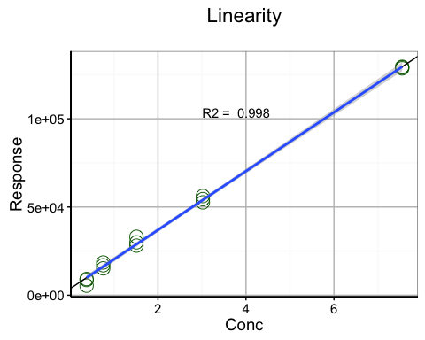

## LOD & LOR

You can also embed plots, for example:

The LOD is 1751.8335823 and the LOR is 5839.4452743.

## Repeatability and Reproducibility

## null device   
## 1

## Df Sum Sq Mean Sq F value Pr(>F)   
## ind 6 5.376 0.896 2.339 0.0758 .  
## Residuals 18 6.895 0.383   
## ---  
## Signif. codes: 0 '***' 0.001 '**' 0.01 '*' 0.05 '.' 0.1 ' ' 1

## Tukey multiple comparisons of means  
## 95% family-wise confidence level  
##   
## Fit: aov(formula = values ~ ind, data = xs)  
##   
## $ind  
## diff lwr upr p adj  
## B-A -0.58248102 -1.9937312 0.8287691 0.8131109  
## C-A -0.75476854 -2.1660187 0.6564816 0.5839703  
## D-A -1.04286028 -2.4541104 0.3683899 0.2377208  
## E-A 0.16976570 -1.2414844 1.5810159 0.9996001  
## F-A -0.53565765 -1.9469078 0.8755925 0.8633477  
## G-A -1.13421288 -2.5454630 0.2770373 0.1668098  
## C-B -0.17228751 -1.8421012 1.4975262 0.9998351  
## D-B -0.46037925 -2.1301930 1.2094344 0.9659449  
## E-B 0.75224673 -0.9175670 2.4220604 0.7477323  
## F-B 0.04682338 -1.6229903 1.7166371 0.9999999  
## G-B -0.55173186 -2.2215456 1.1180818 0.9225721  
## D-C -0.28809174 -1.9579054 1.3817220 0.9969664  
## E-C 0.92453424 -0.7452795 2.5943479 0.5465600  
## F-C 0.21911089 -1.4507028 1.8889246 0.9993429  
## G-C -0.37944435 -2.0492580 1.2903693 0.9869088  
## E-D 1.21262598 -0.4571877 2.8824397 0.2540694  
## F-D 0.50720263 -1.1626111 2.1770163 0.9466080  
## G-D -0.09135260 -1.7611663 1.5784611 0.9999961  
## F-E -0.70542335 -2.3752370 0.9643903 0.7970355  
## G-E -1.30397859 -2.9737923 0.3658351 0.1895311  
## G-F -0.59855524 -2.2683689 1.0712585 0.8911232

## [1] 0.6189002

## [1] 0.7257161

## null device   
## 1

## Bias

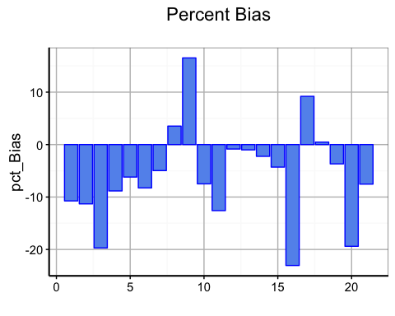

## X-Y Comparison

##   
## Call:  
## lm(formula = New ~ Old, data = data3)  
##   
## Residuals:  
## Min 1Q Median 3Q Max   
## -2.12202 -0.50605 0.04204 0.38383 2.48564   
##   
## Coefficients:  
## Estimate Std. Error t value Pr(>|t|)   
## (Intercept) 1.66106 0.99211 1.674 0.115   
## Old 0.97231 0.01647 59.020 <2e-16 ***  
## ---  
## Signif. codes: 0 '***' 0.001 '**' 0.01 '*' 0.05 '.' 0.1 ' ' 1  
##   
## Residual standard error: 1.298 on 15 degrees of freedom  
## Multiple R-squared: 0.9957, Adjusted R-squared: 0.9954   
## F-statistic: 3483 on 1 and 15 DF, p-value: < 2.2e-16

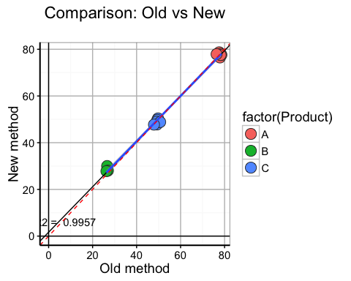

## (Intercept) Old   
## 1.6610610 0.9723107

## 2.5 % 97.5 %  
## (Intercept) -0.4535766 3.775699  
## Old 0.9371963 1.007425

## Standard Addition

##   
## Pearson's product-moment correlation  
##   
## data: data_stdadd$Abs and data_stdadd$Addition  
## t = Inf, df = 2, p-value < 2.2e-16  
## alternative hypothesis: true correlation is not equal to 0  
## 95 percent confidence interval:  
## 1 1  
## sample estimates:  
## cor   
## 1

##   
## Call:  
## lm(formula = data_stdadd$Abs ~ data_stdadd$Addition)  
##   
## Coefficients:  
## (Intercept) data_stdadd$Addition   
## 30 1

## Warning in summary.lm(fit): essentially perfect fit: summary may be  
## unreliable

##   
## Call:  
## lm(formula = data_stdadd$Abs ~ data_stdadd$Addition)  
##   
## Residuals:  
## 1 2 3 4   
## 0 0 0 0   
##   
## Coefficients:  
## Estimate Std. Error t value Pr(>|t|)   
## (Intercept) 30 0 Inf <2e-16 ***  
## data_stdadd$Addition 1 0 Inf <2e-16 ***  
## ---  
## Signif. codes: 0 '***' 0.001 '**' 0.01 '*' 0.05 '.' 0.1 ' ' 1  
##   
## Residual standard error: 0 on 2 degrees of freedom  
## Multiple R-squared: 1, Adjusted R-squared: 1   
## F-statistic: Inf on 1 and 2 DF, p-value: < 2.2e-16

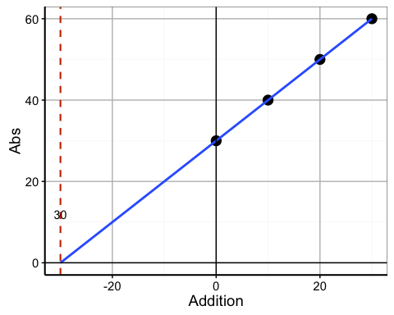

## (Intercept)   
## 30