TrueExtract Solutions Overview

“TrueExtract Solutions” is provisional and hopefully could be improved.

An invoice is basically a bill. It details the items bought or services performed and their cost, and requests payment. Here’s an invoice I received yesterday:
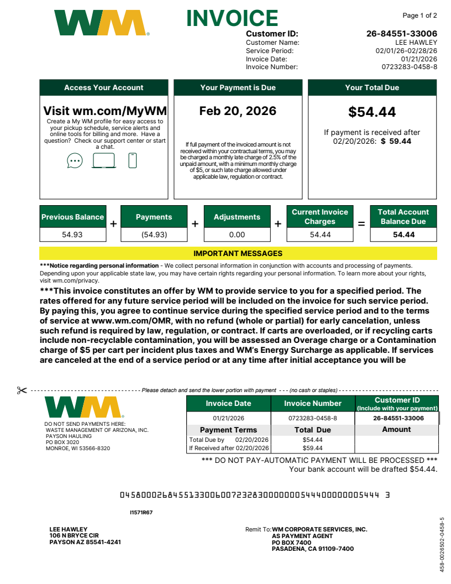

3.

That one is pretty ornate. They’re not usually so gaudy.
Here is another example:

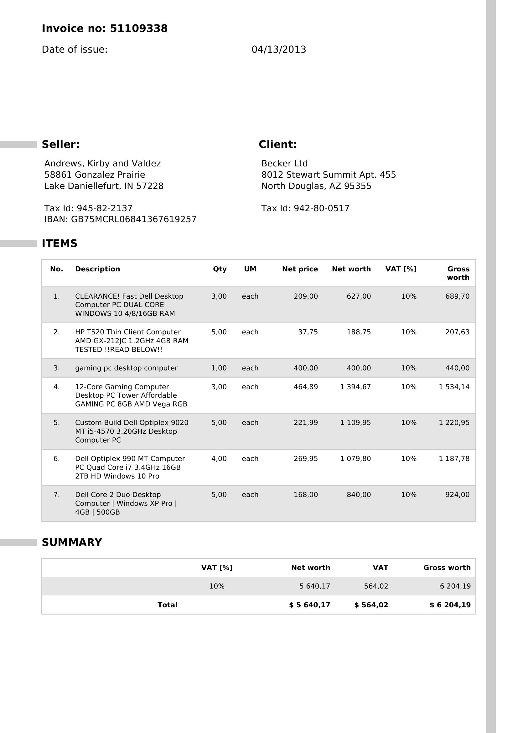

This one gives a computer problems because the individual item descriptions are on multiple lines. I’m currently handling this invoice with no problems.

Businesses potentially get dozens of these a week. Manual invoice processing often costs $7–$20 per invoice (or more), while automated OCR + AI solutions (which is what we would be doing here) can drop this to $2–$5 per invoice.

You can’t do much electronically with an invoice – it usually comes in the mail or as an image in an email.

If it comes in the mail, it can be scanned. If it comes as email, it will usually be a PDF or an image file. In order to automatically add the invoice data to a company’s bookkeeping system and process the invoice, it needs to be converted to text. This is difficult.

There are two big problems there:
1. Invoices from two different companies are going to look completely different. Processing invoices that are all similar isn’t too hard for a computer, but as soon as you have invoices from different companies, it becomes a huge problem.
2. The labels that identify the data you need may have different names – for instance, the total owed may be called TOTAL, or it may be called BALANCE OWED, or something else. So you can’t just look for TOTAL. A human can handle that without a problem, but a computer can’t.

Currently I have a program that handles both of these problems, and produces a file with data that can be easily imported into Excel.

As I said above, it costs a human 7 to 20 dollars to process an invoice because of the time it takes. Currently, the program I have can get the invoice ready to import into Excel for 1 cent (Azure charges for the service I’m using). That’s not the whole job of completely processing an invoice, but it’s a lot of it. An account can send money by just looking at Excel without having to handle the paper, or it can be imported into whatever program they are using to automatically send payments.

Another issue: I’m seeing stats that indicate that when humans process invoices, there is a high error rate because they’re manually entering data. I have a solution for this – a website where you can look at the invoice, see the processing results, and fix errors, plus I have come up with ways to automatically flag problems. So after processing, the company’s bookkeeper can look right at the invoice and quickly check the results.

Problems:
- The scanned invoices may be fuzzy or rotated or have other imperfections that are difficult to process. My process can automatically attempt to improve these issues and flag bad images and in my web app it will be easy for the bookkeeper to find the bad scans and fix the data manually.
- Yes, there is competition, but not a lot, and the most of the providers I’ve looked at don’t provide the comprehensive solution that addresses validating and editing the results.
- Marketing – how do we get customers? I already have some ideas.

Opportunities:
- Once you have a business going with customers, other issues come up. Some customers will have paper invoices that haven’t been scanned. When you get the first customer with this issue, we buy a scanner and have the customer ship the invoices to us. We scan the invoices, and charge for it.
- Some customers will have unique unique requirements. Some of these issues can be handled manually (they may want the invoices printed and shipped to them). Some of these issues might require programming, which I can do. All of these services will be charged to the customer.
- We offer a validation service, where we ourselves look at all of the invoices on the web app, check that all the fields are correct, and fix any errors we see. We charge by the hour.
- Once this is working, there are Upwork jobs that will become easy to do.
- There may be possibilities of selling (and updating) the system.

So how does this look on a day-to-day basis? A customer emails us some invoice scans, or uploads them to us by dropping them on the web app, or using Dropbox. We put these invoices into a folder on a computer, set up an import in a program on the computer, the files are automatically processed and the resulting files are returned to the customer, probably using Dropbox. We charge by the page, probably fifty cents to two dollars. Turnaround should be 24-48 hours. That’s the basic process. Anything else the customer needs us to do is extra.

Initial setup will require getting customer information, agreeing on a payment method, and getting the user to tell us what fields they want from the invoices. We will have defaults that will probably need to be changed per customer. This will be handled with a fairly simple configuration file, one per customer. We would probably ask for 1-20 representative invoices up front so we can evaluate any issues.

