

Statistics for Computer Science

Assignment Guidelines
Read the following instructions carefully before you start the assignment. If you do not understand any of them, ask your lecturer.
- The assignment coversheet should be the first sheet in your assignment. Moreover, the coversheet should be fully completed with all the necessary details.
- All text\code must be properly referenced. In the absence of proper referencing, the assignment will be regarded as plagiarised.
- Copying is strictly prohibited and will be penalized in line with the College’s disciplinary procedures.
- The deadline should be specified by your lecturer. When the deadline is due, you shall hand in the assignment according to the instructions found on Moodle.
- The submission may be submitted to a plagiarism detection tool as part of your submission.
- In addition to the Moodle submission, and additional hard copy submission may be required.
- The lecturer may hold a post-submission interview. Attendance to such interview is mandatory. Moreover, marks assigned to the criteria will be affected by the interview performance.
- All work that has been carried out, must be written down and included within the assignment as evidence. No marks will be awarded for work that is not presented.
- Please refer to the cover sheet for the assignment deadline.

Part 1 (29 marks)

Dry bean dataset
A data set that contains data on dry beans is available online at:
UCI Machine Learning Repository: Dry Bean Dataset Data Set
Citation:
KOKLU, M. and OZKAN, I.A., (2020), “Multiclass Classification of Dry Beans Using Computer Vision and Machine Learning Techniques.” Computers and Electronics in Agriculture, 174, 105507. DOI: https://doi.org/10.1016/j.compag.2020.105507

Section 1

Investigate the dry bean data set and perform dimensionality reduction. (AA3.2, 7 marks)

The attributes have 16 dimensions (excluding the class attribute). Can the number of dimensions be reduced without losing too much information about the client?
Use PCA to perform dimensionality reduction (see task for the detailed description of the work required).

Task 1:
- Perform PCA on the all the attributes (except the y attribute), write down the results. (2 marks)

- Write down the eigenvalues for each of the attributes, sorted in descending order. (1 mark)

- Create a Scree plot using the eigenvalues found in (b). (1 mark)

- Chose the number of dimensions to keep, given a sound explanation as to how you arrived at this decision.
Which of the dimensions did you choose? Why?
The dimensions chosen were the first 2 dimensions (PC1, PC2). The reason for this is that these 2 dimensions have a high percentage of explained variances (55.5% and 26.4% respectively), whereas the rest of the dimensions fall off with all of them having less than 10%.
Save an updated file with the new data. Paste the first 10 rows of the data. (3 marks)
PC1 PC2
-4.98137799 1.824630283
-5.436592527 2.932257073
-4.75791351 1.826816734
-4.300383058 2.003587511
-6.349107092 4.088054754
-4.946297172 2.339648659
-4.518819302 2.179813099
-5.01453424 2.453733467
-4.934817682 2.423467017
-4.78965238 2.183309095

Section 2

Present a write-up on the K-means algorithm. (AA4.2, 7 marks)

Task 2:
Define the term clustering. (1 mark)
[1] Clustering is used to find similarities between a group of subjects. In other words, clustering is a technique used to group unlabelled samples based on their similarities.
Explain why clustering is a type of unsupervised learning (1 mark).
The reason that clustering is a type of unsupervised learning is because the samples are not labelled beforehand.

Describe how the k-means algorithm works. (3 marks)
[2] K-means algorithm categorizes data points into clusters based on a mathematical distance measure, usually Euclidean distance, from the cluster centre.
Explain how randomness can affect the convergence of the k-means algorithm. (2 marks)
[2] Randomness can affect the convergence because if the initial cluster centroids are not well spread out or close to each other, the final clustering might not be the best possible partition of the data. Furthermore, K-means runs multiple times in order to further reduce the chance of ending up with suboptimal solutions.

Section 3

Cluster using K-means (15 marks)

Task 3 (KU3.1, 5 marks):
Carry out the k-means algorithm on either the dry beans dataset, or the results of the PCA in section 1 (3 marks)
Present a confusion matrix for the output of the k-means algorithm, relabelling the classes identified by the clustering, as appropriate (2 marks).
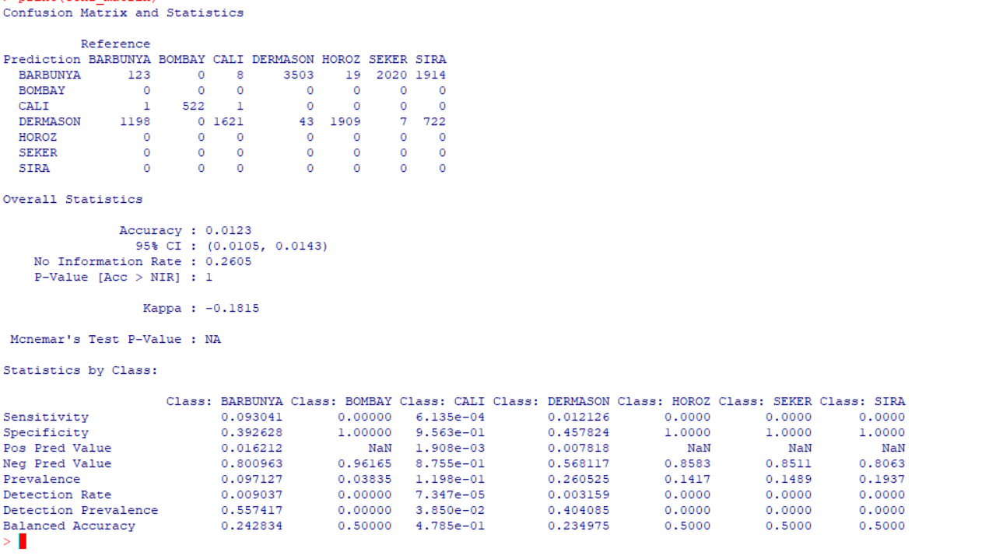

Task 4 (SE4.3, 10 marks):

Define the terms inter-cluster distance and intra-cluster distance. (2 marks)
Inter-cluster distance:

Measures the distance from the centroids of each cluster, this will show how well separated clusters are. [3]
Intra-cluster distance:
- Measures the distance between data points in the same cluster, this will show the compactness of a cluster. [3]

How are the inter-cluster distance and the intra-cluster distance used in k-means to identify the correct number of clusters? (2 marks)
[3] Inter-cluster and Intra-cluster distance are used to indicate the viability of the result clusters. Maximizing Inter-clustering will result in distinct clusters, whilst minimizing Intra-clustering will result in more compact data points (maximizing similarities). The best case of these two methods will result in distinct, compact, and easily interpretable clusters.

What is a silhouette plot? How is a silhouette plot used to examine the number of clusters chosen? (3 marks)
According to [4], a silhouette plot is a plot designed to show how well data points fit into the clusters they were assigned to. This is also called ‘The quality of fit cohesion’. The number of clusters chosen are examined by measuring the cohesion and separation values of each cluster point into a value which ranges from [-1, 1]. If the mean value of all points is closer to 1, that indicates a good clustering.

Carry out a silhouette plot on your k-means. Does the result match the number of classes in the data? Discuss your result. (3 marks)

Cluster sizes and average silhouette widths:
 | Cluster 1 | Cluster 2 | Cluster 3
Avg Silhouette Size | 5500 | 520 | 7587
Avg Silhouette Width | 0.4482220 | 0.7191140 | 0.5187408

Individual Silhouette widths:
Min. | 1st Qu. | Median | Mean | 3rd Qu. | Max.
-0.09218 | 0.44105 | 0.55013 | 0.49796 | 0.60548 | 0.80540

The results indicate that the clusters' average silhouette widths fall between 0.44 and 0.72. Keeping in mind that well-defined clusters are indicated by values closer to 1, but weak clustering is suggested by values closer to -1, it is concluded that the cluster with the lowest width (0.44) has moderate coherence, and the cluster with the maximum silhouette width (0.72) is more pronounced. The number of clusters (3) is not entirely consistent with the data's natural grouping because of the different silhouette widths.


Part 2 (37 marks)
The Two Girls Fallacy
Assume that the probability of a boy or a girl being born is 0.5.
Consider families with exactly 2 children.
Given a family for which we know that one of the children is a girl, what is the probability that the other child is also a girl?
Even though it may sound counter-intuitive, the correct answer is $\frac{1}{3}$.

In order to fully understand this problem, it is important to understand the question correctly. Notice that the question only considers the families that already have at least one girl, and the girl can be the first child or the second child. Consider the probability tree in figure 1 – only the families with at least one girl are considered. Therefore, if a family is known to have at least one girl, ordering children by age, the children could be a girl and a boy, a boy and a girl, or both girls. All these options are equally likely in this scenario, giving rise to the probability of $\frac{1}{3}$.
0.5
boy
0.5
girl
0.5
0.5
boy
girl
0.5
boy
0.5
girl
Figure 1 - Probability tree. The shaded section of the probability tree is not being considered, since in this case, the family would have two boys.

Section 4

Implement a Simple-Monte Carlo Solution

Task 5 (AA1.4, 7 marks):

Implement a Simple Monte Carlo algorithm to find the probability of the two girls fallacy. An output of 1 in the simulation means that the other child is also a girl, while a 0 means that the other child is a boy. (4 marks)
Add screenshots of your implementation (only the Simple Monte Carlo algorithm itself is required) and of your estimated probability that the other child is also a girl, using a sample size of 10,000. (3 marks)
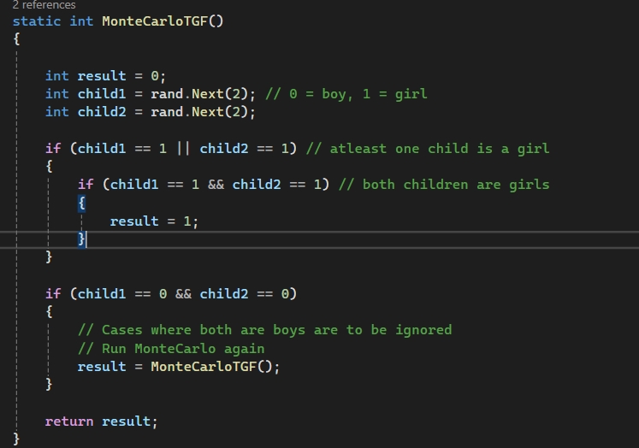

Task 6 (SE3.4, 10 marks):

Find the variance of the random variable representing the two girls fallacy (4 marks)
The variance of the simulation can be obtained by using the following formula:
$$s^{2}=\frac{1}{n-1}\sum_{i=1}^{n}{{\left(Y_{i}- {\hat{μ}}_{n}\right)}^{2}}$$
where n is the sample size, ${\hat{μ}}_{n}$ is the sample mean and $Y_{i}$ is the result of the $i^{th}$ simulation, representing a girl or a boy for the $i^{th}$ family as described above.
Result Variance: 0.22325736573654312

What is the RMSE error for the chosen sample size of 10,000? (2 marks)
Result RMSE: 0.004725011806721155
Use the variance to find the sample size to obtain an RMSE error of 0.001. Run the Simple Monte Carlo with the new sample size and present the new estimated probability that the other child is also a girl (4 marks).
Calculated sample size: 223258
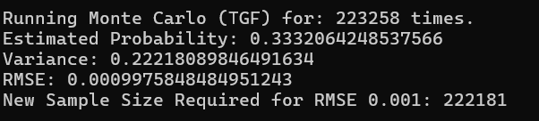
The result probability is very close to 0.33 recurring.

Task 7 (KU1.2, 5 marks):

Use the probabilities presented in this assignment to provide an analytical solution to the probability that the other child is also a girl. (3 marks)
P(Both are girls∣One is a girl) = Total possible outcomes / Number of favorable outcomes​ = 1/3
P(Both are girls∣One is a girl) = 10000 / 3288​ = 1/3
Child 1 | Child 2 | Outcome
Boy | Girl | 0
Girl | Boy | 0
Girl | Girl | 1
Boy/Girl, Girl/Boy are more likely than Girl/Girl.

Compare the result of this task, with the probability obtained from the Simple Monte Carlo algorithm. Does the Simple Monte Carlo algorithm produce a good estimate for the probability? (2 marks)
Simple Monte Carlo: 0.3303
Result of Task 6: 0.3332064248537566
Monte Carlo was correct to the second decimal place, which is quite close to the true probability of 1/3. I would consider this a good estimate, however if precision is highly required, Task 6 implementation is better.

Task 8 (KU4.1, 5 marks):

What are the assumptions that a simulation being analysed using Simple Monte Carlo must satisfy (3 marks)?

- Randomness: Monte Carlo assumes inherent randomness in both inputs and outputs, resulting in an unbiased and more accurate result. [5]
- Quality input data: Bad input data will lead to inaccurate results. [5]
- Normal distribution: Most Monte Carlo solutions use a normal distribution which assumes that outcomes are equally distributed around the mean. Signs that the median and average are significantly different will indicate an incorrect distribution. [5]
- Observation Independence: Many probabilistic solutions assume that each individual observation is independent of the observations before.
Give 2 examples of scenarios for which Simple Monte Carlo would perform well. (2 marks)
- Project Management: According to [6]’s study using Monte Carlo, if there is variability, Monte Carlo will perform better than Averaging. In this study, Monte Carlo was very close to forecasting the number of items closed by a team of 6 developers.
- Portfolio Management: A Monte Carlo simulation allows an analyst to determine the size of the portfolio a client would need at retirement to support their desired retirement lifestyle and other desired gifts and bequests. The result is a distribution of portfolio sizes with the probabilities of supporting the client's desired spending needs. [7]

Task 9 (SE3.3, 10 marks):

The 99% confidence interval is given by $[ {\hat{μ}}_{n}-2.58\frac{s}{\sqrt{n}} , {\hat{μ}}_{n}+2.58\frac{s}{\sqrt{n}} ]$(refer to Section 2.2 of the book Monte Carlo theory, methods and examples).
Implement the formula described above. The standard deviation, s, can be estimated using the formula implemented in Task 6. (4 marks)
Find the 99% confidence interval for the following values of n (2 marks each):
- n=10,000
  - Confidence Interval: [0.3195521369254453, 0.34384786307455467]
- n=20,000
  - Confidence Interval: [0.32350777333505826, 0.34069222666494176]
- n=100,000
  - Confidence Interval: [0.328586557500945, 0.336273442499055]

References
- Qualtrics. (n.d.). Cluster Analysis. [Online]. Available: https://www.qualtrics.com/experience-management/research/cluster-analysis/. [Accessed: Mar. 20, 2025].
- IBM. (n.d.). K-means Clustering. [Online]. Available: https://www.ibm.com/think/topics/k-means-clustering. [Accessed: Mar. 20, 2025].
- S. Yadav. (2020). Understanding Intra-cluster Distance, Inter-cluster Distance, and Dunn Index: A Comprehensive Guide. [Online]. Available: https://medium.com/@Suraj_Yadav/understanding-intra-cluster-distance-inter-cluster-distance-and-dun-index-a-comprehensive-guide-a8de726f5769#:~:text=cluster%20is%2018.-,Inter%2Dcluster%20distance,clusters%20are%20from%20each%20other. [Accessed: Mar. 20, 2025].
- Baeldung. "Silhouette Plots in Cluster Analysis." Baeldung on Computer Science, 18 Mar. 2024. https://www.baeldung.com/cs/silhouette-values-clustering. Accessed 20 Mar. 2025.
- T. Cagley, "Monte Carlo: The Assumptions," Software Process and Measurement, Aug. 23, 2018. [Online]. Available: https://tcagley.wordpress.com/2018/08/23/monte-carlo-the-assumptions/. [Accessed: Mar. 20, 2025].
- B. Huser-Berta, "The Flaw of Averages — Comparing Monte Carlo Simulations with Estimates based on Averages," Medium, Dec. 22, 2023. [Online]. Available: https://medium.com/mastering-agility/the-flaw-of-averages-comparing-monte-carlo-simulations-with-estimates-based-on-averages-267528ae4f47. [Accessed: Mar. 20, 2025].
- K. Agarwal, "The Monte Carlo Simulation: Understanding the Basics," Investopedia, Nov. 25, 2021. [Online]. Available: https://www.investopedia.com/articles/investing/112514/monte-carlo-simulation-basics.asp. [Accessed: Mar. 20, 2025].

