Report
GitHub URL:
https://github.com/LeeMckiernan/Project

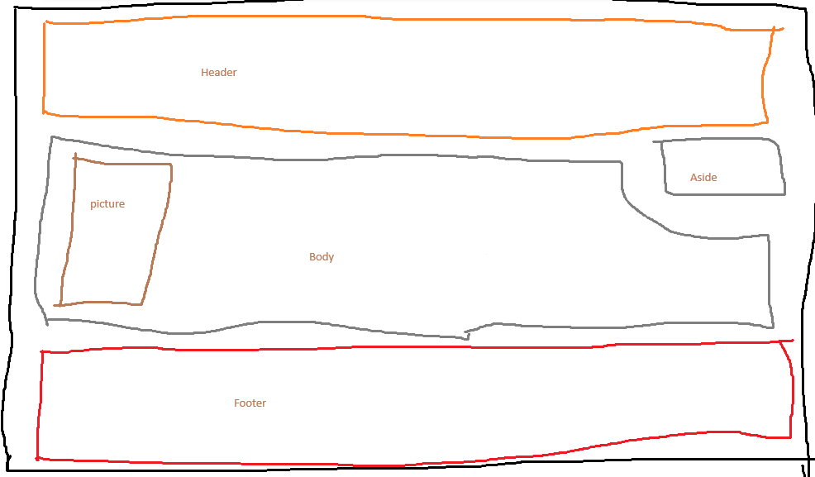

Brief Description:
The Index page contains why I like video Games so much.

The Main page contains the background of Gears of War and has statistics and a video on it as well.

The third page lets you pick between learning about the Gears or the Locusts.

The Gears page tells you about some of the Gears and their backgrounds and there is a link to show you even more about the character at the end of every character paragraph, you can also go to the bottom and top of the page.

The Locusts page tells you about the Locusts and goes into how they were made and there are also links to them to learn even more about them.

The Lore page goes into depth about the first game and what happens during the first act, it also tells you why they are named gears.
The Contact page has google maps showing where the college is and a form for people to fill out if needed.

Declaration of work:
This is my own work.

Sources of information:
https://gearsofwar.fandom.com/wiki/Gears_of_War_Wiki

Validator results:
