**Introduction**

The COVID-19 pandemic of 2020 created the largest disruption of education systems in human history. In the US, students were forced to continue their education through a remote learning capacity as schools at all levels shut down across the country. After students returned to the classroom in 2021, educators observed the largest drop in standardized test scores in recorded testing history among K-12 students, with Elementary and Middle School students being the most negatively impacted. While test scores dropped for every subject, the drop in scores for mathematics was the most significant. Gamified learning was evaluated as a potential solution to reduced US test scores and was found to significantly increase student performance when present in comparison to control groups with traditional study methods only. The results suggest that a coordinated, national approach to introduce gamified learning to K-12 students may have an overwhelmingly positive outcome.

**Problem Analysis**

To obtain a better understanding of the state of K-12 test scores in the United States, data was collected from the US Department of Education and the National Assessment of Educational Progress (NAEP) on 4th and 8th grade students. The NAEP, or simply the *Nation’s Report Card*, has tested 4th, 8th, and 12th grade students in the US every two years since 1990 in mathematics, reading, writing, and science in order to track overall educational progress. Data tables for 4th and 8th grade students were pulled from each of the 50 US states showing average math scores for 2022 and previous years (see “Test Results By State” folder above). Scores were then collected from each table and organized into a master table containing score changes for 4th and 8th grade students in every state (see “NationalTestScoreChanges2022” file above). The calculated score changes were then imported into a Tableau workbook to create visualizations showing each state and its reduction in math scores since 2019 (see visualizations below).

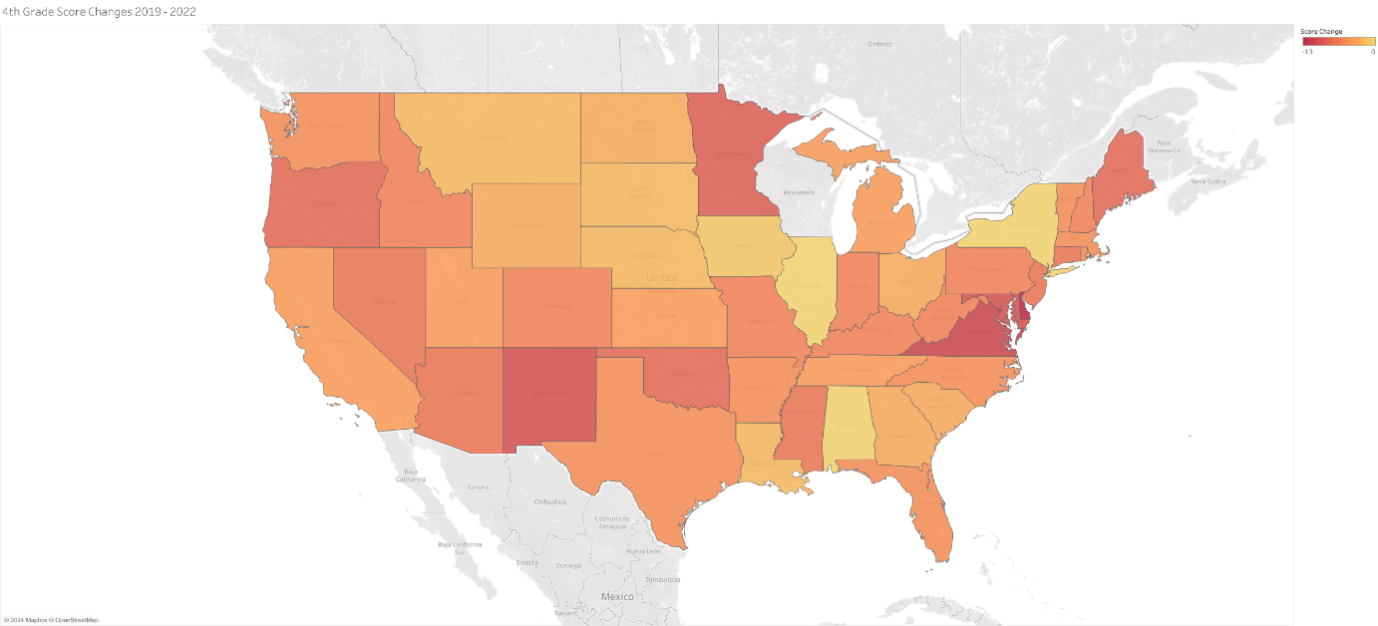

Change in 4th grade test scores for mathematics from 2019 to 2020

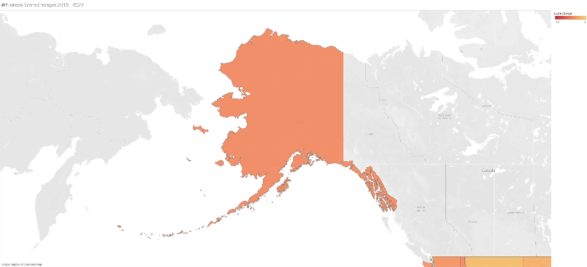

Alaska 4th grade

Hawaii 4th grade

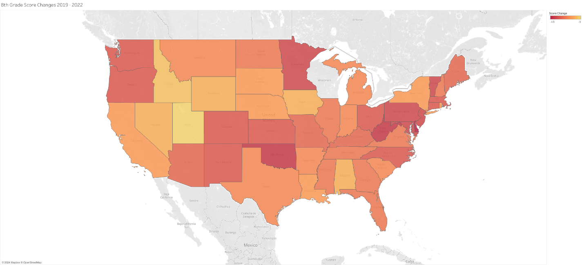

Change in 8th grade test scores for mathematics from 2019 to 2020

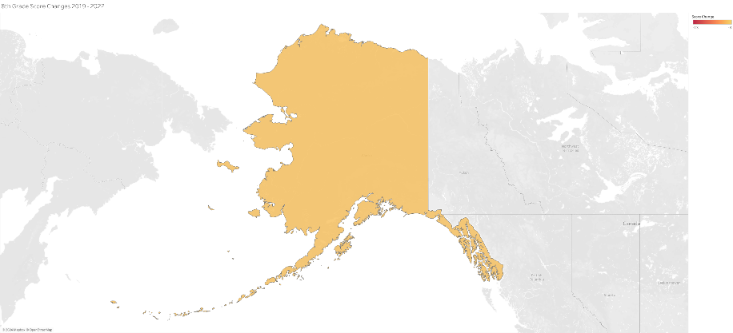

Alaska 8th grade

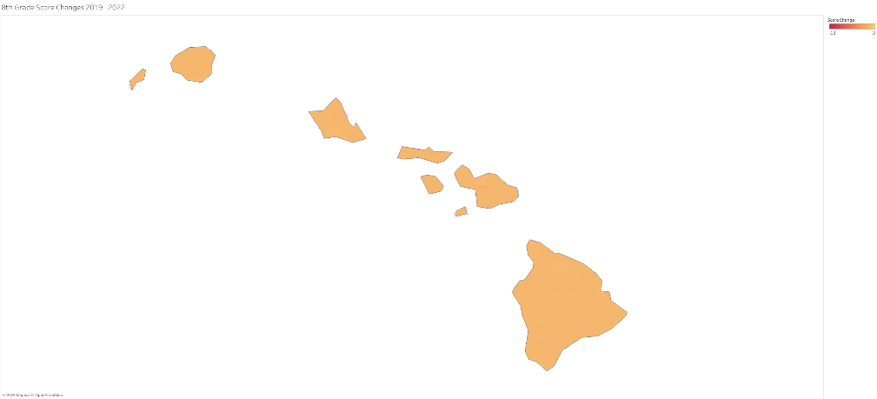

Hawaii 8th grade

Analysis of the national 4th grade test scores showed zero states had increases in scores from 2019. Only three states, New York, Illinois, and Alabama had no change in scores from 2019 to 2022. The remaining 47 states had decreases in scores ranging from 1 to 13 points reduction in average test scores. Analysis of the national 8th grade test scores also showed no states with increases in scores from 2019. All 50 states had decreases in math test scores for 8th grade students, again ranging from 1 to 13 points reduction. Noticeably, the reduction in average test scores for 8th grade students was significantly worse than the reduction in average test scores for 4th grade students. Overall analysis of test scores from 1990, when testing first began, shows a steady increase in scores for all students leading up to 2020. The marked decrease in scores in 2022 is the first significant drop in student scores in the NAEP’s history of testing.

**Potential Solution: Analysis of Gamified Learning**

In 2015, the review article *Gamification and Learning: A Review of Issues and Research* reviewed the published literature on gamified learning and its impact on learning and retention up to its point of publication. The article ultimately concluded that, while gamified learning had been found to enhance learning and retention, little research had been done regarding gamification in education specifically. In an attempt to better understand the effects of gamified learning within education, this case study reviewed data from students in a classroom environment with gamified elements introduced. The data analyzed is the result of a study performed consisting of 69 elementary school students with gamified elements introduced teaching basic arithmetic. The experiment organized 25 students into a control group that used strictly traditional study methods, and 39 students into an experimental group that used strictly gamified learning methods. At the start of the experiment, each student was given a pre-test to better determine overall improvement. After six weeks of learning with respective methods, the students were tested again, and the test scores were recorded. This case study organized the data from this experiment and calculated total grade increase for each group (see “ExperimentalGradeChanges.xlsx” above). Visualizations of the results can be viewed below.

Increase in test scores: Traditional vs Gamified Learning

Overall Increase in Test Scores: Traditional vs Gamified Learning

Relationship between number of games played and score increase

The experiment results showed a significant increase in test scores for students with gamified learning elements over those in the control group. The experimental group scored an average of 7.35 on the final exam, increased from 5.76 on the practice exam, while the control group scored an average of 6.25 on the final exam, increased from 5.66 on the practice exam. Overall, the gamified learning students had a test score increase of 44.18% while the traditional study students had an increase 16.48%. Additionally, the number of times the game was played for each student of the experimental group was tracked and plotted against percent score increase. A trendline was created for the plot showing a slight increase in test scores relative to an increase in number of times a student played the game (slope of 0.0302).

**Analysis of Results and Recommendations**

With the NAEP’s data showing US test scores on a constant, steady rise since testing began in 1990, and with the sharp and only decrease in US test scores occurring after the remote learning period of the covid-19 pandemic, it is reasonable to conclude that the remote learning period, or a related variable, was responsible for the sharp decline among 4th and 8th grade students. The observation that 8th grade math scores dropped significantly more than 4th grade math scores may be due to the increased difficulty in middle school math concepts in comparison to elementary math concepts. Little research has been done to validate the efficacy of remote learning for elementary and middle school students, especially in mathematics, and until evidence exists to suggest otherwise, it may be best to assume remote learning will only have an overall negative impact on learning and retention. With US students now back in the classroom, the question of how to help students improve learning and retention is more important than ever, not only to return test scores to baseline, but to potentially enhance learning permanently. The research conducted outside this case study has so far shown only positive results when assessing gamified learning’s effects on learning and retention. The examination of positive results from elementary students using gamified learning performed in this case study only serves to add to the continued growing body of evidence that gamification may be a reasonable next step in K-12 education’s development in the US.

**Aftermath**

Once the results of this case study were analyzed, in order to better gauge the efficacy of gamified learning in the classroom, a simple video game was developed titled *Meteor Multiplication* that focuses on teaching multiplication tables to elementary students. In short, the game requires a student to help a rocket ship prevent collisions with meteors by solving simple multiplication problems against a timer. After development, the game was made available for free to elementary students through the coordination with High Tech Middle Mesa in San Diego, California. Over time, the test scores of students tested on multiplication tables will be collected for further analysis.

Note: Meteor Multiplication can be viewed here.