Image Downloader
Image downloader script finds image URLSs previously scraped by Image Selector in a csv file and downloads them. Images are renamed to <web-scraper-order>-<selector-name>.ext. This version is a fork from webscraper.io's original script. I have made some small tweaks:
- A Windows binary (.Exe) is available for those who cannot, or will not install Python.
- Changed the User-agent to the one for the latest Chrome on Windows 10 64-bit. The original script is reporting itself as "Chromium 63 on Ubuntu".
- Removed the 10-second delay when downloads are completed, and replaced it with a call to Windows' built-in Pause command. This will display "Press any key to continue..." instead of closing the console window after 10 seconds.
- Added a 0.25 second delay between each download. You can change or remove this in the source.
- A sample scrape results file, sample-images-dl.csv is available for testing. You can drag-n-drop this file on the .EXE or .py file for testing.
Windows usage
- [OPTIONAL] Download and install python 3.x from here: https://www.python.org/downloads/
- Download image downloader .EXE and script from here: https://github.com/LeeMeng2020/image-downloader-lm/releases
- Scrape the target site and export data in CSV format
- Drag and drop the CSV file onto image-downloader.exe
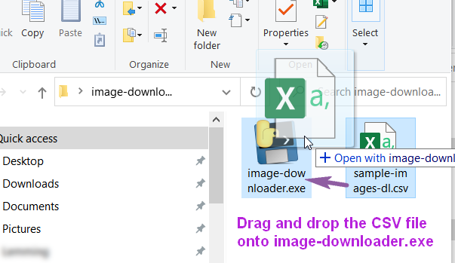
- Alternatively, if you have Python 3.x installed, drag and drop the CSV file onto image-downloader.py. On some computers, you may need to enable drag & drop onto Python files.
MacOS, Linux usage
- Install python if necessary through your package manager. Most likely you already have it preinstalled.
- Download image downloader script from here: https://github.com/LeeMeng2020/image-downloader-lm
- Move image-downloader.py to Downloads directory
- Scrape the target site and export data in CSV format
- Save the CSV file in Downloads directory
- Open Terminal application. You should have one preinstalled
- Change working to Downloads directory by typing:
cd Downloads
8. Run image downloader script by typing:
python image-downloader scraped_data.csv

