CHESS: ChessBoard
ChessBoard is an interactive GUI application that simplifies the typical user interactions with CHESS, such as launching CHESS runs and managing test results. Its main purposes are
- Simplify simultaneous running of multiple tests and viewing of multiple results
- Quick repro & display of failing testcases and races
- Simplify experimentation with various CHESS parameters

Restrictions
ChessBoard currently works only with mchess (that is, with managed code). It does not support wchess tests.

The Basics

Starting and Quitting ChessBoard
To launch ChessBoard, navigate to a folder you want to work from (ChessBoard will create temporary files in this folder) and type “ChessBoard.exe”. This starts ChessBoard with an empty session (the first time).
To run tests or look at results, you first need to do one of the following:
- Import a testlist from a file (choose the menu Session->Import Testlist). Testlists define collections of tests. To create or edit testlists, use a text editor (or better, your favorite XML editor). The format for testlists is described in the document testlists.doc.
- Import results (choose Session->Import Results From File) from a previously run mchess testcase, by locating its ‘results.xml’ file.
You can import any number of testlists and results, and you can import the same testlist or test multiple times. You can also import a test directly from the commandline by passing the results.xml file as a commandline argument.
ChessBoard auto-saves your session state to a file called session.xml (in the same directory that you started ChessBoard from). Thus, you can quit ChessBoard at any time (even if there are tasks still running) without worrying about losing your current session. When you start ChessBoard again in the same directory, it will read the session state from the file session.xml.

ChessBoard Views
The ChessBoard window is organized into four views (see picture below) that organize the session data in different ways. You can resize all partititions with the mouse. The current selection is synchronized between views: if you select a run in the test view (e.g. the blue selection in the picture below), it will be highlighted in the task view (the gray selection), and its details are shown in the Detail View (showing the list of results and the output for this specific run).

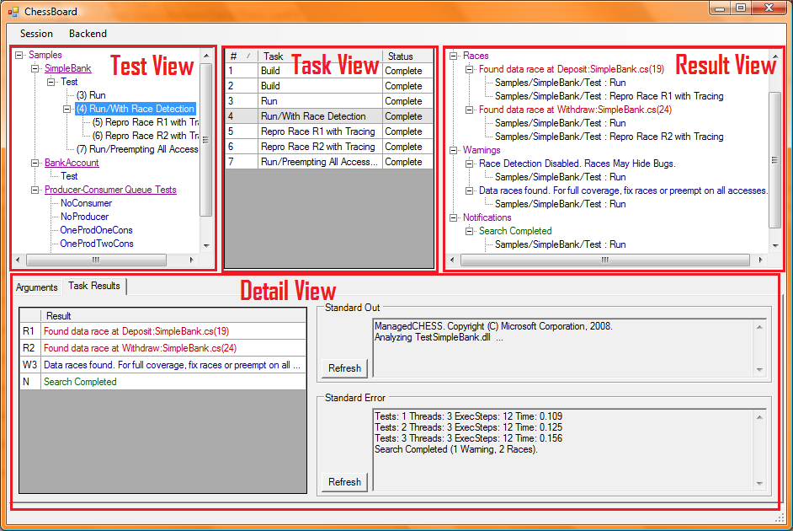

Test View
The test view shows a hierarchical view of
- Testlists (purple text). Testlists can contain tests or other testlists. Some testlists (recognizable by an underline) have a build action associated. To start a build, right-click the testlist and choose Build from the context menu.
- Tests (blue text). Each test describes the necessary ingredients for an invocation of chess (the test specifies a start directory, an .exe or .dll file containing the ChessTest class, and arguments that should be used). To run a test, right-click it and choose Run from the context menu.
- Tasks (black text). Each task describes an individual run of a test. To keep track which task belongs to which test, the test view shows tasks nested inside tests. Since a test can be run many times, it can contain many tasks. Moreover, tasks can contain other tasks (for example, if you rerun a task for repro, it will be shown as a nested task).

Task View
The task view shows a list of all tasks that have executed in the past, are currently executing, or are waiting to execute. Each task has a sequence number, shown in the left column (this sequence number is also displayed in the testview, adjacent to the task). It has a name indicating the type of task, shown in the middle column. Finally, it has a status, which is one of Waiting, Running, and Complete. The task view is convenient for the following:
- To get a quick idea of the status of the computation (in particular, how many tasks are pending). Note that you can click the sort symbol in the column headers to sort by status (or by any other column).
- To perform some action on a task (say, to view its result, or to repeat it). You can simply right- click a task in the task view to bring up the popup menu, then select from the options.
- To have a temporally organized history of tasks. Since tasks are numbered consecutively, the task view provides a history of what you have done in this session.

Detail View
The detail view shows detailed information about the currently selected task.
On the right, the contents of the standard out and standard error are displayed. When running chess, the standard out displays whatever the code under test is printing, while the standard error contains information about the exploration (how many schedules are being explored, the number of threads, the number of steps in each schedule, and the time taken for the exploration). The display of standard out and standard error refreshes automatically (with a 7 second interval), but you can also force an immediate refresh of either of them by clicking the respective refresh button.
On the left, the results of the task are displayed (once the task is complete). Tasks can report many results. Each result has a label (like R1, R2, W1, or N) and a description. You can right-click on a result to pop up a context menu. For example, in the situation shown in the picture above, you could click on the first reported race and choose Repro Race R1 With Tracing.

Result View
The result view displays the results of ALL tasks, organized into categories:
- Error: a significant failure that requires the exploration to abort.
- Race: a detected data race or store buffer vulnerability.
- Warning: a potential error, or a condition that my cause CHESS to miss and error.
- Notification: a conclusion printed at the end of an exploration that did not terminate in an error.
The first letters (E,R,W,N) match the first letter of the labels of the results in the detail view.
When displaying a result, the Result View shows a textual description of the task that produced the result. You can right-click on the task to get a context menu for this result. If there are multiple results with the exact same message (for example, the same race is often detected many times over), they are grouped together.

Cleaning Up
As you use ChessBoard, your session may get cluttered with old information you do not care about. To clean up, you have the following options:
- Delete the entire session (all testlists and all tasks) by choosing Session->Delete Session.
- Delete all tasks (keeping all testlists) by choosing Session->Clear All Tasks.
- To delete a specific testlist, test, or task, you can
  - select it (in the testlist or task view) and hit the Delete key.
  - right-click it to pop up a context menu, then choose Delete Testlist, Delete Test, or Delete Task respectively.
- You can delete multiple tasks at a time by selecting them in the task view (using the shift key or by dragging the mouse) and then hitting the Delete key.
- You can delete all tasks for a specific test or testlist by right-clicking it and choosing Clear Tasks from the pop-up menu.
IMPORTANT: ChessBoard saves all the information pertaining to tasks in folders called, for example, taskdir000042 (if the number of the task is 42). These folders also persist until you actively delete the task from your session. If the session should ever become irrevocably corrupted for some reason, you can forcefully clean up by deleting both (1) the session.xml file, and (2) all taskdir* folders.

Issuing Commands
Most commands are accessed exclusively using context menus, by right-clicking a testlist, test, task or result. The content of a context menu varies as not all commands are applicable to all targets.

Command Option Dropdowns
When you choose a command, you often have additional options pop up. You need not follow these menus: you can left-click most items without following the hierarchy all the way down. These pop-up options provide a quick way to specify combinations of options for running mchess.
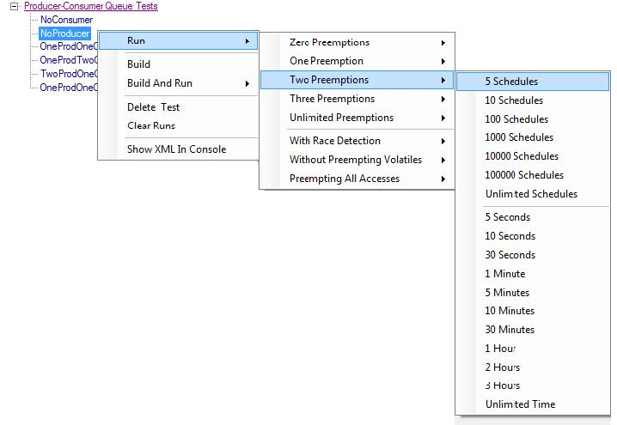

Running Tests
To run tests, right-click a testlist or a test in the testview and choose Run from the context menu.

Bound Options
The following options are grouped into categories; if you do not choose a particular setting from that category, the default setting applies.
Category | Choices | Default | Effect
Preemption Bound | Zero Preemptions ... Unlimited Preemptions | 2 | Limit the search to schedules with at most that many preemptions.
Schedule Limit | 5 Schedules ... Unlimited Schedules | Unlimited Schedules | Interrupt the search after n schedules. Note: you can continue an interrupted search later on.
Time Limit | 5 Seconds ... Unlimited Time | Unlimited Time | Interrupt the search if time runs out. Note: you can continue an interrupted search later on.

Coverage Options
With Race Detection | CHESS detects races during its exploration (race detection is not turned on by default).
Without Preempting Volatiles | CHESS does not preempt on volatile variable accesses. This reduces the number of explored schedules but means that bugs may be missed.
Preempting All Accesses | CHESS inserts preemptions on all memory accesses. This vastly increases the number of schedules explored, but can find bugs that would otherwise be hidden by data races. There is no need to use this option on tests that are race-free.

Following up on results
Right-click on a result in the Detail View or the Result View to bring up the context menu.
- You can choose Repro to rerun the specific schedule that caused the error. If the result in question is a race, the command is more specific as it will repro a specific race: Repro Race XX. In either case, choose the option With Tracing if you would like to use ConcurrencyExplorer to look at a trace.
- If the task ran with tracing, you can choose View With ConcurrencyExplorer to bring up ConcurrencyExplorer (see the separate document for info on ConcurrencyExplorer). If you were reproducing the race, choose View Race With ConcurrencyExplorer. This brings up a special view of the trace that includes only events that precede the race (that is, it makes it look as if the program ran straight to the race and then stopped).
- You can repeat an entire task by choosing Repeat Test from the context menu for the task. You can change the run options if desired.
- You can repeat the last schedule of a task by choosing Repro Last Schedule from the context menu for the task. You can select options listed below.
- If the task ran with tracing enabled, you can view a trace by choosing View With ConcurrencyExplorer.

Repro/Repeat Options
With Bounds | Choose schedule or time limits (only applicable when repeating an entire task)
With Tracing | Create a trace of the execution that is suitable for viewing with ConcurrencyExplorer.
With Logging | Log full information (for debugging purposes)
With Debugger | Insert debugging breaks. This is useful for analyzing failing testcases. See the mchess documentation for the meaning of the various sub-options.

Backend Options
You can limit how many tasks should execute concurrently by choosing from the Backend Menu:
Backend->Local (1) | Run tasks locally, at most one at a time.
Backend->Local (4) | Run tasks locally, at most 4 at a time.
Backend->Local (16) | Run tasks locally, at most 16 at a time.

