CHESS: Concurrency Explorer
Concurrency Explorer visualizes concurrent execution traces under CHESS. Unlike a debugger, ConcurrencyExplorer does not attach to a running program. Rather, it displays synchronization events that CHESS records automatically in a trace file.

How to use ConcurrencyExplorer
1. When reproducing a test with mchess.exe or wchess.exe, add the option /trace to the command line. This makes chess dump all synchronization events to a file called “trace”.  2. Open up a graphical representation of the events by invoking ConcurrencyExplorer.exe trace  3. Customize the display as needed (see snapshot to right)  a. The bottom pane shows the threads (4 in this example). Each thread has its own color (here purple, teal, light blue, dark blue).  Uncheck the box left of the threadname to hide a thread from the display.  b. The leftmost pane shows the sequence of all synchronization events in temporal order, color-coded by thread. Click on an event to select it & display its source code in the corresponding thread pane to the right.  Use the up- and down arrows to quickly step through the program.  c. The panes to the upper right display the source for each thread (top part) and the stack trace (bottom part). Click on stack trace entries to display the corresponding source location.  4. Choose “Quit” from the File menu to exit ConcurrencyExplorer, or use the close box to close the current view only (see explanation below). | 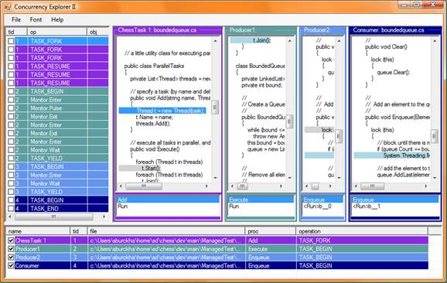

FAQ

Q: Why does the thread pane display “no information available”?
A: There are two common reasons. For one, you need to compile your source in debug mode for CHESS to properly display source code locations. Second, some of the events (especially the more exotic CHESS-internal ones like QUIESCE) may not have a specific source code location associated with them.

Q: How can I see the values of variables?
A: ConcurrencyExplorer does not support this level of detail. You will need to use a normal debugger instead (either in VSTS integration, or from the command line, using the /brk argument to tell CHESS to enter a debugger).

Q: Can I filter the events displayed?
A: There is some limited support for filtering, see next section (Advanced Features).

Q: Why do I see weird colored boxes instead of the normal source view?
A: You need to make sure the checkbox “Use colorbox style” is not checked. If you can’t uncheck it, you are looking at a multiple-execution-trace file (for which the normal view is unavailable). Most likely, you forgot the /repro option (which made CHESS record several tests in the trace file, instead of a single one).

Advanced Features

Saving Trace Files
If you want to preserve a trace file for later inspection, you can copy it to different directory and open it with Concurrency Explorer at some later point of time ( If you leave it in the same directory, it will be overwritten next time you run a repro with the /trace option). Note that if the source files change, the source display in Concurrency Explorer will be incorrect. Also, the source files need to be reachable at the location where they were compiled (because the trace files stores absolute paths to the source files, obtained from the debug information embedded by the build).

Opening Views from the Command Panel
Concurrency Explorer opens a second window, called the Command Panel.
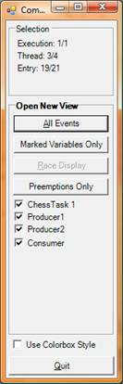 | You can open new views of the data by using the following buttons:  • All Events opens a new window, displaying all events  • Marked Variables only displays only events that target marked variables. You can mark or unmark variables using the check-box next to the events in the event sequence pane.  For example, you can put a checkmark next to a Monitor.Enter event, then click “Marked Variables Only’; Concurrency Explorer now opens a new view that shows accesses to this particular monitor object only.  • Race Display displays a data race if one was found (race detection is not currently available in CHESS).  • Preemptions Only displays only the events immediately before and after a preemption (a preemption is a situation where the scheduler switches to a different thread even though the original thread is not blocked).  You can uncheck threads to filter events further.  The “Use Colorbox Style” checkbox selects a legacy bare-bones skin that displays low-level information about the events. It is mainly intended for debugging purposes by Chess Developers.

Working with Multiple Views
You can open multiple views at the same time. Whenever you select an event in one view, all views that display that event will scroll to its location automatically.

