Samples: Banking with mchess.exe

The Example
To analyze the C# version of the Bank Account example with mchess.exe, open a Visual Studio 2008 shell and cd to Samples\Managed\BankAccount. To create the executable ChessTest.exe, type:
csc /debug ChessTest.cs Bank\Account.cs
The file Bank\Account.cs contains the (supposedly thread-safe) code of the Account class, with methods for deposit and withdrawing funds. The file ChessTest.cs contains the following code:
public class ChessTest
{
static public void Main(string[] args)
{
Console.WriteLine(Run());
}

static public bool Run()
{
var account = new Account(10);
var child = new Thread(
o => { (o as Account).Withdraw(2); }
);
child.Start(account);
account.Deposit(1);
child.Join();
return (account.Read()==9);
}
}
In ChessTest.cs we have provided the required ChessTest.Run method, which creates an account of $10 and a child thread to withdraw $2. The main thread starts the child thread, concurrently deposits $1, and waits for the child thread to terminate. The return expression is an assertion that the account contains $9 (which should be true, no matter the scheduling of the threads). The class also contains a main method so you can test the code without CHESS. Try running ChessTest.exe. What does it report? Our experience usually looks like:
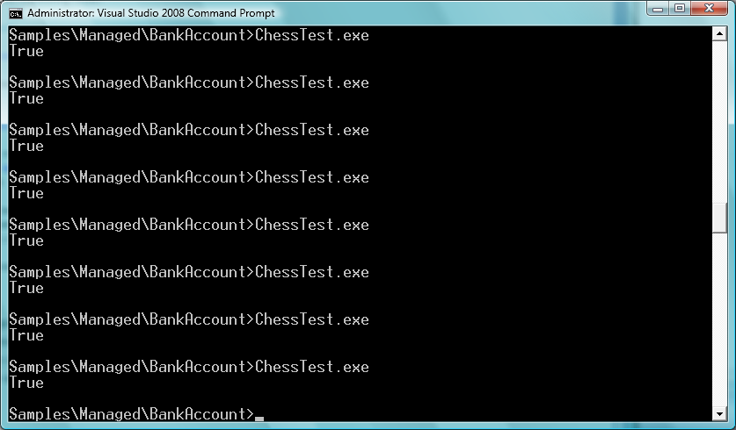
Now, run it under CHESS as follows:
mchess ChessTest.exe
To see:
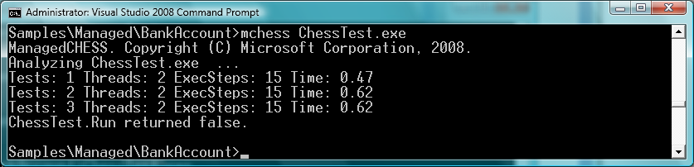
The output shows that CHESS ran the test four times: for the first three schedules, ChessTest.Run return true; on the fourth schedule, it returned false. Type the command again. You will see exactly the same behavior, because CHESS deterministically explores the thread schedules:
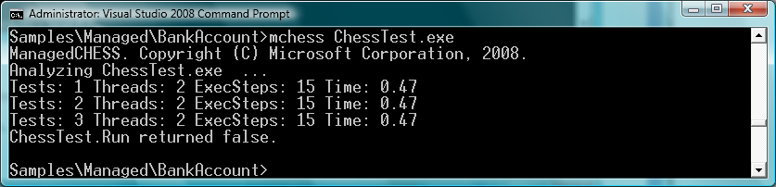

Reproducing the Error with CHESS
To reproduce just the error-revealing schedule, try
mchess /repro ChessTest.exe
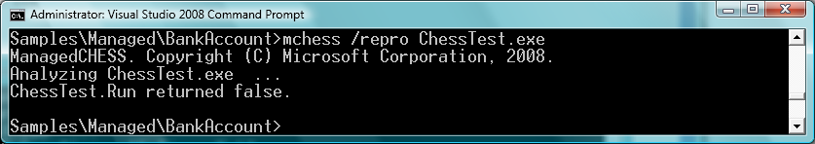

Viewing the Error Schedule with Concurrency Explorer
Now, let’s examine the buggy thread schedule using ConcurrencyExplorer. First, generate the trace file for ConcurrencyExplorer with
mchess /trace ChessTest.exe
Then, type
Concurrencyexplorer trace
You should see a window appear that looks like:
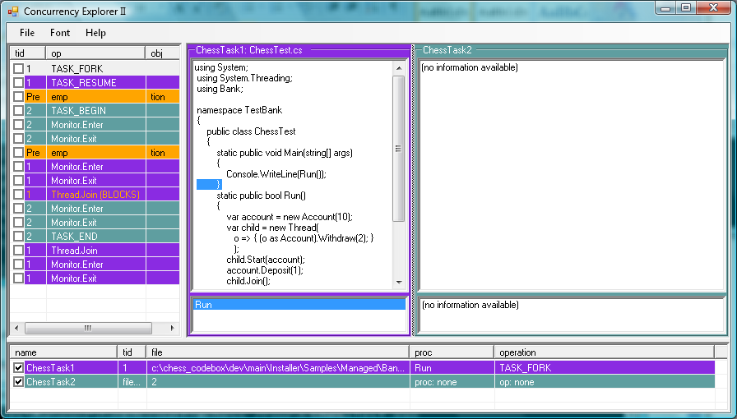
The threads are colored coded: the main thread is purple and the child thread is blue. The list pane on the left shows the trace of thread synchronization events (the thread schedule), color-coded with which thread is executing. By selecting an event in the schedule, the source browsers will show you the corresponding statements executing in the two threads. Select the first event (TASK_FORK) and use the up and down arrow keys to navigate the trace.
Now, select the first preemption event (first orange line). The view (below) shows that the main thread is being preempted before locking the account to do a Deposit. The source view of the child thread shows that the next synchronization event to execute there will be a lock of the account in the Read method. Note that stack view of the child thread shows it is calling Read from the Withdraw method.
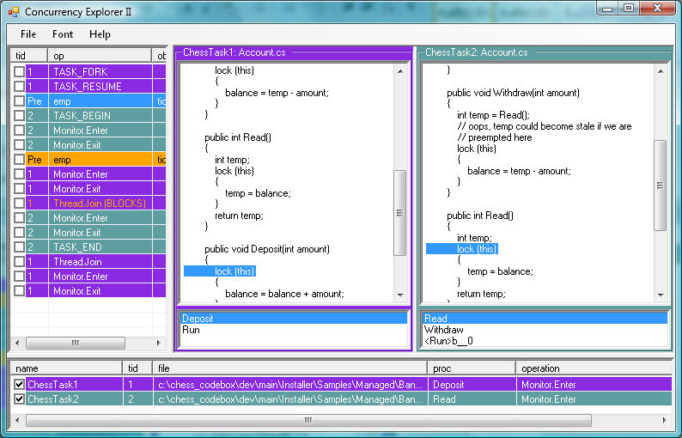

Continue to the second preemption to see that the child thread is preempted after the Read method has completed, but before the Withdraw method requires the lock on account to update the balance (the comments shows you the bug):
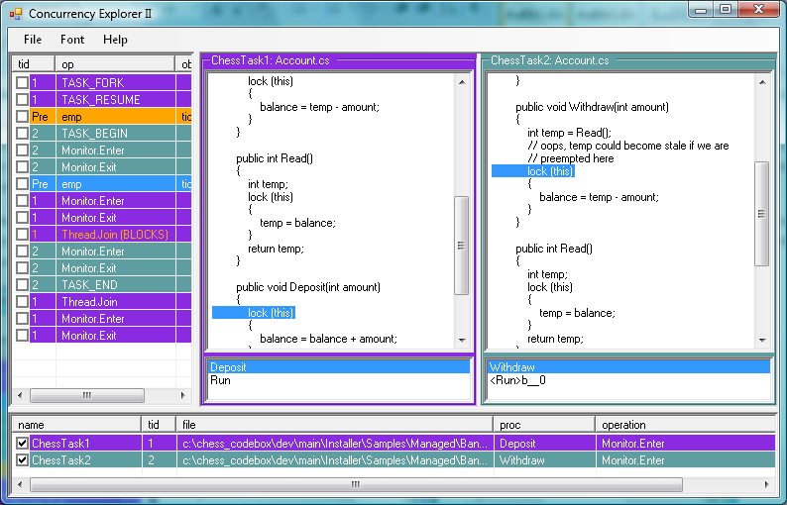

Using CHESS with a Debugger
Concurrency Explorer has no support for viewing variables’ values or many other features associated with debuggers. However, you can use CHESS’s repro capability in combination with your favorite debugger to get a sequential debugging experience for a concurrent program. For example:
mchess /repro /break:c ChessTest.exe
instructs CHESSS to perform a debugger break just before each context switch. Below, we show our experience using the Visual Studio debugger. The first context switch takes place just before the main thread is about to acquire a lock on the account:
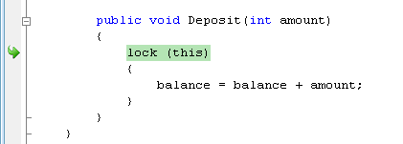
Pressing F5, we are taken to the next context switch which takes place after the child thread has read the value of the account balance into the local variable “temp” but before reacquiring the lock to perform the update:
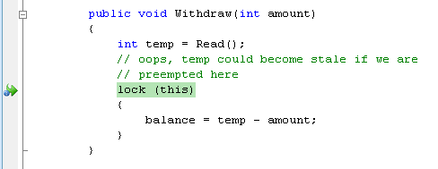
Pressing F5 again, the next context switch takes place after the main thread has completed the deposit and blocks on the Join statement (since the child thread still is running):
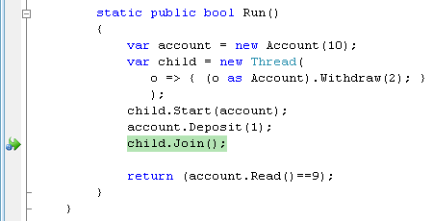
Pressing F5 one last time, we see that the last context switch takes place at the end of the child thread. There is no source code location when CHESS detects the end of the child’s thread execution. The stack shows (at the bottom) that CHESS is in the TaskEnd() operation.
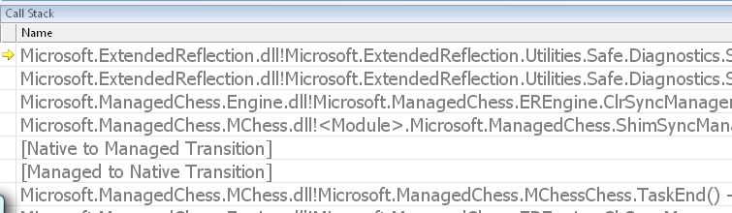

Note that in the debugger we have seen four context switches, which agrees with the number of context switches in the trace we saw in Concurrency Explorer.
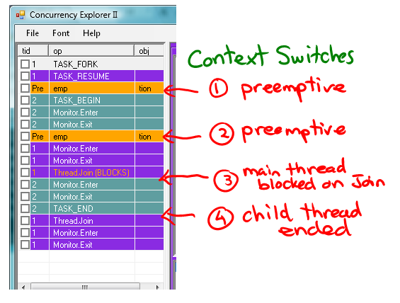

For More Information
See the user manual for mchess.exe

