CHESS: Producer/Consumer Queue Example
This document walks you through compiling, running and debugging unit tests with CHESS and Visual Studio 2008 Team Suite. For a simpler example, see BankAccount, and then come back here.

Opening the Solution in Visual Studio
At the top level of the directory, there is a file called ProducerConsumerQueue.sln. Open this file with Visual Studio 2008.
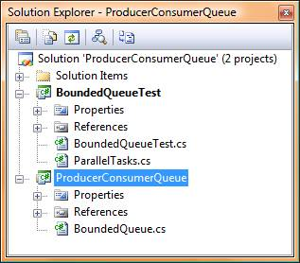 | The solution contains two projects.  ProducerConsumerQueue contains the code for the queue. This queue is a little utility that lets one or more producer threads communicate data to one or more consumer threads, using a FIFO queue of bounded capacity.  BoundedQueueTest contains eight unit tests to test the queue under various scenarios. The unit tests use CHESS for more convenient and thorough testing of concurrent behaviors.

BoundedQueue implementation
The file BoundedQueue.cs implements a class with the following interface:
class BoundedQueue<ElementType>
{
// Create a queue that holds at most (bound) entries.
public BoundedQueue(int bound) { ... }
// Remove all elements from the queue.
public void Clear() { ... }

// Add an element to the queue (may block if there is no room).
public void Enqueue(ElementType element) { ...}

// Remove the oldest element from the queue (may block if empty).
public ElementType Dequeue() { ... }

// return the number of elements currently in the queue.
public int Size() { ... }
}

The file BoundedQueue.cs actually contains two implementations of BoundedQueue, one with lots of typical concurrency bugs, and one being correct (as far as we know). By default, the buggy version is used. If you compile with the build type “BugsFixed”, the correct implementation is used.

Unit Tests
1. The first two unit tests are not concurrent and do not use CHESS.
a. IllegalBound calls the constructor with an invalid bound. The expected behavior is an exception.
b. TwoInTwoOut enqueues two elements, then dequeues them and checks the returned values.

2. NoConsumer tries to overflow the queue (there is a producer, but no consumer). The expected behavior is deadlock, because the thread gets blocked once the queue is full. We use CHESS as the host type in order to correctly identify the deadlock.

3. NoProducer “underflows” the queue (there is a consumer, but no producer). Again, the expected result is a deadlock.

4. OneProdOneCons is the first test to use true concurrency. For improved readability, we use a little utility class called “ParallelTasks” (implemented in ParallelTasks.cs) that lets us easily construct a scenario where one or more tasks execute concurrently. In the test, we create a producer and consumer task, using C#’s syntax for anonymous delegates. The producer adds four elements, the consumer removes four, and we check the returned values and the size of the queue after completion.

5. OneProdTwoCons is similar, but uses two consumers and one producer.

6. TwoProdOneCons uses two producers and one consumer.

7. OneProdOneClear uses one producer, but instead of a consumer, there is a thread that clears the queue once it is full.

Walkthrough: Fixing the Implementation

Compiling the Code and Running the Tests
1. Choose menu “Build”->“Build Solution”. This will compile both projects.
2. Choose menu “Test”->”Run”->”All Tests in Solution”. This will run all unit tests.
3. After all tests are completed (which may take a few minutes, especially for the test OneProdOneCons), the results should show three test failures (OneProdTwoCons, TwoProdOneCons, and OneProdOneClear).

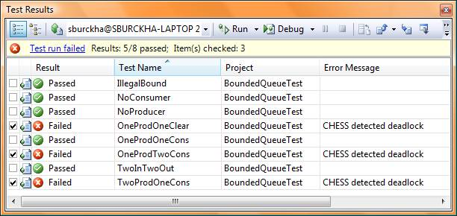

Finding the First Bug
Let’s first try to repro the failed OneProdTwoCons test. Double-click the test in the “Test Results” pane/window. Read the test results. In the section “Standard Console Output”, you will find instructions on how to copy/paste the schedule (from “Standard Console Error”) back into the source code. Do this now. Your code should look like:
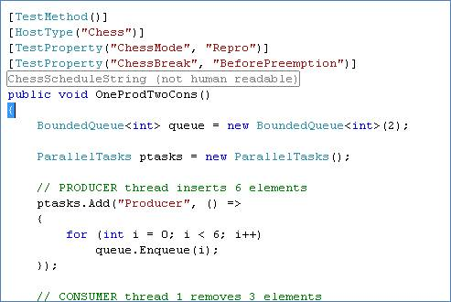

For a small test case like this one, it is helpful to step through manually when trying to figure out what went wrong. So let’s add a breakpoint at the beginning of each task (on the for loops, should be about lines 116, 123, 130 of BoundedQueueTest.cs). Your code should look like:
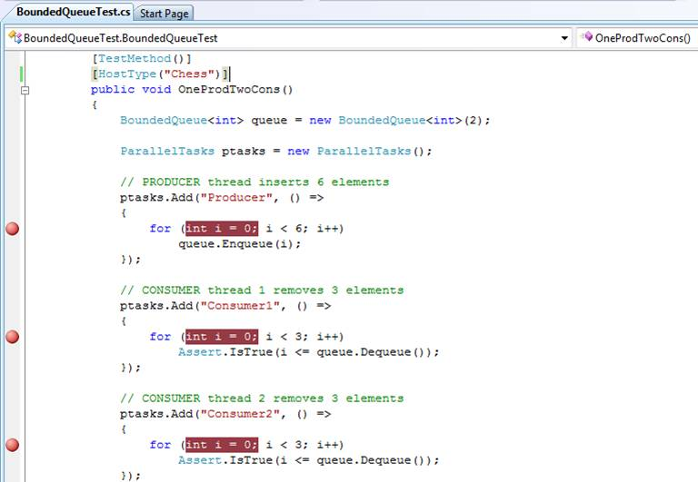

Now, build again. In the “Test Results” pane, make sure OneProdTwoCons has its checkbox checked and all other tests don’t, then hit the button “Debug” at the top of the pane.
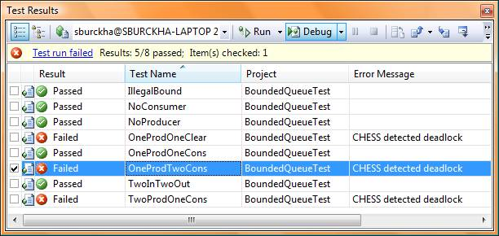

We are now running in Debug mode, controlled by CHESS. CHESS forces a certain schedule; whenever you do a step, only one thread is moving, according to the schedule on which CHESS found the bug. The debugger stops at the first iteration of the producer.


Repeatedly choose “Debug”->”Step Into”. You will see the producer enqueueing two elements, then going into a wait because the queue is full.
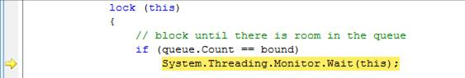

Keep doing “Debug”->”Step Into”. Now Consumer1 is dequeueing an an element, and does a “Pulse” at the end of the dequeue. This pulse wakes up the waiting producer (meaning that the producer is allowed to continue, but does not necessarily do so right this instant). Consumer1 keeps going until it has dequeued all elements, then it goes into a wait.
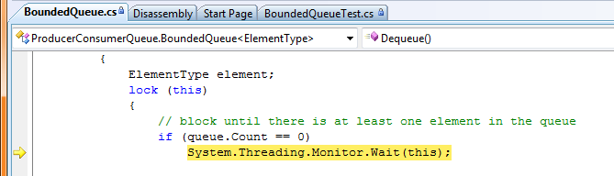
Keep doing “Debug”->”Step Into”. Now Consumer2 is trying to dequeue, but the queue is empty, so it goes into a wait immediately.
Keep doing “Debug”->”Step Into”. Now Producer is coming out of its wait and adds an element to the queue. It then calls Pulse to wake up a waiting thread, which could be either Consumer1 or Consumer2 (again, the fact that they are woken up does not mean they are immediately scheduled). Producer keeps going, enqueues one more element to make the queue full, then goes into a wait.
Keep doing “Debug”->”Step Into”. Now Consumer1 comes out of the wait (so it must have been woken up by Producer) and dequeues an element, does a Pulse (waking up either Consumer2 or Producer), and finishes (it has done all its work... dequeueing a total of 3 elements).
Now, Consumer2 comes out of its wait (so it must have been woken up by Consumer1) , dequeues an element, tries to dequeue another one, but the queue is empty so it goes into a wait.
Now we have a deadlock because producer was never woken up! CHESS automatically exits the debugger and reports the test failed.

Fixing the First Bug
The deadlock is caused by an incorrect use of Pulse, where we should have used PulseAll. When the producer enqueues the first element after the queue was empty, it has to wake up ALL waiting consumers; symmetrically, when the consumer dequeues an element from a full queue, it has to wake up all producers.
So, go ahead and replace the Pulse in both the Enqueue and Dequeue methods (file BoundedQueue.cs) with PulseAll:
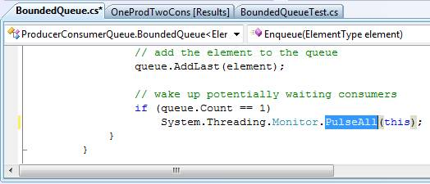 | 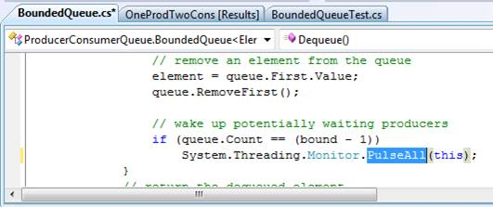

Before rerunning all tests, make sure to remove the pasted properties before the method OneProdTwoCons (we are done with the repro).
Now rebuild, and Choose “Test”->”Run”->”All Tests in Solution” to rerun all tests.
More tests are passing now! We still have two tests failing, namely OneProdOneClear (fails with deadlock) and OneProdTwoCons (fails with an exception).

Finding the Second Bug
As before, open the test results for OneProdOneClear and copy the properties over to the source, add a breakpoint at the beginning of each task:
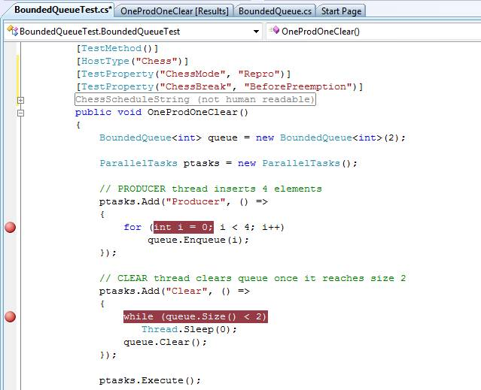

Then rebuild, select the test OneProdOneClear in the “Test Results” pane, and hit the “Debug” button.
Keep doing “Debug”->”Step Into”. The scenario is simple: the producer inserts two elements, then blocks. The clear thread detects that the queue is full, and clears the queue. But it does not signal, so we have a deadlock.

Fixing the Second Bug
We have to signal waiting producers when we clear the queue. In the Clear() method in file BoundedQueue.cs add the following code
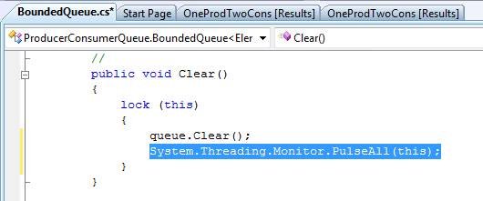

After fixing this, make sure to remove the pasted properties from the test method OneProdOneClear().
Now rebuild, and Choose “Test”->”Run”->”All Tests in Solution” to rerun all tests.
OneProdOneClear now passes. The only one still failing is OneProdTwoCons (fails with an exception).

Finding the Third Bug
Repro the failure (you should now what to do by now). Again, we can see the Producer enqueueing 2 elements and then going into a wait. Consumer1 dequeues the two elements (waking up producer), then goes into a wait. Consumer2 tries to dequeue, but the queue is empty, so it goes into a wait. Producer2 adds two more elements (waking up both consumers), then goes into a wait. Now Consumer2 comes out of the wait, dequeues two elements (waking up producer), then goes into a wait. Now Consumer2 comes out of the wait and incorrectly dequeues an element (the queue is still empty, so an exception is thrown).

Fixing the Third Bug
The mistake is in the following statement:
if (queue.Count == 0)
System.Threading.Monitor.Wait(this);

the count can be nonzero when we come out of the wait, for many reasons! What we need to do is re-check when exiting the wait
while (queue.Count == 0)
System.Threading.Monitor.Wait(this);

Similarly, we need to replace the if statement inside the Enqueue method with a while statement:
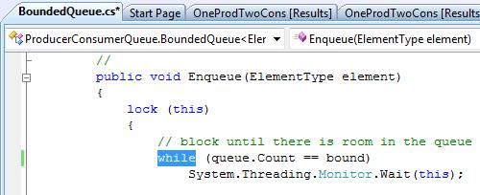 | 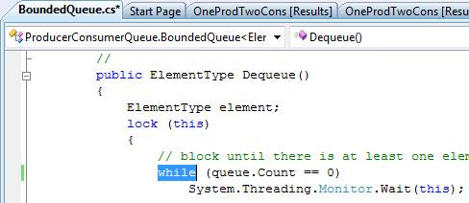

After making these changes, remove the pasted properties from the test method OneProdTwoCons(), then rebuild and rerun all the tests.

All tests are passing now. Be patient: it takes much longer to run the test now (because CHESS is trying a LOT of different schedules without finding any bugs).
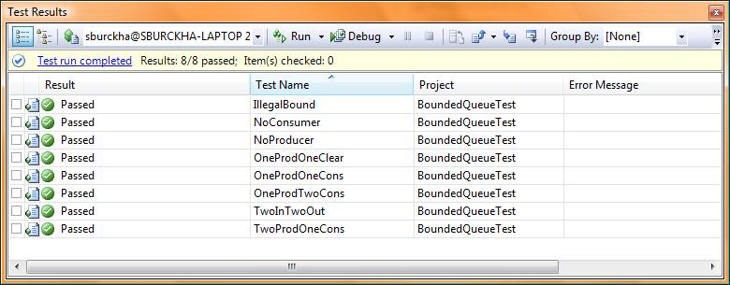

Advanced Topic: Did we Find All Bugs?
Generally speaking, we never know for sure if we have found all bugs. The test suite could be lacking, or the schedule needed to find them may need to contain more than 2 preemptions (by default, CHESS only tries schedules with at most 2 preemptions).
In fact, we did not find all bugs. The Size() method contains a rather obvious mistake:
lock (queue)
return queue.Count;

this should really be
lock (this)
return queue.Count;

Why did our tests not find this bug?
For one, we certainly do not have enough tests (only one of our tests accesses the queue size concurrently).
But there is a bit more to say: this bug is actually hard if not impossible to find using testing!
Note that this bug introduces a data race on the field queue.Count, which is considered a bad thing by most people. However, the effects of this data race are likely to be “benign”, because any read of queue.Count is likely to be atomic. You can not (and should not) fully count on that though, compilers and relaxed hardware memory models may play tricks on you (for example, by reordering instructions). We won’t go into more details here!

