Samples: SimpleBank with ChessBoard

Preparation
To work with this example,
- Open the solution SimpleBank.sln. There you will see
  - Account.cs, which contains a buggy implementation of a bank account class (has a data race).
  - Two test classes in Test1.cs and Test2.cs.
  - A testlist definition in the file testlist.xml, which tells ChessBoard how to run the two tests.
- Choose “Build->Build Solution” from the menu.
- Start ChessBoard (from a command prompt, type ‘ChessBoard’ in a folder where it is o.k. to store temporary files and session information)
- In ChessBoard, choose “Load Testlist”, and then locate the file testlist.xml in the SimpleBank folder. You should see the window below.
(If you prefer, you may also open the larger testlist in the Managed folder, which contains all managed examples rather than just this one).
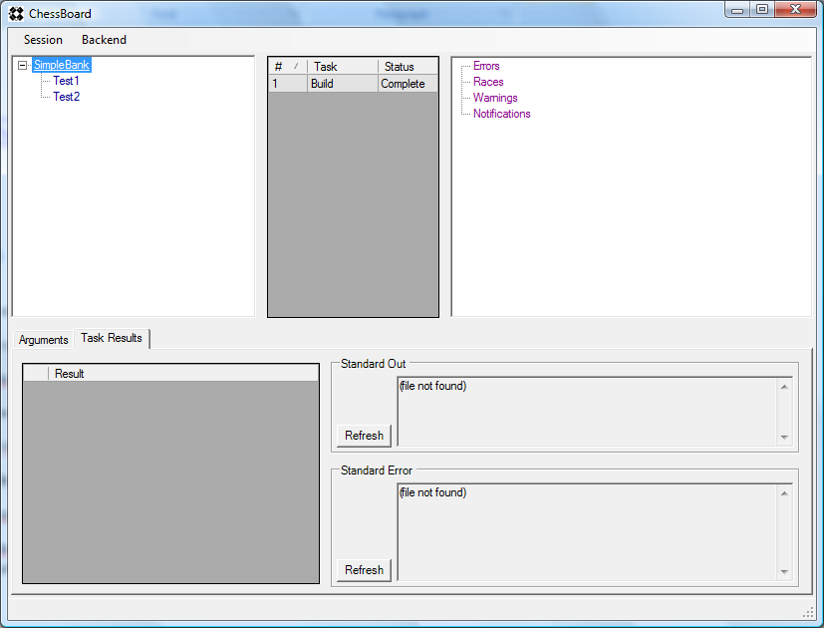

Running without Race Detection
- Right-click on “SimpleBank” in the top left pane, then left-click on “Run”. This runs both tests without race detection.
- Wait until both runs have completed (see status in the top middle pane).
- Click on any one of the two runs, to see the results (bottom pane). You can see
  - A warning (“Race Detection Disabled”)
  - A notification (“Search Completed”) meaning that the search explored all schedules (within the default preemption bound, usually 2).
However, there is no report of an error. Chess did not find a schedule that fails the test because it does not preempt threads on regular data accesses.

Running with Race Detection
Now, we try the same test with race detection enabled.
- Right-click on “SimpleBank” in the top left pane, hover over “Run” to bring up the submenu, then left-click on “With Race Detection”. This runs both tests with race detection.
- Wait until both runs have completed (see status in the top middle pane).
- Click on any one of the two runs, to see the results. This time, races were found. To view the race, we first have to repro.
- Right-click on any one of the reported races, then left-click on “Repro Race With Tracing”. (You can start several repro runs without waiting for each one to complete).
- Once the repro run completes, right-click it, then left-click on “View Race With ConcurrencyExplorer”. This brings up ConcurrencyExplorer to show the race. The racing accesses are shown in orange in the schedule on the left.

Running with Preemptions on All Accesses
To trigger the actual bug (rather than just reporting a race), we can rerun CHESS with preemptions enabled on ALL data accesses (this causes CHESS to explore a LOT more schedules, so using race detection and fixing races is often a better idea).
- Right-click on “SimpleBank” in the top left pane, hover over “Run” to bring up the submenu, then left-click on “Preempting All Accesses”.
- Wait until both runs have completed (see status in the top middle pane).
- Click on any one of the two runs, to see the results. This time, CHESS reports that the test failed.
- You can now either
  - View the failed test in ConcurrencyExplorer by choosing “Repro Error With Tracing” from the context menu, wait for it to complete, and then choosing “View With ConcurrencyExplorer” from the context menu.
  - Repro the failing test in the debugger, by choosing “Repro Error With Debugger” and an appropriate break point setting (see documentation of mchess for details).

