Samples: ThreadPoolWait
A small example from a .NET matters article by Stephen Toub (http://msdn.microsoft.com/en-us/magazine/cc163914.aspx, “Figure 3 Better Implementation of ThreadPoolWait”; this EULA governs the code in the directory Samples\Managed\ThreadPoolWait).
There is a data race in the class ThreadPoolWait, as shown below (racing lines are highlighted below in Concurrency Explorer, the field _remainingWorkItems is accessed without synchronization on the left). This race leads to an atomicity violation (essentially the effect of method DoneWorkItem on the right should appear as atomic to the other threads, but does not).
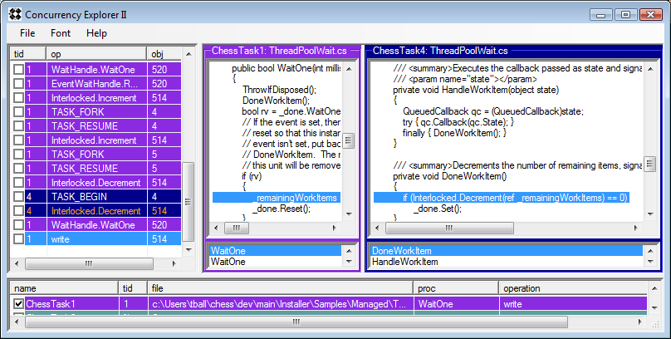
The race/atomicity violation leads to bizarre behavior later in the test, as described below.The test code of ThreadPoolWait looks like:
using (ThreadPoolWait tpw = new ThreadPoolWait())
{
// Queue up a bunch of items and wait for them all
for(int i=0; i<5; i++)
{
tpw.QueueUserWorkItem(new WaitCallback(DoSomething), i);
}
while(!tpw.WaitOne(50, false)); // can call WaitOne with a timeout
Console.WriteLine("done");
// Queue up a bunch of items and wait for them all
for(int i=0; i<5; i++)
{
tpw.QueueUserWorkItem(new WaitCallback(DoSomething), i);
}
tpw.WaitOne(); // wait indefinitely
Console.WriteLine("done");
}
Note, in particular, the first WaitOne with a timeout. Here is what happens:
- The first for loop executes, queuing up the 5 DoSomethings (the count of _remainingWorkItems is now 6; see Toub’s article for explanation of why it is 5+1);
- WaitOne blocks (having decremented _remainingWorkItems from 6 to 5);
- Four of the DoSomethings complete, _remainingWorkItems is now 1.
- The fifth DoSomething (having finished its work) calls DoneWorkItem, which decrements _remainingWorkItems to 0 and enters the then-branch in order to execute the Set of the ManualResetEvent, but is preempted before doing its Set. The count of _remainingWorkItems is now 0.
- The WaitOne times out (remember no Set has occurred yet), so _remainingWorkItems is now 1 (logic of WaitOne on timeout is to increment _remainingWorkItems), and WaitOne returns false.
- The while loop iterates, so WaitOne is called again, but before actually Waiting, WaitOne calls DoneWorkItem(). Since _remainingWorkItems is 1, DoneWorkItem will decrement it to 0 and call Set, thus releasing itself from the subsequent Wait, and resetting the ManualResetEvent.
- But now the fifth DoSomething (remember that one that CHESS preempted back in step 4?) reawakes and does its Set. Oops!
Now we are in a situation we don't want to be - we are past the first for loop and the while loop, but the ManualResetEvent has been Set (because of the delayed Set of the 5th DoSomething coming after the Reset). Oops!

