Samples: Banking with wchess.exe

The Example
To analyze the C++ version of the Bank Account example with wchess.exe, open a Visual Studio 2008 shell and cd to Samples\Win32. To compile the example as a DLL and EXE, type:
nmake balance.dll
nmake balance.exe
In addition to the code for the class Account, the file balance.cpp contains the ChessTestRun function, as required by wchess.exe:
extern "C"
__declspec(dllexport) int ChessTestRun(){
DWORD tid;
HANDLE hThread;

Account* a = new Account(10);
hThread = CreateThread(NULL, 0, WithdrawThread, a, 0, &tid);

a->deposit(1);

WaitForSingleObject(hThread, INFINITE);
CloseHandle(hThread);

bool expResult = (a->read() == 9);
if(expResult)
printf("True\n");
else
printf("**** False ****\n");

delete a;
return expResult ? 0 : -1;
}
This function creates an account of $10 and a child thread to withdraw $2. Concurrently with the child thread, the main thread deposits $1, and waits for the child thread to terminate. The function then checks that the account contains $9 (which should be true, no matter the scheduling of the threads). The class also contains a main procedure so you can test the code without CHESS. Try running balance.exe. Our experience usually looks something like:
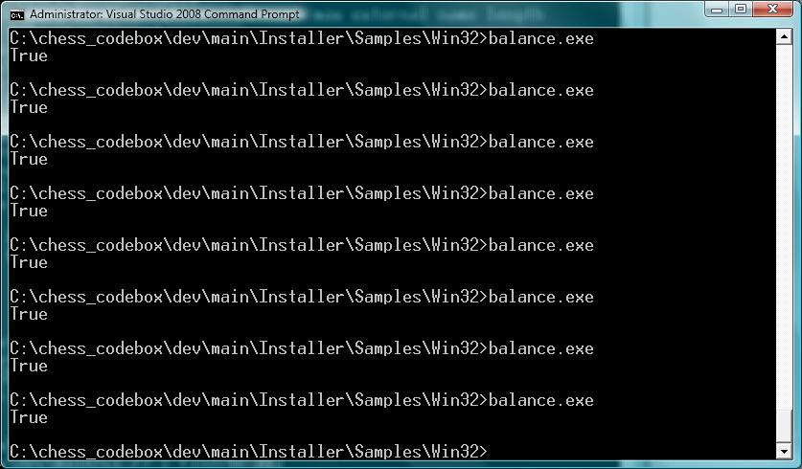
Now, run it under CHESS as follows:
wchess balance.dll
To see:
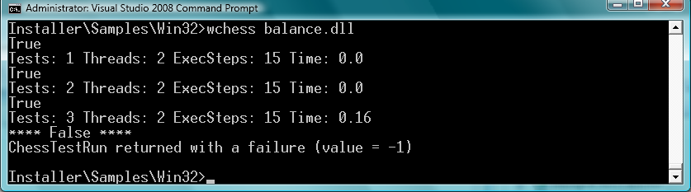

The output shows that CHESS ran the test four times: for the first three schedules, ChessTestRun return true; on the fourth schedule, it returned false. Type the command again. You will see exactly the same behavior, because CHESS deterministically explores the thread schedules:
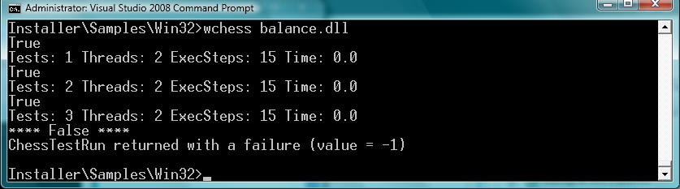

Reproducing the Error with CHESS
To reproduce just the error-revealing schedule, try
wchess /repro balance.dll
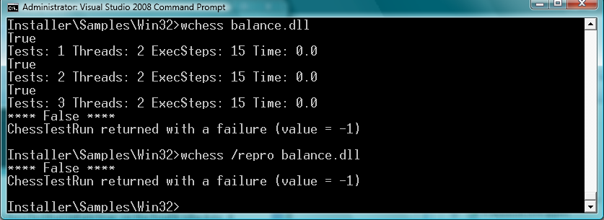

Using CHESS with a Debugger
You can use CHESS’s repro capability in combination with your favorite debugger to get a sequential debugging experience for a concurrent program. For example:
mchess /repro /break:p balance.dll
instructs CHESSS to perform a debugger break just before each preemption. Below, we show our experience using the Visual Studio debugger. The first context switch takes place just before the main thread is about to acquire a lock on the account:

Pressing F5, we are taken to the next context switch which takes place after the child thread has read the value of the account balance into the local variable “temp” but before reacquiring the lock to perform the update:

Pressing F5 again, the next context switch takes place after the main thread has completed the deposit and blocks on the Join statement (since the child thread still is running):

Pressing F5 one last time, we see that the last context switch takes place at the end of the child thread. There is no source code location when CHESS detects the end of the child’s thread execution. The stack shows (at the bottom) that CHESS is in the TaskEnd() operation.

Note that in the debugger we have seen four context switches, which agrees with the number of context switches in the trace we saw in Concurrency Explorer.

Viewing the Error Schedule with Concurrency Explorer
Now, let’s examine the buggy thread schedule using ConcurrencyExplorer. First, generate the trace file for ConcurrencyExplorer with
wchess /trace balance.dll
Then, type
concurrencyexplorer trace
You should see a window appear that looks like:
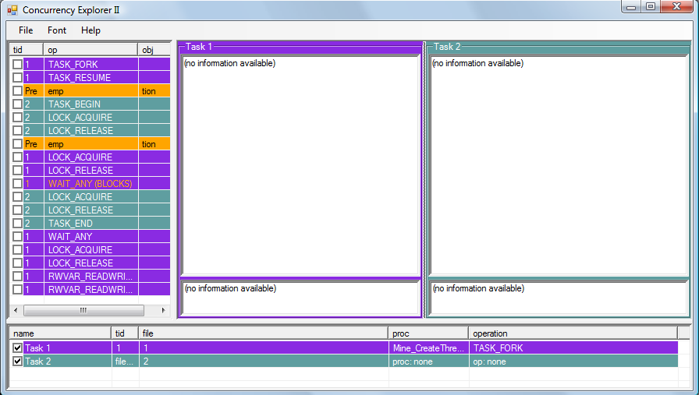
The threads are colored coded: the main thread is purple and the child thread is blue. The list pane on the left shows the trace of thread synchronization events (the thread schedule), color-coded with which thread is executing. By selecting an event in the schedule, the source browsers will show you the corresponding statements executing in the two threads. Select the first event (TASK_FORK) and use the up and down arrow keys to navigate the trace.
Now, select the first preemption event (first orange line). The view (below) shows that the main thread is being preempted before locking the account to do a Deposit.
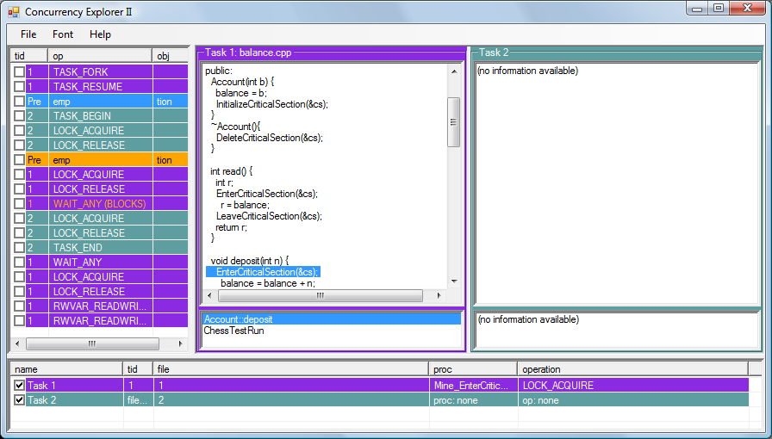
We can see that the main thread is preempted right before entering the critical section in the deposit method. The child thread has not started. Continue navigating the trace to the second preemption.
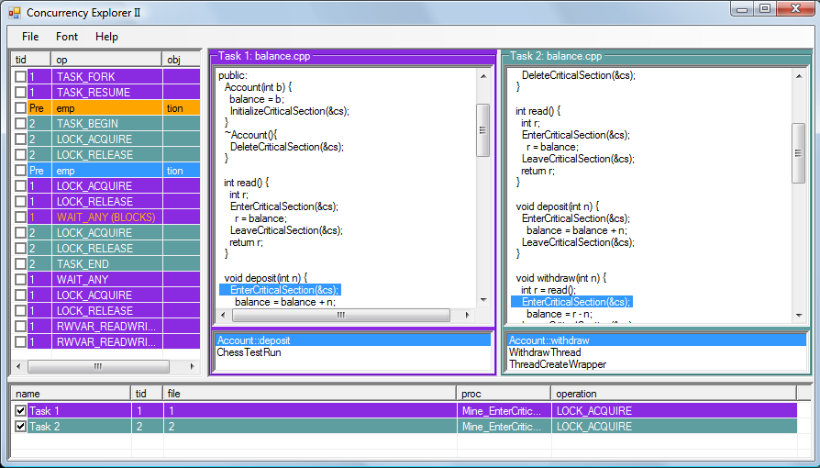
Now the child thread is preempted after the read method has completed but before entering the critical section. This shows where the bug is. The withdraw method store the current bank balance in the stack variable r. When the main thread continues, it will update the balance in the deposit method. This makes the value stored in r stale.

For More Information
See the user manual for wchess.exe

