Samples: Simple Example for wchess.exe

The Example
To analyze critsec.cpp with wchess.exe, open a Visual Studio 2008 shell and cd to Samples\Win32. To compile the example as a DLL, type:
nmake critsec.dll
The main goal of this sample is to illustrate the unit-testing methodology of CHESS. The file critsec.cpp contains a ChessTestRun method that creates threads that increment a shared location x that is protected by a lock. Note, the ChessTestRun method satisfies the following requirements specified in the CHESS manual.
- ChessTestRun waits for all threads created during the execution to complete. This is accomplished by the call to WaitForMultipleObjects
- ChessTestRun resets global state by reinitializing the shared variable x to zero. It also cleans up all resources by closing all handles and deleting the critical section lock.
Now, run critsec.dll under CHESS as follows:
Wchess critsec.dll
To see:
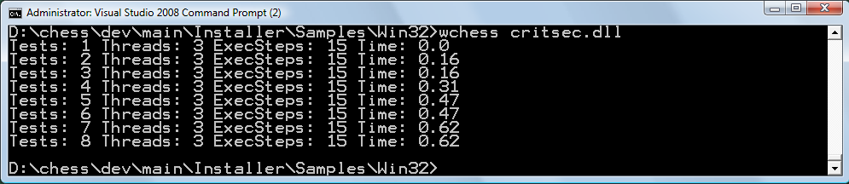
The output shows that CHESS ran the test 8 times. Each run took a different interleaving of the two threads created by the test. After exploration, CHESS did not find any errors in this example. The deadlock sample contains a test with a bug that CHESS finds. Now, rerun this sample by modifying the NUM_CHILDREN constant in critsec.cpp. As you will notice, the number of runs increases (exponentially) with more threads.

For More Information
See the user manual for wchess.exe

