Samples: Banking with wchess.exe

The Example
To analyze deadlock.cpp with wchess.exe, open a Visual Studio 2008 shell and cd to Samples\Win32. To compile the example as a DLL and EXE, type:
nmake deadlock.dll
nmake deadlock.exe
In addition to the code for the class BankAccount, the file deadlock.cpp contains the ChessTestRun function, as required by wchess.exe:
extern "C"
__declspec(dllexport) int ChessTestRun() {
HANDLE hThread[NUM_TRANSFER_THREADS];

if(NUM_TRANSFER_THREADS %2 != 0){
return -1; // set NUM_TRANSFER_THREADS to an even number
}

BankAccount* account = new BankAccount();
int initialDeposit = 100*NUM_TRANSFER_THREADS/2;
account->SavingsDeposit(initialDeposit);
account->CheckingDeposit(initialDeposit);

for(int i=0; i<NUM_TRANSFER_THREADS/2; i++){
hThread[2*i] = CreateThread(NULL, 0, SavingsToCheckingThread, (LPVOID)account, 0, NULL);
hThread[2*i+1] = CreateThread(NULL, 0, CheckingToSavingsThread, (LPVOID)account, 0, NULL);
}

WaitForMultipleObjects(NUM_TRANSFER_THREADS, hThread, true, INFINITE);

for(int i=0; i<NUM_TRANSFER_THREADS; i++){
CloseHandle(hThread[i]);
}
delete account;

return 0;
}

This function creates a bank account and creates NUM_TRANSFER_THREADS, half of which is moving money from the savings account to the checking account, while the other half is moving money from the checking account to the savings account. The bank account contains a deadlock potential. The main function in deadlock.cpp repeatedly calls ChessTestRun a certain number of times. Try running balance.exe and you would likely see that you don’t find the deadlock without CHESS. Our experience usually looks something like:
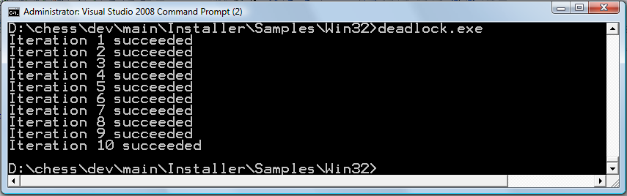
Now, run it under CHESS as follows:
wchess deadlock.dll
To see:
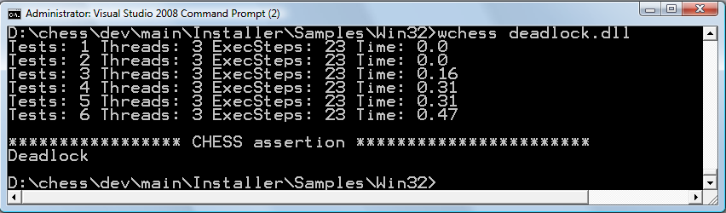

The output shows that CHESS ran the test six times: for the first five schedules, ChessTestRun didn’t result in a deadlock; on the sixth schedule, it resulted in a deadlock. Type the command again. You will see exactly the same behavior, because CHESS deterministically explores the thread schedules:

Reproducing the Error with CHESS
To reproduce just the error-revealing schedule, try
wchess /repro deadlock.dll
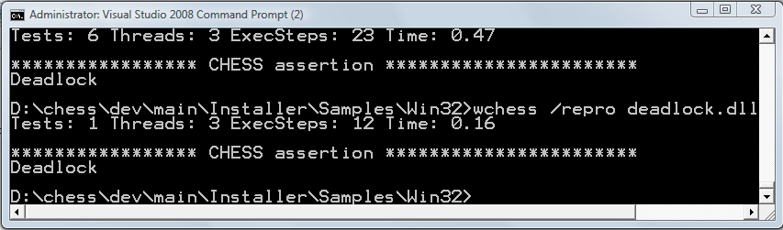

Using CHESS with a Debugger
You can use CHESS’s repro capability in combination with your favorite debugger to get a sequential debugging experience for a concurrent program. For example:
mchess /repro /break:p deadlock.dll
instructs CHESSS to perform a debugger break just before each preemption.

Viewing the Error Schedule with Concurrency Explorer

You can examine the buggy thread schedule using ConcurrencyExplorer. First, generate the trace file for ConcurrencyExplorer with
wchess /trace deadlock.dll
Then, type
concurrencyexplorer trace
You should see a window appear that looks like:
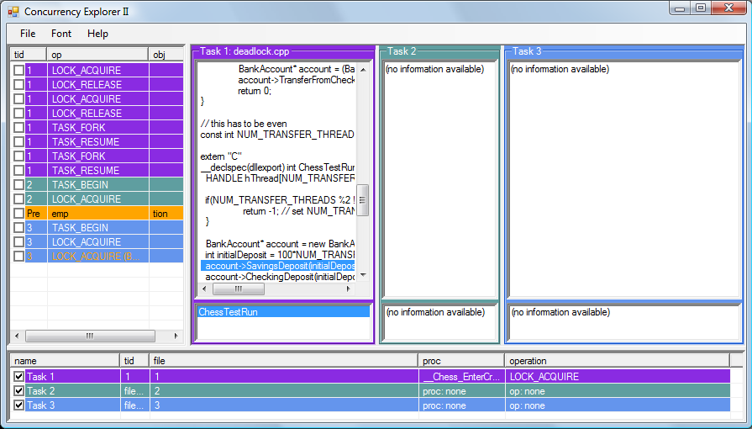
The threads are colored coded: the main thread is purple and the child thread is blue. The list pane on the left shows the trace of thread synchronization events (the thread schedule), color-coded with which thread is executing. By selecting an event in the schedule, the source browsers will show you the corresponding statements executing in the two threads. Select the first event (TASK_FORK) and use the up and down arrow keys to navigate the trace.
Now, select the first preemption event (first orange line). The view (below) shows that the second thread is being preempted after acquiring the savings lock before acquiring the checking lock.
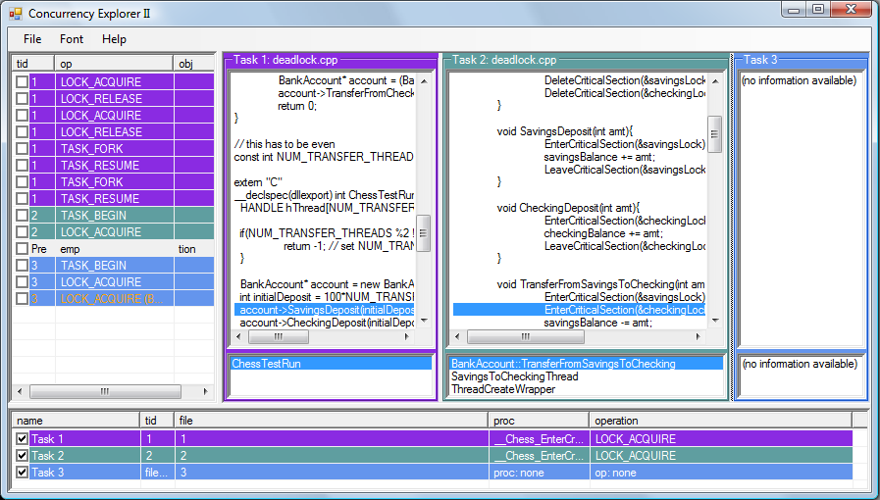

Navigating the trace to the last event, you can see the “deadly embrace” of the third thread acquiring the lock on the savings account but waiting to acquire the checking lock.
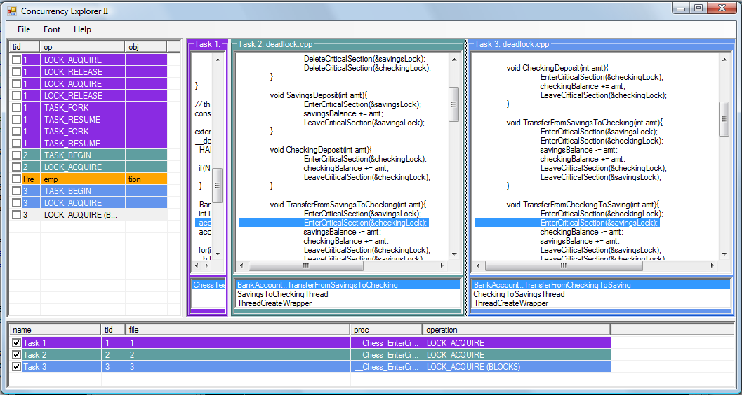

For More Information
See the user manual for wchess.exe

