package com.example.hj;

import android.app.Activity;  
import android.os.Bundle;  
import android.view.Menu;  
import android.view.MenuItem;  
import android.view.View;  
import android.widget.Button;  
import android.widget.EditText;  
import android.widget.Toast;

public class MainActivity extends Activity {  
 // 1.선언  
 EditText e1;  
 Button b1;

 @Override  
    protected void onCreate(Bundle savedInstanceState) {  
        super.onCreate(savedInstanceState);  
        setContentView(R.layout.activity_main);  
        //2.연결  
        e1 = (EditText)findViewById(R.id.editText1);  
        b1 = (Button)findViewById(R.id.button1);  
         
        //3.이벤트  
        b1.setOnClickListener(new View.OnClickListener() {  
     
   @Override  
   public void onClick(View v) {  
    // TODO Auto-generated method stub  
    //1.사용자가 입력한 날수를 가져온다.  
    String days = e1.getText().toString();  
    //2.날수를 숫자로 바꾼다.  
    int days2 = Integer.parseInt(days);  
   //  double days2 = Integer.parseDouble(days);  
    //3.날수를 초로 바꾼다.  
    int seconds = days2 * 24 * 60 * 60;  
    //초 = 날수 *24 *60 * 60  
    Toast.makeText(getApplicationContext(),  
      "입력한 날수는 "+days+"이고, "+seconds+"초입니다.",  
      Toast.LENGTH_SHORT).show();  
      
      
      
   }  
  });  
    }

 @Override  
 public boolean onCreateOptionsMenu(Menu menu) {  
  // Inflate the menu; this adds items to the action bar if it is present.  
  getMenuInflater().inflate(R.menu.main, menu);  
  return true;  
 }

 @Override  
 public boolean onOptionsItemSelected(MenuItem item) {  
  // Handle action bar item clicks here. The action bar will  
  // automatically handle clicks on the Home/Up button, so long  
  // as you specify a parent activity in AndroidManifest.xml.  
  int id = item.getItemId();  
  if (id == R.id.action_settings) {  
   return true;  
  }  
  return super.onOptionsItemSelected(item);  
 }  
}

<LinearLayout xmlns:android="<http://schemas.android.com/apk/res/android>"  
    android:layout_width="fill_parent"  
    android:layout_height="fill_parent"  
    android:orientation="vertical" >

    <TextView  
        android:id="@+id/textView1"  
        android:layout_width="wrap_content"  
        android:layout_height="wrap_content"  
        android:text="날수를 입력하시오"  
        android:textAppearance="?android:attr/textAppearanceMedium" />

    <EditText  
        android:id="@+id/editText1"  
        android:layout_width="match_parent"  
        android:layout_height="wrap_content"  
        android:ems="10" >

        <requestFocus />  
    </EditText>

    <Button  
        android:id="@+id/button1"  
        android:layout_width="match_parent"  
        android:layout_height="wrap_content"  
        android:text="결과" />

</LinearLayout>

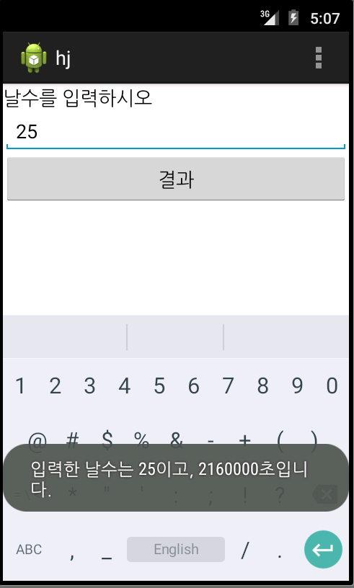

package com.example.wer;

import android.app.Activity;  
import android.os.Bundle;  
import android.view.Menu;  
import android.view.MenuItem;  
import android.view.View;  
import android.widget.Button;  
import android.widget.EditText;  
import android.widget.Toast;

public class MainActivity extends Activity {  
 EditText e1;  
 EditText e2;  
 EditText e3;  
 Button b1;

    @Override  
    protected void onCreate(Bundle savedInstanceState) {  
        super.onCreate(savedInstanceState);  
        setContentView(R.layout.activity_main);  
        e1 = (EditText)findViewById(R.id.editText1);  
        e2 = (EditText)findViewById(R.id.editText2);  
        e3 = (EditText)findViewById(R.id.editText3);  
        b1 = (Button)findViewById(R.id.button1);  
         
        b1.setOnClickListener(new View.OnClickListener() {  
     
   @Override  
   public void onClick(View v) {  
    // TODO Auto-generated method stub  
    String kor = e1.getText().toString();  
    String eng = e2.getText().toString();  
    String math = e3.getText().toString();  
      
    int kor2 = Integer.parseInt(kor);  
    int eng2 = Integer.parseInt(eng);  
    int math2 = Integer.parseInt(math);  
      
    int total = kor2 + eng2 + math2;  
      
    double avg = Double.parseDouble( String.format( "%.1f" , total / 3.0 ));  
    Toast.makeText(getApplicationContext(),  
      "총합은"+total+"이며 평균은 "+avg+"입니다.",  
      Toast.LENGTH_SHORT).show();  
      
   }  
  });  
    }

    @Override  
    public boolean onCreateOptionsMenu(Menu menu) {  
        // Inflate the menu; this adds items to the action bar if it is present.  
        getMenuInflater().inflate(R.menu.main, menu);  
        return true;  
    }

    @Override  
    public boolean onOptionsItemSelected(MenuItem item) {  
        // Handle action bar item clicks here. The action bar will  
        // automatically handle clicks on the Home/Up button, so long  
        // as you specify a parent activity in AndroidManifest.xml.  
        int id = item.getItemId();  
        if (id == R.id.action_settings) {  
            return true;  
        }  
        return super.onOptionsItemSelected(item);  
    }  
}

<LinearLayout xmlns:android="<http://schemas.android.com/apk/res/android>"  
    android:layout_width="fill_parent"  
    android:layout_height="fill_parent"  
    android:orientation="vertical" >

    <TextView  
        android:id="@+id/textView1"  
        android:layout_width="wrap_content"  
        android:layout_height="wrap_content"  
        android:text="국어점수는?"  
        android:textAppearance="?android:attr/textAppearanceMedium" />

    <EditText  
        android:id="@+id/editText1"  
        android:layout_width="match_parent"  
        android:layout_height="wrap_content"  
        android:ems="10" >

        <requestFocus />  
    </EditText>

    <TextView  
        android:id="@+id/textView2"  
        android:layout_width="wrap_content"  
        android:layout_height="wrap_content"  
        android:text="영어점수는?"  
        android:textAppearance="?android:attr/textAppearanceMedium" />

    <EditText  
        android:id="@+id/editText2"  
        android:layout_width="match_parent"  
        android:layout_height="wrap_content"  
        android:ems="10" />

    <TextView  
        android:id="@+id/textView3"  
        android:layout_width="wrap_content"  
        android:layout_height="wrap_content"  
        android:text="수학점수는?"  
        android:textAppearance="?android:attr/textAppearanceMedium" />

    <EditText  
        android:id="@+id/editText3"  
        android:layout_width="match_parent"  
        android:layout_height="wrap_content"  
        android:ems="10" />

    <Button  
        android:id="@+id/button1"  
        android:layout_width="match_parent"  
        android:layout_height="wrap_content"  
        android:text="결과" />

</LinearLayout>

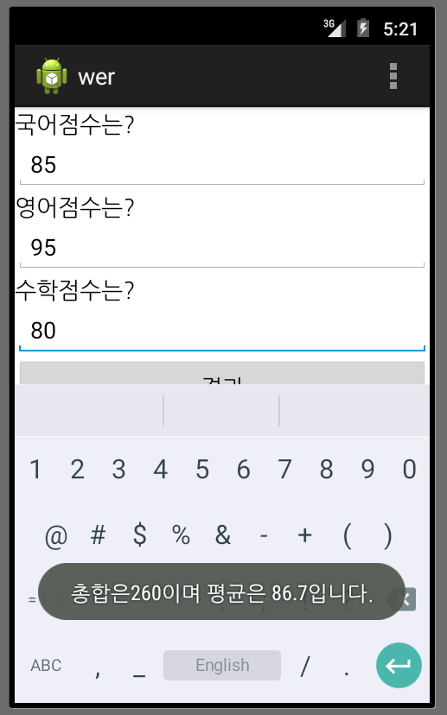

package com.example.fdsgsd;

import android.app.Activity;  
import android.os.Bundle;  
import android.view.Menu;  
import android.view.MenuItem;  
import android.view.View;  
import android.widget.Button;  
import android.widget.EditText;  
import android.widget.Toast;

public class MainActivity extends Activity {  
 EditText e1;  
 Button b1;

    @Override  
    protected void onCreate(Bundle savedInstanceState) {  
        super.onCreate(savedInstanceState);  
        setContentView(R.layout.activity_main);  
         
        e1 = (EditText)findViewById(R.id.editText1);  
        b1 = (Button)findViewById(R.id.button1);  
         
        b1.setOnClickListener(new View.OnClickListener() {  
     
   @Override  
   public void onClick(View v) {  
    // TODO Auto-generated method stub  
    String bytes = e1.getText().toString();  
    int bytes3 = Integer.parseInt(bytes);  
    int meagbytes = bytes3 *1024;  
    long kilobytes = meagbytes * 1024;  
    long bytes2 = kilobytes * 1024;  
    Toast.makeText(getApplicationContext(),  
      ""+meagbytes+"메가바이트, "+kilobytes+"킬로바이트, "+bytes2+"바이트입니다.",  
      Toast.LENGTH_SHORT).show();  
      
   }  
  });  
    }

    @Override  
    public boolean onCreateOptionsMenu(Menu menu) {  
        // Inflate the menu; this adds items to the action bar if it is present.  
        getMenuInflater().inflate(R.menu.main, menu);  
        return true;  
    }

    @Override  
    public boolean onOptionsItemSelected(MenuItem item) {  
        // Handle action bar item clicks here. The action bar will  
        // automatically handle clicks on the Home/Up button, so long  
        // as you specify a parent activity in AndroidManifest.xml.  
        int id = item.getItemId();  
        if (id == R.id.action_settings) {  
            return true;  
        }  
        return super.onOptionsItemSelected(item);  
    }  
}

<LinearLayout xmlns:android="<http://schemas.android.com/apk/res/android>"  
    android:layout_width="fill_parent"  
    android:layout_height="fill_parent"  
    android:orientation="vertical" >

    <TextView  
        android:id="@+id/textView1"  
        android:layout_width="wrap_content"  
        android:layout_height="wrap_content"  
        android:text="파일의 용량을 기가바이트 단위로 입력"  
        android:textAppearance="?android:attr/textAppearanceMedium" />

    <EditText  
        android:id="@+id/editText1"  
        android:layout_width="match_parent"  
        android:layout_height="wrap_content"  
        android:ems="10" >

        <requestFocus />  
    </EditText>

    <Button  
        android:id="@+id/button1"  
        android:layout_width="match_parent"  
        android:layout_height="wrap_content"  
        android:text="결과" />

</LinearLayout>

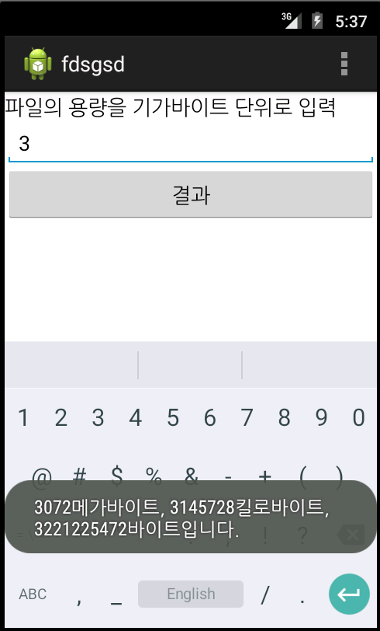

package com.example.dfsgasf;

import android.app.Activity;  
import android.os.Bundle;  
import android.view.Menu;  
import android.view.MenuItem;  
import android.view.View;  
import android.widget.Button;  
import android.widget.EditText;  
import android.widget.Toast;

public class MainActivity extends Activity {  
 EditText e1;  
 EditText e2;  
 EditText e3;  
 Button b1;

    @Override  
    protected void onCreate(Bundle savedInstanceState) {  
        super.onCreate(savedInstanceState);  
        setContentView(R.layout.activity_main);  
        e1 = (EditText)findViewById(R.id.editText1);  
        e2 = (EditText)findViewById(R.id.editText2);  
        e3 = (EditText)findViewById(R.id.editText3);  
        b1 = (Button)findViewById(R.id.button1);  
         
        b1.setOnClickListener(new View.OnClickListener() {  
     
   @Override  
   public void onClick(View v) {  
    // TODO Auto-generated method stub  
    String coffe = e1.getText().toString();  
    String milk = e2.getText().toString();  
    String gocoffe = e3.getText().toString();  
      
    int coffe2 = Integer.parseInt(coffe);  
    int milk2 = Integer.parseInt(milk);  
    int gocoffe2 = Integer.parseInt(gocoffe);  
      
    int total = coffe2*200 + milk2*300 + gocoffe2*500;  
      
    Toast.makeText(getApplicationContext(),  
      "총 주문금액은 "+total+"입니다.",  
      Toast.LENGTH_SHORT).show();  
      
   }  
  });  
    }

    @Override  
    public boolean onCreateOptionsMenu(Menu menu) {  
        // Inflate the menu; this adds items to the action bar if it is present.  
        getMenuInflater().inflate(R.menu.main, menu);  
        return true;  
    }

    @Override  
    public boolean onOptionsItemSelected(MenuItem item) {  
        // Handle action bar item clicks here. The action bar will  
        // automatically handle clicks on the Home/Up button, so long  
        // as you specify a parent activity in AndroidManifest.xml.  
        int id = item.getItemId();  
        if (id == R.id.action_settings) {  
            return true;  
        }  
        return super.onOptionsItemSelected(item);  
    }  
}

<LinearLayout xmlns:android="<http://schemas.android.com/apk/res/android>"  
    android:layout_width="fill_parent"  
    android:layout_height="fill_parent"  
    android:orientation="vertical" >

    <TextView  
        android:id="@+id/textView1"  
        android:layout_width="wrap_content"  
        android:layout_height="wrap_content"  
        android:text="커피개수는?"  
        android:textAppearance="?android:attr/textAppearanceMedium" />

    <EditText  
        android:id="@+id/editText1"  
        android:layout_width="match_parent"  
        android:layout_height="wrap_content"  
        android:ems="10" >

        <requestFocus />  
    </EditText>

    <TextView  
        android:id="@+id/textView2"  
        android:layout_width="wrap_content"  
        android:layout_height="wrap_content"  
        android:text="우유개수는?"  
        android:textAppearance="?android:attr/textAppearanceMedium" />

    <EditText  
        android:id="@+id/editText2"  
        android:layout_width="match_parent"  
        android:layout_height="wrap_content"  
        android:ems="10" />

    <TextView  
        android:id="@+id/textView3"  
        android:layout_width="wrap_content"  
        android:layout_height="wrap_content"  
        android:text="고급커피개수는?"  
        android:textAppearance="?android:attr/textAppearanceMedium" />

    <EditText  
        android:id="@+id/editText3"  
        android:layout_width="match_parent"  
        android:layout_height="wrap_content"  
        android:ems="10" />

    <Button  
        android:id="@+id/button1"  
        android:layout_width="match_parent"  
        android:layout_height="wrap_content"  
        android:text="결과" />

</LinearLayout>

