ex3-0
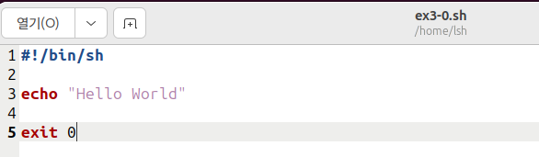
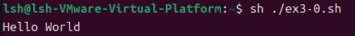

ex3-1
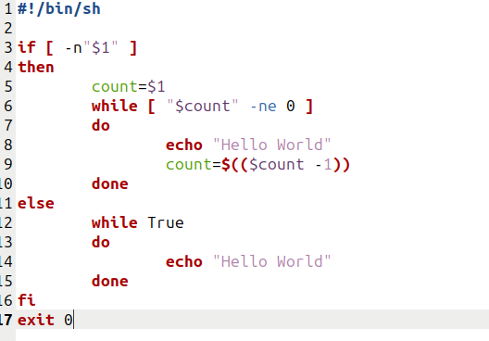
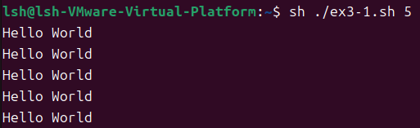

ex3-2
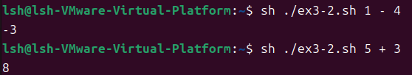

ex3-3

ex3-4

ex3-5

ex3-6

ex3-7

ex3-8

ex3-9

