|  |  |
| --- | --- |
| Lab 1: Bomb | |
| Student ID: 21102376 | Student Name: 이연우 |

**1. Phase 1 (1pt)**

* What is your password?

A ) 0x0141FF28

**2. Phase 2 (1pt)**

* What is your password?

A ) 0xAF8035C0

**3. Phase 3** **(2pt)**

* What is your password?

A ) 0x0D050201

* Write C code that does exactly the same thing as the phase3 device.

A ) 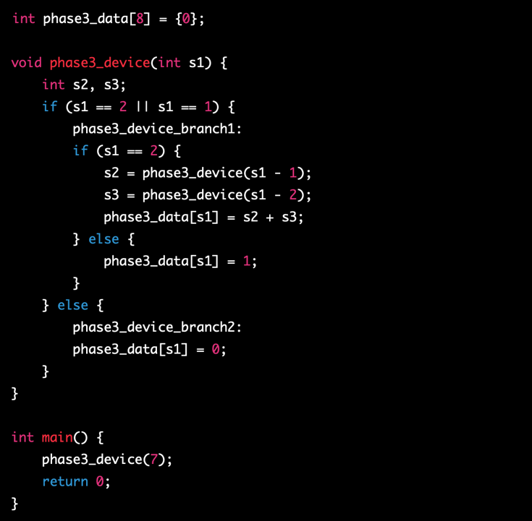

**4. Phase 4** **(2pt)**

* Write the unlock code and explain what the unlock code does and why it is needed.

A ) The unlock code should be the sorting algorithm, because the condition to escape ‘phase4_something_wrong’ is descent order of the phase4_data(which contains student id). So the phase4_unlock_code should be the sorting algorithm which arranges the number into descent order.