|  |  |
| --- | --- |
| Lab 2: xv6: Hello World | |
| Student ID: 21102376 | Student Name: 이연우 |

1. Text, letter

   Description automatically generated booting

ls

1. 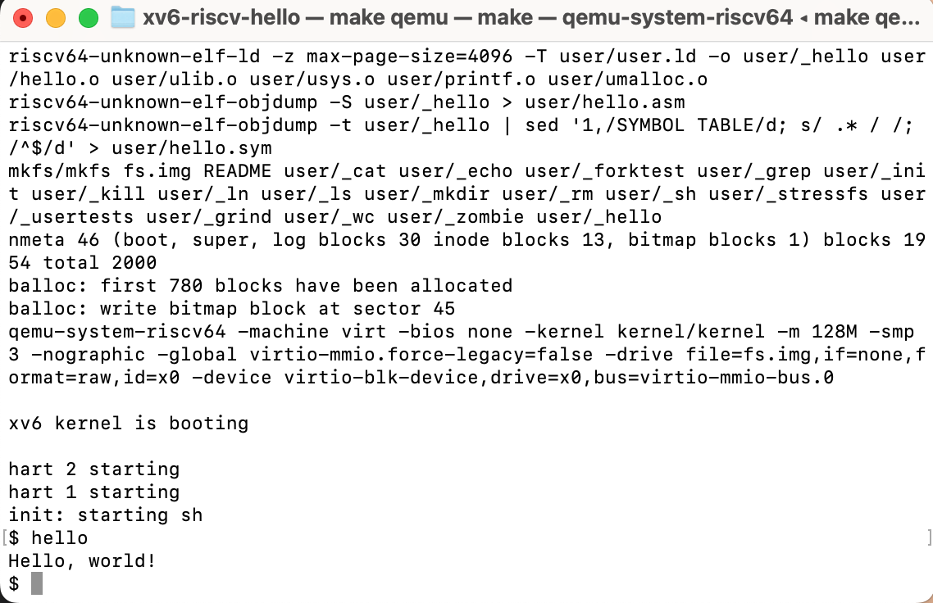hello, world
2. 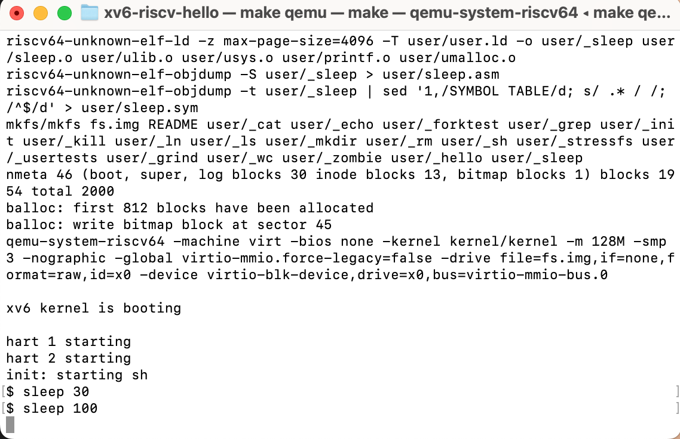 sleep
3. Text, letter

   Description automatically generated pingpong
4. Table

   Description automatically generated with medium confidence cp program