IPT102- INTEGRATED PROGRAMMING

NAME: Osorio, Rheyvon E.
PERCENTAGE
SCORE

STUDENT NO: 23-2230

YEAR/SECTION: 3B

DATE: 11/5/2025

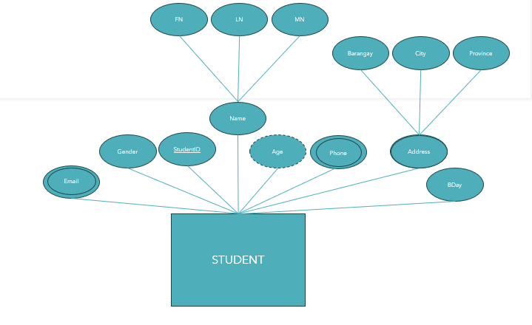

- Using the Entity on top, Create Table SQL Script (15pts)
CREATE DATABASE StudentDB;
USE StudentDB;

CREATE TABLE STUDENT (
StudentID VARCHAR(20) PRIMARY KEY,
FN VARCHAR(50) NOT NULL,
LN VARCHAR(50) NOT NULL,
MN VARCHAR(50),
Gender VARCHAR(10),
Age INT CHECK (Age >= 0),
BDay DATE,
Email VARCHAR(100) UNIQUE,
Phone VARCHAR(15),
Barangay VARCHAR(100),
City VARCHAR(100),
Province VARCHAR(100)
);

- Using item no1 Create Data Dictionary (15pts)
Field Name | Description | Data Type | Size | Constraint | Example
StudentID | Unique identifier for each student | VARCHAR | 20 | PRIMARY KEY | S2025-002
FN | First Name of the student | VARCHAR | 50 | NOT NULL | Rheyvon
LN | Last Name of the student | VARCHAR | 50 | NOT NULL | Osorio
MN | Middle Name of the student | VARCHAR | 50 | NULL | —
Gender | Student’s gender | VARCHAR | 10 | NULL | Male
Age | Age of the student (derived from birthday) | INT | — | CHECK (Age >= 0) | 20
BDay | Student’s date of birth | DATE | — | NULL | 2005-06-06
Email | Student’s email address | VARCHAR | 100 | UNIQUE | rheyvon.osorio@example.com
Phone | Student’s contact number | VARCHAR | 15 | NULL | 09123456789
Barangay | Barangay part of the address | VARCHAR | 100 | NULL | Sta. Lucia
City | City part of the address | VARCHAR | 100 | NULL | Novaliches
Province | Province part of the address | VARCHAR | 100 | NULL | Quezon City

- Create Database Schema (15pts)

