TECHNICAL STUDY
Transcript Accuracy and Performance
Windows CUDA vs. Apple Silicon CPU, Turbo, and hybrid MPS
Scope: ASR accuracy, end-to-end latency, and optimization decision
Test date: July 17, 2026
Status: Measured study; production recommendation with follow-up gates

Decision: Keep Windows CUDA with large-v3 as the production default. Turbo is a strong local-Mac fast profile, but its 34–42% speed gain came with a measurable WER increase on both the controlled and real-meeting samples. Do not make Turbo the quality default until it passes a larger human-annotated meeting corpus.

Executive summary
The study added a reusable, dependency-free benchmark that runs identical SHA-256-pinned media through the public local or remote production path. It reports normalized word error rate (WER), character error rate (CER), end-to-end latency, real-time factor (RTF), and optional pass/fail gates. Alignment and diarization were disabled to isolate ASR.
- Windows large-v3 processed the controlled 44.67-second corpus in 2.94 seconds end to end (15.19× realtime), with 2.48% strict WER.
- Mac large-v3 achieved the best controlled-corpus WER, 1.65%, but required 29.63 seconds (1.51× realtime).
- Mac Turbo reduced controlled-corpus time to 19.70 seconds (33.5% faster), while WER increased to 2.48% because one noisy proper name changed.
- On a 70-second real AMI meeting excerpt, Mac Turbo was 41.8% faster than Mac large-v3, but WER rose from 18.14% to 19.47%. Windows matched the 18.14% WER in 1.68 seconds—18.2× faster than Mac large-v3.

1. Study design

1.1 Systems and configurations
ID | Host / backend | Model | Precision | Batch | Role
W0 | Windows · CUDA | large-v3 | float16 | 16¹ | Remote quality baseline
M0 | M4 Pro · CPU | large-v3 | int8 | 16 | Local quality baseline
M1 | M4 Pro · CPU | Turbo | int8 | 16 | Local fast candidate

¹The Windows service uses the project default; batch size is not returned in result metadata.
The Mac was an Apple M4 Pro with 24 GB unified memory and 12 CPU cores. CTranslate2 4.7.2 does not expose Apple MPS as an ASR backend; the production Mac path therefore used CPU INT8. The Windows service reported CUDA/float16 but did not expose its GPU model.

1.2 Corpora
Corpus | Duration | Reference | Coverage | Purpose
Controlled TTS | 44.67 s | 121 words | US clean; UK technical; AU fast; IE + pink noise | Repeatability and short-job latency
AMI ES2010a | 70.00 s | 226 words | Four-person meeting; overlap; backchannels; laughter | Exploratory real-meeting accuracy
Dense TTS probe | 60.00 s | Text hash | Continuous clean speech | Beam/model tuning only
Long TTS probe | 120.00 s | Not scored | ASR, alignment, diarization stages | Longer-file throughput

AMI fixture: meeting ES2010a Mix-Headset, 245–315 seconds; manual annotations v1.6.2; CC BY 4.0. The all-speaker linear reference retains overlap-related ambiguity.

1.3 Metrics and protocol
Normalized WER = word-token Levenshtein errors ÷ reference words. CER uses the same NFKC/case-folded normalizer with spaces removed. Apostrophes are removed without creating a token boundary; other punctuation and symbols become spaces. Digits are not converted to words, so “sixteen kilohertz” and “16 kHz” count as strict formatting errors.
- One excluded warm-up, followed by three measured runs per configuration.
- Known language forced to English; alignment and diarization disabled.
- Remote time includes upload, queue/polling, server work, and result fetch.
- All measured hypotheses were deterministic across the three runs.

2. Controlled-corpus results
Configuration | WER | CER | Corpus time | RTF | Throughput
Windows CUDA · large-v3 | 2.48% | 2.15% | 2.94 s | 0.066 | 15.19×
Mac CPU · large-v3 | 1.65% | 1.99% | 29.63 s | 0.663 | 1.51×
Mac CPU · Turbo | 2.48% | 2.15% | 19.70 s | 0.441 | 2.27×

Medians across three warm corpus passes; strict normalized metrics from benchmarks/run.py.
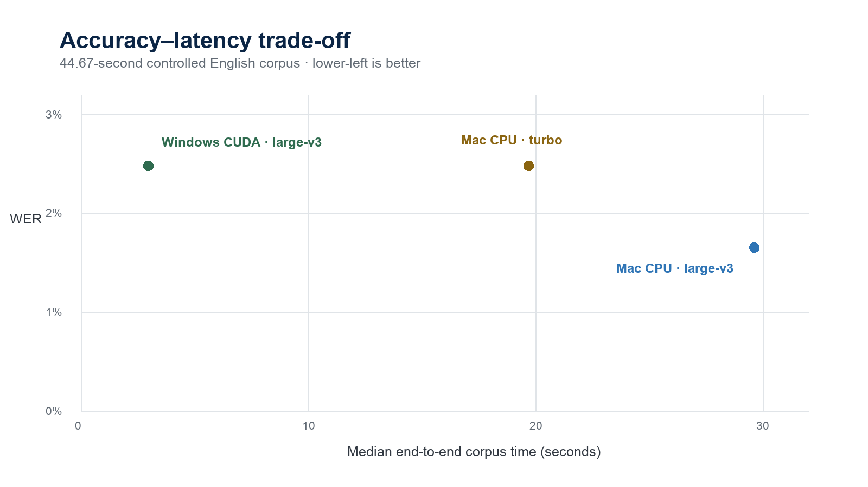
Figure 1. Controlled-corpus accuracy–latency frontier.

2.1 Error analysis
Clip | Windows large-v3 | Mac large-v3 | Mac Turbo | Observed issue
Clean US | 0.00% | 0.00% | 0.00% | Exact normalized match
Technical UK | 6.67% | 6.67% | 6.67% | “sixteen kilohertz” → “16 kHz”
Fast AU | 0.00% | 0.00% | 0.00% | Exact normalized match
Noisy IE | 3.45% | 0.00% | 3.45% | “Maria” → “Mario” on Windows/Turbo

Interpretation: Two of the three strict Windows/Turbo word errors are number-and-unit formatting, not lost content. The remaining error is a proper-name substitution in noise. A semantic scoring policy would yield approximately 0.83% content WER for Windows/Turbo and 0% for Mac large-v3 on this corpus; the formal benchmark intentionally preserves the stricter result.

3. Real-meeting result: AMI ES2010a
The 70-second AMI excerpt adds real voices, spontaneous disfluency, overlap, laughter, and backchannels. Its reference merges all four speakers into one time-ordered text. Whisper produces one linear transcript and may omit a secondary overlapping speaker, so the absolute WER is useful as an exploratory regression measure—not a complete meeting-quality score.
Configuration | WER | CER | E2E time | RTF | Throughput
Windows CUDA · large-v3 | 18.14% | 12.67% | 1.68 s | 0.024 | 41.62×
Mac CPU · large-v3 | 18.14% | 12.67% | 30.54 s | 0.436 | 2.29×
Mac CPU · Turbo | 19.47% | 13.03% | 17.77 s | 0.254 | 3.94×

AMI manual reference: 226 normalized words. All outputs identical across three runs.
Measured trade-off: Turbo reduced Mac time by 41.8% (30.54 → 17.77 seconds) but increased WER by 1.33 percentage points (18.14% → 19.47%). Windows matched Mac large-v3 accuracy and completed the same excerpt 18.2× faster end to end.

3.1 What the current sample can—and cannot—prove
- It confirms the benchmark detects both real content errors and repeatable speed differences.
- It is too small for confidence intervals or an organization-wide WER claim.
- It does not score diarization, speaker-attributed WER, or word timestamp error.
- Overlap makes a single linear WER reference incomplete; future scoring should add speaker-aware annotations.

4. Additional performance probes
Probe | Baseline | Candidate | Time change | Accuracy evidence
Mac dense 60 s | large-v3, beam 5 · 24.15 s | large-v3, beam 1 · 19.46 s | −19.4% | Same text hash on one clean sample
Mac dense 60 s | large-v3, beam 5 · 24.15 s | Turbo, beam 5 · 16.12 s | −33.3% | Same text hash on one clean sample
Mac dense 60 s | large-v3, beam 5 · 24.15 s | Turbo, beam 1 · 15.47 s | −35.9% | Same text hash on one clean sample
Mac aligned 120 s | CPU stages · 47.72 s | MPS VAD + align · 41.86 s | ≈−12% | Minor harness difference; no diarization token
ASR 120 s | Mac CPU · 45.47 s | Windows CUDA · 1.81 s | Windows 25.1× faster | Same segment/text counts; byte hash differed

Secondary probes use separate synthetic inputs and are not pooled with corpus WER results.

5. Platform optimization assessment

5.1 Windows CUDA
The Windows host is already compute-efficient for a single warm job. Its largest remaining user-visible gains come from reducing client polling delay and avoiding full-video uploads. Larger batches can improve throughput on long recordings, but the short corpus under-fills the current batch of 16. Turbo and beam 1 remain unmeasured on this service and must be A/B tested before deployment.
- Keep large-v3/float16 as the accuracy baseline.
- Use --language when known and a 0.1–0.25 second LAN poll interval.
- Upload 16 kHz mono FLAC for transcript-only jobs instead of the full video.
- Test batch 16/32/64 only on representative 30–60 minute files while recording VRAM.

5.2 macOS
CTranslate2 currently supports CPU and NVIDIA CUDA, not Apple MPS for Whisper ASR. The directly measured low-effort option is therefore the smaller Turbo model on CPU. Hybrid MPS can accelerate PyTorch VAD, alignment, and diarization stages, but it cannot remove the dominant CTranslate2 CPU ASR cost. True Apple-GPU ASR requires a separate MLX or whisper.cpp backend and a new output-parity test surface.
- Keep CTranslate2 at four CPU threads; 8 and 12 were slower on the tested M4 Pro.
- Offer Turbo as an explicit fast mode, not the quality default.
- Add optional MPS routing for VAD/alignment/diarization only after token-enabled end-to-end validation.
- Spike MLX only if offline Mac transcription is a product requirement; remote Windows remains much faster.

6. Recommendation
Use case | Recommended profile | Reason
Connected production | Windows CUDA · large-v3/float16 | Best measured accuracy–latency balance; 15–42× realtime in scored tests
Offline Mac, accuracy-first | Mac CPU · large-v3/int8 | Lowest strict WER on controlled corpus; matches Windows large-v3 on AMI
Offline Mac, speed-first | Mac CPU · Turbo/int8 | 34–42% faster locally; accept measured WER increase and label output as fast profile
Mac post-processing | Experimental hybrid MPS | Incremental gain for VAD/alignment/diarization; ASR remains CPU
Future local-Mac ceiling | MLX Turbo spike | Only warranted if local offline latency remains a requirement after simpler options

7. Production acceptance plan
The current study is sufficient to choose a deployment direction, but not to certify a new model. Run at least 20 human-annotated recordings totaling roughly three hours, covering accents, microphones, noise, overlap, names, acronyms, dates, and amounts. Randomize configuration order and report paired bootstrap confidence intervals by recording.
Change | Provisional quality gate | Required speed benefit
Turbo | Upper 95% CI for ΔWER ≤ +0.5 pp overall; no risk slice > +1.5 pp; critical-token recall loss ≤ 1 pp | ≥25% lower ASR latency
Beam 1 | ΔWER ≤ +0.25 pp; critical-token recall loss ≤ 0.5 pp; no hallucination regression | ≥15% lower ASR latency
Hybrid MPS | ΔWER ≤ +0.2 pp; ΔDER ≤ +0.5 pp; timestamp p95 degradation ≤ 50 ms | ≥10% lower end-to-end latency
MLX backend | ΔWER ≤ +0.5 pp overall; names/numbers and hallucination gates equal to Turbo | ≥30% lower Mac ASR latency

Current gate status: Turbo passes the provisional speed gate, but the observed ΔWER is +0.83 pp on controlled speech and +1.33 pp on AMI—above the provisional +0.5 pp limit. Because the sample is small, the decision is “continue evaluation,” not “reject.”

7.1 Metrics to add for meeting quality
- Critical-token accuracy for people, acronyms, dates, amounts, and domain terms.
- Hallucination words per hour and insertions during annotated silence/non-speech.
- Diarization error rate (DER) and speaker-attributed WER with an explicit overlap policy.
- Median and p95 word start/end error plus aligned-word coverage.
- Cold start, warm p50/p95, peak RAM/VRAM/unified memory, and failure rate.

8. Reproducibility
The repository now contains benchmarks/run.py and a pure unit test for normalization, Levenshtein scoring, digest validation, aggregation, and WER/RTF gates. Benchmark media remains external so the repository does not acquire large or license-sensitive fixtures.
PYTHONPATH=src python benchmarks/run.py /path/to/cases.json \
--backend local --model large-v3 --device cpu --compute-type int8 \
--max-wer 0.05 --max-rtf 1.0 --output mac.json
PYTHONPATH=src python benchmarks/run.py /path/to/cases.json \
--backend remote --max-wer 0.05 --max-rtf 0.1 --output windows.json
Remote authentication is read only from TRANSCRIPT_TOKEN. The study document and saved reports contain no bearer token. The remote runner deletes each terminal job it creates after fetching the result.

9. Limitations
- The controlled corpus is synthetic and only 121 words; it cannot represent natural meeting WER.
- The AMI clip is 70 seconds and role-played; its all-speaker linear reference is ambiguous during overlap.
- The Windows service was not reconfigured to Turbo or beam 1, so those cross-platform A/B cells remain open.
- Alignment, diarization, timestamp accuracy, energy use, and memory were outside the scored comparison.
- Model/backend outputs may differ by precision and hardware even when the configuration name is unchanged.

Sources
- OpenAI Whisper model table and Turbo guidance. Open source
- WhisperX 3.8.6 batching, alignment, and diarization guidance. Open source
- CTranslate2 4.7.2 hardware support. Open source
- CTranslate2 performance recommendations. Open source
- PyTorch MPS backend notes. Open source
- Apple MLX Whisper example and word timestamps. Open source
- AMI Meeting Corpus license (CC BY 4.0). Open source
- AMI transcription and review process. Open source
- Requests multipart file encoding implementation. Open source

Appendix A. Result identifiers
Artifact | SHA-256 / location
Controlled corpus manifest | Pinned manifest used by all three configurations; SHA stored in benchmark JSON
AMI audio | 4b4508fa1b4aecf36d578e32f28cdace8ae18e26909fe8392773567cbbafcfbe
AMI reference | ad216442efc833beb8643344c11398eeb3ddb8fb526181e7abea2275be9962a0
AMI manifest | a653f9319445854c0fa10e175df1303e8be87817ada49b9e87e2abbf3d173435
Benchmark implementation | benchmarks/run.py (repository working tree, July 17, 2026)

