Create a recipe web site. The site should include a home page with links to each of your recipes (at least 3 recipes).   
  
As you have worked through chapter 3 and adding visual properties to your webpages, the emphasis in grading will be not only on validated html pages but will also consist of basic styling applied through an external style sheet (also validated). Use a color theme from Adobe Color throughout this site.

1. Create a folder called Web08.
2. Open basic.html and save it in the Web08 folder calling it index.html.
3. In the index.html file you should have you elements such as header, nav, main and footer. This first page acts as a menu.
   1. Include a level-1 heading that displays “Your Name’s Favorite Recipes”.
   2. A paragraph in the main element that describes what this page.
   3. A nav element within the main element with an unorganized list that links to three subpages.
4. At the bottom of this page include a footer with the copyright symbol and your name.
5. 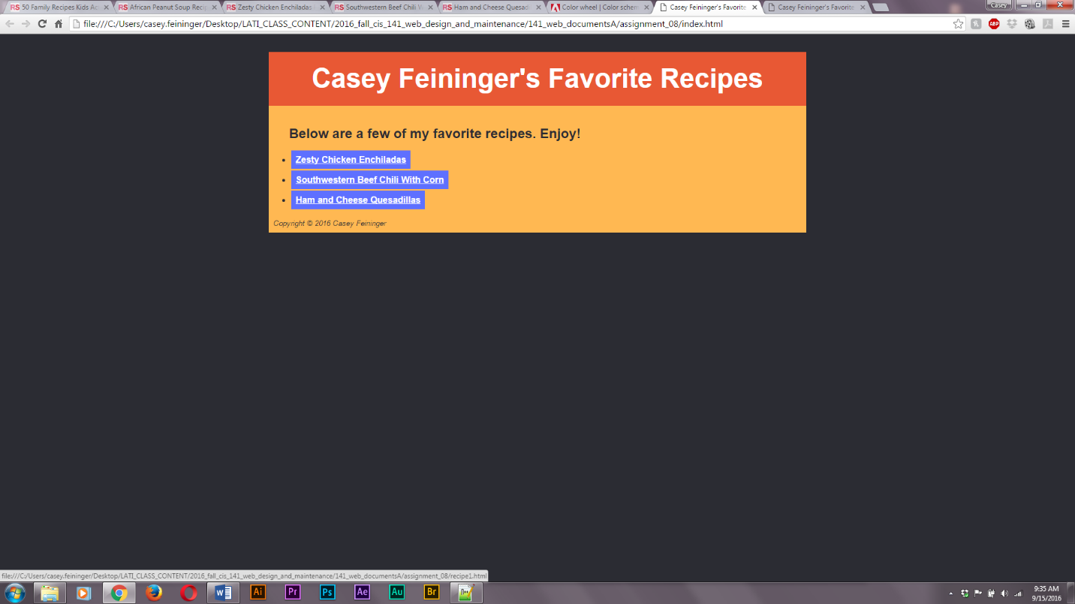Be creative (but consist throughout the site) in your use of style properties.
6. Rename your index page to recipe01.html.
7. Keep the level-1 heading and the footer but add elements as needed to make the recipe page functional and visually appealing!
8. In each of the recipe page, display ingredients and instructions for the recipe. You should use the paragraph element as well as list elements on the subpages.
9. On the individual recipe pages there will be a nav element under the level-1 heading that links to links to your three subpages and back to the menu (your index.html page).
10. You should complete the first recipe page in full and test it prior to using it as a template for future pages.

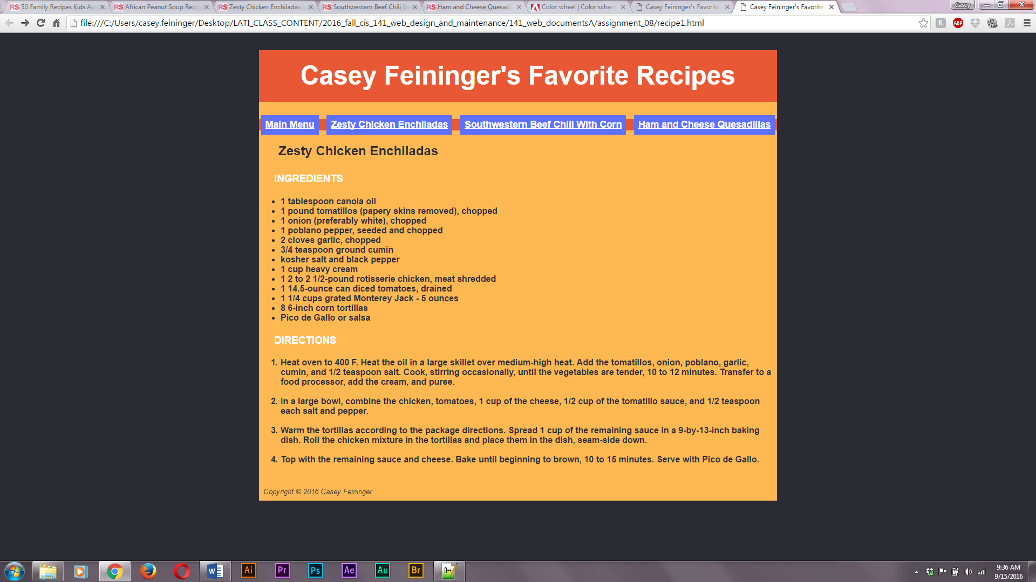

1. Be sure to add an external style sheet to format all the files.
2. Zip the pages and CSS file and submit the completed assignment.

\*Not all selectors that are present in a style sheet need to be on every page.   
\*\*Try creating a div id that wraps your pages. Not graded… rather a challenge to you!

What came first the chicken or the egg? When it comes to CSS I recommend do the structure of the site prior to building the style sheet.