**Assignment 4**

11510257 彭福

**Exe.2**

Solution:

1. True.

Proof:

Squaring each edge cost does not affect the order of edge during the execution of algorithm, so T must still be a minimum spanning tree for this different costs.

i.e. a<b<……<z → a2<b2<……<z2

b） False.

Counterexample：

Before squaring, b → c is the shortest path.

After squaring, b → a → c is the shortest path.

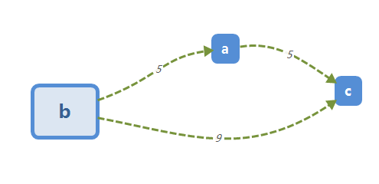

**Exe.8**

Solution：

Suppose that G has two different MST **P** and **Q**. Assume that we find a minimum weighted edge **e** from **P** which is not included in **Q**. And we add **e** to **Q** to become **I**. (**Q** + **e** = **I**) it is easy to know that **I** must has a circuit that at least has one edge **f** whose weight is larger than **e**. After removing **f**, we get another connected graph **J** whose weight is smaller than **H**, which is a contradiction. So G has a unique minimum spanning tree.

**Exe.22**

Solution:

False.

Counterexample:

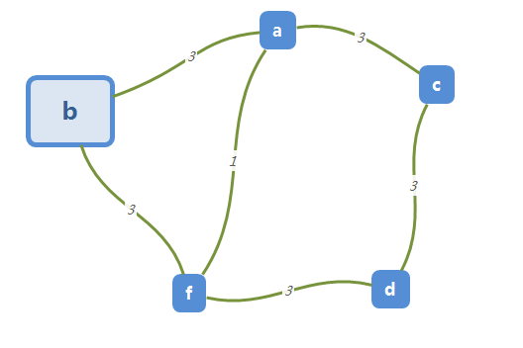 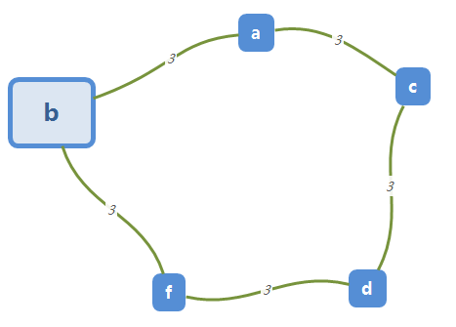 Graph G Spanning tree T

every edge e ∈ some MST，but H is NOT a MST.