Assignment 1 Data Visualisation

Excel & Tableau Assignment

Lee Hembling

Contents

First Task 2

Second Task 2

1. Set a password 2

2. Highlight column C and change the data to display in British Pound symbol 3

3. Turn the GDP sheet into a table 3

4. Filter the table to display only the information for 2019 4

5. Create a chart that will only display the following data ‘Rank, Countryand GDP -per capita (PPP). 4

6. 5

a & b. Add a title, X & Y axis labels 5

c. Make the chart visually pleasing 7

7. Move the chart to a new sheet tab and label with a suitable name 7

8. Create a sort for the top 20 highest ranking counties 8

9. Create a new Bar chart to display the 20 highest ranking countries from your sort and then move the chart to be underneath the table. 9

10. Colour the background. 10

Part three 10

1. Create 3 macro buttons 10

Word Gross domestic product report 1 12

Tableau 13

1. & 2. Importing and setting relationships 13

3. Check data types 13

4. Build charts 14

Wealth of Nations dashboard 15

# First Task

Policies that need to be adhered to when working with data:

* Data protection – This regards what data different people have access to and what is the data being used for. This preserves data integrity, aids safeguarding, and prevents data breaches. Organisations in the UK follow the General Data Protection Regulation framework.
* Data governance – These are guidelines that ensure data is accurate, consistent and secure.

As a data analyst, it is vital to understand these policies in order to maintain data integrity, make sure it is fit for purpose, to ensure sensitive data is kept secure, and to make sure processes are efficient.

# Second Task

## Set a password

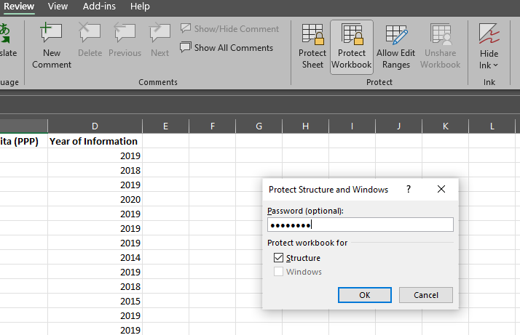

To set a password to protect the workbook, I clicked **Review** from the Ribbon menu, then **Protect Workbook**. I then entered a password and clicked **OK**.

## Highlight column C and change the data to display in British Pound symbol

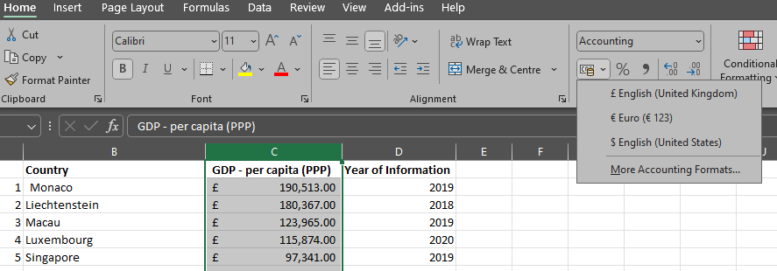

I selected the **Home** Ribbon menu, then selected **Column C** by clicking on the column letter. To change the format to £, I clicked on the drop-down menu for accounting and selected **£ English (United Kingdom).**

## Turn the GDP sheet into a table

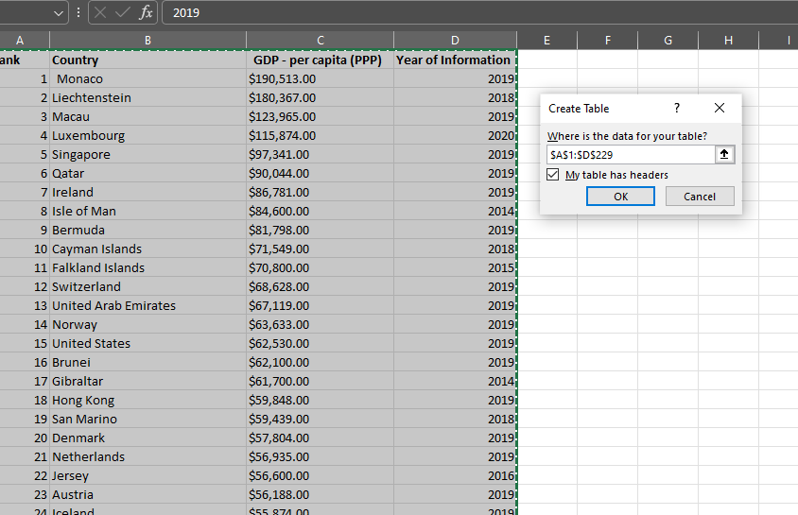

I selected all data on the sheet, followed by clicking on the **Insert** Ribbon menu and then **Table**. I checked the cell references in the dialog box that appeared, made sure the **My table has headers** option was selected (as it does) and clicked **OK**.

## Filter the table to display only the information for 2019

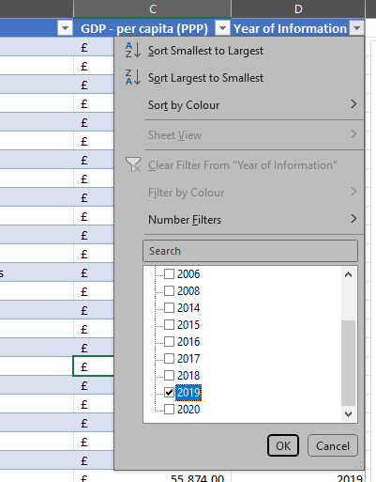

Clicking on the down arrow next to the **Year of Information** table heading, displays the **sort and filter** menu box, which allows me to **deselect all**, then **just select 2019**, followed by **OK**.

## Create a chart that will only display the following data ‘Rank, Countryand GDP -per capita (PPP).

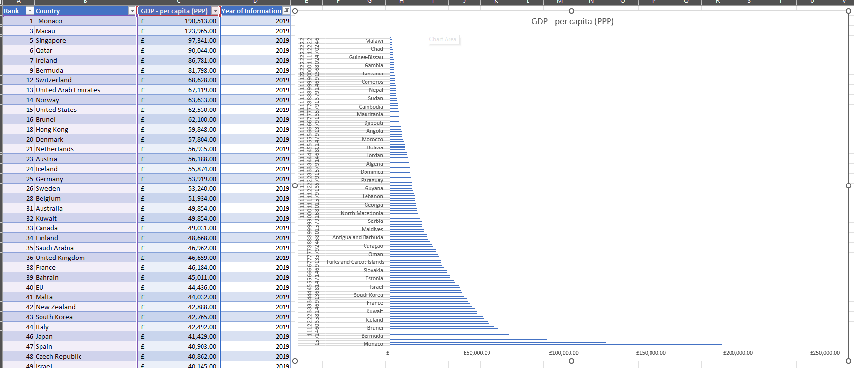

I selected the relevant **columns (A,B,C**), clicked on the **INSERT** Ribbon menu and then selected a **2D bar chart** from the **Charts** area of the Ribbon.

## 

## a & b. Add a title, X & Y axis labels

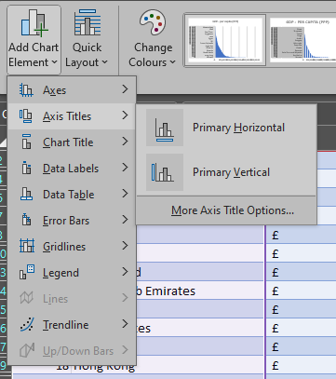

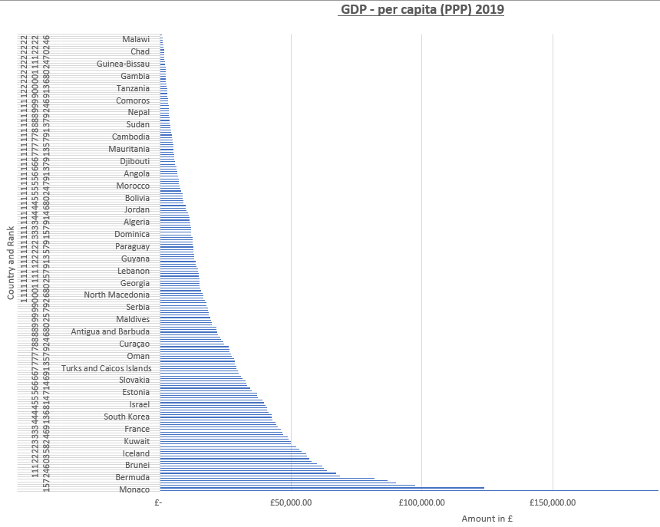

Using the **Chart Design** Ribbon menu, I click on the **Add Chart Element** icon and proceed to give the **X & Y axis suitable titles**, as well as improve the generic **chart title** by specifying a year.

## Make the chart visually pleasing

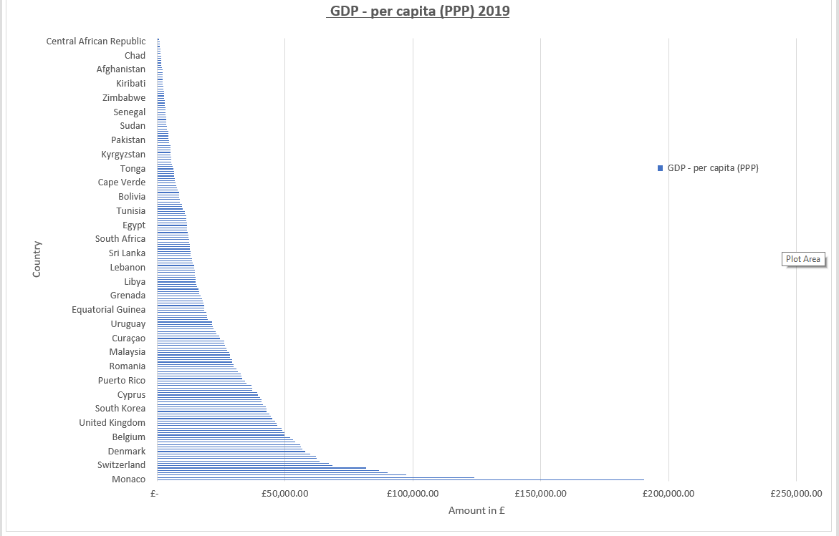

As there is a lot of data to represent, to make the chart as large as possible, so **moved it to a new sheet, called the same as the chart title**. I also added a **legend** that floats above an empty area of the chart. I decided to remove the Rank data from the chart as it looked really crowded and is unnecessary when looking at the data visually in a chart.

## Move the chart to a new sheet tab and label with a suitable name

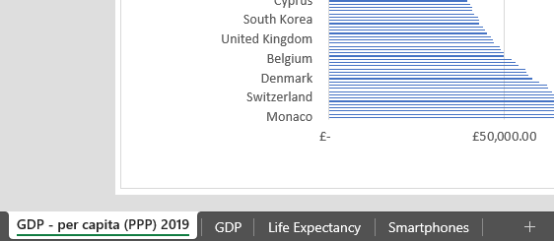

See (6c) above.

## Create a sort for the top 20 highest ranking counties

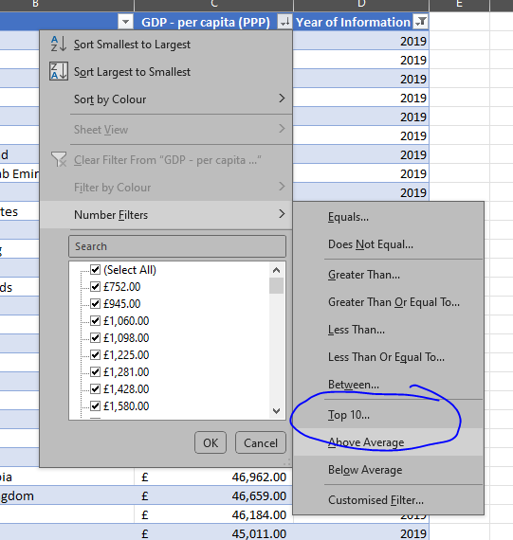

To do this, I again bring up the **sort** and filter box and select **Number Filters**, **Top 10…** and then change Top 10 to **Top 20**

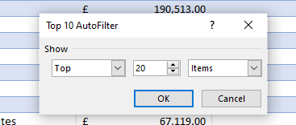

## Create a new Bar chart to display the 20 highest ranking countries from your sort and then move the chart to be underneath the table.

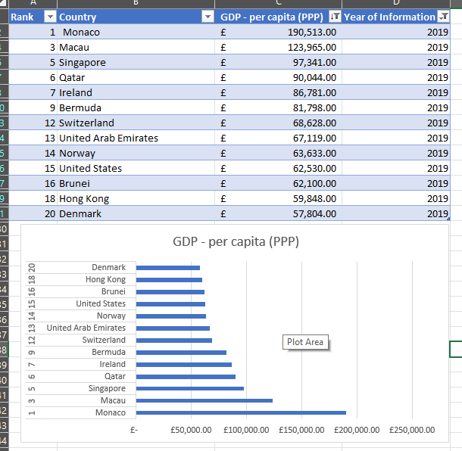

## Colour the background.

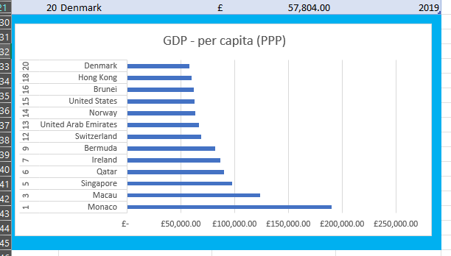

This was achieved by using the **Fill Colour** option on the **Home** Ribbon.

# Part three

## Create 3 macro buttons

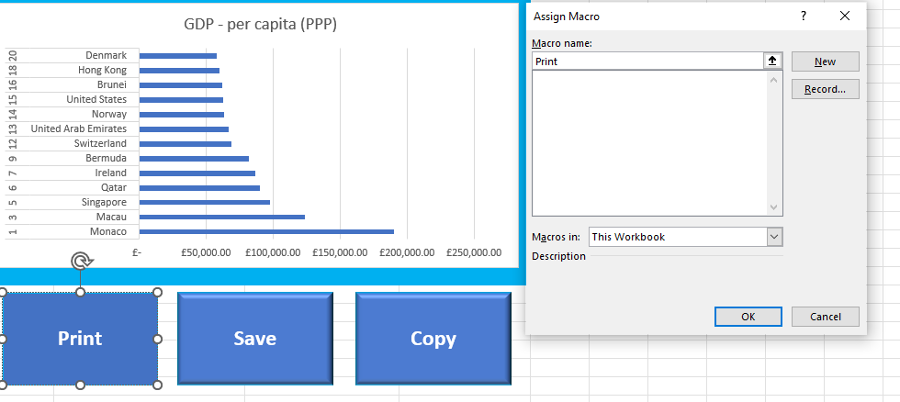

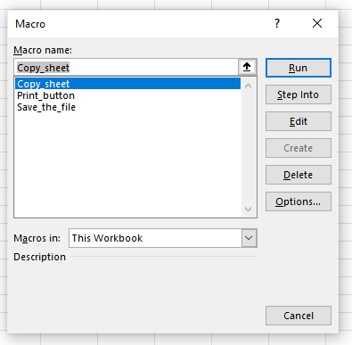

## Word Gross domestic product report 1

|  |  |  |  |
| --- | --- | --- | --- |
| **Rank** | **Country** | **GDP - per capita (PPP)** | **Year of Information** |
| 1 | Monaco | £ 190,513.00 | 2019 |
| 3 | Macau | £ 123,965.00 | 2019 |
| 5 | Singapore | £ 97,341.00 | 2019 |
| 6 | Qatar | £ 90,044.00 | 2019 |
| 7 | Ireland | £ 86,781.00 | 2019 |
| 9 | Bermuda | £ 81,798.00 | 2019 |
| 12 | Switzerland | £ 68,628.00 | 2019 |
| 13 | United Arab Emirates | £ 67,119.00 | 2019 |
| 14 | Norway | £ 63,633.00 | 2019 |
| 15 | United States | £ 62,530.00 | 2019 |
| 16 | Brunei | £ 62,100.00 | 2019 |
| 18 | Hong Kong | £ 59,848.00 | 2019 |
| 20 | Denmark | £ 57,804.00 | 2019 |
| |  | | --- | |  | |  |  |  |
|  |  |  |  |
|  |  |  |  |
|  |  |  |  |
|  |  |  |  |
|  |  |  |  |
|  |  |  |  |
|  |  |  |  |
|  |  |  |  |
|  |  |  |  |
|  |  |  |  |
|  |  |  |  |
|  |  |  |  |
|  |  |  |  |
|  |  |  |  |
|  |  |  |  |

# Tableau

## & 2. Importing and setting relationships

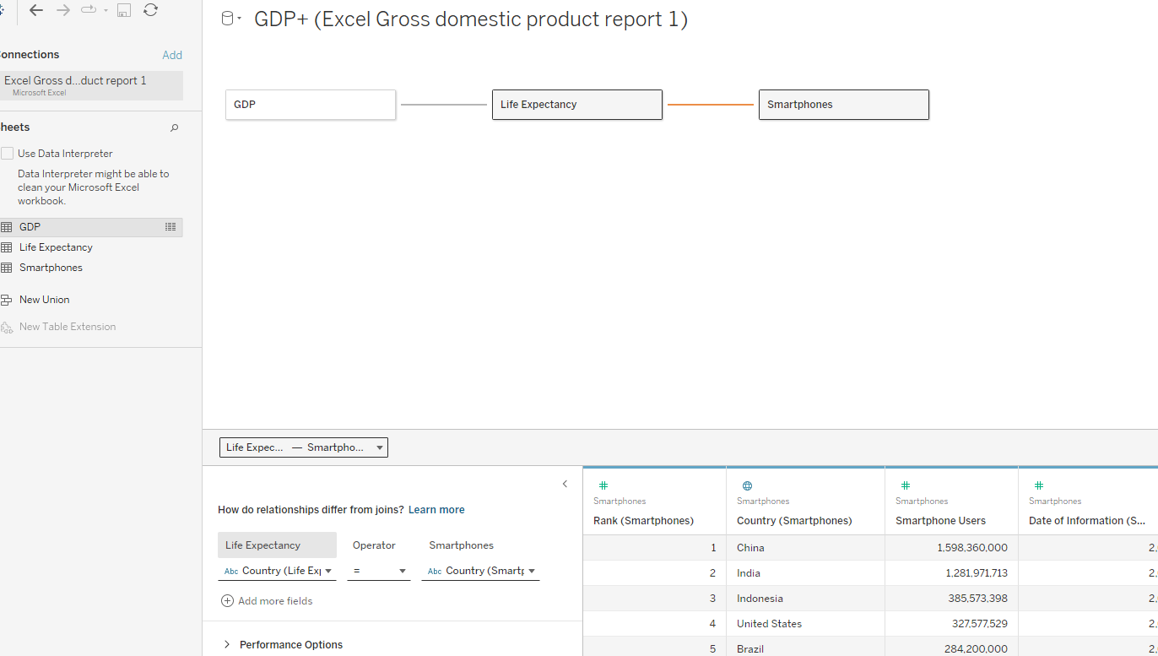

Each of the three tables is linked by the **Country** field.

## 3. Check data types

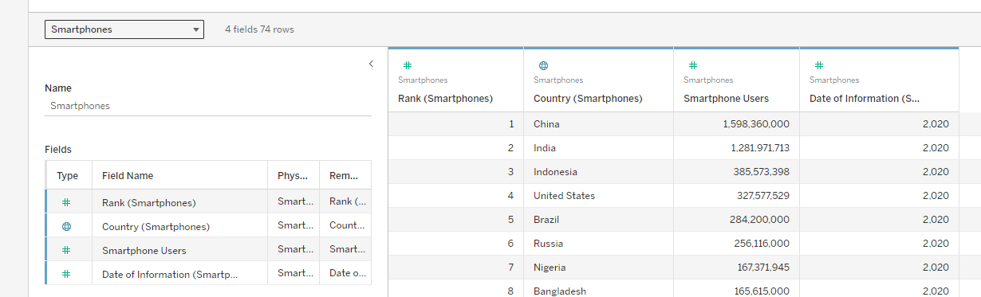

I checked each data type was correct for the tables.

## 4. Build charts

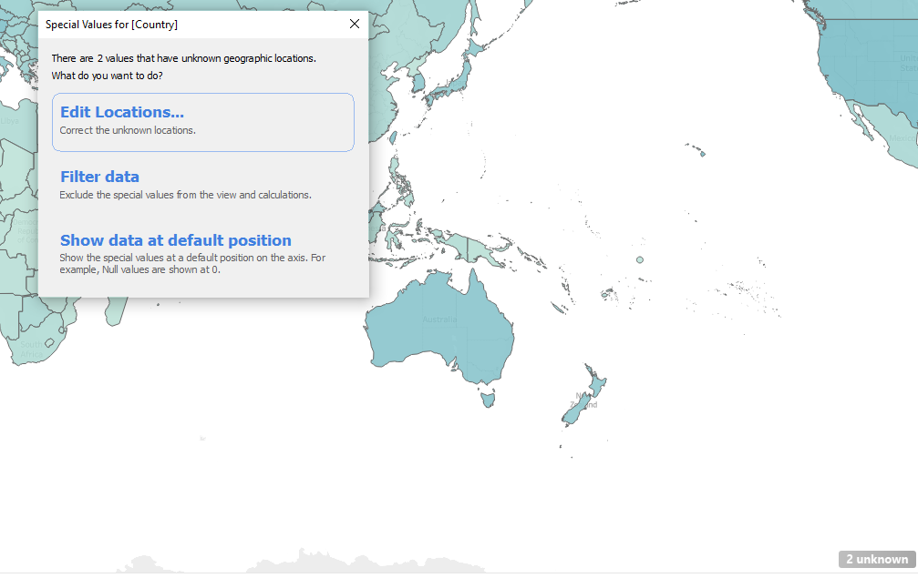

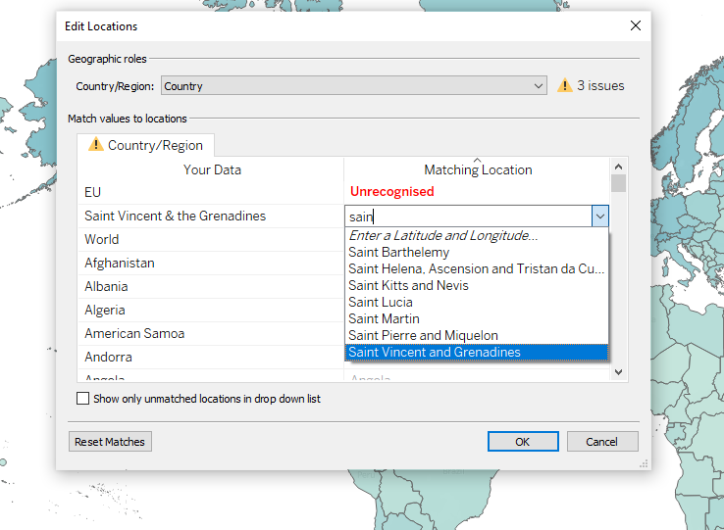

Some data has missing information, such as Saint Vincent & the Grenadines not being recognised, as Tableau only recognises Saint Vincent and Grenadines, so I manually corrected this. The other two remaining ‘errors’ were ‘World’ and ‘EU’ so I ignored them and hid the warning.

# Wealth of Nations dashboard

