**Student Name:** Ba Huy Hoang Le

**Student ID:** 224309594

**Query Appendix**

# Question 1

* Query 1a:

Finding which products are the most popular by volume (based on Quantity)

SELECT Product_SKU, SUM(Quantity) AS Total_Product_Quantity

FROM `mis784t22025-466123.224309594_Assign1.Transaction_Table`

WHERE EXTRACT(YEAR FROM Transaction_Date) = 2024

GROUP BY Product_SKU

ORDER BY SUM (Quantity) DESC;

* Result Screenshot

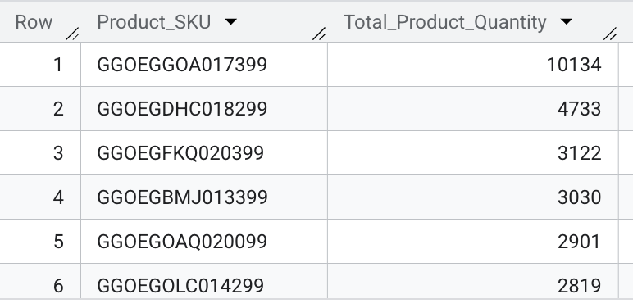

* Finding the number of unique customers who purchased product GGOEGGOA017399, the total number of transactions, and average rating

SELECT

COUNT(DISTINCT Customer_ID) AS Total_Customer,

COUNT(Transaction_ID) AS Total_Transaction,

ROUND(AVG(Transaction_Rating),2) AS Average_Trans_Rating

FROM `mis784t22025-466123.224309594_Assign1.Transaction_Table`

WHERE

Product_SKU = 'GGOEGGOA017399' AND

EXTRACT(YEAR FROM Transaction_Date) = 2024;

* Result Screenshot

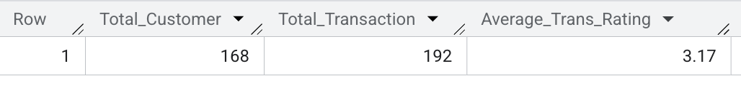

* Query 1b:

Finding which products are the most popular by reach (based on number of unique customers)

SELECT Product_SKU, COUNT(DISTINCT Customer_ID) AS Total_Unique_Customer

FROM `mis784t22025-466123.224309594_Assign1.Transaction_Table`

WHERE EXTRACT(YEAR FROM Transaction_Date) = 2024

GROUP BY Product_SKU

ORDER BY Total_Unique_Customer DESC;

* Result Screenshot

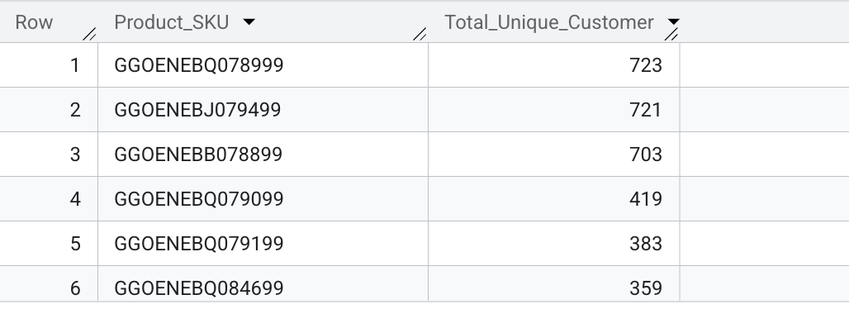

Finding the number of unique customers who purchased product GGOENEBQ078999, the total number of transactions, and average rating

SELECT

COUNT(DISTINCT Customer_ID) AS Total_Customer,

COUNT(Transaction_ID) AS Total_Transaction,

ROUND(AVG(Transaction_Rating),2) AS Average_Trans_Rating

FROM `mis784t22025-466123.224309594_Assign1.Transaction_Table`

WHERE

Product_SKU = 'GGOENEBQ078999' AND

EXTRACT(YEAR FROM Transaction_Date) = 2024;

* Result Screenshot

* Query 1c:

Finding which products are the most popular number of transactions (Transaction_ID)

SELECT Product_SKU, COUNT(Transaction_ID) AS Total_Transaction

FROM `mis784t22025-466123.224309594_Assign1.Transaction_Table`

WHERE EXTRACT(YEAR FROM Transaction_Date) = 2024

GROUP BY Product_SKU

ORDER BY Total_Transaction DESC;

* Result Screenshot

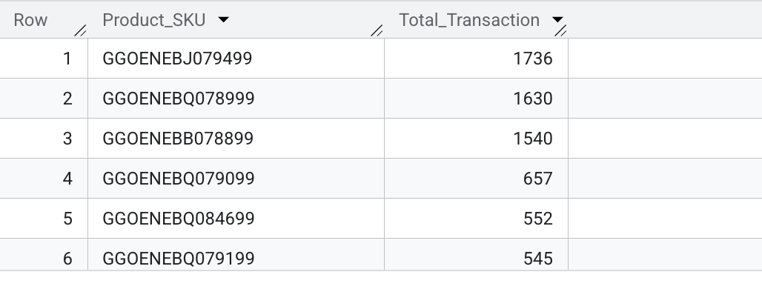

Finding the number of unique customers who purchased product GGOENEBJ079499, the total number of transactions, and average rating

SELECT

COUNT(DISTINCT Customer_ID) AS Total_Customer,

COUNT(Transaction_ID) AS Total_Transaction,

ROUND(AVG(Transaction_Rating),2) AS Average_Trans_Rating

FROM `mis784t22025-466123.224309594_Assign1.Transaction_Table`

WHERE

Product_SKU = 'GGOENEBJ079499' AND

EXTRACT(YEAR FROM Transaction_Date) = 2024;

* Result Screenshot

* Query 1d:

Finding which products are most favored

SELECT Product_SKU, ROUND(AVG(Transaction_Rating),2) AS Average_Trans_Rating

FROM `mis784t22025-466123.224309594_Assign1.Transaction_Table`

WHERE EXTRACT(YEAR FROM Transaction_Date) = 2024

GROUP BY Product_SKU

ORDER BY Average_Trans_Rating DESC;

* Result Screenshot

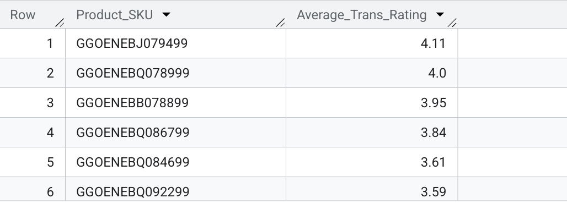

Finding the number of unique customers who purchased product GGOENEBJ079499, the total number of transactions, and average rating

SELECT

COUNT(DISTINCT Customer_ID) AS Total_Customer,

COUNT(Transaction_ID) AS Total_Transaction,

ROUND(AVG(Transaction_Rating),2) AS Average_Trans_Rating

FROM `mis784t22025-466123.224309594_Assign1.Transaction_Table`

WHERE

Product_SKU = 'GGOENEBJ079499' AND

EXTRACT(YEAR FROM Transaction_Date) = 2024;

* Result Screenshot

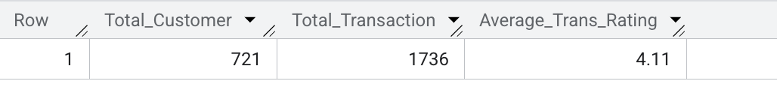

# Question 2

* Query 2a:

Calculating Recency, Frequency, and Monetary Score

SELECT

Customer_ID,

DATE_DIFF(CURRENT_DATE(), MAX(Transaction_Date), DAY) AS Recency_Score,

COUNT(DISTINCT Transaction_Date) AS Frequency_Score,

ROUND(SUM(Avg_Price * Quantity * (1 - IFNULL(Discount_pct, 0)/100)), 2) AS Monetary_Score

FROM `mis784t22025-466123.224309594_Assign1.Transaction_Table`

GROUP BY Customer_ID;

* Result Screenshot

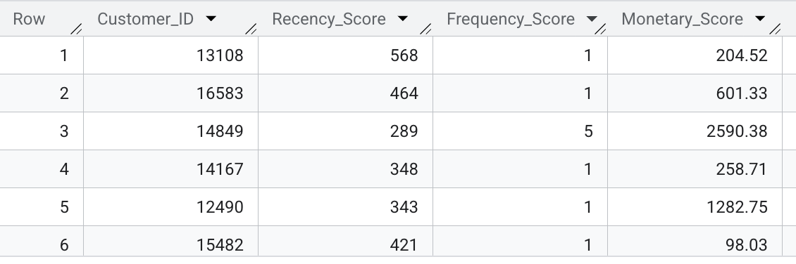

* Query 2b:

Finding the most valuable customers based on Recency_Score

SELECT

Customer_ID,

DATE_DIFF(CURRENT_DATE(), MAX(Transaction_Date), DAY) AS Recency_Score

FROM `mis784t22025-466123.224309594_Assign1.Transaction_Table`

GROUP BY Customer_ID

ORDER BY Recency_Score ASC

LIMIT 100;

* Result Screenshot

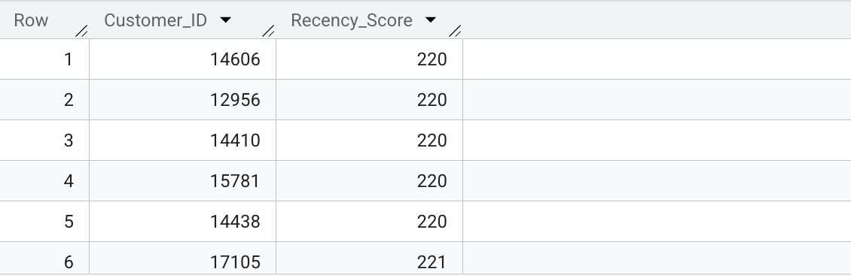

* Query 2c:

Finding the most valuable customers based on Frequency_Score

SELECT

Customer_ID,

DATE_DIFF(CURRENT_DATE(), MAX(Transaction_Date), DAY) AS Recency_Score

FROM `mis784t22025-466123.224309594_Assign1.Transaction_Table`

GROUP BY Customer_ID

ORDER BY Recency_Score ASC

LIMIT 100;

* Result Screenshot

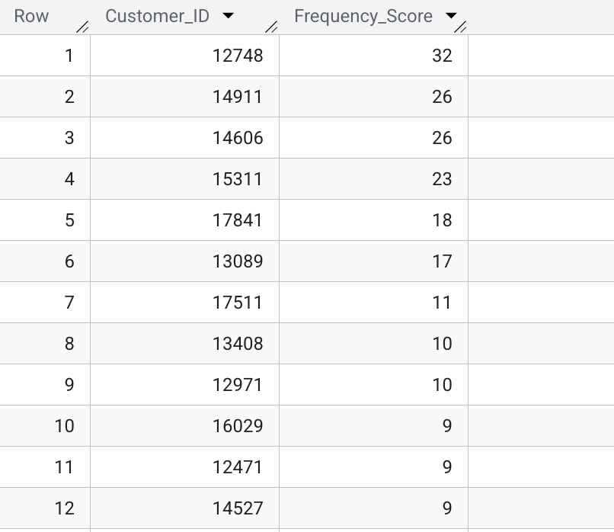

* Query 2d:

Finding most valuable customers based on Monetary_Score

SELECT

Customer_ID,

ROUND(SUM(Avg_Price * Quantity * (1 - IFNULL(Discount_pct, 0)/100)), 2) AS Monetary_Score

FROM `mis784t22025-466123.224309594_Assign1.Transaction_Table`

GROUP BY Customer_ID

ORDER BY Monetary_Score DESC

LIMIT 100;

* Result Screenshot

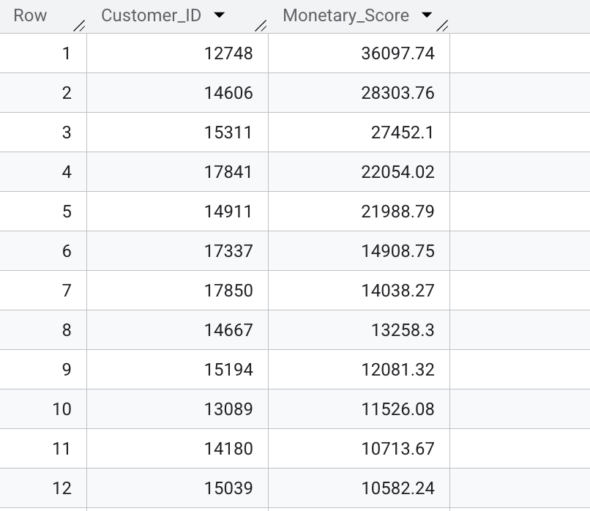

# Question 3

* Query 3a:

Segment customers into five groups for each of the three key metrics: Recency, Frequency, and Monetary value based on their transaction history.

WITH RFM_Scores AS (

SELECT

Customer_ID,

DATE_DIFF(CURRENT_DATE(), MAX(Transaction_Date), DAY) AS Recency_Score,

COUNT(DISTINCT Transaction_Date) AS Frequency_Score,

ROUND(SUM(Avg_Price * Quantity * (1 - IFNULL(Discount_pct, 0)/100)), 2) AS Monetary_Score

FROM `mis784t22025-466123.224309594_Assign1.Transaction_Table`

GROUP BY Customer_ID

),

RFM_Quintiles AS (

SELECT

Customer_ID,

NTILE(5) OVER (ORDER BY Recency_Score DESC, Customer_ID) AS Recency_Quintile,

NTILE(5) OVER (ORDER BY Frequency_Score ASC, Customer_ID) AS Frequency_Quintile,

NTILE(5) OVER (ORDER BY Monetary_Score ASC, Customer_ID) AS Monetary_Quintile

FROM RFM_Scores

)

SELECT

Customer_ID,

Recency_Quintile,

Frequency_Quintile,

Monetary_Quintile,

CONCAT(Recency_Quintile, Frequency_Quintile, Monetary_Quintile) AS RFM_Code

FROM RFM_Quintiles

ORDER BY RFM_Code DESC;

* Result Screenshot

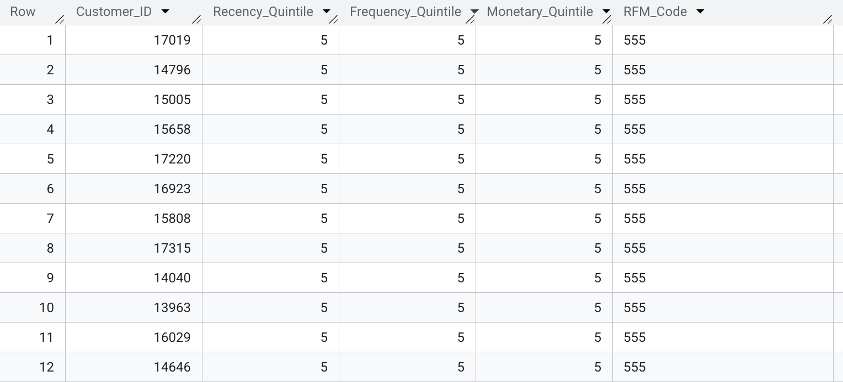

* Query 3b:

Extra step to name customer segments

WITH RFM_Scores AS (

SELECT

Customer_ID,

DATE_DIFF(CURRENT_DATE(), MAX(Transaction_Date), DAY) AS Recency_Score,

COUNT(DISTINCT Transaction_Date) AS Frequency_Score,

ROUND(SUM(Avg_Price * Quantity * (1 - IFNULL(Discount_pct, 0)/100)), 2) AS Monetary_Score

FROM `mis784t22025-466123.224309594_Assign1.Transaction_Table`

GROUP BY Customer_ID

),

RFM_Quintiles AS (

SELECT

Customer_ID,

NTILE(5) OVER (ORDER BY Recency_Score DESC, Customer_ID) AS Recency_Quintile,

NTILE(5) OVER (ORDER BY Frequency_Score ASC, Customer_ID) AS Frequency_Quintile,

NTILE(5) OVER (ORDER BY Monetary_Score ASC, Customer_ID) AS Monetary_Quintile

FROM RFM_Scores

),

RFM_Labeled AS (

SELECT

Customer_ID,

Recency_Quintile,

Frequency_Quintile,

Monetary_Quintile,

Monetary_Score,

CASE

WHEN Recency_Quintile = 5 AND Frequency_Quintile = 5 AND Monetary_Quintile = 5 THEN 'Power Users'

WHEN Recency_Quintile = 5 THEN 'Newly Engaged Buyers'

WHEN Frequency_Quintile = 5 THEN 'Frequent Shoppers'

WHEN Monetary_Quintile = 5 THEN 'High-Value Purchasers'

WHEN Recency_Quintile = 1 THEN 'Lapsed Buyers'

WHEN Frequency_Quintile = 1 THEN 'Infrequent Buyers'

WHEN Monetary_Quintile = 1 THEN 'Budget Buyers'

ELSE 'General Segment'

END AS Segment

FROM RFM_Quintiles

JOIN RFM_Scores USING (Customer_ID)

)

SELECT

Segment,

COUNT(*) AS Num_Customers,

ROUND(AVG(Monetary_Score), 2) AS Avg_Spend

FROM RFM_Labeled

GROUP BY Segment

ORDER BY Avg_Spend DESC;

* Result Screenshot

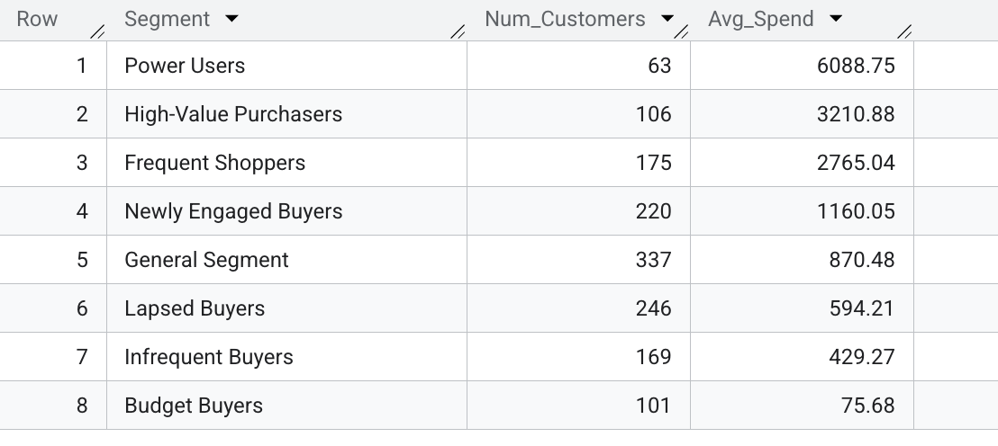

# Question 4 - Which types of customer engagement are most strongly associated with higher spending? How do combinations of these behaviors identify SmartStream’s most valuable customers?"

* Query 4a:

CREATE OR REPLACE VIEW `mis784t22025-466123.224309594_Assign1.Customer_1_Engagement_Monetary` AS

SELECT

c.Customer_ID,

ROUND(SUM(t.Avg_Price * t.Quantity * (1 - IFNULL(t.Discount_pct, 0)/100)), 2) AS Monetary_Score,

c.Chatbot_Usage_Count,

c.Email_Opened_Count,

c.Clicked_Ad_Campaigns,

c.Preferred_Channel

FROM

`mis784t22025-466123.224309594_Assign1.Customer_1` c

INNER JOIN

`mis784t22025-466123.224309594_Assign1.Transaction_Table` t

ON c.Customer_ID = t.Customer_ID

GROUP BY

c.Customer_ID,

c.Chatbot_Usage_Count,

c.Email_Opened_Count,

c.Clicked_Ad_Campaigns,

c.Preferred_Channel;

* Result Screenshot

# 

* Query 4b:

To understand the distribution of email opens, chatbot usage, and ad clicks and justify "High", "Medium", and "Low" engagement levels

SELECT

MIN(Chatbot_Usage_Count) AS Min_Chatbot,

MAX(Chatbot_Usage_Count) AS Max_Chatbot,

AVG(Chatbot_Usage_Count) AS Avg_Chatbot,

MIN(Email_Opened_Count) AS Min_Email,

MAX(Email_Opened_Count) AS Max_Email,

AVG(Email_Opened_Count) AS Avg_Email,

MIN(Clicked_Ad_Campaigns) AS Min_AdClick,

MAX(Clicked_Ad_Campaigns) AS Max_AdClick,

AVG(Clicked_Ad_Campaigns) AS Avg_AdClick

FROM `mis784t22025-466123.224309594_Assign1.Customer_1`;

* Result Screenshot



* Query 4c:

To find out which communication channel preference is associated with higher spending

SELECT

Preferred_Channel,

COUNT(*) AS Num_Customers,

ROUND(AVG(Monetary_Score),2) AS Avg_Spend

FROM

`mis784t22025-466123.224309594_Assign1.Customer_1_Engagement_Monetary`

GROUP BY

Preferred_Channel

ORDER BY

Avg_Spend DESC;

* Result Screenshot

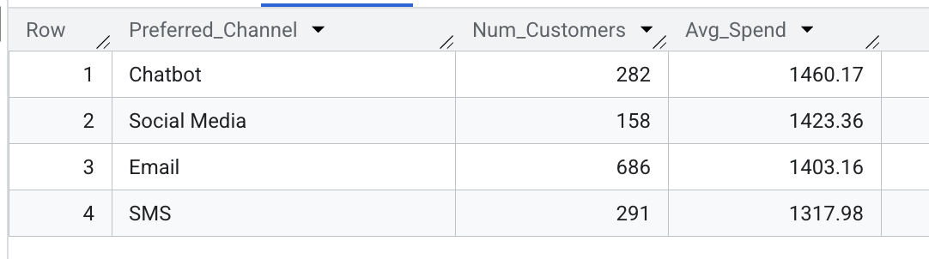

* Query 4d:

To segments customers by how engaged they are and determine if more engagement means more spending, and which channel is the strongest

SELECT

CASE

WHEN Chatbot_Usage_Count = 0 THEN 'None'

WHEN Chatbot_Usage_Count <= 1 THEN 'Low'

WHEN Chatbot_Usage_Count <= 3 THEN 'Medium'

ELSE 'High'

END AS Chatbot_Level,

ROUND(AVG(Monetary_Score), 2) AS Avg_Spend

FROM `mis784t22025-466123.224309594_Assign1.Customer_1_Engagement_Monetary`

GROUP BY Chatbot_Level

ORDER BY Avg_Spend DESC;

* Result Screenshot

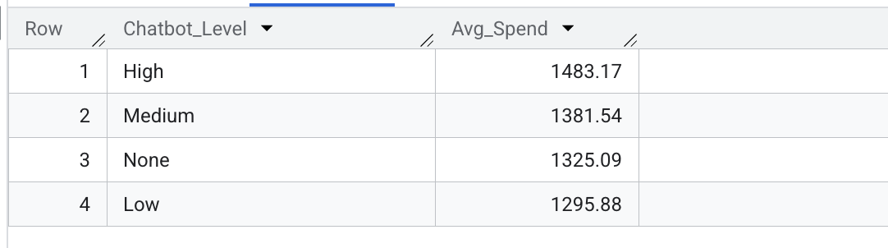

SELECT

CASE

WHEN Email_Opened_Count = 0 THEN 'None'

WHEN Email_Opened_Count <= 2 THEN 'Low'

WHEN Email_Opened_Count <= 5 THEN 'Medium'

ELSE 'High'

END AS Email_Level,

ROUND(AVG(Monetary_Score), 2) AS Avg_Spend

FROM `mis784t22025-466123.224309594_Assign1.Customer_1_Engagement_Monetary`

GROUP BY Email_Level

ORDER BY Avg_Spend DESC;

* Result Screenshot

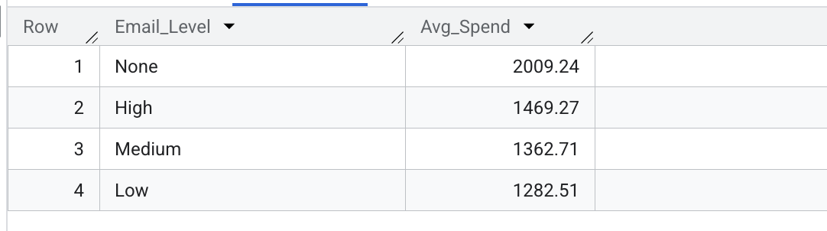

SELECT

CASE

WHEN Clicked_Ad_Campaigns = 0 THEN 'None'

WHEN Clicked_Ad_Campaigns <= 1 THEN 'Low'

WHEN Clicked_Ad_Campaigns <= 2 THEN 'Medium'

ELSE 'High'

END AS Ad_Level,

ROUND(AVG(Monetary_Score), 2) AS Avg_Spend

FROM `mis784t22025-466123.224309594_Assign1.Customer_1_Engagement_Monetary`

GROUP BY Ad_Level

ORDER BY Avg_Spend DESC;

* Result Screenshot

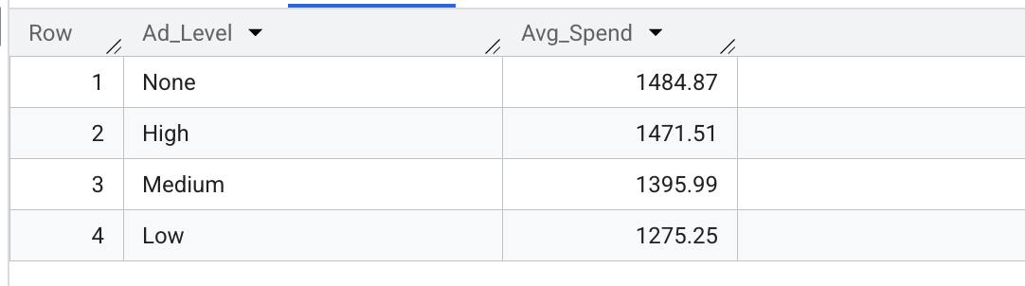

* Query 4e:

To define targetable customer profiles

WITH Engagement_Monetary AS (

SELECT

c.Customer_ID,

ROUND(SUM(t.Avg_Price * t.Quantity * (1 - IFNULL(t.Discount_pct, 0)/100)), 2) AS Monetary_Score,

c.Chatbot_Usage_Count,

c.Email_Opened_Count,

c.Clicked_Ad_Campaigns,

c.Preferred_Channel

FROM

`mis784t22025-466123.224309594_Assign1.Customer_1` c

INNER JOIN

`mis784t22025-466123.224309594_Assign1.Transaction_Table` t

ON c.Customer_ID = t.Customer_ID

GROUP BY

c.Customer_ID,

c.Chatbot_Usage_Count,

c.Email_Opened_Count,

c.Clicked_Ad_Campaigns,

c.Preferred_Channel

),

Percentile_Threshold AS (

SELECT

APPROX_QUANTILES(Monetary_Score, 4)[OFFSET(3)] AS Top25_Threshold

FROM Engagement_Monetary

),

Flagged AS (

SELECT

e.*,

CASE WHEN e.Monetary_Score >= p.Top25_Threshold THEN 1 ELSE 0 END AS Is_High_Spender,

CASE WHEN e.Chatbot_Usage_Count > 3 THEN 1 ELSE 0 END AS High_Chatbot,

CASE WHEN e.Email_Opened_Count > 5 THEN 1 ELSE 0 END AS High_Email,

CASE WHEN e.Clicked_Ad_Campaigns > 2 THEN 1 ELSE 0 END AS High_AdClick

FROM Engagement_Monetary e

CROSS JOIN Percentile_Threshold p

)

SELECT

Is_High_Spender,

High_Chatbot,

High_Email,

High_AdClick,

COUNT(*) AS Num_Customers

FROM Flagged

GROUP BY

Is_High_Spender,

High_Chatbot,

High_Email,

High_AdClick

ORDER BY

Num_Customers DESC;

* Result Screenshot

