Hanyang univ.ERICA

REPORT of CHEF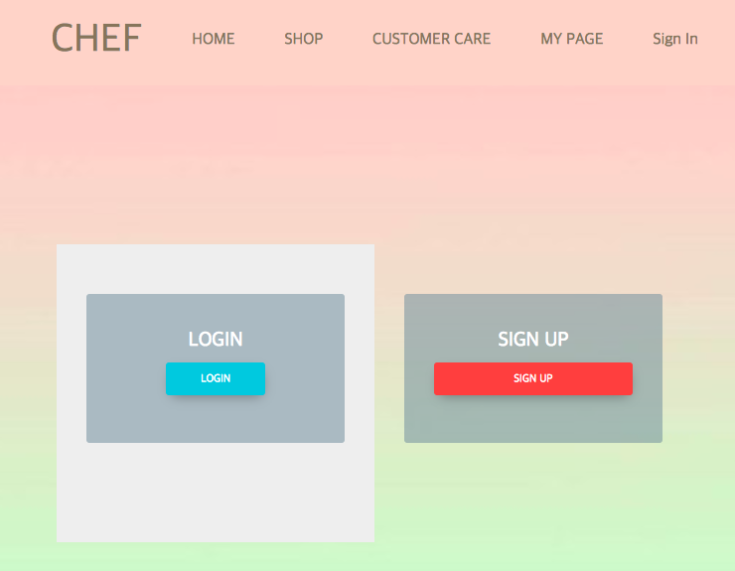

2016003290 Kwon Chaeeun

2016003454 Kim Hyebeen

2016003463 Nam Hyemin

2016003609 Sung Jina

2016003854 Lee Wyowon

Summary

We is able to see the founding clubs once or twice a year only in the flea market or festival.

Even if you want to buy earrings or necklaces of founding clubs, it is hard to buy unless it it a festival.

To complement this point, we has devised a shopping mall page for brokering founding clubs and consumers. Therefore, access to the products of the founding clubs at this ‘CHEF’ shopping mall will be increase the accessibility between the founding clubs and consumers.

Architecture & Structure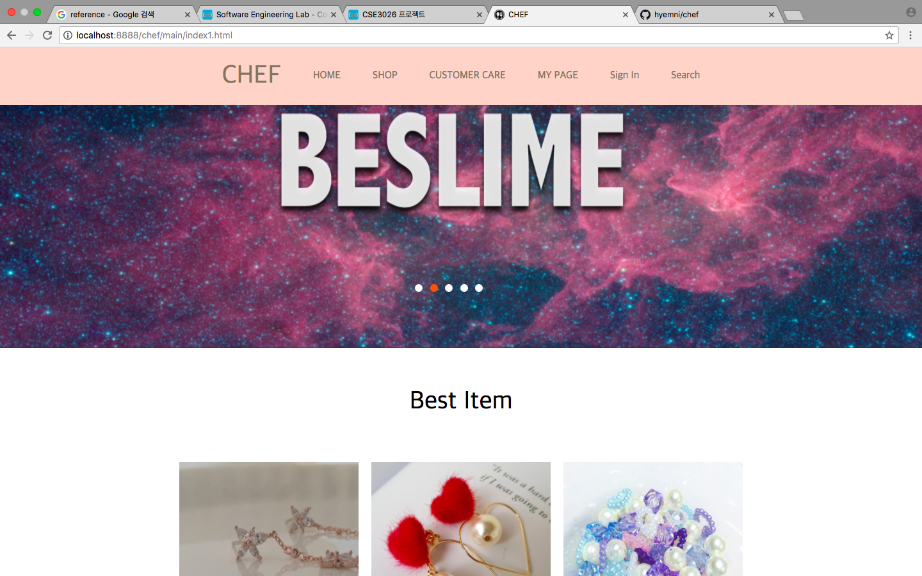

CHEF

<nav 1>

HOME Go back to the main screen(/chef/main/index1.html).

( screen of main page )

<nav 2>

SHOP > by brand

> To share categories by brands.

> When you click on a brand name in the submenu,

a page with products corresponding to that brand will open.

> We entered each branding information in the chef.sql file.

And We linked the database to fetch the information from chef.sql and apply it to brand.php.

> /chef/brand.php?brand=(name of brand)

( screen of SHOP > by Brand > (name of brand) )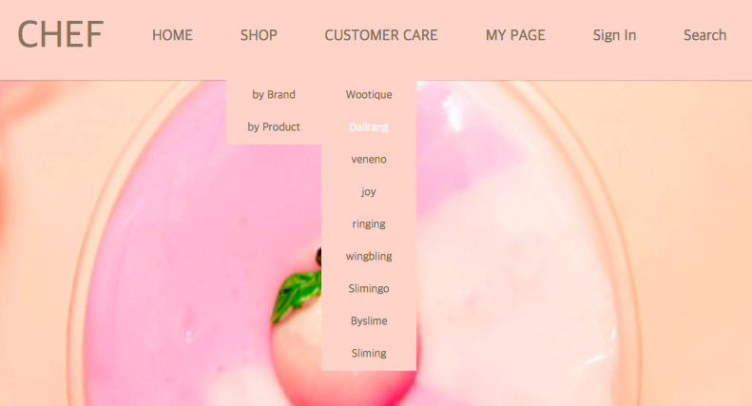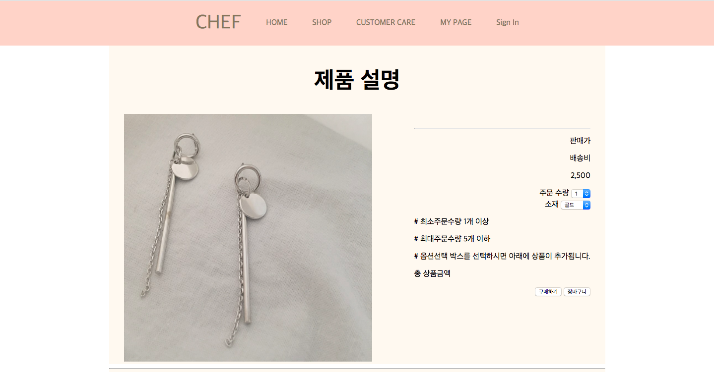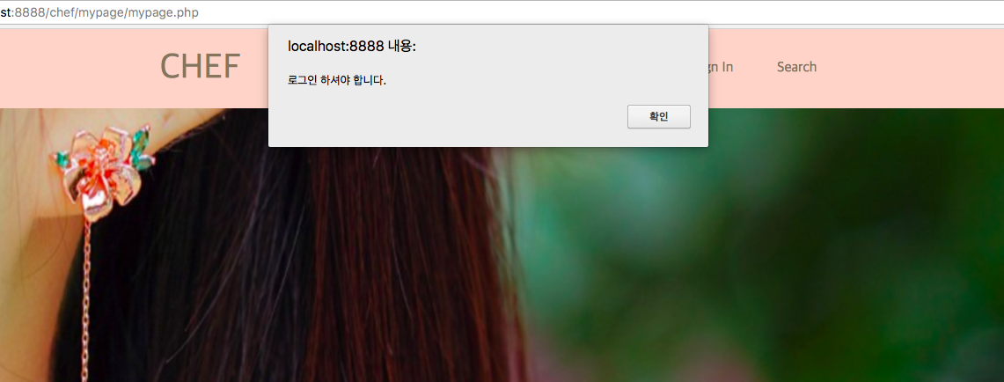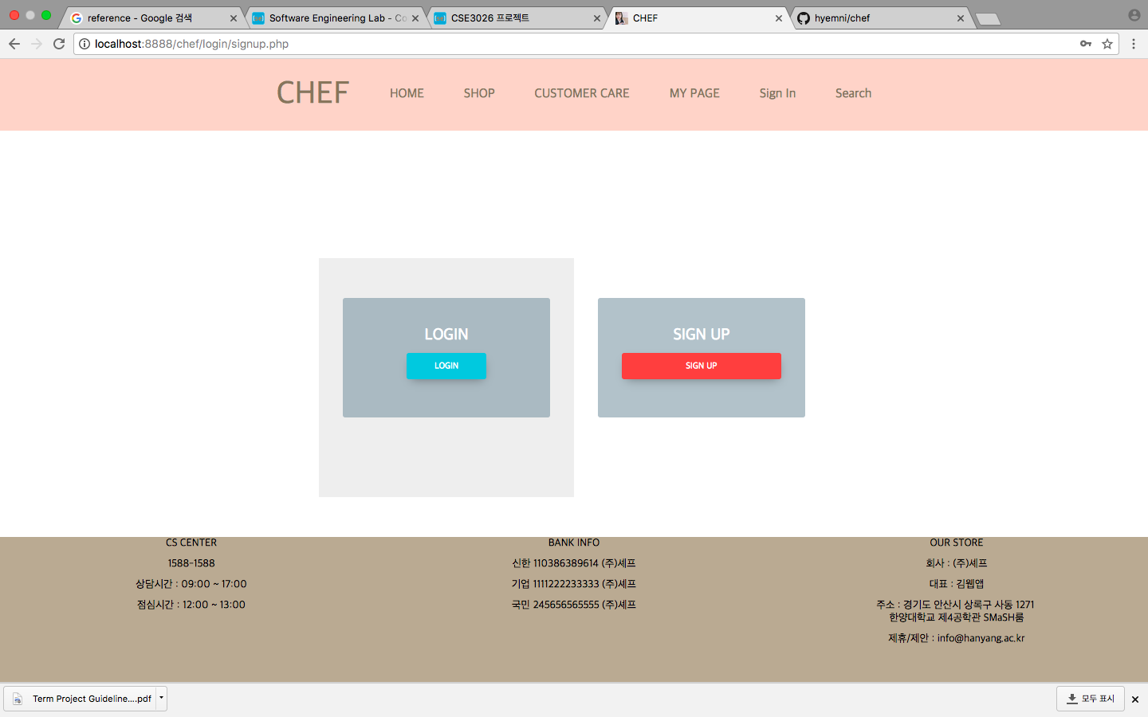

SHOP > by brand > (name of brand) > CLICK THE PHOTO OF PRODUCT

When you click the photo of product in brand.php page, you can enter the detail page of that product.

Then, you can see the kinds of that product, and the product’s name at the Upper right of page.

Just below that "(kinds of product)", On the left side is the product's photo, on the right is the price, option, and notice related to the product.

You can choose your option, move to shopping basket page, and move to purchase page.

And you can see the product’s information at this page.

<nav 3> MY PAGE

<nav 4> Sign In

> If you did not Login, when you click ‘MY PAGE’,

you will be prompted to log in.

> In ‘my page’, there are 6 menus; shopping pocket, search order list,

your information, wish list, point, and management address.

> You can see your shopping pocket list and wish list,

can search the list you ordered before, can see your information and points, and can manage your address.

> You can search the list you ordered before.

> You can see your

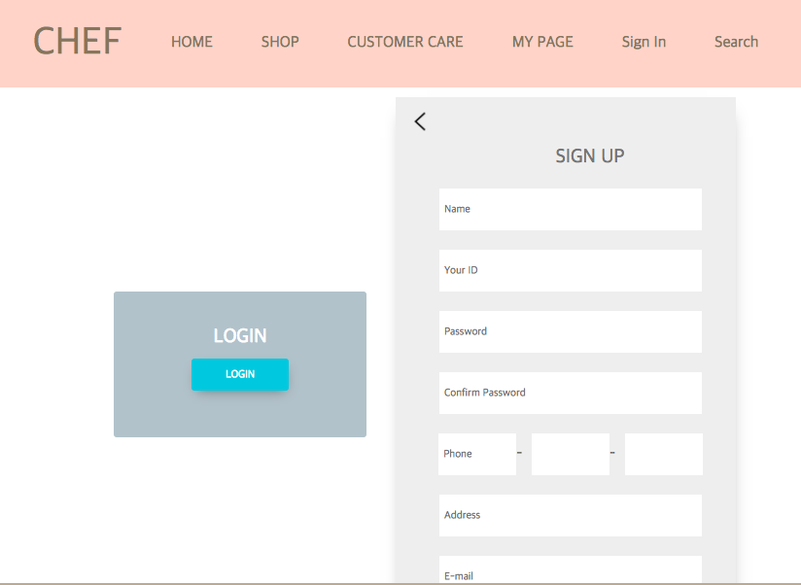

( MY P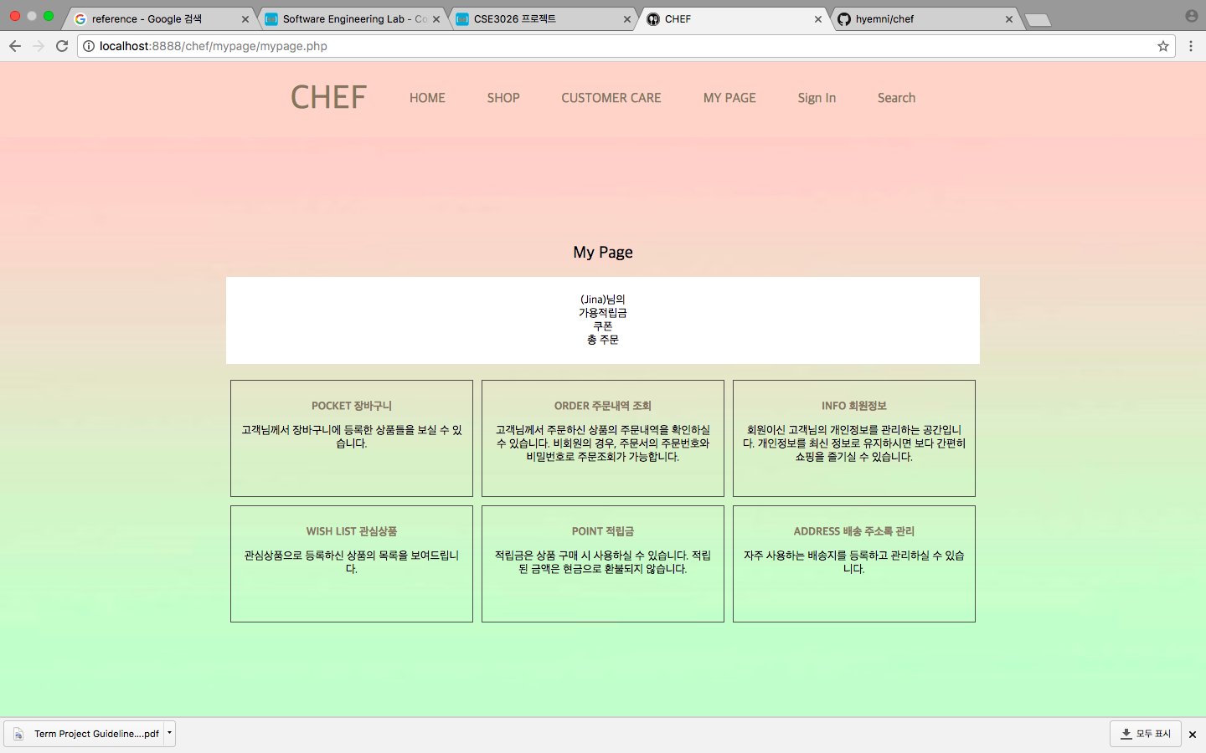AGE )

How to run this page in Mac OS

1. Download and Install MAMP at <https://www.mamp.info/en/downloads/>
2. Open the terminal.app
3. Turn on the MAMP
4. Write there

> cd /Applications/MAMP/htdocs/

> git clone <https://github.com/hyemni/chef.git>

> sudo ln -s /Applications/MAMP/Library/bin/mysql /usr/local/bin/mysql

> (write your password of your Mac)

> create database chef;

> exit

> mysql -uroot -proot chef (drag ‘chef.sql’ file => chef.sql address)

> mysql -uroot -proot

> use mysql;

> create user ‘chef’@‘%’ identified by ‘1234’;

> grant all privileges on chef.\* to chef@‘%’;

> flush privileges;

( Now, everything is ready. )

1. Open the Chrome.
2. Please enter “localhost:8888/chef/main/index1.html“ in the address bar.

Conclusion

We can purchase a work created by a founding club only in the flea market and festival, but flea market and festival is in once or twice a year. This means that the consumer are less accessible to the product of founding clubs.

So, We thought about shopping mall called 'CHEF' so that consumers can connect easily with founding club. By using 'CHEF', consumers will be able to see the founding club more easily and learn more about the founding club. From the standpoint of the founding club, it is possible to exhibit and sell works without restriction at any time and place. For Hanyang University, they can get the effect of promoting the founding club, and if the founding club becomes famous afterwards, Hanyang University can be famous.

While creating this founding clubs brokering shopping mall, the problem of using a lot of html was supplemented by database and PHP.