DIGITAL LIBRARY

Submission date : 05/11/2020

We are a team that includes 3 people. We call ourselves Di-Lib Members (DLM). Our names are Uygar Utku Öztürk, Onur Andiç and Atakan Üner. You can see us discussing about project on online below.

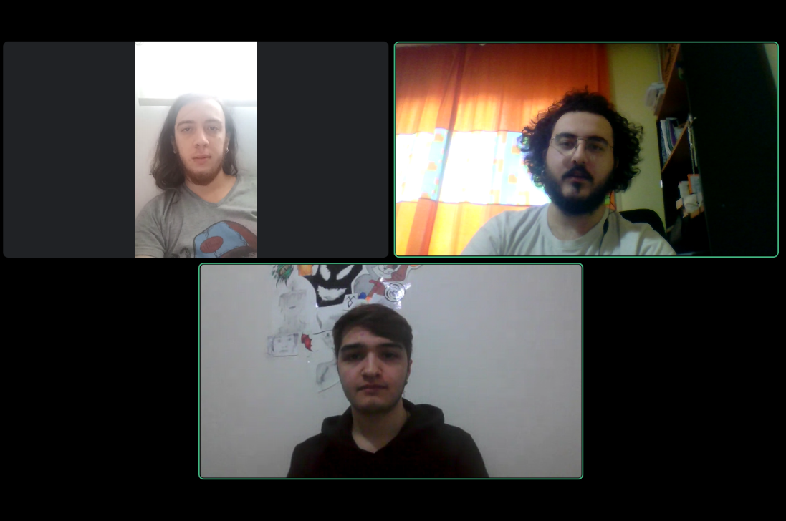

Some of our strengths is we love searching things on the internet. We know each other almost 3 years and that makes every one us a good team member. We can easily adapt different circumstances and easily get over with it.

You can find our pictures and biographies below.

Onur Andiç :

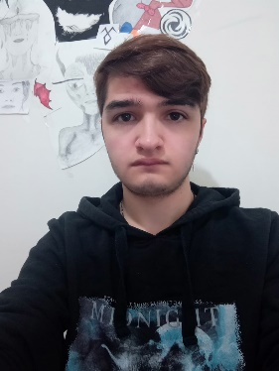 My name is Onur Andiç. I was born in Malatya in 1998. I am 22 years old and a computer engineering student. I started my education at Hanımçiftliği primary school and continued at Konak Anatolian High School in the same city. Currently, I am continuing in Aydın Adnan Menderes University Computer Engineering Department. I love reading books, listening to music and playing the piano. Also, in my spare time, I do pencil drawing and prepare portraits with oil painting. My phobias are darkness and height. One of my ideals in life is to be a software developer specialized in artificial intelligence.

Uygar Utku Öztürk :

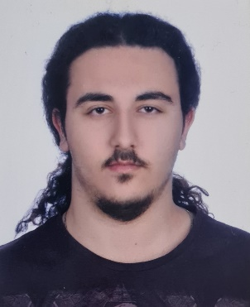My name is Uygar Utku Öztürk. I am a Computer Engineering student in Adnan Menderes University. It’s my 3rd year. I know C,Python,Java and R programming languages. Last year i made a project with R about statistics. Before that i made a project with Java for a different class. I also attended many meetings and seminars about my department in past 3 years. In present i am taking Harvard University’s CS50 lessons with other students on my department as a group and we are doing every week’s homework together on [www.kodluyoruz.org](http://www.kodluyoruz.org). You can contact me via my personal e-mail [uygarutku99@gmail.com](mailto:uygarutku99@gmail.com) or my university mail [171805046@stu.adu.edu.tr](mailto:171805046@stu.adu.edu.tr).

Atakan Üner :

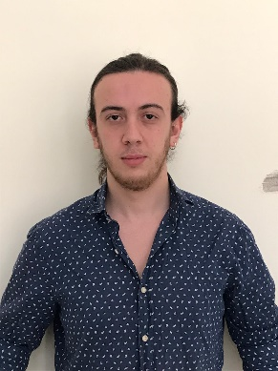 My name is Atakan Üner. My homeland is Çanakkale. I was born in 1998 and I am 21 years old. I am currently a Computer Engineering student in Aydın Adnan Menderes University. It's my 3rd year. I know C, Python, Java and R programming languages. Last year i made 2 projects. First one was about statistics in R programming language and the second one was a web project in C# using ASP.NET. I'm trying to improve myself and get to know about many topics in programming so I am currently taking classes and attending seminars about it. You can contact me via my e-mail unerata@gmail.com

Uygar Utku Öztürk will be the main contact for the instructor.

We discussed and decided to ;

Communicate via e-mail, text messages, online meetings (Discord,Google Meet and Skype).

Our communication response time will be 30 minutes top.

Meet every 2 days all together and our meetings lasts 30 minutes average.

We prepare our parts before the meetings.

Everyone take the part who thinks he’s good at it or enjoys while doing it.

We all together will check the project and everyone will submit the project as it told.

If one or some of us wants to drop the Project or being dishonest or does anything that effect our Project bad, we take him out and keep going who’s left.

Our github accounts:

Onur Andiç : <https://github.com/morgenstar72>

Student Number : 171805028

Atakan Üner : <https://github.com/unerata99>

Student Number : 171805011

Uygar Utku Öztürk : <https://github.com/LeeiTo7>

Student Number : 171805046