Contains AI-generated

Contains AI-generated

Excavatable
3D Scanning System
From a handful of photos to a complete, explorable 3D model
powered by AI that runs on the edge.

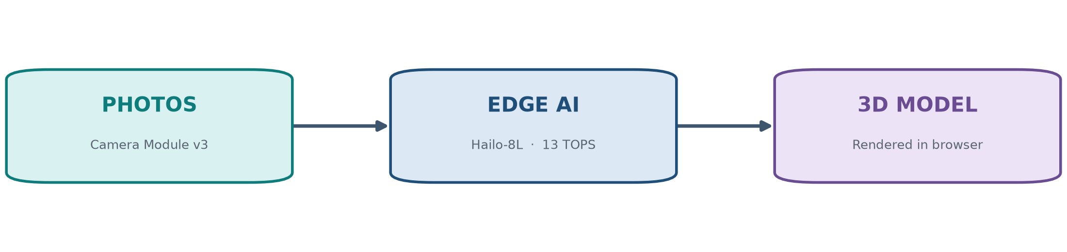

Prepared for FLL Judging

1. What Is Excavatable?

Excavatable turns ordinary photographs of an object into a fully interactive 3D model that you can rotate, zoom and explore inside a web browser. It pairs a small, portable camera rig with on-device Artificial Intelligence that finds the object, cuts it out from its background, and rebuilds it in three dimensions — automatically.
Rather than an expensive, single-purpose 3D scanner, Excavatable is built from an affordable Raspberry Pi 5, a camera, and a tiny AI accelerator chip. The result is a scanning system that is low-cost, portable, and clever enough to clean up its own data before the heavy 3D reconstruction work even begins.
At a glance
- A three-tier system: a camera edge node, a reconstruction server, and a web viewer.
- AI acceleration on-device — 13 trillion operations per second (13 TOPS) on the Hailo-8L.
- One button from photos to a finished, browser-ready 3D model.
- Runs even without specialist hardware, so it always has something to show.
2. The Challenge We Set Out to Solve

Digitising physical objects — for museums, classrooms, or engineering projects — normally needs either an expensive commercial 3D scanner or a slow, fiddly software workflow that demands an expert operator. Both options put 3D capture out of reach for most schools and small teams.
We asked a simple question: could a small, low-power, low-cost device do this automatically? Our answer is Excavatable — a system that handles the entire process, from the first photograph to a finished model you can open in a browser, and does part of the hard work with AI right on the device.
3. How Excavatable Works

Excavatable is built from three independent parts that talk to each other over the network. Keeping them separate means each one can be improved, tested, or even run on a different machine on its own.
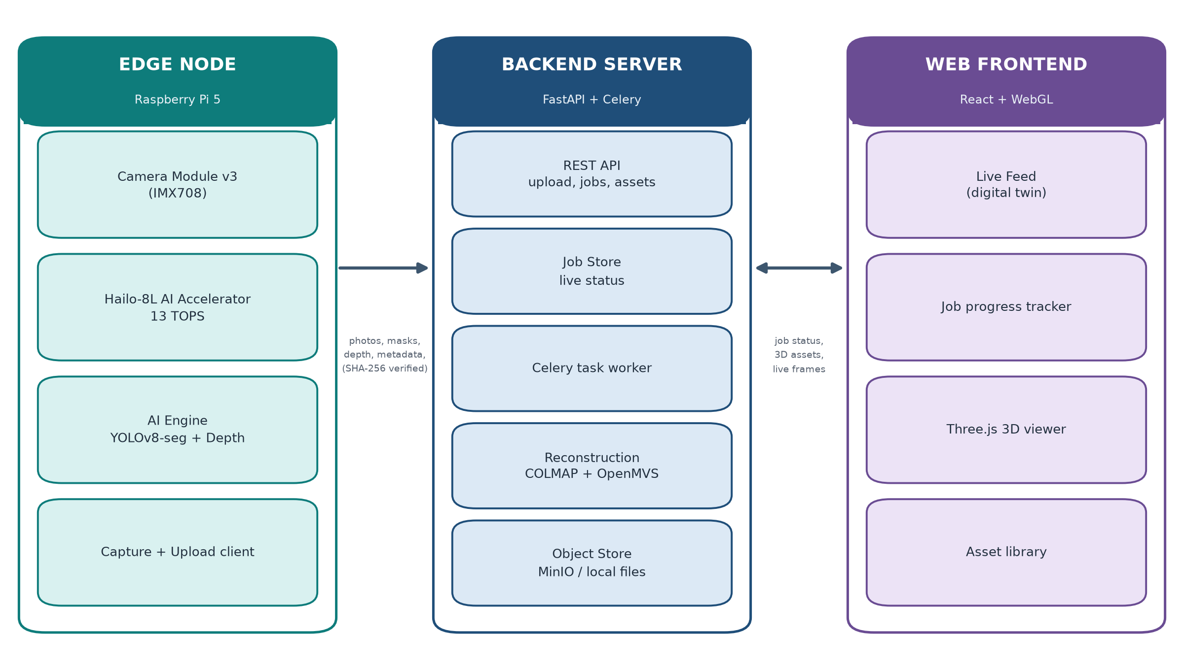
Figure 1 — The three tiers of Excavatable.
The Edge Node is the camera rig itself. A Raspberry Pi 5 with a Camera Module v3 captures the photos, while a Hailo-8L AI accelerator looks at each frame and produces a mask (which pixels are the object) and a depth estimate (how far away each part is). The node then packages everything up and uploads it.
The Backend Server receives the data and does the heavy computing. It stores the jobs, strips away the background using the AI mask, and runs photogrammetry — the science of turning overlapping photos into 3D geometry — using established tools such as COLMAP and OpenMVS. The finished model is published as a web-friendly file.
The Web Frontend is what the operator sees. It shows the live camera feed with AI labels in real time, tracks the progress of each reconstruction, and displays the final model in an interactive 3D viewer built with Three.js and WebGL.
4. From Photos to a 3D Model

Here is the journey of a single object through Excavatable. Nine stages turn a set of flat photographs into a textured, explorable 3D asset.
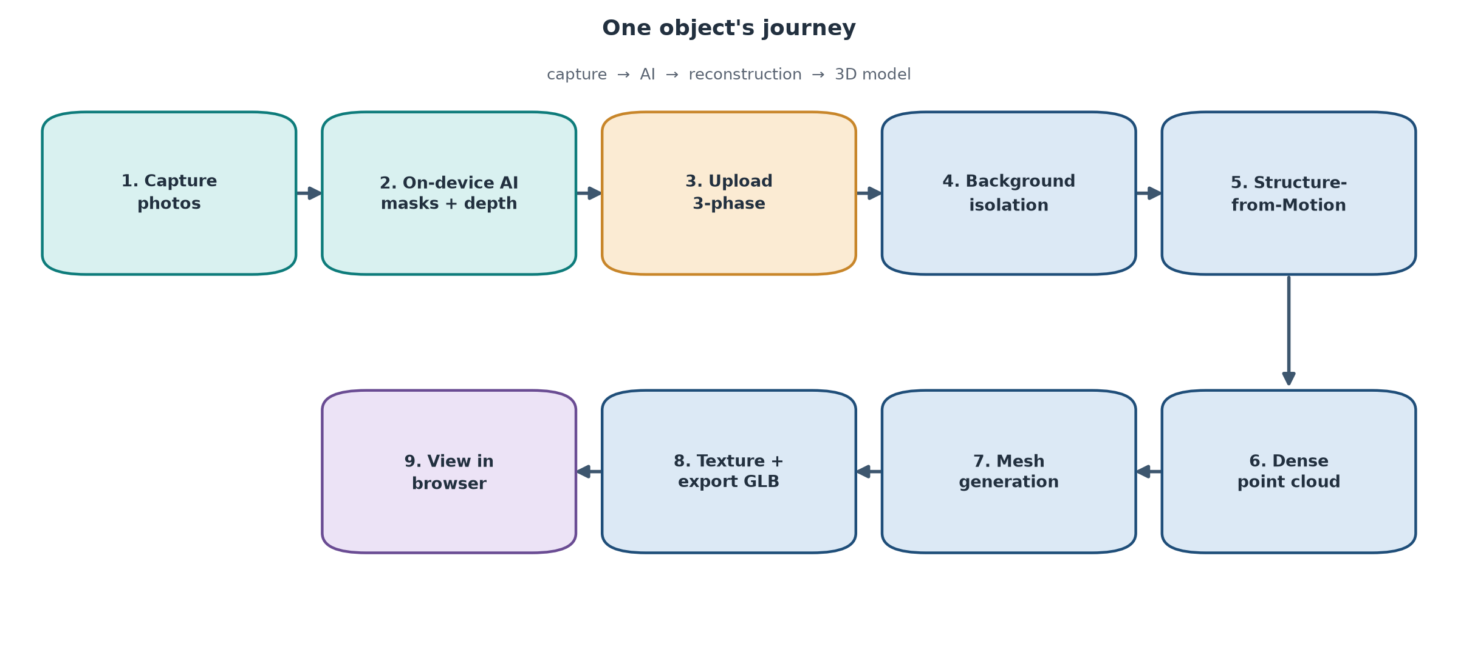
Figure 2 — The nine stages of reconstruction.
- Capture — the camera takes overlapping photos of the object from several angles.
- On-device AI — the Hailo-8L identifies the object and produces a mask plus a depth map.
- Upload — data is sent to the server in a verified three-phase transfer that checks every file.
- Background isolation — the AI mask is used to remove the background, leaving only the object.
- Structure-from-Motion — COLMAP works out where the camera was for each photo.
- Dense point cloud — millions of 3D points are generated from the photos.
- Mesh generation — OpenMVS joins the points into a smooth surface.
- Texture + export — colour from the photos is applied and the model is saved as a GLB file.
- View in browser — the model opens in the web viewer, ready to explore.
5. A Living Digital Twin

While the operator is photographing an object, Excavatable does not go quiet. It continuously streams what the camera sees, annotated with the objects the AI has found and the depth it has measured. This creates a live digital twin — a real-time reflection of the physical scene on screen.
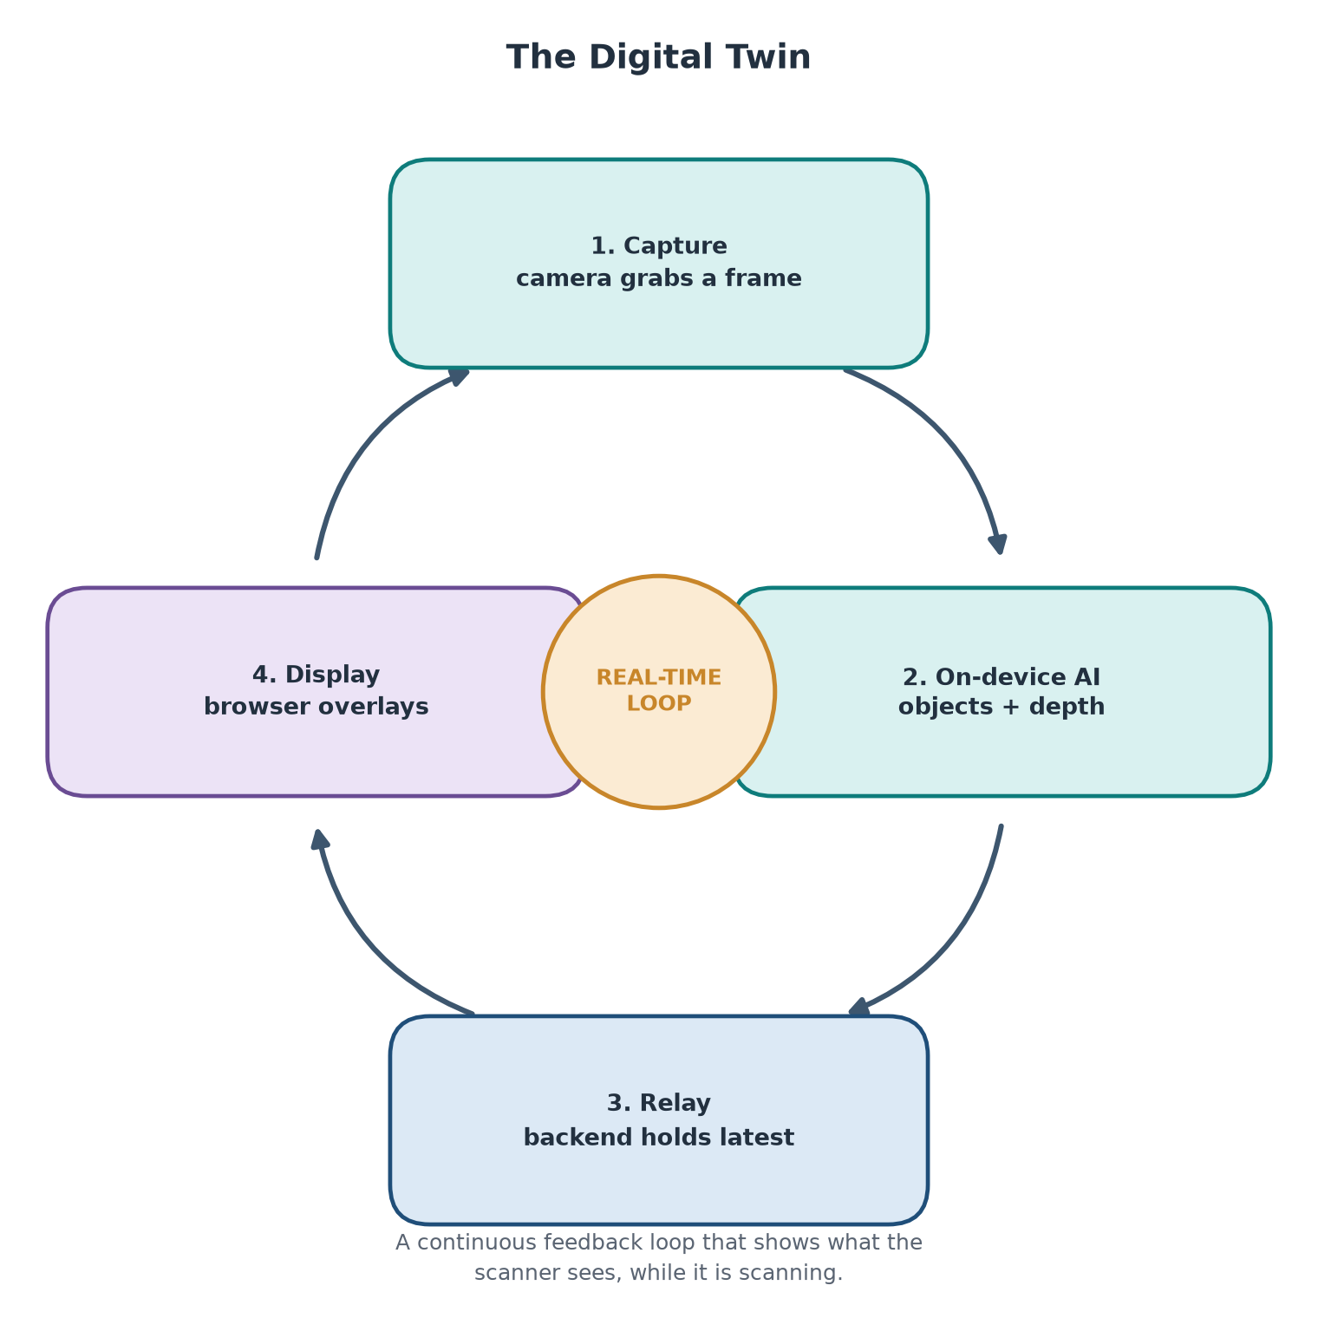
Figure 3 — The live feedback loop.
Because the AI work happens on the device itself, the feedback is quick enough to guide the operator in the moment — for example, showing that an object has been recognised, or that the camera needs to move closer. It turns scanning from a blind, guess-and-check process into an informed one.
6. What Makes It Innovative

AI on the edge — The segmentation and depth models run directly on a compact AI accelerator attached to the Raspberry Pi — not in the cloud. This keeps the system fast, private and able to work offline.
Automatic background removal — The AI mask produced on the edge means the object is isolated from its background automatically. This is normally a slow, manual task, and doing it up front makes the final model noticeably cleaner.
Built to keep working — Every specialised part — the camera, the AI chip, the object store, even the reconstruction tools — has a safe fallback. If any piece is missing, Excavatable keeps running and says so, instead of failing.
Everything ends in the browser — The final model is delivered as a standard web 3D file (GLB), so anyone with a browser can view it — no special software, no extra downloads.
7. The Technology Behind It

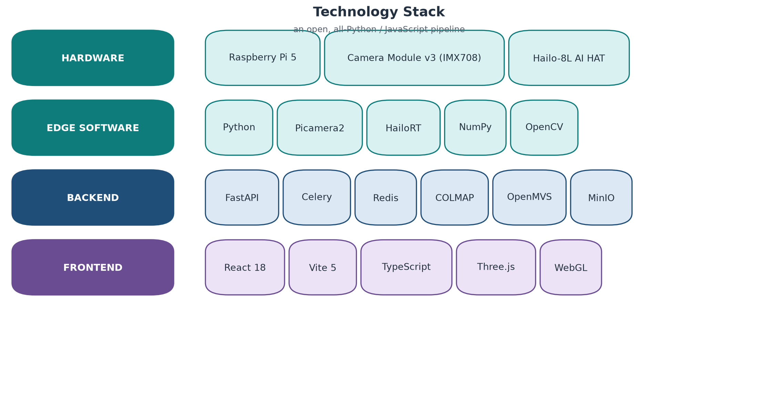
Figure 4 — Hardware and software used in Excavatable.
Excavatable is built entirely from open, well-documented tools. The edge node is written in Python and drives the camera through Picamera2 while talking to the AI chip through HailoRT. The backend is a FastAPI service with Celery and Redis for background jobs, and it uses the established photogrammetry pipeline of COLMAP and OpenMVS. The frontend is a modern React application that renders 3D with Three.js.
8. Why It Matters

Affordable, automatic 3D capture opens doors in many areas:
- Museums and archaeology — creating digital records of artefacts and exhibits.
- Education — letting students scan, study and print objects in three dimensions.
- Online retail — producing 3D previews of products without costly equipment.
- Robotics and inspection — building a digital twin of a workspace or a machine.
By proving that meaningful 3D reconstruction can run on a small, cheap device with AI at the edge, Excavatable shows that this technology does not have to belong only to well-funded laboratories.
9. Summary

Excavatable is a portable, affordable 3D scanning system that combines edge AI with classic photogrammetry to turn photographs into interactive 3D models. It is fast enough to give live feedback while scanning, robust enough to keep working when hardware is missing, and simple enough to be used from a web browser. It is our answer to a real problem — and a step toward making 3D capture available to everyone.

