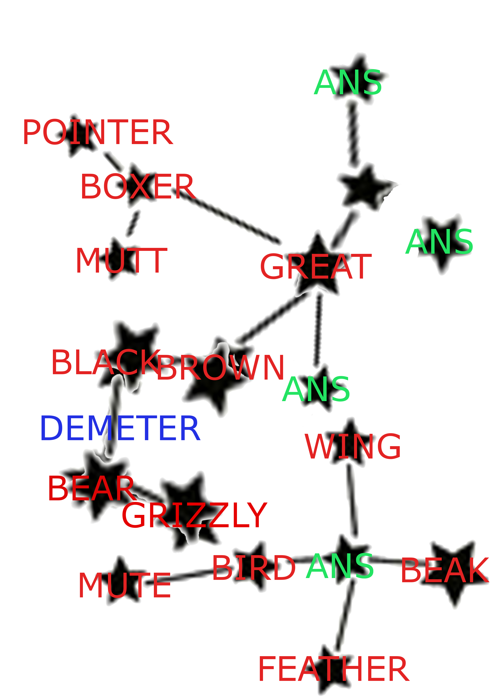
I climbed onto the roof and strained my neck to see the night sky.
I reached into my bag and brought out my laser pointer, took aim at the moon.
Below, a boxer was training. The thought of fighting, blood, the dislodging of teeth, made my canines hurt. I thought it was a great blessing that I had drifted into a far more docile profession.
I thought to shout hello, but remembered the Law of Demeter: don't talk to strangers.
My bear feet were black, soles pressing down on the cold tiles. I opened up the parcel to let the creature breathe; for a moment it was still, its long
brown and grizzly hair flowing inertially in the breeze. It open an eye and twitched a wing.

I kept mute as I raised the bird-like thing, beak aimed at the sky.

It shot up to the sky, leaving only a feather.

For the first time, I felt my dreams were aligned with the universe.

