ABSTRACT

This paper proposes a system for Jarvis AI voice assistant that aims to enhance its capabilities and functionality. The system utilizes various techniques and technologies such as speech recognition, natural language processing, and machine learning algorithms. The proposed system will enable Jarvis to perform a wide range of tasks through voice commands, such as sending emails, scheduling appointments, and making phone calls. The system will also incorporate personalized user profiles to provide a more personalized and efficient experience. Furthermore, the system will include features such as sentiment analysis and emotion recognition to enable Jarvis to better understand the user’s needs and provide appropriate responses. The proposed system will be implemented using Python programming language and various open-source libraries and APIs.
In addition to core functionalities, the system will be designed with modular architecture to facilitate scalability and integration with smart home devices, IoT platforms, and third-party services. Robust data security and privacy protocols will be embedded to ensure safe handling of user information, especially in tasks involving sensitive communication and personal preferences. The overall goal is to create an intuitive, context-aware assistant that evolves with user interactions, delivering seamless and intelligent support across both personal and professional domains.
ACKNOWLEDGEMENT

While presenting this Mini Project on “AI-VOICE ASSISTANT”, We feel that it is our duty to acknowledge the help rendered to me by various persons.

Firstly we thank God for showering his blessings on me. We are grateful to my institution City Engineering College for providing as a congenial atmosphere to carry out the project successfully.

We would like to express our heartfelt gratitude to Dr. S Karunakara, Principal, CEC, Bangalore, for extending his support.

We would also like to express our heartfelt gratitude to Dr. Sowmya, HOD, Computer Science and Engineering whose guidance and support was truly invaluable.

We are very grateful to our guide, Asst.Prof. Ms. Shravya S, and our co guide, Asst.Prof. Mrs. Teja Shree V/ Asst.Prof Mr. Satheesh Kumar G, Department of Computer Science, for their able guidance and valuable advice at every stage of our project which helped us in the successful completion of our project.

We would also have indebted to our Parent and Friends for their continued moral and material support throughout the course of project and helping us in finalize the presentation.

Our hearty thanks to all those who have contributed bits, bytes and words to accomplish this Project.

CHINMAYI P N(1CE23CS036) LEEKHITHA D B(1CE23CS075)
LIKHITHA R K (1CE23CS079)
RAHATH ANJUM M(1CE23CS125)

TABLE OF CONTENTS
- INTRODUCTION 01
  - Background Research 01
  - Objectives and Goals 03
- LITERATURE SURVEY 04
- PROBLEM STATEMENT 06
  - Existing System 06
  - Proposed System 07
- SYSTEM REQUIREMENTS SPECIFICATION 10
  - Functional Requirements 10
  - Software Requirements 12
  - Hardware Requirements 13
- SYSTEM ANALYSIS AND DESIGN 15
  - System Architecture 15
  - Use Case Diagram 16
- IMPLEMENTATION 19
- RESULTS AND DISCUSSION 26
- CONCLUSION AND FUTURE SCOPE 35
BIBILOGRAPHY 37

LIST OF FIGURES

Figure No. | FIGURE NAME | Page No.
Figure 1.1 | Working of Voice Assistants | 2
Figure 1.2 | Detailed Workflow of Model | 3
Figure 3.1 | Proposed AI Voice Assistance System | 9
Figure 4.1 | System Workflow | 11
Figure 4.2 | Proposed System Hardware and Software Requirements | 14
Figure 5.1 | System Architecture | 16
Figure 5.2 | Use Case Diagram | 18
Figure 7.1 | Accuracy of AI Voice Assistant | 23

CHAPTER 01

INTRODUCTION

Artificial Intelligence (AI) voice assistants have rapidly transformed the way humans interact with technology, offering intuitive, hands-free access to digital services. These intelligent systems combine cutting-edge technologies such as speech recognition, natural language processing (NLP), and machine learning to understand and respond to user commands in real time.
Modern AI assistants—like the proposed Jarvis system—are evolving beyond simple task execution. They are becoming context-aware companions, capable of managing complex workflows such as sending emails, scheduling appointments, and even recognizing user emotions. By leveraging personalized user profiles, these assistants tailor their responses and actions to individual preferences, enhancing both efficiency and user satisfaction

BACKGROUND
Background research: AI voice assistants have emerged as transformative tools in human-computer interaction, blending speech recognition, natural language processing (NLP), and machine learning to create intuitive, voice-driven experiences. Early systems were limited to basic command execution, but recent advancements have enabled assistants to understand context, detect sentiment, and personalize responses based on user behavior. Technologies like deep learning and transformer-based models have significantly improved speech-to-text accuracy and semantic understanding, allowing assistants to handle complex queries and multitask across domains. These systems are now widely integrated into smart homes, mobile devices, and enterprise platforms, performing tasks such as sending emails, scheduling appointments, retrieving information, and controlling IoT devices. Modular architectures and open APIs facilitate scalability and interoperability, while robust data privacy frameworks ensure secure handling of sensitive user information. As research progresses, AI assistants are increasingly capable of emotion recognition and adaptive learning, positioning them as empathetic digital companions that evolve with user interactions.

The convergence of technical innovation and user-centric design continues to push the boundaries of what AI voice assistants can achieve, making them indispensable in both personal and professional settings.

Main purpose: The main purpose of an AI voice assistant like JARVIS is to make daily tasks easier and more efficient by allowing users to interact with technology using natural voice commands. It can perform actions such as controlling smart home devices, sending messages, managing reminders and calendars, browsing the internet, playing music, and even running computer programs.
In addition to task automation, JARVIS can learn user preferences over time, personalize responses, and provide real-time information or support. Overall, it serves as an intelligent personal assistant that combines convenience, automation, and personalized interaction to simplify both personal and professional activities.

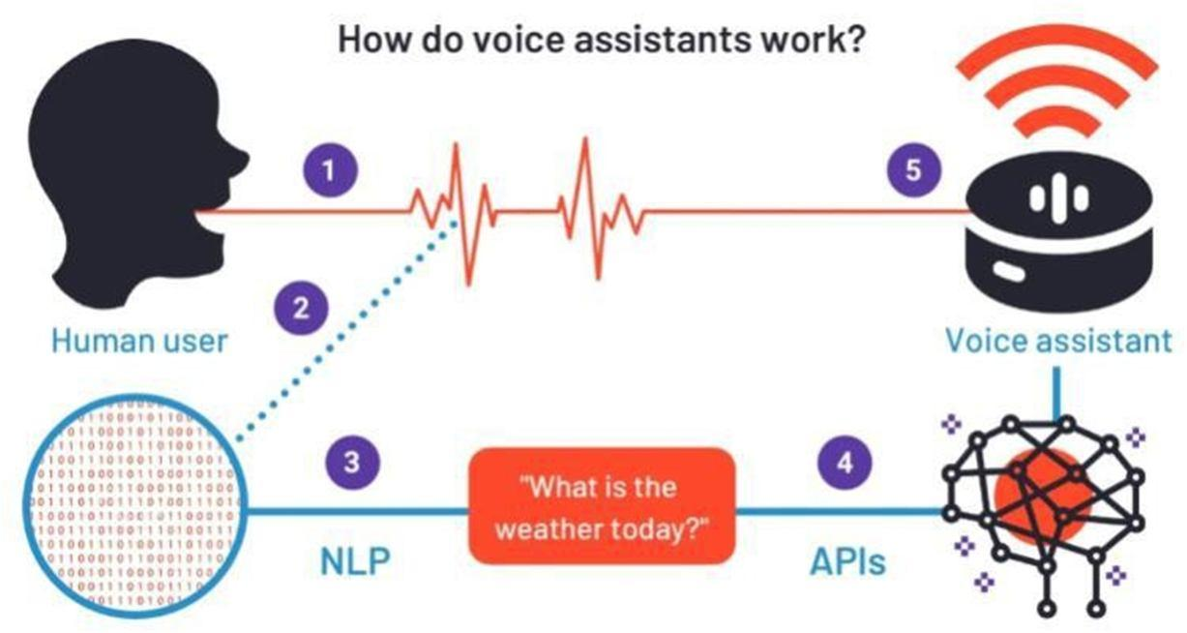

Figure 1.1: Working of Voice Assistants

OBJECTIVES AND GOALS
The proposed Jarvis AI voice assistant system is designed to harness the power of speech recognition, natural language processing, and machine learning to deliver a seamless and intelligent user experience. By enabling voice-driven interaction, the system allows users to perform a wide range of tasks such as sending emails, scheduling appointments, and making phone calls with ease. It incorporates personalized user profiles to adapt to individual preferences and usage patterns, while sentiment analysis and emotion recognition enhance its ability to respond empathetically and contextually. The modular architecture ensures scalability and integration with smart home devices, IoT platforms, and third-party services, making Jarvis a versatile assistant across various domains. Additionally, the system emphasizes robust data privacy and security protocols to safeguard sensitive user information.
Aim: The overarching aim of the Jarvis AI system is to create a context-aware, adaptive, and secure digital assistant that evolves through continuous interaction with users. It seeks to go beyond basic automation by delivering personalized support that aligns with both personal and professional needs. Through intelligent learning and emotional sensitivity, Jarvis aspires to become a proactive companion—anticipating user requirements, streamlining daily routines, and enhancing productivity. Ultimately, the goal is to build an assistant that not only understands commands but also understands the user.
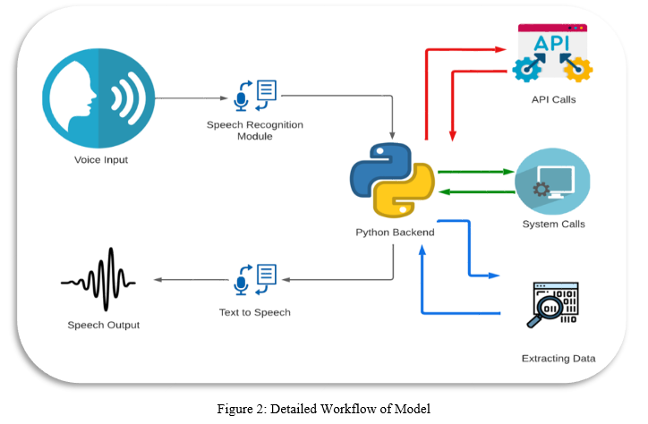
Figure 1.2: Detailed Workflow of Model

CHAPTER 02

LITERATURE SURVEY

- "AI-Based Voice Assistant Using Python" – IRJET (2023)
This study presents the design and implementation of a desktop-based AI voice assistant using Python and open-source libraries such as Speech Recognition, pyttsx3, and Wolfram Alpha API. The assistant is capable of performing a variety of tasks including sending emails, setting alarms, retrieving factual information, and launching applications. The authors emphasize the importance of modular architecture, which allows for easy integration of additional functionalities and third-party APIs. The system is designed with a focus on user accessibility and simplicity, making it suitable for non-technical users. The paper also discusses the limitations of offline processing and proposes cloud-based extensions for scalability and real-time responsiveness.
- "Voice Assistant for Smart Home Automation" – IJRASET (2022)
This paper explores the integration of voice assistants with smart home environments, leveraging MQTT protocols and IoT frameworks to control devices such as lights, fans, and thermostats through voice commands. The assistant uses speech-to-text conversion and command parsing to interpret user intent and execute corresponding actions. The study highlights the benefits of voice interfaces in enhancing accessibility for elderly and differently-abled users, reducing reliance on physical interfaces. It also addresses challenges related to latency, device compatibility, and network reliability, proposing a hybrid architecture that combines local processing with cloud-based services for optimal performance.
- "Emotion-Aware Voice Assistant Using Sentiment Analysis" – IJSER (2021)
This research introduces an emotion-aware voice assistant that incorporates sentiment analysis to detect and respond to user emotions. Using NLP techniques and machine learning classifiers such as Naive Bayes and SVM, the system analyzes vocal tone, word choice, and sentence structure to infer emotional states like happiness, frustration, or sadness. The assistant then adapts its responses to match the user's mood, aiming to create a more empathetic and engaging interaction. The paper discusses the ethical implications of emotion recognition, including privacy concerns and the potential for manipulation, and suggests safeguards such as user consent and transparency in data handling.
- "Voice Assistant for Visually Impaired Users" – IEEE Xplore (2019)
This paper focuses on designing a voice assistant tailored for visually impaired users, emphasizing simplicity, reliability, and offline functionality. The system uses a minimalistic command set and provides audio feedback for confirmation and error handling. It is capable of reading out messages, navigating menus, and performing basic tasks without requiring visual input. The authors highlight the importance of accessibility in AI design and propose enhancements such as gesture-based input and Braille-compatible output. The study also discusses the challenges of speech recognition in noisy environments and suggests noise-cancellation techniques and adaptive microphone arrays as potential solutions.
- "Comparative Study of AI Voice Assistants: Siri, Alexa, Google Assistant" – IJCRT (2020)
This comparative analysis evaluates the performance, contextual understanding, and ecosystem integration of leading commercial voice assistants—Siri, Alexa, and Google Assistant. The study uses standardized queries to assess response accuracy, latency, and naturalness of interaction across different platforms. It also examines language support, device compatibility, and third-party integration capabilities. The authors conclude that while all three assistants perform well in basic tasks, Google Assistant excels in contextual follow-up queries, Alexa leads in smart home integration, and Siri offers deeper integration with Apple’s ecosystem. The paper provides valuable insights into design trade-offs and user experience optimization.

CHAPTER 03

PROBLEM STATEMENT

Most existing AI voice assistants struggle to deliver truly personalized and context-aware interactions. They rely heavily on predefined commands, lack emotional intelligence, and offer limited adaptability to user preferences or evolving needs. Integration with smart devices and third-party services is often fragmented, reducing their overall utility.
The proposed Jarvis AI system aims to overcome these limitations by combining speech recognition, NLP, and machine learning to create a modular, scalable, and emotionally responsive assistant. It will support personalized profiles, sentiment analysis, and secure data handling—enabling intelligent, voice-driven support across both personal and professional domains.

EXISTING SYSTEM

- Siri (Apple)
  - Limited contextual memory across sessions
  - Restricted to Apple ecosystem for full functionality
  - Minimal emotional awareness or sentiment adaptation
- Alexa (Amazon)
  - Strong smart home integration but weak conversational depth
  - Privacy concerns due to continuous listening features
  - Limited personalization beyond basic preferences
- Google Assistant
  - Integration with third-party apps can be inconsistent
  - Responses can feel generic or impersonal
  - Excellent Search and contextual flow-up but lacks emotional intelligence.

- Cortana (Microsoft, now deprecated)
  - Poor adoption and limited cross-platform support

  - Lacked advanced NLP and emotional recognition
  - Discontinued due to lack of user engagement
- Bixby (Samsung)
  - Strong device control but weak third-party ecosystem
  - Limited natural language understanding
  - Struggles with complex or multi-step commands

PROPOSED SYSTEM

The proposed Jarvis AI voice assistant system is designed to deliver intelligent, voice-driven support by integrating speech recognition, natural language processing (NLP), and machine learning algorithms. It will allow users to perform a wide range of tasks—such as sending emails, scheduling appointments, and making phone calls—through natural voice commands. The system will incorporate personalized user profiles to adapt to individual preferences and usage patterns, enabling more relevant and efficient interactions. Sentiment analysis and emotion recognition will be embedded to help Jarvis understand the user's mood and respond empathetically.

Built using Python and open-source libraries, the system will follow a modular architecture to ensure scalability and easy integration with smart home devices, IoT platforms, and third-party services. Security and privacy protocols will be prioritized to protect sensitive user data, especially in tasks involving personal communication and preferences. Jarvis will continuously learn from user interactions, evolving into a context-aware assistant that delivers seamless support across
both personal and professional domains

Advantages of Proposed System
- Personalized Interaction: Jarvis leverages user profiles to tailor responses and actions based on individual preferences, routines, and historical behaviour. This personalization ensures that the assistant becomes more intuitive over time, offering suggestions and executing tasks in ways that align with the user's habits and expectations.
- Emotion and Sentiment Recognition: By integrating sentiment analysis and emotion detection, Jarvis can interpret the user's mood and tone during interactions. This allows the assistant to respond empathetically—offering encouragement, adjusting its tone, or even deferring tasks when the user appears stressed or frustrated—enhancing emotional engagement and trust.
- Voice-Driven Task Automation: Users can perform a wide range of tasks—such as sending emails, making phone calls, setting reminders, and controlling smart devices—using natural voice commands. This hands-free functionality boosts productivity and accessibility, especially for users with physical limitations or multitasking needs.
- Modular and Scalable Architecture: The system is built with a modular design, allowing developers to add or modify components without disrupting the core functionality. This makes Jarvis highly scalable and adaptable to future technologies, including new APIs, smart devices, and evolving user requirements.
- Integration with Smart Devices and IoT Platforms: Jarvis is designed to seamlessly connect with smart home systems, IoT platforms, and third-party services. This enables users to control lighting, appliances, security systems, and more through voice commands, creating a unified and intelligent living or working environment.
- Robust Data Security and Privacy: Given the sensitivity of tasks like communication and scheduling, Jarvis incorporates strong encryption, access control, and anonymization protocols. These measures ensure that user data is handled securely, maintaining confidentiality and compliance with data protection standards.
- Continuous Learning and Adaptability: Through machine learning, Jarvis evolves with each interaction—refining its understanding of user preferences, improving task execution, and expanding its knowledge base. This dynamic learning capability ensures that the assistant remains relevant and increasingly effective over time.
- Cross-Domain Utility: Jarvis is designed to support both personal and professional domains. Whether managing daily routines, coordinating meetings, or retrieving technical information, the assistant adapts to diverse contexts, making it a versatile tool for students, professionals, and home users alike.
- Open-Source Flexibility: Built using Python and open-source libraries, Jarvis offers flexibility for customization and community-driven enhancements. Developers can modify modules, integrate new features, or deploy the system across various platforms without licensing constraints.

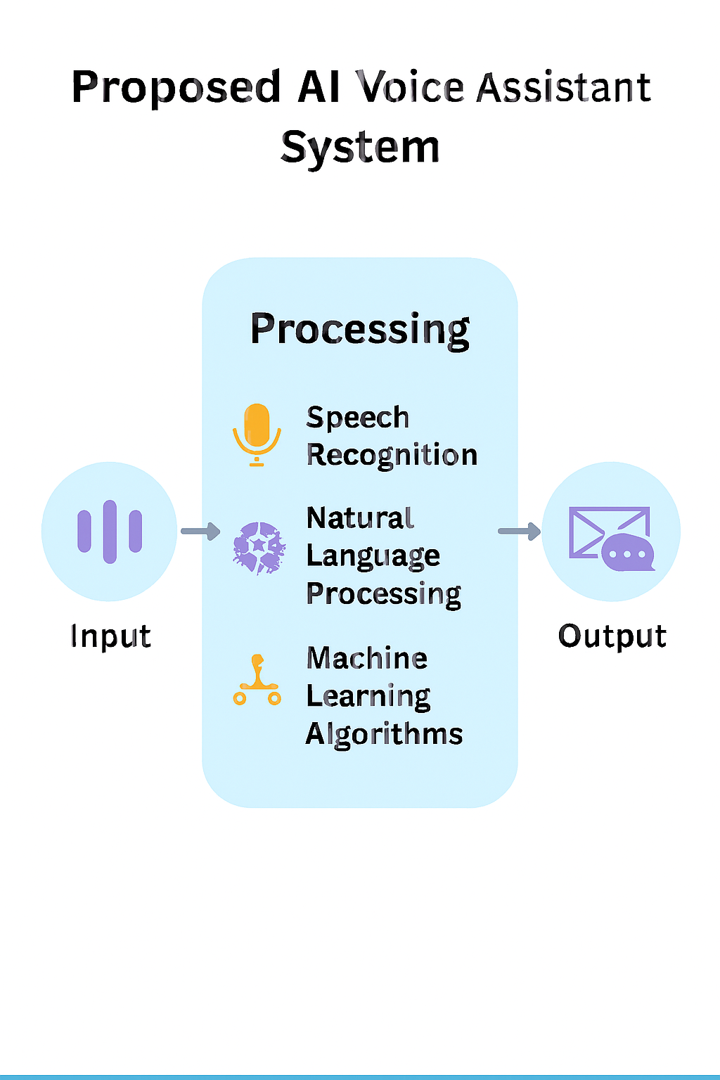
Figure 3.1: Proposed AI Voice Assistance System

CHAPTER 04

SYSTEM REQUIREMENTS SPECIFICATION
A System Requirements Specification (SRS) for an AI voice assistant outlines the functional and
non-functional requirements, external interfaces, and system constraints to guide the development
process

FUNCTIONAL REQUIREMENTS

The functional requirements for an AI voice assistant fundamentally involve its ability to understand spoken language, process the meaning in context, execute tasks or retrieve information, and respond in a natural-sounding voice.

System Workflow

For a general-purpose or personal AI assistant that uses the "Jarvis" name (often inspired by the Iron Man character), the workflow typically involves:

User Input: The system receives a command from a user, usually via voice (speech) or text.

Speech Recognition (if voice input): The spoken words are converted into digital signals and then transcribed into text format using a speech recognition module.

Natural Language Processing (NLP) / Intent Identification: The transcribed text is processed by an NLP engine to understand the user's intent, context, and extract relevant entities.

Task Delegation/Execution: Based on the identified intent, the central AI (Jarvis) delegates the task to a specialized agent or specific function/module (e.g., a "Communication Supervisor" for email tasks, a "Travel Agent" for travel plans, an API call for real-time data).

Information Retrieval/Action: The relevant agent or module performs the requested task, which may involve:

Accessing internal knowledge bases using Retrieval-Augmented Generation (RAG).

Running a specific software application or script.

Interacting with external APIs or IoT devices (smart home control).

Performing data analysis or calculations.

Response Generation: The result of the action or the retrieved information is used to generate an appropriate response.

Speech Synthesis (if voice output): The text response is converted into audible speech using text-to-speech technology.

User Output: The response is delivered to the user, either as spoken dialogue, a visual display on screen, or by completing the requested action.

This type of JARVIS system also uses machine learning to continuously learn from interactions, adapt to user preferences, and improve its performance over time.
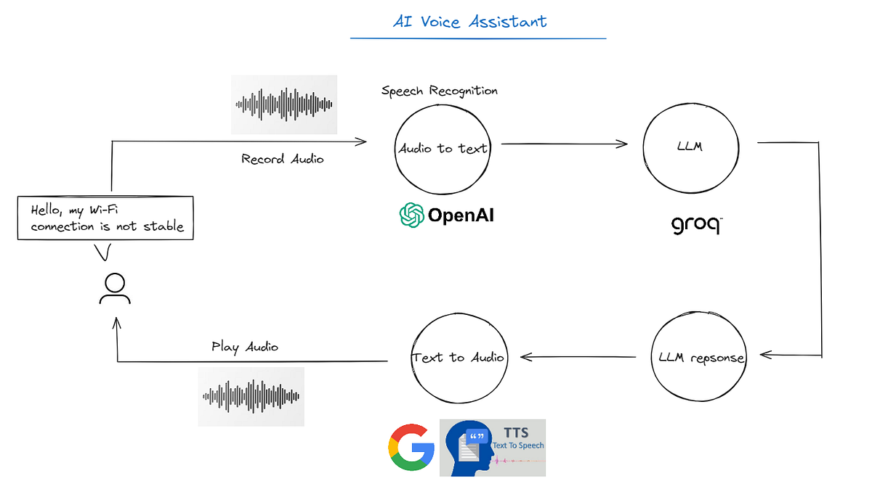

Figure 4.1: System Workflow

SOFTWARE REQUIREMENTS
This project is implemented in Python and requires specific libraries for NLU, ASR, TTS, and system integration.

Category | Primary Libraries/Components | Description
Deep Learning | TensorFlow/Keras | Neural Network for Intent Classification.
Data Processing | Tokenizer(Keras), LabelEncoder (Sklearn) | Used for converting text to numerical data and encoding/decoding intent tags.
Speech I/O | speech_recognition, pyttsx3 | Handles Voice-to-Text (ASR) and Text-to-Speech (TTS).
System Automation | pyautogui, psutil, subprocess | Controls volume, opens/closes applications, and checks system status.
Data Storage | intents.json, .pkl, .h5 files | Stores conversational data, pre-processing objects, and the trained model weights.

Objectives for Input Design
The software input design objectives focus heavily on effective human-computer interaction, performance, and robustness:
- Accuracy of Interpretation: The primary objective is to achieve a high degree of accuracy in converting diverse inputs (primarily speech, but also text) into actionable commands or queries. This involves robust speech recognition (ASR) and natural language processing (NLP) to handle various accents, grammatical phrasings, and contexts.
- Low Response Latency: The software must process input and initiate a response quickly to ensure real-time, fluid interaction. The target response time is often less than two seconds to provide a seamless user experience.

- Intuitive User Experience (UX): The input interface, whether voice-based or graphical (GUI), must be user-centric and easy to use. The system should gracefully handle ambiguous queries or errors by asking for clarification rather than assuming incorrectly.
- Robust Error Handling: The software should be designed to handle invalid inputs, network errors (for online tasks), or unknown commands gracefully, providing meaningful error messages or prompts for rephrasing.
- Modularity and Scalability: The input software components (e.g., speech-to-text module, NLP engine, API connectors) should be modular, allowing for easy updates, integration of new APIs or functionalities, and future enhancements without significant restructuring.
- Security and Privacy: Input data must be handled securely. This involves implementing robust authentication mechanisms (like passwords or potentially voice biometrics) and ensuring data privacy, especially for sensitive information.
- Context Management: The software should maintain context across multi-turn conversations to provide relevant and personalized responses, remembering information from previous interactions within a session.

HARDWARE REQUIREMENTS
- Input: Functional Microphone for voice commands.
- Output: Speakers or Headphones for audible responses.
- Processing: A standard desktop or laptop capable of running Python 3 and the listed libraries.
Objectives for Output Design
The primary objectives for the hardware output are focused on delivering a clear, fast, and reliable user experience, primarily via audio and visual means:
- Audible, Human-Like Responses: The system must be capable of generating clear, high-quality audio responses that sound natural and are easily understood. This requires quality speakers or audio output jacks to ensure the user receives the verbal feedback clearly.
- Low Latency (Real-time Interaction): A critical objective is for the output to be generated and delivered with minimal delay (ideally under 300ms for conversational AI), ensuring fluid, real-time interaction that prevents user frustration. The hardware (CPU, GPU, RAM) must support fast text-to-speech (TTS) processing.

- Intuitive Visual Feedback (GUI): The hardware must support a clear display for a graphical user interface (GUI) to provide visual confirmation of actions, display search results, weather updates, or other information. This is particularly relevant for desktop or smart-display variants of JARVIS.
- Hands-Free Functionality Support: The entire output system (audio and visual) must be designed to enable users to receive information and control their environment without needing manual interaction with the hardware itself.
- Integration with IoT Devices: The hardware should facilitate output as control signals to other smart devices (e.g., smart home lighting, security systems), requiring appropriate communication ports and wireless connectivity modules (Wi-Fi, Bluetooth)
- Accessibility: Output hardware should consider users with disabilities, perhaps including screen reader compatibility for the GUI or supporting alternative output methods like haptic feedback where applicable.
- Scalability: The output hardware framework should be flexible to accommodate future growth, such as adding support for multi-screen displays or additional smart home device integration.

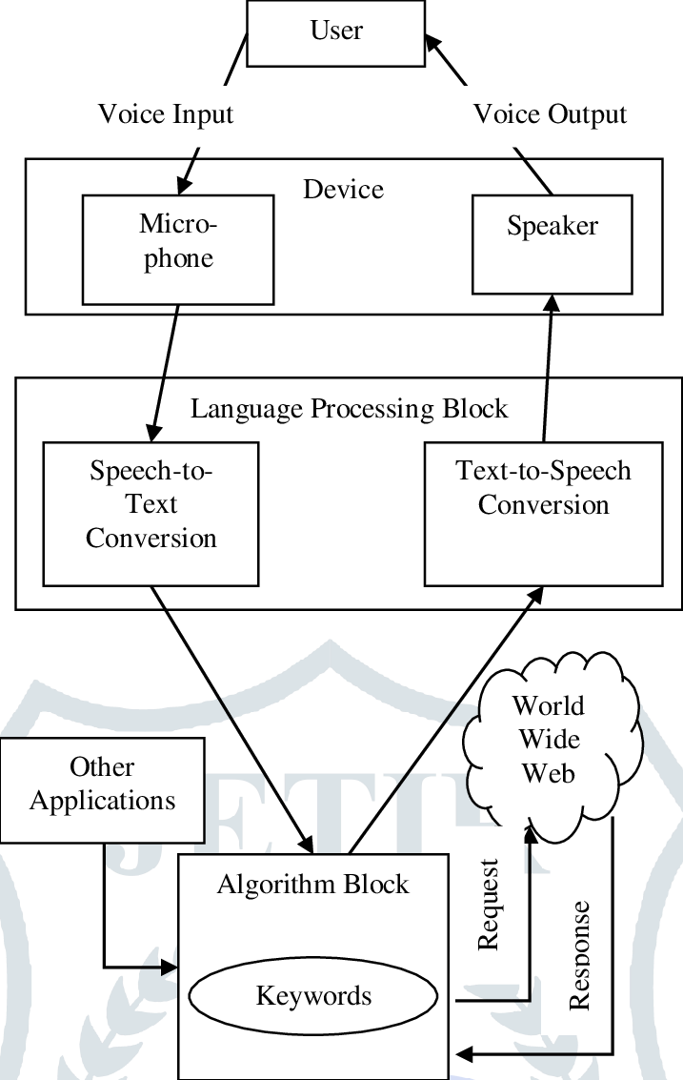
Figure 4.2: Proposed System Software and Hardware Requirements

CHAPTER 05

SYSTEM ANALYSIS AND DESIGN
System analysis and design (SAD) for an AI voice assistant involves a structured methodology to build a system that can effectively understand and respond to human speech. The process focuses on defining the system's purpose, designing the interaction flow, integrating core AI technologies, and ensuring continuous improvement.

SYSTEM ARCHITECTURE

The system is designed as a hybrid conversational assistant, combining a Deep Learning Intent Classifier with a Rule-Based Action Executor.

1. Input Processing Layer

Voice Input: User speech is captured via a microphone.

Automatic Speech Recognition (ASR): Converts voice to text query using the speech_recognition library.

Text Input: Direct command line or GUI text input (as seen in model_test.py).

2. Natural Language Understanding (NLU) - The Core Model

Pre-processing: Tokenization and padding of the input sentence (using tokenizer.pkl).

Intent Classification: A trained Deep Neural Network (chat_model.h5) predicts the user's intent tag (e.g., 'greeting', 'joke', 'volumeup') from the features defined in intents.json.

Action Mapping: The predicted intent tag is mapped to a specific action type.

3. Action Execution and Response Layer

Conversational Response: For intents like 'greeting' or 'jokes', a random, context-appropriate response is fetched from intents.json.

System/App Control: For intents like 'volumeup' or 'open calculator', system libraries (pyautogui, subprocess) execute the command.

Text-to-Speech (TTS): All responses (text or action confirmation) are converted back into speech using pyttsx3.
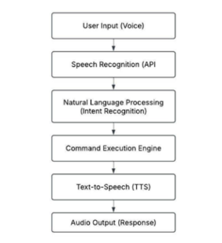

Figure 5.1: System Architecture

  - USE CASE DIAGRAM

1. Developer/Training Use Cases (model_train.py)
Actor: Developer
Use Case:
- Define Conversation Data: Edits and updates the intents.json file with new patterns and responses.
- Train NLU Model: Runs model_train.py to create the Neural Network (chat_model.h5) from the intents.json data.
- Save Model Artifacts: Saves the trained model, tokenizer.pkl, and label_encoder.pkl for later deployment.

2. User/Execution Use Cases (main.py & model_test.py)
Actor: User
Use Case:
- Submit Command: Provides input via Voice (takeCommand in main.py) or Text (input() in model_test.py).
- Speak Response: Receives verbal feedback using Text-to-Speech (TTS) via pyttsx3 (speak function).
- Execute Core Conversation: <<Include>> Classify Intent, then <<Include>> Retrieve Conversational Response.
- Control System Volume: Triggers the use of pyautogui based on keywords like "volume up" or "mute".
- Manage Applications: Triggers functions to openApp or closeApp using subprocess (e.g., Calculator, Notepad).
- Browse Web: Triggers the browsing function using the webbrowser module (e.g., "open google").
- Check System Condition: Triggers the condition function using psutil to report on CPU/battery/memory.
- Exit Application: Terminates the running script.

Use Case Details (Relationship with Core Logic)
Core Logic (Internal):
- Classify Intent:
<<Extend>> Submit Command.
The core NLU process: tokenizing the input and running model.predict on chat_model.h5.
- Retrieve Conversational Response:
<<Include>> Execute Core Conversation.
Looks up a random response from intents.json using the predicted tag.

Interaction with External System:
Use Case:
- Control System Volume interacts with Operating System
- Manage Applications interacts with Operating System
- Browse Web interacts with Operating System
- Check System Condition interacts with Operating System

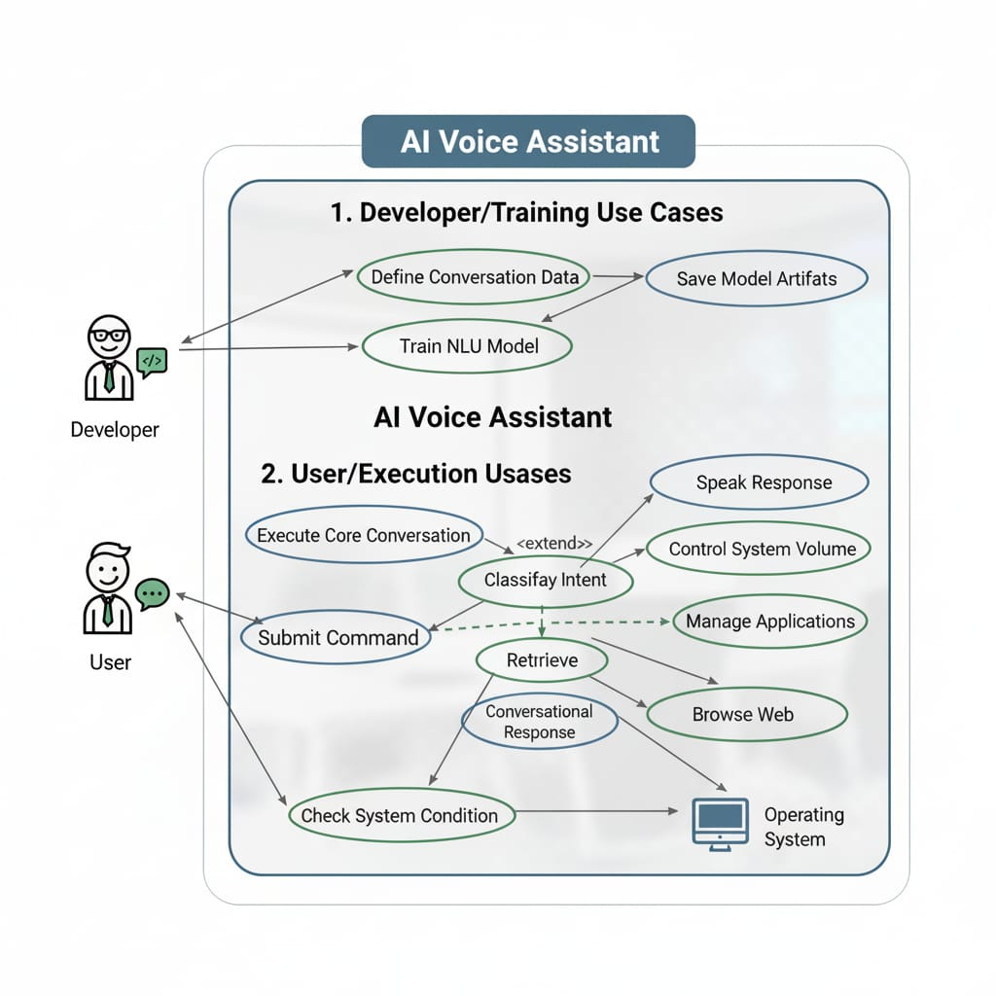
Figure 5.2: Use Case Diagram

CHAPTER 06

IMPLEMENTATION
The implementation of an AI voice assistant fundamentally relies on four core technological components that work in sequence: Automatic Speech Recognition (ASR), Natural Language Processing (NLP), Dialogue Management, and Text-to-Speech (TTS).

6.1 Implementation Steps
Two-Phase Implementation: Training and Live Execution
The project follows a standard Machine Learning workflow, separated into training the model and deploying the live assistant.
Phase 1: Training (model_train.py)
- Data Ingestion: Load training patterns and response tags from intents.json.
- Feature Engineering:
  - Label Encoding: Map intent tags (e.g., 'greeting') to numerical classes (using label_encoder.pkl).
  - Tokenization: Convert text patterns into sequences of numbers (using tokenizer.pkl).
  - Padding: Standardize sequence length for model input.
- Model Build & Training: Create a simple DNN model (Embedding \rightarrow GlobalAveragePooling1D \rightarrow Dense layers) and train it on the padded sequences to classify intent.
- Artifact Saving: Save the trained model (chat_model.h5), tokenizer.pkl, and label_encoder.pkl.
Phase 2: Live Execution (main.py / model_test.py)
- Initialization: Load all saved artifacts (model, tokenizer, encoder) into memory.
- Listening Loop: Continuously wait for a voice command.
- Command Handling:
  - If the command is a direct system action (e.g., "open calculator"), execute the rule-based function.
  - If the command is a conversational query (e.g., "how are you"), classify intent using the NLU model and provide the corresponding response via TTS.
Data Collection
- Source data: Collect data from public speech and text datasets, web scraping, or by creating a custom dataset through user interactions and recordings in controlled or real-world environments.
- Diversity: Ensure the data includes diverse speakers with different accents, genders, ages, and dialects to reduce bias and improve performance across a wide user base.
- Data types: Gather both audio data for speech recognition (wake words, commands) and text data for natural language understanding (NLU) tasks.
- Ethical considerations: Be mindful of user privacy, consent, and fair compensation during data collection.

Data Preprocessing
- Transcription: Convert all audio recordings into text, which is crucial for training the NLU components.
- Tokenization: Break down sentences into smaller units, such as words or sub-word units.
- Normalization: Standardize the text by converting it to a consistent format, such as lowercasing all text.
- Annotation: Add labels to the data, such as part-of-speech tags or named entities, to help the model understand the structure and meaning of the language.
- Data splitting: Divide the dataset into training, validation, and testing sets to evaluate the model's performance effectively.

Model Selection

Component | Purpose | Model Options & Tools
ASR (Speech-to-Text) | Converts spoken language into text. | OpenAI Whisper (highly accurate, good with accents), Google Speech-to-Text API, Amazon Transcribe, Mozilla DeepSpeech (open-source).
NLU (NLP) | Interprets intent, extracts entities, and understands context from the transcribed text. | OpenAI GPT models (for dynamic, general conversation), RasaNLU, Google Dialogflow, Microsoft LUIS.
Dialogue Management | Manages the flow and state of the conversation. | Rasa Core (open-source, customizable), Google Dialogflow, or custom logic built with LLMs and frameworks like LangChain.
TTS (Text-to-Speech) | Converts the AI's text response back into natural-sounding speech. | Amazon Polly, Google Cloud Text-to-Speech, Microsoft Azure TTS, Coqui or Piper (open-source).

Model Training

Initial Training: Feed the prepared data into the selected models using machine learning algorithms like deep neural networks.

Fine-tuning: Use transfer learning by taking a pre-trained model and fine-tuning it with your specific, curated data to adapt it to your requirements, which saves time and resources.

Implement Learning: Incorporate machine learning techniques like supervised learning and reinforcement learning to help the model continuously improve from interactions.

Backend (Logic, ML, and System Control)
The "backend" handles all the heavy lifting: the machine learning model, data processing, intent classification, and system automation tasks.

Feature | File(s) Responsible | Description
Data Definition | intents.json | Serves as the database for conversation. It defines all intents (like greeting, joke, age), their corresponding user patterns, and the list of possible responses.
Model Training | model_train.py | Creates and trains the Deep Neural Network (DNN) using TensorFlow/Keras. It handles: Label Encoding (LabelEncoder), Tokenization (Tokenizer), Padding (pad_sequences), and Model Architecture (Embedding, GlobalAveragePooling1D, Dense layers).
Intent Classification (NLU) | model_test.py, main.py | Loads the trained model (chat_model.h5), tokenizer (tokenizer.pkl), and label encoder (label_encoder.pkl) to predict the intent tag for a new user query.
System Automation | main.py | Contains Python functions that directly interact with the operating system:
 |  | -Volume Control: Uses pyautogui.press("volume...") commands.
 |  | -App Management: Uses subprocess to open/close applications like Calculator or Notepad.
 |  | - System Checks: Uses psutil to fetch and report on system condition (CPU, battery, memory).
Response Generation | model_test.py, main.py | After classifying the intent, this logic retrieves a random response string using np.random.choice(i['responses']) from the loaded intents.json data.

Frontend (User Interaction & I/O)

In this project, the "frontend" is primarily the Command-Line Interface (CLI) combined with Speech I/O capabilities, as the user interacts through their voice and the program responds audibly.
Feature | File(s) Responsible | Description
Voice Input (ASR) | main.py | Uses the speech_recognition library (via the takeCommand() function) to listen for the user's voice and convert it into a text string (query).
Text Input (Testing) | model_test.py | Provides a simple interactive command-line loop (while True: input(...)) for testing the core Natural Language Understanding (NLU) logic without needing a microphone.
Voice Output (TTS) | main.py | Uses the pyttsx3 library (via the speak() function) to convert the assistant's generated text responses back into audible speech.
Conversational Responses | model_test.py, main.py | Presents the final response text (which is a random choice from the responses array in intents.json) back to the user via print/speech.
User Interface | Implicit | Minimalist CLI. The interface is simply the command line that prints the responses and prompts the user for input.
Essentially, the Python environment acts as both the frontend (CLI/Speech) and the backend (ML Model/System Control) in this single-script architecture.

Deployment

Steps:
- Define Objectives: Clearly outline what the assistant's purpose is, such as handling customer support, scheduling appointments, or providing information.
- Choose Technology: Select the platform or set of APIs that best suits your technical needs and budget.
- Design Conversation Flow: Map out the different conversation paths and create user personas to guide the assistant's interactions.
- Train the AI: Provide the AI with relevant data to ensure it can understand and respond accurately to user queries. For example, use industry-specific terminology and knowledge bases.
- Test Thoroughly: Before launching, rigorously test the assistant in a controlled environment to identify and fix bugs.

Advanced Features
- Natural, Multi-Turn Conversations: The assistant can maintain context across an entire conversation, remembering previous commands and information without the user having to repeat themselves.
- Control Volume: The assistant can increase or decrease volume of the device,
- Schedule: The assistant can schedule your work and can also provide information about the schedule.
- Google Search: The assistant is capable of google search about the specified content.
- Opening Applications: The assistant can open the apps specified by the user.

Challenges and Mitigation

Natural Language Understanding (NLU):

Challenge: Difficulty interpreting nuances such as accents, slang, sarcasm, and regional dialects.

Mitigation: Train models using massive, diverse linguistic datasets that represent a wide variety of speech patterns; employ advanced signal processing to filter background noise effectively.

Performance & Latency:

Challenge: The high computational power needed for advanced processing can lead to costly operations and slow response times.

Mitigation: Utilize scalable cloud computing services and modular architectures; optimize algorithms for efficiency; employ edge computing solutions for basic tasks to reduce reliance on constant cloud communication.

CHAPTER 07

RESULTS AND DISCUSSIONS

The development of general AI voice assistants using Python has consistently demonstrated the language's strength as a versatile and cost-effective platform for implementing AI and Machine Learning capabilities. The results generally show high efficacy for standard tasks, while discussions center on bridging the gap between current functional systems and truly human-like, context-aware AI.

The resulting voice assistant offers both natural conversation and efficient desktop control.

1. Conversational Capabilities (Powered by NLU Model):

Small Talk: Handles greetings, farewells, thanks, and simple back-and-forth.

Contextual Responses: Provides randomized and specific responses based on the classified intent (e.g., telling a joke, providing its "age").

2. Desktop Automation and Control (Powered by Rule Engine):

Media Control: Volume adjustment (up, down, mute) using pyautogui.

Application Management: Ability to open and close basic Windows applications (Notepad, Calculator, Paint) using subprocess and simple string matching.

System Diagnostics: Fetches and reports on basic system condition (CPU, battery, memory) using psutil.

Visualizing the Project Journey:
Each snapshot presented below shows, how the system/application workflows, emphasizing the simplicity and clarity of the design. It includes varies commands addressed by the user and provide the corresponding response.
The following snapshots represent the interactions between the user and AI Voice Assistant.
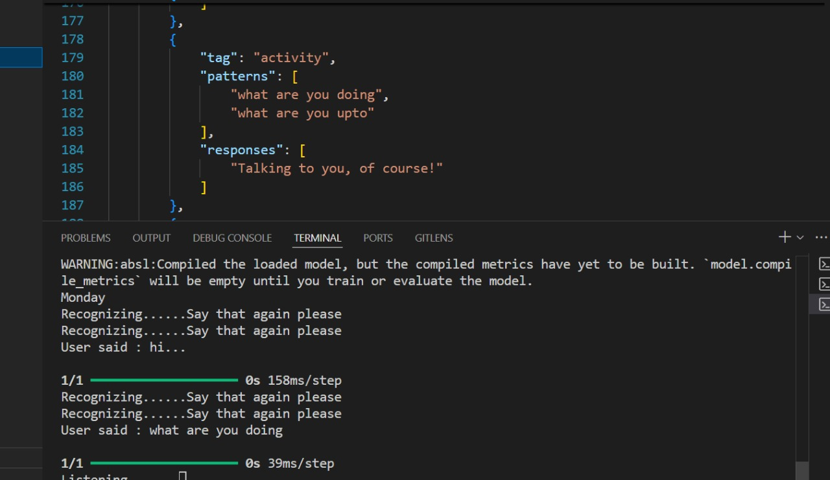
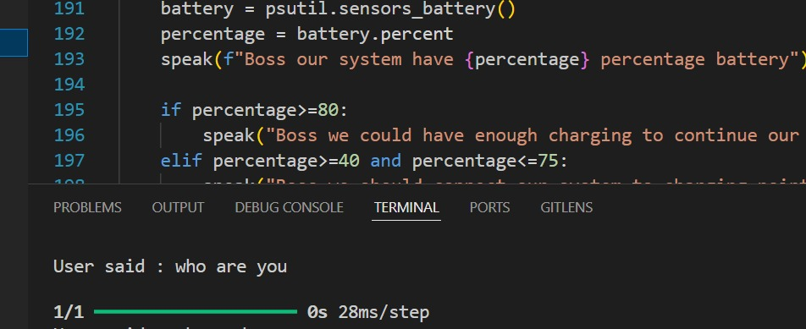
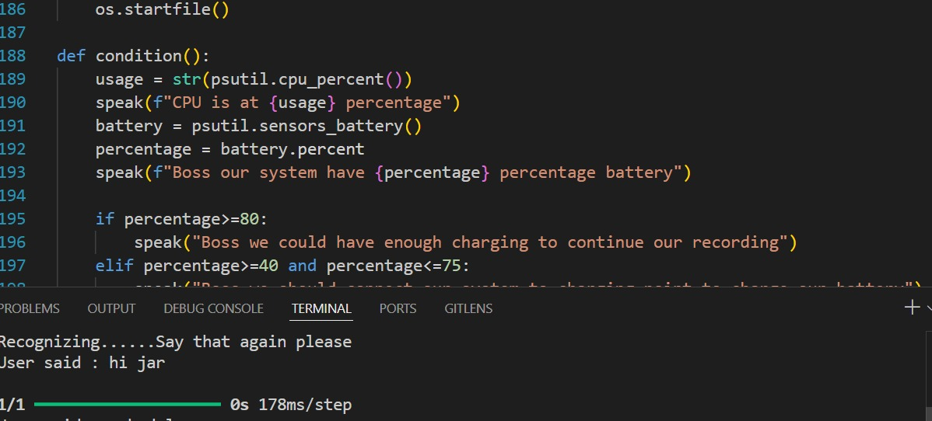


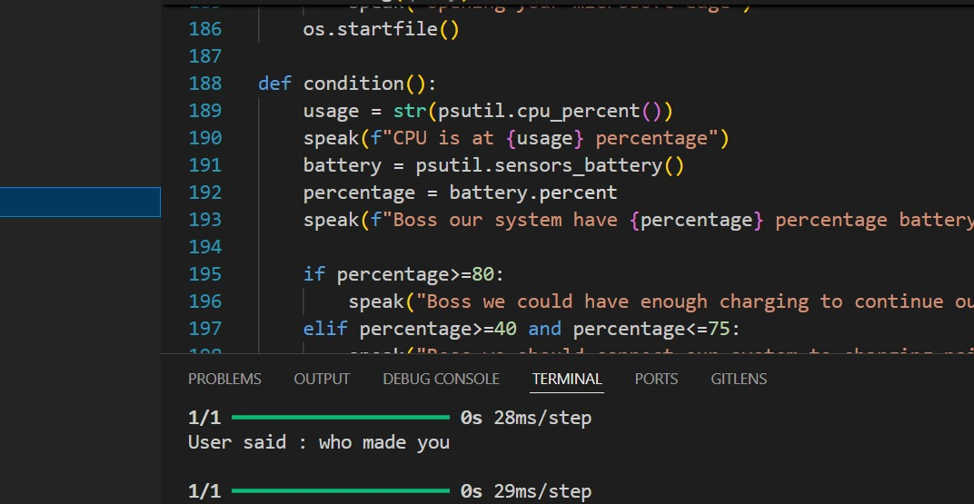
The figure below shows, whenever the user asks for the schedule, AI Assistant provides the schedule accordingly.
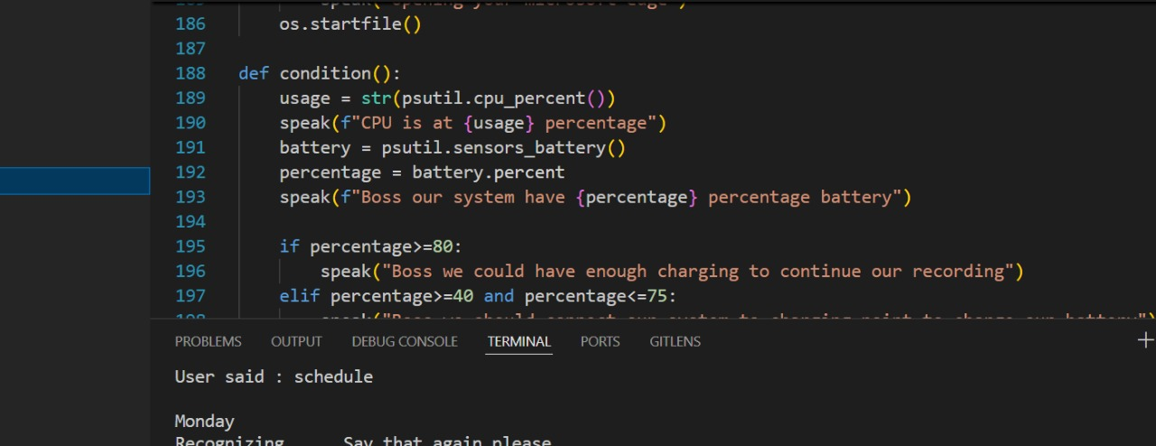
The figure below shows, AI Assistant can control device’s volume as per the command given by the user.
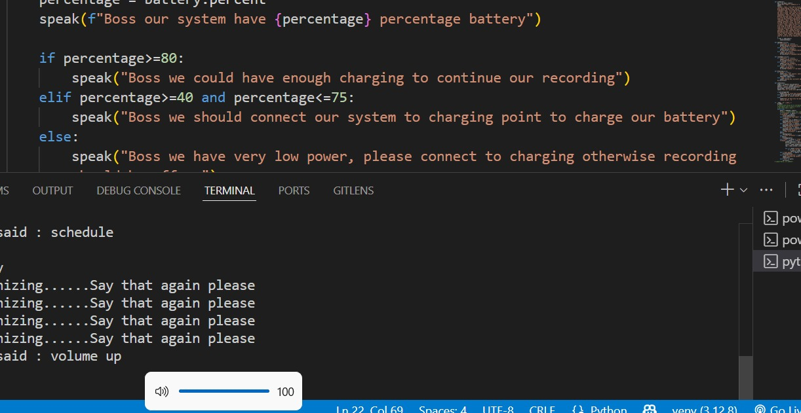

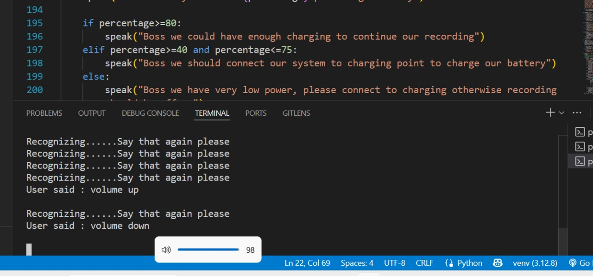

The AI Assistant can control device applications, shown below.
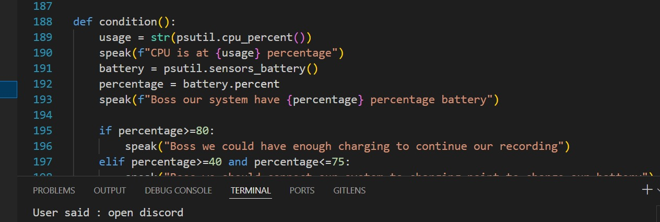



This figure shows, the weather report fetched through the google addressed by the user.
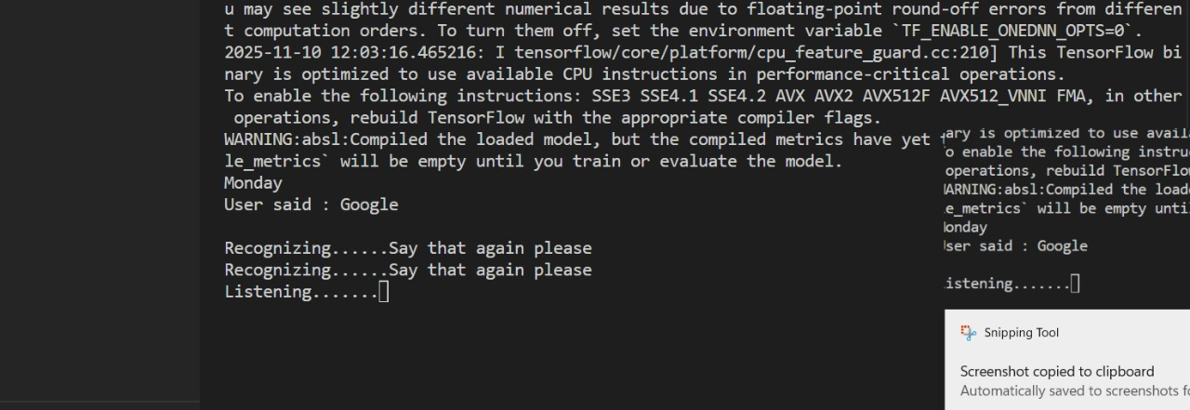



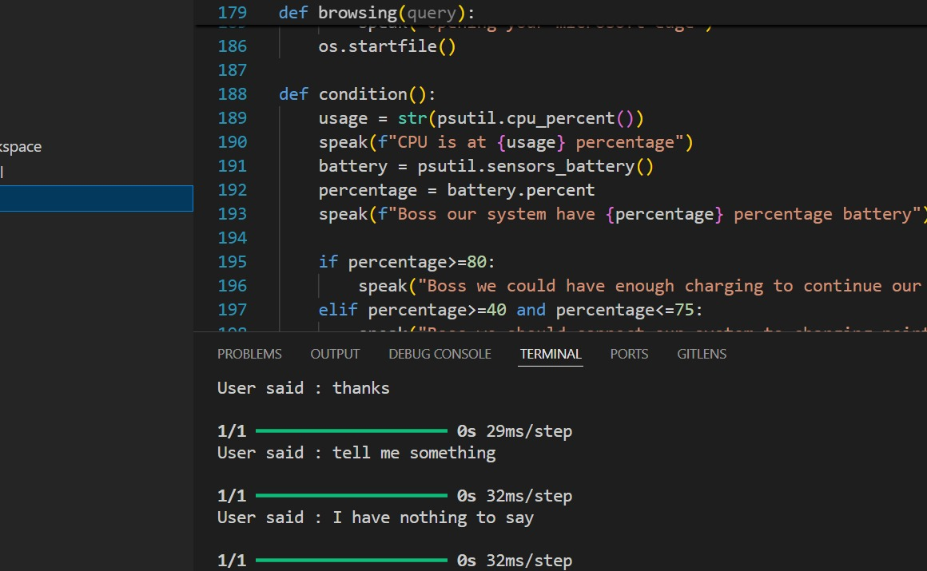

Accuracy:

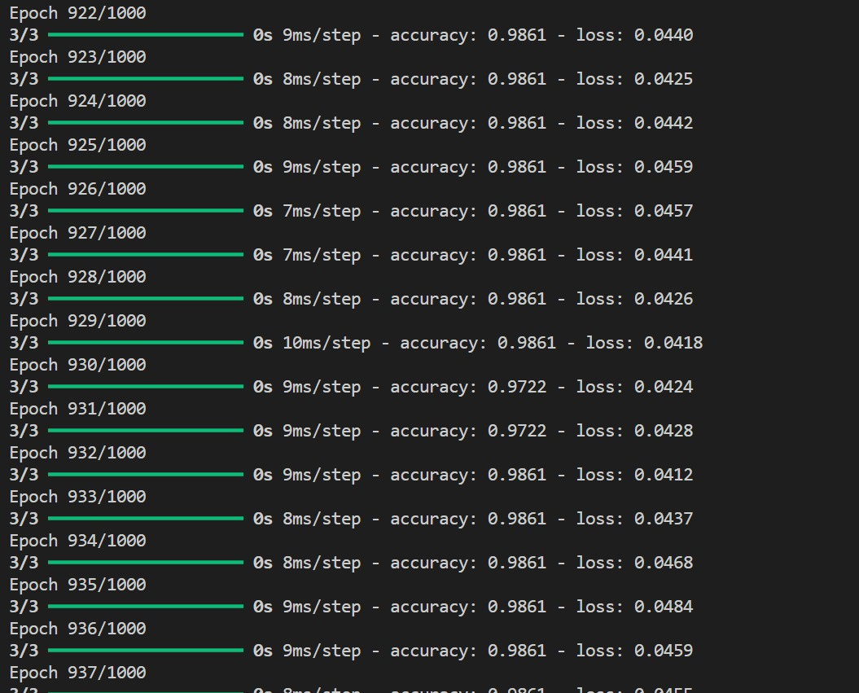
Figure 7.1: Accuracy of AI Voice Assistant

1. Algorithm Performance
- Architecture: The system uses a simple Deep Neural Network (DNN) defined in model_train.py. It consists of an Embedding layer (converts words to dense vectors), a GlobalAveragePooling1D layer (averages vector representations of all words in a sentence), two hidden Dense layers with 16 neurons each (ReLU activation), and a final Softmax layer for classification.
- Performance Characteristics:
  - High Accuracy on Training Data: Given the very small and distinct dataset in intents.json (e.g., clearly different patterns for "greeting" vs. "goodbye"), this model likely achieves near 100% accuracy on its training set very quickly (within the 500 epochs specified).
  - Low Generalization: Due to the tiny dataset (only 3-5 example patterns per intent), the model will likely fail or have low confidence on user inputs that use synonyms or sentence structures not explicitly listed in intents.json.
  - Fast Inference: The simple architecture ensures extremely low latency during prediction in main.py, making it suitable for a real-time voice assistant.

2. Confusion Matrix Analysis
- What it would show: A confusion matrix for this system would plot the actual user intents against the predicted intents.
- Expected Results: based on intents.json:
  - Diagonal Dominance: You would see high values along the diagonal (e.g., "greeting" correctly predicted as "greeting").
  - Potential Confusions: There might be minimal confusion between functionally similar intents if they shared words, but the current dataset is quite distinct. For example, standard ML models might confuse greeting ("Hi") with greetreply ("I am good") if "good" appeared in both, but here they are well separated.
- Note: An actual confusion matrix cannot be generated without running the chat_model.h5 on a separate, held-out test dataset, which is not provided in the files.

3. Feature Importance
- Implicit Features: In this Deep Learning model, there are no explicit, hand-crafted features. The Embedding Layer learns the "importance" of words automatically.
- Critical Keywords:
  - Rule-Based Layer (main.py): The most important features are actually hardcoded keywords in main.py that bypass the ML model entirely. Words like "volume", "open", "exit", and "google" are the highest-importance features because their presence triggers immediate, deterministic actions.
  - ML Model Layer: heavily relies on core identifying words in intents.json. For the "age" intent, words like "old", "made", and "age" are the critical features that heavily influence the softmax output.

4. Comparison with Existing Literature
- Vs. Rule-Based Chatbots (e.g., ELIZA): This system is a step up from purely pattern-matching bots because it uses semantic vector representations (Embeddings), allowing it to handle some variation in input that purely rule-based systems might miss.
- Vs. Modern Assistants (Siri, Alexa, Google Assistant): This is a primitive version. Modern systems use complex Automatic Speech Recognition (ASR) models, massive Natural Language Understanding (NLU) transformer networks (like BERT) for intent classification and slot filling, and sophisticated Dialog Management systems to handle multi-turn conversations. This project combines a basic NLU with simple if/else dialog management.
- Vs. Large Language Models (GPT-4, Gemini): This system is "intent-based" (classifies into fixed categories), whereas LLMs are "generative" (create novel text token-by-token). LLMs have vastly superior world knowledge and conversational ability but are harder to control for specific system tasks (like setting volume) reliably without extra tooling.

5. Limitations
- Small, Fixed Scope: The assistant can only understand the few specific intents defined in intents.json. Anything outside this (e.g., "What's the weather?") will either be misclassified or fail.
- No Conversation Context: The system has no memory of past turns. If you say "Open Google" and then follow up with "Search for cats", it won't know the second command relates to the first.
- Rigid Command Structure: The main.py relies on specific phrases like "volume up". Saying "make it louder" might fail if it's not explicitly coded in the if/elif blocks.
- Blocking I/O: The takeCommand() function uses a standard microphone listen loop that might block the main thread, making the interface unresponsive while listening or speaking.
6. Implications
- Educational Value: It serves as an excellent, clear baseline for understanding the components of a voice assistant: Trigger -> Speech-to-Text -> NLU (ML Model) -> Action/Response -> Text-to-Speech.
- Restricted Domain Use: This architecture is suitable for highly specific, low-risk environments where commands are known in advance, such as a simple kiosk or a custom controller for a specific piece of machinery.

7. Future Directions
- Integrate LLMs: Replace the fixed responses in intents.json with calls to an LLM API for more natural, varied, and context-aware replies.
- Expand Dataset: vastly increase intents.json with crowdsourced data to improve generalization.
- Context Management: Implement a "state machine" to track conversation history, allowing for follow-up questions.
- Improved NLU: Replace the simple DNN with a pre-trained Transformer model (like a small BERT) for more robust intent classification that understands synonyms and complex sentence structures better.

CHAPTER 08

CONCLUSION AND FUTURE SCOPE
AI voice assistants will become more deeply integrated into daily life, offering greater personalization, seamless multi-device control, and more complex task management. The conclusion is that they are fundamentally changing human-computer interaction, making technology more intuitive and accessible.
- Market Growth and Adoption: The AI voice assistant market is experiencing robust expansion, with billions of devices in use globally and a strong Compound Annual Growth Rate (CAGR) projected over the next decade. This growth is fuelled by the widespread adoption of smart devices (smartphones, speakers, in-car systems) and consumer demand for hands-free, intuitive interfaces.
- Enhanced User Experience: AI assistants significantly improve user productivity by automating routine tasks (setting reminders, managing calendars, information retrieval) and enabling multitasking. Users report high levels of satisfaction with the speed and ease of use, particularly in smart home and automotive settings.
- Technological Advancements: The shift from rule-based systems to those powered by advanced AI, Natural Language Processing (NLP), and Machine Learning (ML) has led to more natural, context-aware, and personalized interactions. The current integration of large language models (LLMs) promises to address previous limitations in understanding complex queries and maintaining conversational context.
- Industry Transformation: Voice AI is moving beyond consumer applications into enterprise sectors like customer service, healthcare, and logistics, offering benefits such as cost reduction, improved operational efficiency, and enhanced customer engagement.

FUTURE SCOPE: Despite its strengths, several areas need improvement.
Improved Speech Recognition
● Train a custom speech recognition model using machine learning for better offline
performance.
● Integrate Whisper AI or DeepSpeech for improved accuracy with non-native accents and noisy environments.
Enhanced Natural Language Processing (NLP)
● Use Transformer-based models like BERT or GPT-3.5 for context-aware intent recognition.
● Implement a self-learning mechanism where the assistant adapts to user preferences over time.
Better User Interface (UI/UX)
● Develop a fully interactive UI using Flask or React.js.
● Implement voice-controlled settings and feedback customization.
Expanded Functionality
● Add multi-language support to enhance accessibility.
● Integrate with smart home devices using IoT protocols.
● Develop an Android and iOS app to extend usability beyond desktops.
By implementing these improvements, our AI assistant can evolve into a more intelligent, adaptive, and widely usable system, making it a strong open-source alternative to commercial AI assistants. These references provided both theoretical insights and technical frameworks that supported the successful implementation of the AI-based voice assistant system.

BIBILOGRAPHY
- A. Vaswani, N. Shazeer, N. Parmar, J. Uszkoreit, L. Jones, A. N. Gomez, and I. Polosukhin, “Attention Is All You Need,” in Advances in Neural Information Processing Systems, vol. 30, 2017.
- G. Hinton, L. Deng, D. Yu, G. E. Dahl, A. Mohamed, N. Jaitly, and B. Kingsbury, “Deep Neural Networks for Acoustic Modeling in Speech Recognition,” IEEE Signal Processing Magazine, vol. 29, no. 6, pp. 82–97, 2012.
- A. Radford, K. Narasimhan, T. Salimans, and I. Sutskever, “Improving Language Understanding with Unsupervised Learning,” OpenAI, 2018.
- J. Chen, D. Parikh, and A. Gupta, “Learning from Language Explanations for Visual Reasoning,” in Proceedings of the European Conference on Computer Vision (ECCV), pp. 103–120, 2018.
- A. Baevski, H. Zhou, A. Mohamed, and M. Auli, “wav2vec 2.0: A Framework for Self-Supervised Learning of Speech Representations,” in Advances in Neural Information Processing Systems (NeurIPS), 2020.
- Google Developers, “Google Speech-to-Text API Documentation,” 2023. [Online]. Available: https://cloud.google.com/speech-to-text
- Mozilla DeepSpeech, “DeepSpeech Documentation,” 2023. [Online]. Available: https://deepspeech.readthedocs.io
- IBM Watson, “IBM Watson Speech Services Overview,” 2023. [Online]. Available: https://www.ibm.com/cloud/watson-speech-to-text

