Jaleel Calhoun

Intro:

The objective of this lab is to use/navigate through Wireshark, filter packets between my computer and Easternct.edu, and find provided information from a packet that is captured.

Description:

First I had used the “config/all” command in command prompt to find my IP address.



Then I was able to use Wireshark to capture packets from my computer navigating through Eastern’s website.

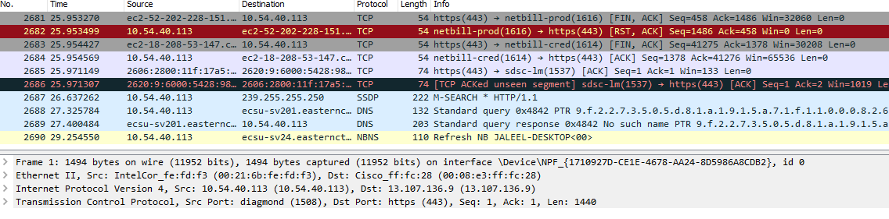

After setting up my Wireshark with it’s preferences, I was able to begin step 1 for the filtering process.

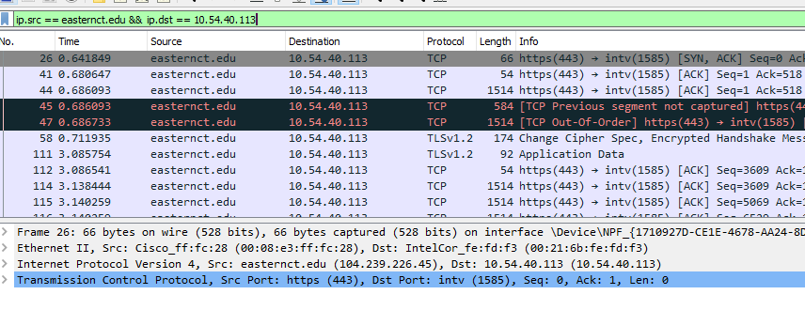

Next, starting step 2, I was able to filter packets revealing exchanges between only my computer and easternct.edu.

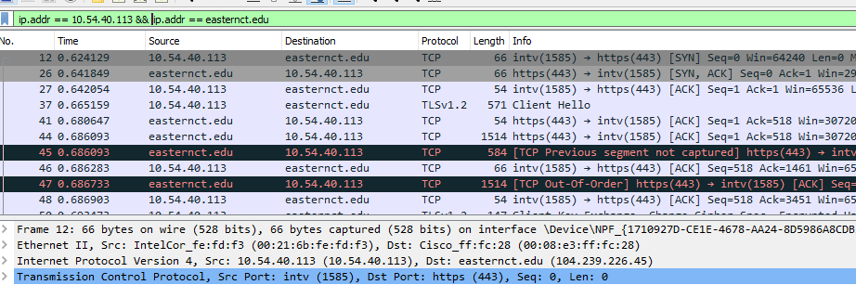

Heading into step 3, I had filtered packets similar to step 2 but with protocols HTTP or TCP.

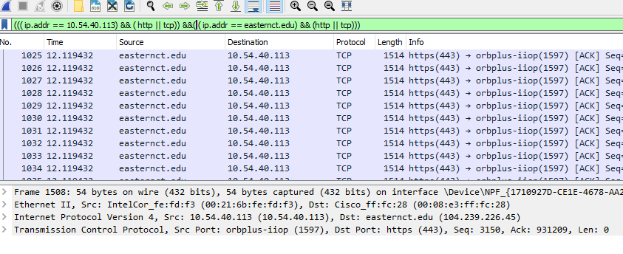

Finalizing with step 4 I had selected a packet that was an exchange with my computer and easternct.edu to fill out the following information:

1. 12, .624129, 66



2. HTTP

3. TCP

4. IP

5. Ethernet

6. 

7. 

8. 

In conclusion, I was able to learn more about wireshark and its navigation, learned how to use the ip.adrr filter instead of having to use “||” filter tools, and was able to learn how to filter packets using various filtering analyzes. I had trouble using the ip.adrr filtering at first but figured out how to format it.