A Web Application based Project Report

On

**PAYROLL MANAGEMENT SYSTEM**

Submitted in partial fulfilment of the requirements for the award of

# BACHELOR OF TECHNOLOGY

# In

# INFORMATION TECHNOLOGY

By

Amar Gopi – 21BQ1A12C3

Asish – 21BQ1A1285

Akhil – 21BQ1A1295

Rajesh – 21BQ1A12B4

Nishoke – 21BQ1A1293

Prashanth – 21BQ1A12D6

Narendra – 21BQ1A12F9

Pavan sai – 22BQ5A1218

Yonesh – 22BQ5A1221

Rajeev chowdary– 21BQ1A12D2

Leela krishnamurthy– 21BQ1A12D4

Vishwanath – 21BQ1A12C8

Sujith paul – 21BQ1A12I0

Himavanth – 21BQ1A12H2

***Under The Supervision of***

**Mr. Ram Bhupal M. Tech (Ph. D)**

**Assistant Professor**



DEPARTMENT OF INFORMATION TECHNOLOGY

# VASIREDDY VENKATADRI INSTITUTE OF TECHNOLOGY

Approved by AICTE and An Autonomous Institution affiliated to JNTUK Accredited by NAAC with “A‟ grade, Accredited by NBA for 3 years

NAMBUR (V), PEDAKAKANI (M), GUNTUR-522 508.

Tel no: 0863-2118036, url: [www.vvitguntur.com](http://www.vvitguntur.com/) January 2023

1

**CONTENTS OUTLINE**

**Chapter Page.No**

1. Abstract i
2. Introduction 1
3. Proposed System with Architecture 5
4. Objectives of Proposed System 9
5. Modules Introduction 12
6. System Requirements 15
   1. Hardware Configuration (Computer Resource) 16
   2. Software Configuration (Technology Stack) 17
7. Design 18
   1. Use case diagram 19
   2. Class diagram 20
   3. Sequence diagram 21
8. Execution screenshots 22
9. Conclusion and Future work 23
10. References 24

2

1. **ABSTRACT**

A payroll management system is a software application designed to streamline and automate the process of paying employees in an organization. It handles tasks such as calculating salaries, deductions, and taxes, generating paychecks or direct deposits, and maintaining records of employee earnings and financial transactions. By efficiently managing payroll, this system helps businesses save time, reduce errors, and ensure compliance with tax and labor regulations, ultimately enhancing the accuracy and efficiency of their payroll processes.

A payroll management system is a critical component of any organization's financial infrastructure, offering several key benefits to businesses and their employees. At its core, this system simplifies and automates the complex task of paying employees accurately and on time. It calculates salaries, deductions, and taxes, taking into account various factors like overtime, bonuses, and benefits. This automation reduces the likelihood of errors, ensuring that employees are compensated correctly. Furthermore, the system generates paychecks or processes direct deposits, offering convenience to both employers and staff.

In addition to its basic functions, a payroll management system also maintains detailed records of employee earnings and financial transactions. This record-keeping is invaluable for auditing, compliance, and reporting purposes. It allows businesses to easily track and report on their labor costs, ensuring they remain in compliance with tax laws and labor regulations. Additionally, the system can generate various reports and documents, such as tax forms and pay stubs, further streamlining administrative tasks.

By efficiently managing payroll, this system not only saves time but also enhances overall productivity within an organization. It frees up HR and finance teams from time-consuming manual calculations and paperwork, allowing them to focus on more strategic and value-added tasks. Additionally, it helps businesses avoid costly penalties and errors associated with payroll and tax compliance.

In summary, a payroll management system plays a pivotal role in modern organizations by automating payroll processes, reducing errors, maintaining accurate records, and promoting efficiency. It ultimately contributes to improved employee satisfaction, compliance, and overall financial management.

3

1. **INTRODUCTION**

The proposed project “Employee Database and Payroll Management System” has been developed to overcome the problems faced in the practicing of manual system. This software is built to eliminate and in some cases reduce the hardships faced by the existing system. Moreover this system is designed for particular need of the company to carry out its operations in a smooth and effective manner.This web application is reduced as much as possible to avoid errors while entering data. It also provides error message while entering invalid data.

It is user-friendly as no formal knowledge is required to use the system. Human resource challenges are faced by every organization which has to be overcome by the organization. Every organization has different employee and payroll management needs.

Therefore I have design exclusive Employee and payroll Management System that are adapted to the organization’s Managerial Requirements.

Payroll is a fundamental aspect of any organization's financial management. It involves the calculation and distribution of employee salaries, deductions, benefits, and taxes. As an organization grows, managing payroll becomes increasingly complex and time-consuming. This is where a Payroll Management System comes into play.

A Payroll Management System is a specialized software application designed to automate and streamline the payroll process. It serves as a comprehensive solution for managing employee compensation and payroll-related tasks efficiently and accurately. This system encompasses various functions, including employee data management, salary calculations, tax compliance, and reporting.

4

**3.Proposed system with architecture**

A proposed payroll management system typically involves a software-based solution that automates and streamlines various aspects of payroll processing within an organization. Below is anoverview of the proposed system's architecture:

1. User Interface (UI):

- The system should have a user-friendly interface accessible to HR personnel and administrators.

- It may include a web-based or desktop application for easy access.

2. Database Management System (DBMS):

- The system should utilize a relational database management system (RDBMS) to store and manage employee data, salary information, and transaction records.

- Popular options include MySQL, PostgreSQL, or Microsoft SQL Server.

3. Employee Data Management:

- This module manages employee profiles, including personal information, job details, and tax-related data.

- It allows HR personnel to add, edit, or remove employee records.

4. Payroll Processing Engine:

- This core component automates payroll calculations, including salaries, hourly wages, overtime, bonuses, and deductions.

- It should consider tax regulations, deductions for benefits, and other compensation factors.

5. Time and Attendance Integration:

- The system may integrate with a time and attendance system or time-tracking software to capture accurate work hours and attendance records.

6. Taxation and Deduction Management:

- This module handles tax calculations, deductions, and contributions for items like income tax, Social Security, healthcare, and retirement plans.

5

- It should stay updated with tax law changes and allow for custom deduction configurations.

7. Payroll Generation:

- This component generates paychecks or initiates direct deposits for employees.

- It can produce printed or electronic pay stubs.

8. Reporting and Analytics:

- The system should offer a reporting module for generating various reports, such as payroll summaries, tax forms, and financial statements.

- It may include data visualization tools for analytics.

9. Compliance and Regulations:

- The system should keep track of labor laws, tax regulations, and compliance requirements, ensuring that payroll processes adhere to legal standards.

10. Security and Access Control:

- Robust security measures, including user authentication and authorization, should be in place to safeguard sensitive payroll data.

- Role-based access control ensures that only authorized personnel can access certain functionalities.

11. Backup and Disaster Recovery:

- Implement regular backups and a disaster recovery plan to prevent data loss in case of system failures or unforeseen events.

12. Scalability and Performance:

- The architecture should be scalable to accommodate the growing number of employees and transactions.

- Performance optimization measures should be in place to ensure speedy processing.

13. Mobile Accessibility:

6

- Consider developing a mobile application or ensuring that the system is responsive for mobile access, allowing HR personnel to manage payroll tasks remotely.

14. Integration with Accounting Software:

- Optionally, the system can integrate with accounting software to seamlessly transfer financial data for accounting and reporting purposes.

15. Vendor and Third-Party Integrations:

- The system may integrate with external vendors for services like tax filing, benefits administration, and employee self-service portals.

This proposed architecture outlines the key components and considerations for a comprehensive payroll management system, which can greatly enhance the efficiency and accuracy of payroll processing within an organization while ensuring compliance with applicable regulations.

7

4.Objectives of proposed system

Certainly, the objectives of a proposed payroll management system are to improve and optimize the payroll processes within an organization. Here are the primary objectives:

1. Efficiency Improvement: Streamline and automate payroll processes to increase the efficiency of payroll administration, reducing manual effort and time.

2. Accuracy Enhancement: Minimize errors in payroll calculations, ensuring that employee salaries, taxes, deductions, and benefits are accurate and consistent.

3. Compliance Assurance: Ensure that the payroll system complies with relevant tax laws, labor regulations, and statutory requirements, reducing the risk of non-compliance penalties.

4. Data Security: Implement robust security measures to protect sensitive employee information and financial data, safeguarding against unauthorized access and data breaches.

5. Cost Reduction: Reduce the costs associated with manual payroll processing, including printing and distributing paper checks or pay stubs.

6. Employee Self-Service: Provide employees with self-service portals to access their payroll information, view pay stubs, update personal details, and request changes, enhancing employee satisfaction and reducing HR inquiries.

7. Reporting and Analytics: Generate comprehensive reports and analytics to support decision-making, auditing, and compliance reporting, helping organizations better manage their finances.

8. Scalability: Ensure that the system can accommodate the organization's growth in terms of the number of employees, complexity, and transaction volumes.

9. Mobile Accessibility: Enable HR personnel to manage payroll tasks remotely through mobile applications or responsive web interfaces, promoting flexibility and accessibility.

8

10.Data Backup and Recovery: Establish backup and disaster recovery procedures to protect against data loss in case of system failures, ensuring data integrity and continuity.

11. Integration: Integrate with other relevant systems, such as time and attendance tracking, accounting software, and benefits administration, to ensure data consistency and streamline processes.

12. Paperless Environment: Minimize the use of paper by generating electronic paychecks, pay stubs, and tax documents, contributing to environmental sustainability.

13. Tax Compliance: Stay up-to-date with changes in tax laws and regulations, ensuring that tax calculations are accurate and timely tax filings are made.

14. Audit Trail: Maintain an audit trail of all payroll-related transactions and changes to ensure transparency and accountability in the payroll process.

15. Enhanced Record Keeping: Store detailed records of employee earnings, deductions, and tax-related information for historical and auditing purposes.

16. User Training and Support: Provide training and support to users to ensure they can effectively utilize the system and resolve any issues promptly.

17. Customer Satisfaction: Ultimately, the system should enhance both employee and HR satisfaction by simplifying the payroll process, reducing errors, and providing easy access to payroll-related information.

These objectives collectively aim to make the payroll management system more efficient, accurate, compliant, and user-friendly, benefiting both the organization and its employees.

9

**5.Modules introduction**

A payroll management system typically consists of various interconnected modules or components, each serving specific functions within the system. Here's an introduction to the key modules commonly found in a payroll management system:

1. Employee Data Management Module:

- This module stores and manages employee information, including personal details, contact information, job roles, tax-related data, and banking details.

2. Time and Attendance Module:

- It tracks and records employee work hours, attendance, leaves, and overtime, often integrating with time-tracking devices or software.

3. Salary Calculation Module:

- This core module calculates employee salaries, factoring in elements like regular pay, hourly wages, bonuses, and overtime, while considering tax deductions and benefits.

4. Taxation and Deduction Management Module:

- This module handles tax calculations, including income tax, Social Security, Medicare, and other statutory deductions. It may also manage deductions for benefits like health insurance and retirement plans.

5. Payroll Processing Module:

- Responsible for generating employee paychecks or initiating direct deposits, ensuring accurate and timely payment of salaries.

6. Employee Self-Service Portal:

- Provides employees with access to their payroll information, allowing them to view pay stubs, update personal details, and request changes or time-off.

7. Reporting and Analytics Module

- Generates a variety of reports, such as payroll summaries, tax forms, and financial statements, to support decision-making, auditing, and compliance reporting. 10

8. Compliance and Regulations Module:

- Keeps the system up-to-date with labor laws, tax regulations, and compliance requirements, ensuring that the payroll process adheres to legal standards.

9. Security and Access Control Module:

- Manages user authentication and authorization, ensuring that only authorized personnel can access and modify payroll data. It also includes security measures to protect sensitive information.

10. Backup and Disaster Recovery Module:

- Implements regular data backups and a disaster recovery plan to prevent data loss in case of system failures, ensuring data integrity and continuity.

11. Mobile Access Module:

- Provides mobile applications or responsive interfaces for HR personnel to manage payroll tasks remotely, promoting flexibility and accessibility.

12. Integration Module:

- Facilitates integration with other systems within the organization, such as time and attendance tracking, accounting software, and benefits administration, to streamline data exchange and maintain consistency.

13. Vendor and Third-Party Integrations Module:

- Integrates with external vendors for services like tax filing, benefits administration, and employee self-service portals.

14. Audit Trail Module:

- Maintains an audit trail of all payroll-related transactions and changes, ensuring transparency and accountability in the payroll process.

15. User Training and Support Module:

- Provides training resources and support for users to effectively utilize the system and resolve any issues promptly.

These modules collectively contribute to the efficient, accurate, and compliant management of an organization's payroll processes. The specific modules and their functionalities may vary depending on the complexity and requirements of the payroll management system.

11

**6.System requirements**

6.1 Hardware Configuaration (computer resourse):

The system requirements for hardware components in a payroll management system can vary depending on the size of the organization, the complexity of the system, and the software being used. However, here are some general hardware requirements that can serve as a starting point for such a system:

1. Server:

- A dedicated server or cloud-based server infrastructure is often required to host the payroll management system.

- The server should have sufficient processing power, RAM, and storage capacity to handle the database and application workload.

- Dual-core or quad-core processors, 8GB to 16GB of RAM, and ample storage space (at least 100GB) are typical server specifications.

2. Database Server:

- If the system uses a relational database management system (RDBMS) like MySQL, PostgreSQL, or Microsoft SQL Server, a separate database server may be needed.

- The database server should meet the recommended requirements for the chosen database system.

3. Network Infrastructure:

- A stable and secure network infrastructure is essential for data transmission between clients and servers.

- High-speed internet connectivity is recommended for cloud-based systems.

- Wired or wireless local area network (LAN) for internal communication.

4. Client Devices:

- PCs, laptops, or mobile devices for users to access and interact with the payroll management system.

- Minimum hardware requirements for client devices typically include a modern web browser and an internet connection.

12

5. Printers and Scanners:

- Printers for generating physical paychecks or reports.

- Scanners for digitizing documents such as signed time sheets or tax-related forms.

6. Backup Systems:

- Backup hardware or cloud-based backup services to ensure data protection and recovery in case of system failures or data loss.

7. Firewall and Security Devices:

- Firewalls, intrusion detection systems, and other security hardware to protect sensitive payroll data from unauthorized access and cyber threats.

8. Uninterruptible Power Supply (UPS):

- UPS units to provide backup power in case of electricity outages, ensuring system uptime and data integrity.

9. Data Storage:

- Sufficient storage capacity for database files, backups, and archived payroll records.

10. Scalability Considerations:

- Ensure that the hardware can be easily scaled to accommodate growth in the number of employees and transactions.

11. Environmental Considerations:

- Adequate cooling and ventilation systems to prevent overheating of servers and networking equipment.

It's important to note that these hardware requirements can vary based on factors such as the number of employees, the complexity of payroll calculations, the frequency of payroll runs, and the specific software being used. Organizations should work closely with their software vendors or IT professionals to determine the precise hardware specifications needed to run their payroll management system effectively and efficiently.

13

* 1. Software configuaration (Technology stack):

The software configuration or technology stack for a payroll management system typically includes a combination of programming languages, frameworks, libraries, and software components. Below is a common technology stack used in developing a payroll management system:

1. Programming Languages:

- Java: Java is a versatile language commonly used for building enterprise-level applications, including payroll systems.

- Python: Python is known for its simplicity and readability, making it suitable for various parts of a payroll system, such as scripting and data analysis.

- C#: C# is often used in combination with the .NET framework for Windows-based payroll systems.

2. Web Development Frameworks:

- Ruby on Rails: A popular choice for web applications due to its rapid development capabilities.

- Django: A high-level Python framework known for its robustness and security.

- ASP.NET: Suitable for Windows-based web applications and integrates well with Microsoft technologies.

3. Database Management System (DBMS):

- MySQL: A free, open-source RDBMS widely used for storing payroll data.

- PostgreSQL: Another open-source RDBMS known for its advanced features and scalability.

- Microsoft SQL Server: A commercial RDBMS often used in Windows environments.

4. Web Frontend Development:

- HTML/CSS: Standard web technologies for building the user interface (UI).

- JavaScript: Used for client-side interactivity and dynamic web features.

- React: A JavaScript library for building interactive user interfaces.

- Angular: A TypeScript-based framework for building dynamic web applications.

- Vue.js: A progressive JavaScript framework for building modern web apps.

5. Server-Side Development:

- Node.js A runtime environment for executing JavaScript on the server side.

- Ruby: For Ruby on Rails applications.

- Python: For Django-based applications.

- ASP.NET Core: For ASP.NET-based applications.

6. Middleware and APIs:

- RESTful APIs: Commonly used for communication between frontend and backend components.

- GraphQL: A query language for APIs that provides efficient data retrieval.

- Message Queues (e.g., RabbitMQ, Apache Kafka): Used for background processing and asynchronous tasks.

7. Authentication and Security: 14

- OAuth 2.0: For secure user authentication and authorization.

- JWT (JSON Web Tokens): Used for token-based authentication.

- SSL/TLS: Ensures secure data transmission over the internet.

8. Version Control:

- Git: For source code version control and collaboration.

9. Development Environment and Tools:

- Integrated Development Environment (IDE): Such as Visual Studio Code, Eclipse, or PyCharm.

- Database Management Tools: Such as MySQL Workbench or pgAdmin for managing the database.

- Testing Frameworks: Like JUnit, pytest, or Jasmine for unit and integration testing.

- Continuous Integration/Continuous Deployment (CI/CD) Tools: Such as Jenkins, Travis CI, or GitHub Actions for automated testing and deployment.

10. Operating System (OS):

- The choice of the OS depends on your server infrastructure but commonly includes Linux distributions (e.g., Ubuntu, CentOS) or Windows Server.

11. Containerization and Orchestration (Optional):

- Docker: For containerizing application components.

- Kubernetes: For container orchestration and scaling.

12. Cloud Services (Optional):

- Cloud platforms like AWS, Azure, or Google Cloud may be used for hosting, scalability, and data storage.

13. Reporting and Analytics (Optional):

- Tools such as Microsoft Power BI, Tableau, or custom reporting libraries can be integrated for generating detailed reports and analytics.

The specific technology stack you choose may depend on your organization's preferences, existing infrastructure, and development expertise. It's important to select technologies that align with your project's requirements and goals while considering factors such as scalability, security, and maintainability.

15

**7.Design**

7.1 Use case diagram:

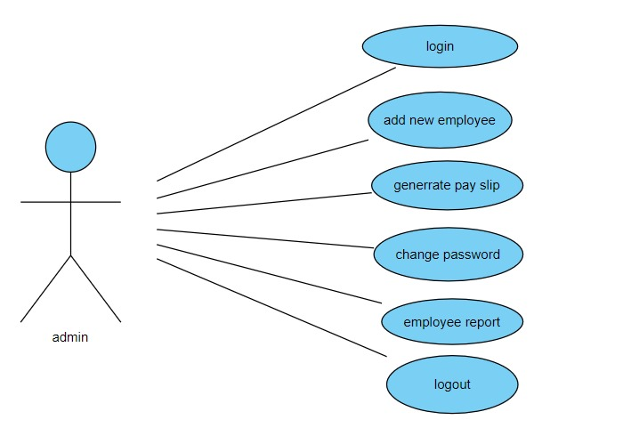 16

Class diagram:

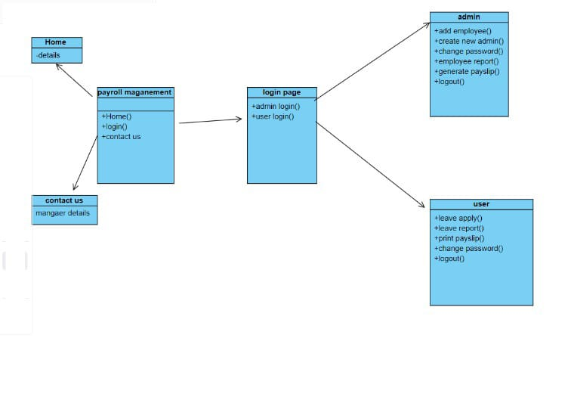 17

* 1. Sequence diagram:
  2. 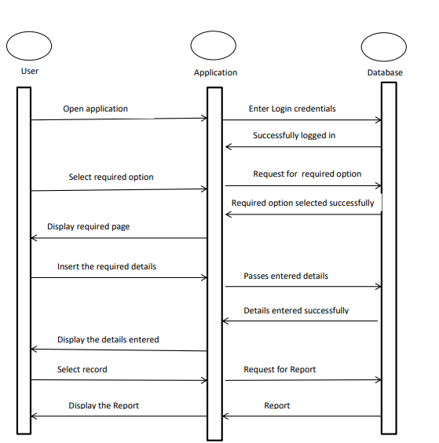 18

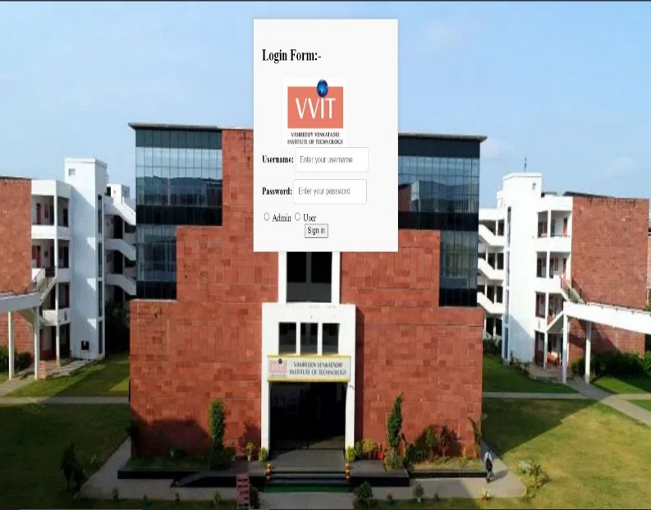

This is the output screen when we want to login

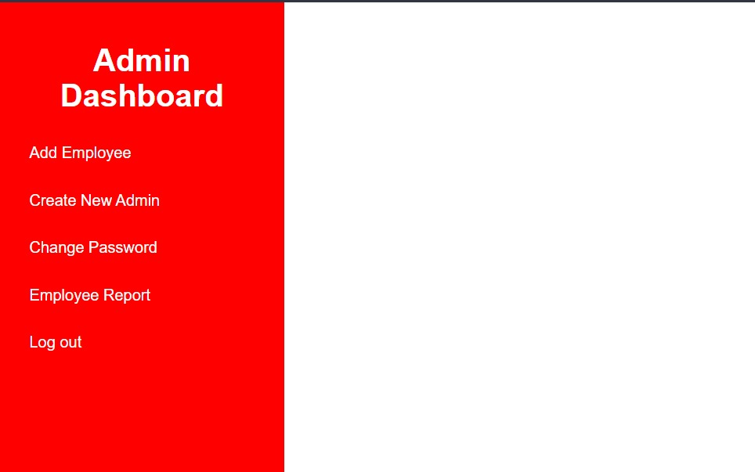

This is the admin dashboard and tasks performed by the admin

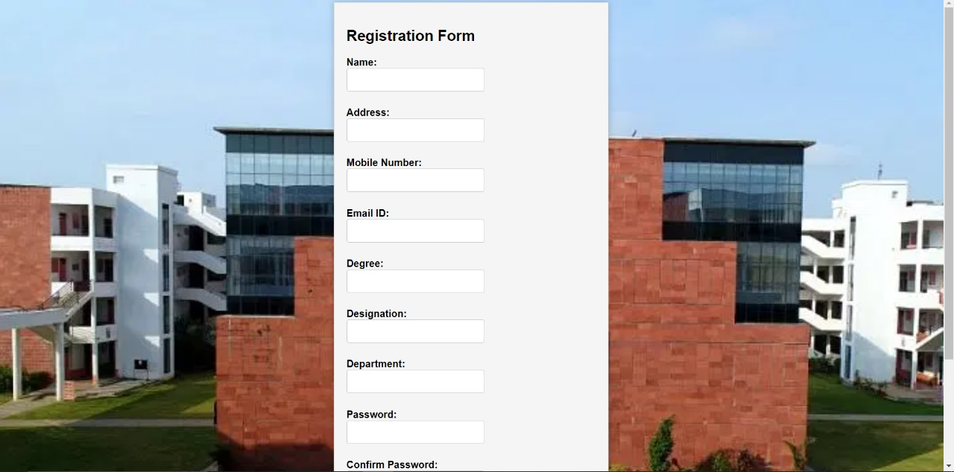

This is the registration form of the employee 19

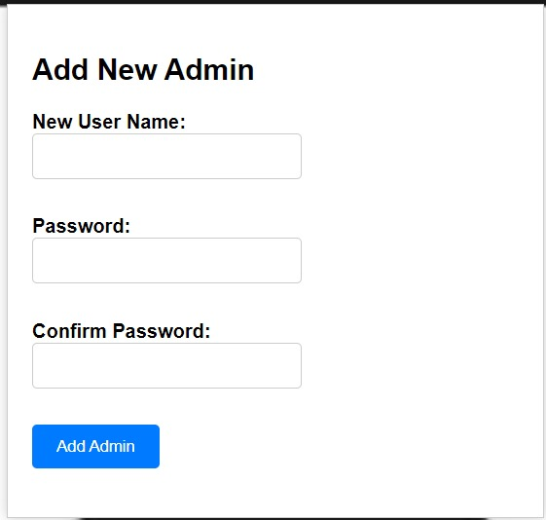

This is the webpage when a new admin to add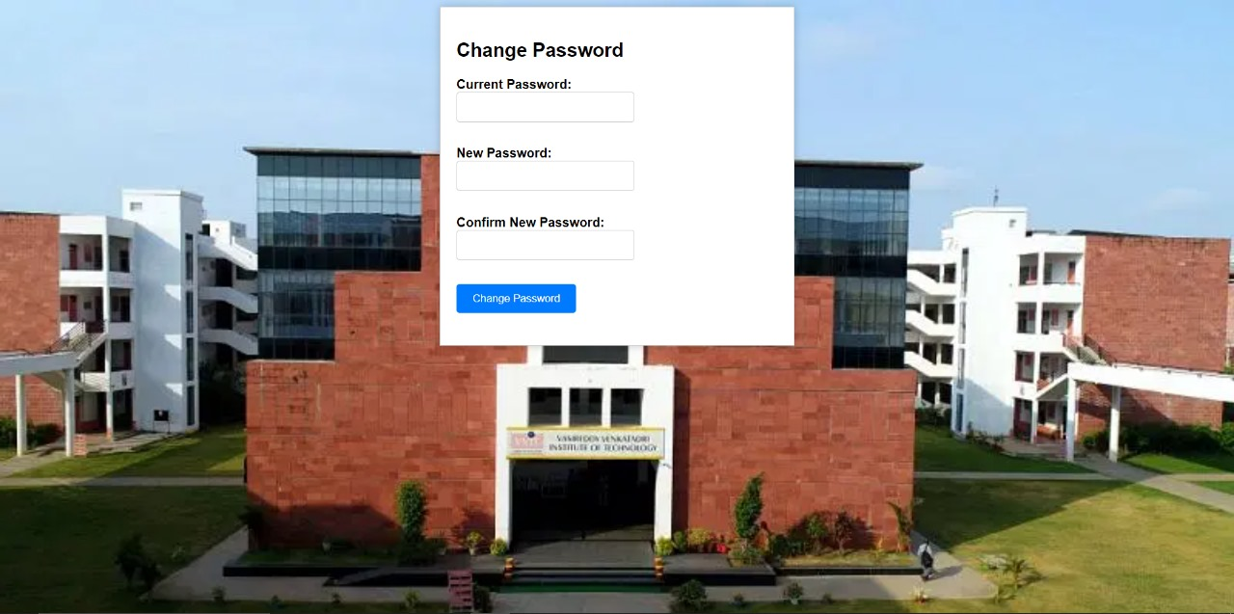

this is used to change the password of the employee

20

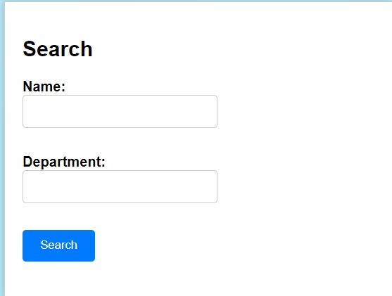

21

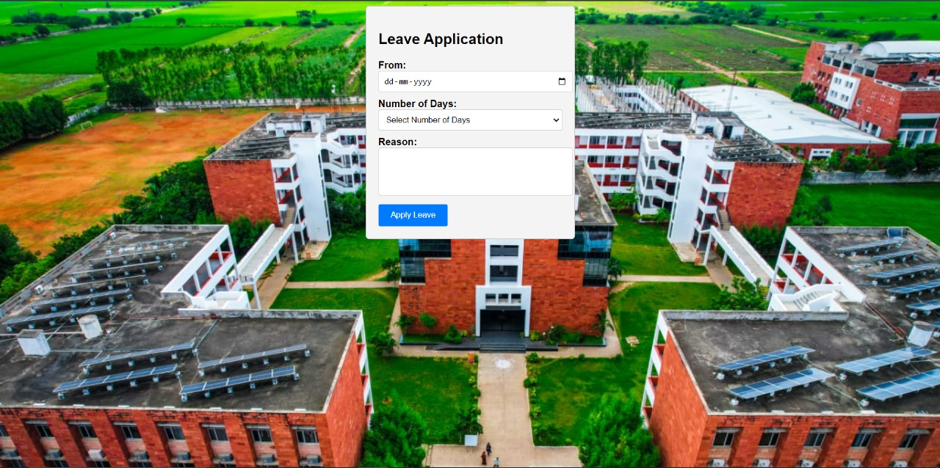

This is application of the employee for the leave

22

**Conclusion:**

In conclusion, a payroll management system is a crucial tool for organizations of all sizes to streamline and optimize the complex process of paying employees accurately and efficiently. By automating various payroll tasks and calculations, such a system brings several benefits to both employers and employees.

**Future work:**

1.Generating the pay slip.

2.Data base connection.

3.Further modifications of web pages.

4.creating the database tables.

23

**References:**

1.chatGpt.

2.JavaTpointer.

3.w3 schools.

4.Google scholar.

24