Express JS:
- Framework
-Built on nodejs
-Gives pre built features instead of writing from scratch
-npm install express for installing express
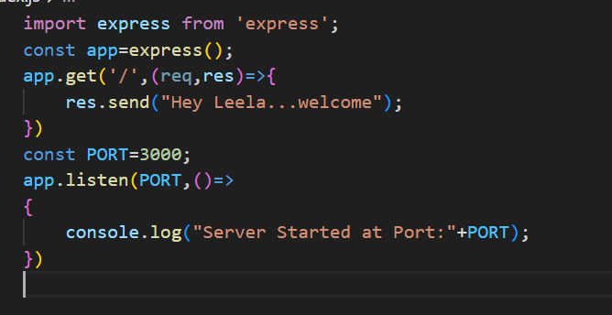
-express() -> factory function which provides all tools and methods to use express js
-.get() is method runs when user performs get operation on specified path
-get takes path and cb fn. Cb fn has req and res
.listen is same as nodejs

Making This file as Start:
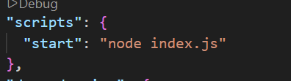
In package-json…put filename
Automatic Save Changes:
-use nodemon
-npm install nodemon
-make nodemon index.js in start
-put it in devDependecies
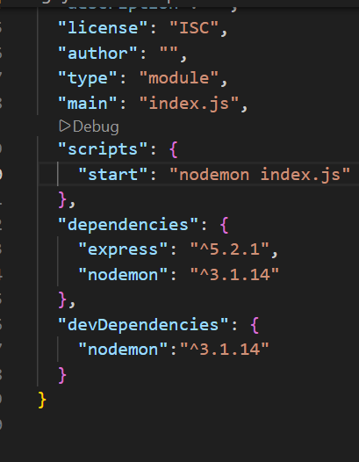
-then run npm start again
Note:
-we can run many express() function in single file and all are isolated

Routing:
-making the http methods for requests
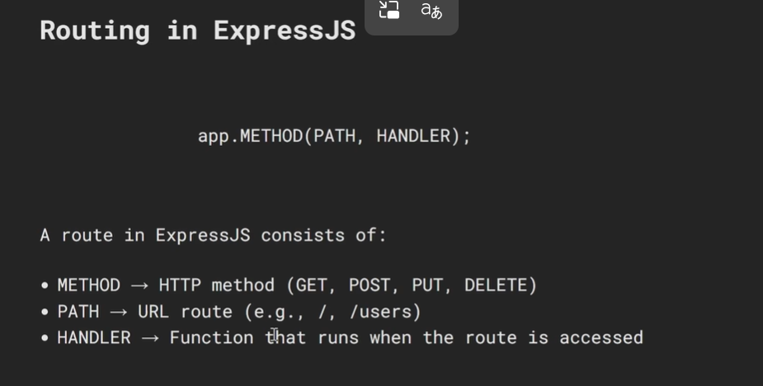
Dynamic Parameters:
-also called as path parameters
-use :id in path of method like angular
-use req.params.id for access it
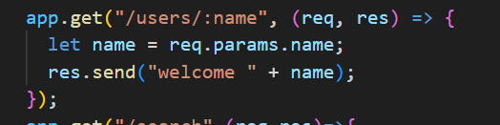
Query Parameters:
-use .query for access
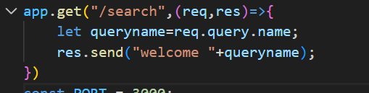

Express.Router():
-Allows code organizing
-instead of writing everything In single js…allows to handle in multiple Route files
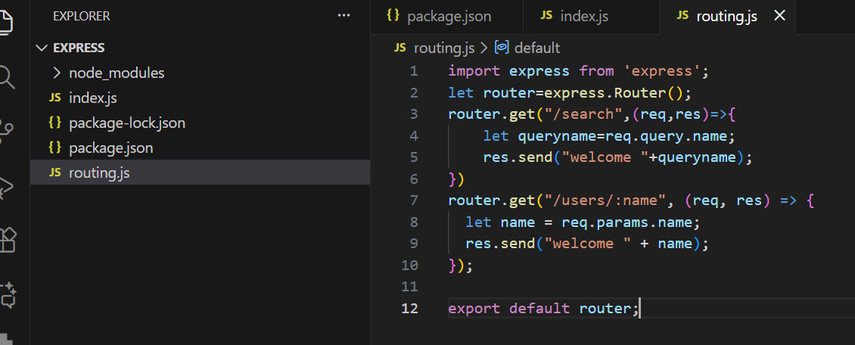
-Here … router comes from Express.Router() not Express().Router()..
-cause, Router() is static function present in Express module
-router will have methods get,post etc same as app.method
-definition and syntax and working is same as app.method
-order is important
-/:id matches anything..so write at last for these cases.
This is one file
In index.js..
-use app.use instead of app.method
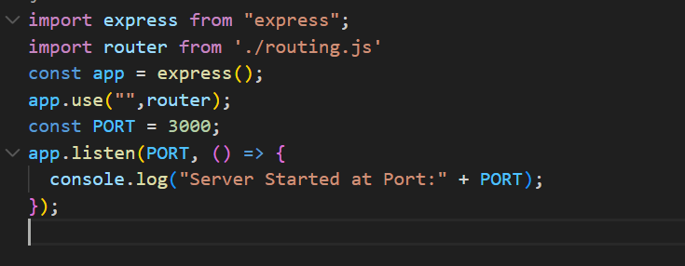
-Here …. The method .use tells when this path is prefix of url..use this router config
-similary for diff prefixes..we can use different route files
-here if url empty..uses route file
-in routefile ..it scans from top and matches exact path including path that we define in app.use
-This is called Decoupling(separating codes and putting independtly to avoid hectic)
Note :
-in imports use .js as extension
-not like angular here
Handling Unknown URL:
-use ‘/*any’ for handling unknown
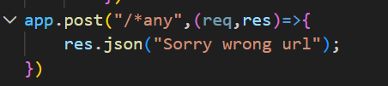

Req and Res in Handler Methods:
- Req and Res are streams even in express but added with extra functionalities
-we can use nodejs stream methods in even express
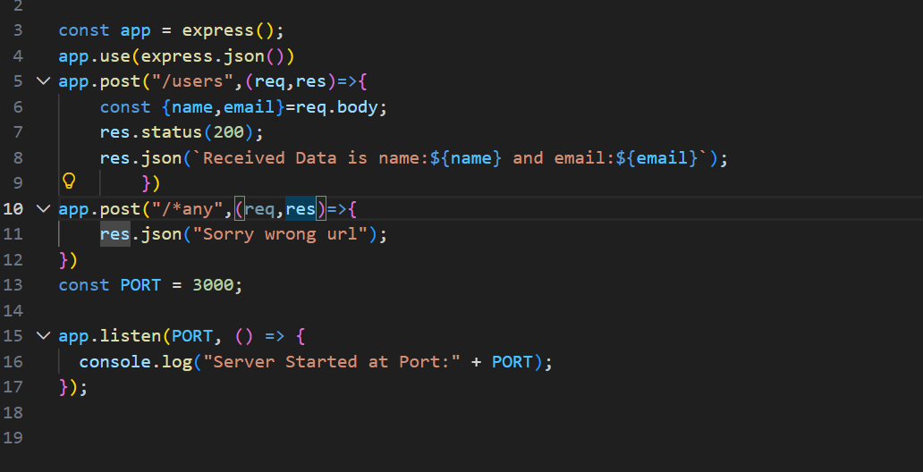
-Req Methods:
-req.params
-req.query
-req.body ->must have middleware
-req.headers //same as nodejs
-and we can use nodejs req like req.url, req.method etc

-Res Methods:
-res.send () // sends response like string,html(html in string) , JS Object( express converts into json—uses json.stringify internall) ,number ,Boolean etc
-also send() ends connection
-html-> text/html , string->text/plain ..json-> application/json
-boolean ,number comes under string
-so we can go with json in these cases
-res.json() //specifically designed for json only…where as send() is for all

-also json() ends connection
-here number,Boolean has same types not as string

-res.status()
-Takes status code in it
-internally uses res.statusCode of nodejs
-we can still use res.write, res.end and res.statusCode also
-res.redirect():
-Redirects to specific path
-Exp checks all paths again from top
-re runs all middle wares
-By default, method changes to GET irrespective of any method
-use 307 statuscode for preserver original method
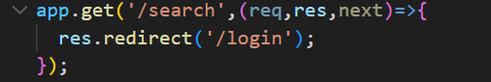
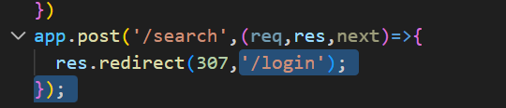

HTTP METHODS:
-already we did get..
POST:
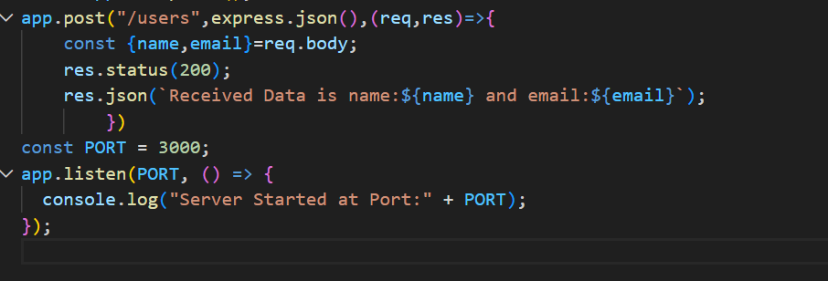
-post takes 2 or 3 args
-1st is path
-2nd is middleware…we will discuss later
-3rd is handler
Access data and send response
Discussion on 2nd Args:
-There is no req.body in express too
-So we should either use nodejs approach or middleware
-Here express.json() is middleware
Express.json():
-checks content type-> if it is json-> waits for all chunk and parses and gives js object to req.body
-then req.body will work
-if content-type is other than json-> skips waiting and parsing
Express.text()
-same as json works for text format
Express.raw()
-works for raw data like images,pdf etc
We can give this middleware in 2 ways
1.Route level
2.Application level
The above way is route level..where u want provide for every method/route use
The application would be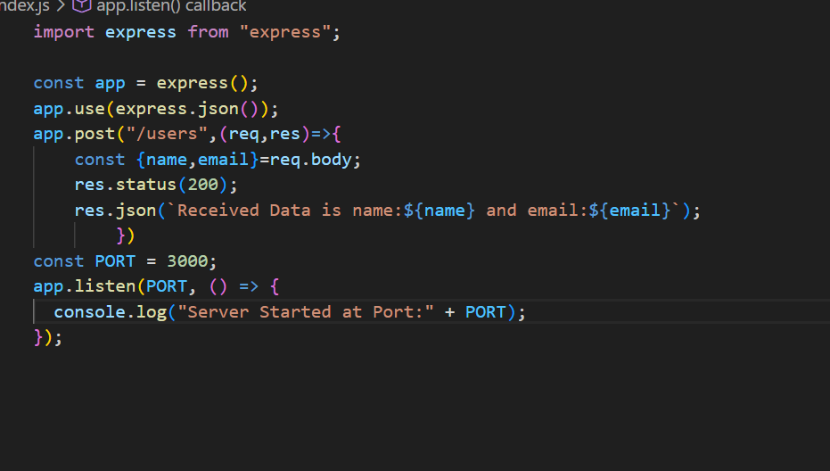
-no need to provide for every method
PUT:
-same as post syntax
-just provide dynamic parameter
Delete:
-same as put
Patch:
-same as put

Middlewares:
-Middle wares are the functions that execute even before request handler in a request
-It is a fn which has 3 args req,res,next where next is used for transfer the handling for next middle ware we defined
-Order of middle ware is very important.
-next() depends on order only
-next() must be called..else req will be strucked in middleware only.
-we can modify req, res in middleware even before going to req handler
Application Level Middleware:

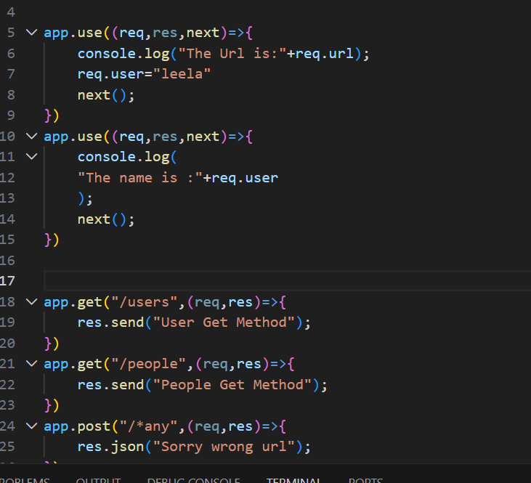

-here we used application level middleware
-just like how we used express.json() earlier
- This means that every single request (whether it's a GET, POST, or DELETE) that enters your server will be processed by that middleware first.
Route Level Middleware:
-2 ways to do it
- insert the middleware function as an argument between the path and the final handler.

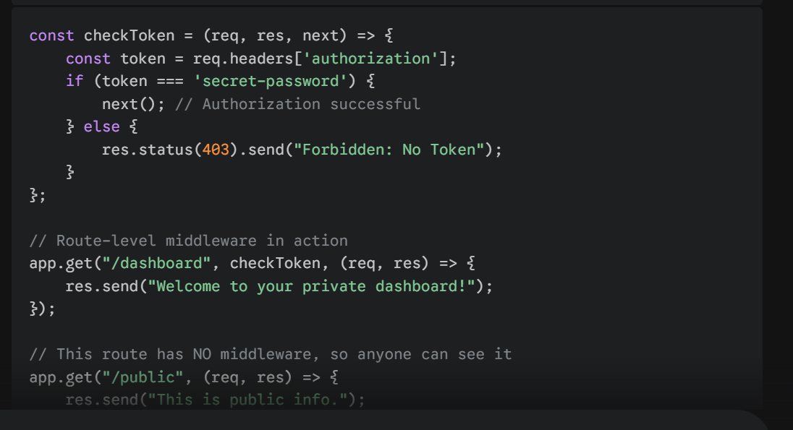
And
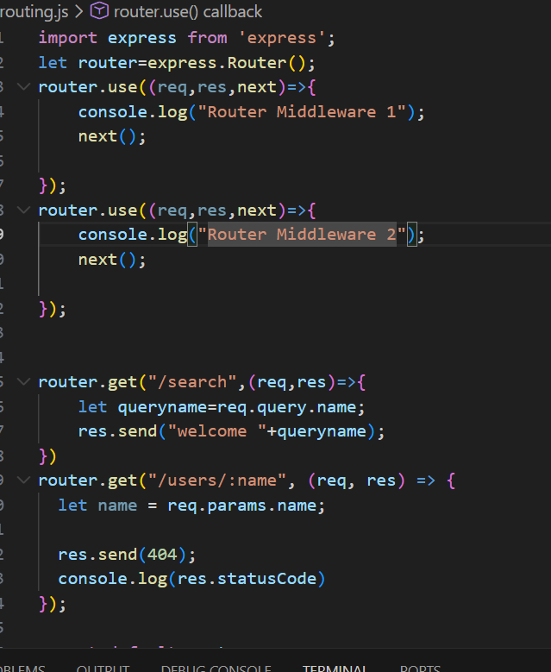
-this is route level where we define in route file itself
-we can also do as 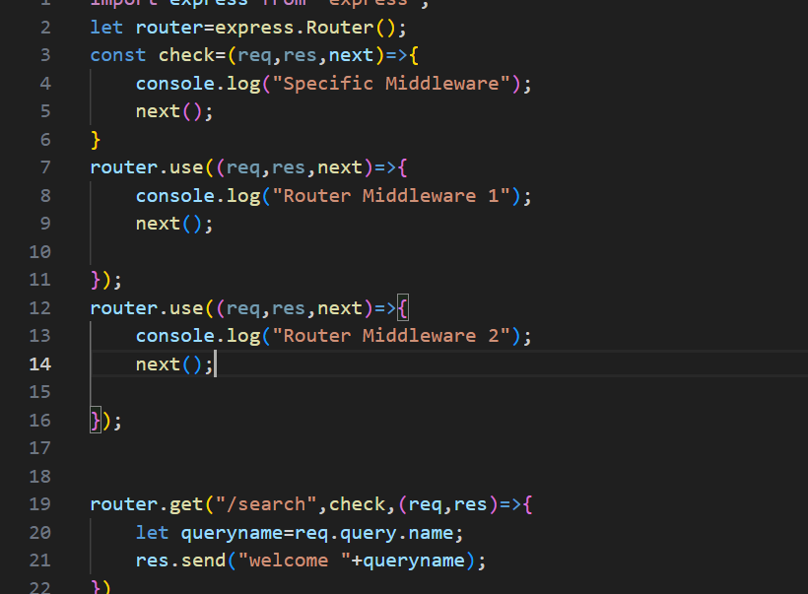
-YOU CAN ALSO PASS SPECIFIC MIDDLEWARE ALONG WITH GLOBAL
-ORDER OF DEFINING IS IMP
Note:
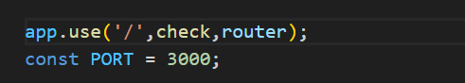
-Even this is also works
InBuilt Middlewares:
1.express.json():
-used for parse json to js object and gives req.body
2.express.urlencoded():
-used for x-www-form-encoded
-reads form data and converts into js object and allow us to use req.body
-It receives data as query string only
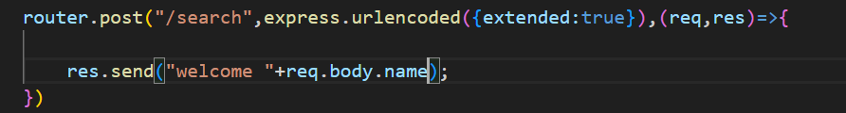
Extended:
-Tells how to parse
-false->uses querystring module to parse ..best for small data
-true->use external qs library to parse…best for complex and nested objects
3.Express.static(foldername)
-Allows to access file ,img, etc via url
-instead of defining route for each…we can allow all files to access via url
-starts searching in local disk from current running application path
-goes deep untill it finds
-in url..directly call finename
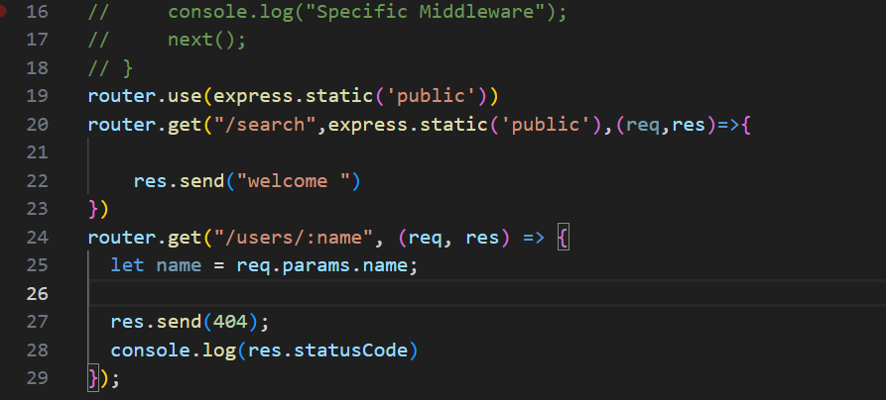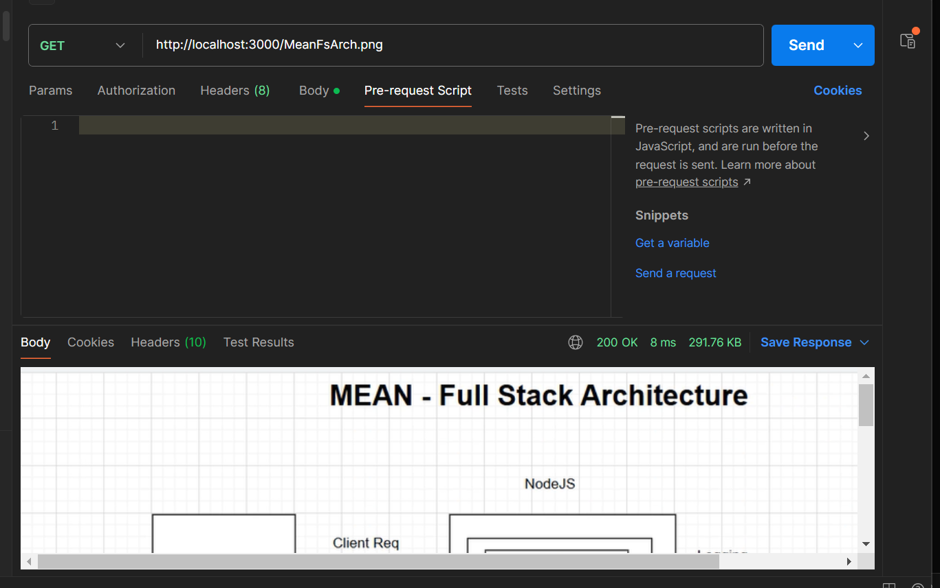
-Here express.static is defined globally in route file
-So every request executes this
-returns file if file present..else next() internally
-public is folder name
-ignore that search path one
-if u want use static for specified urll….make sure file located in same url flow directory
4.Express.text()
-uses plain text and makes parse it
Note:
even if the data is correct, but Content-Type is wrong, the built-in middleware may:
- ignore the body
- or fail to parse it
- or leave req.body empty {}
Third Party Middlewares:
-present outside of express
-use npm install middleware_name
-then import In file and use it
1.morgan:
-usefull for logging purposes of incoming requests.
-morgan(format)
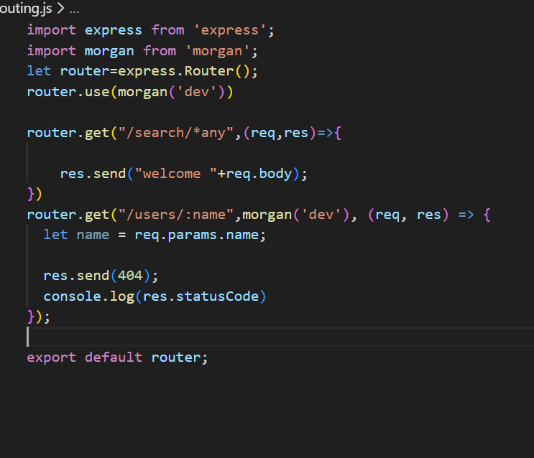
And output would be

-last is content length of res In bytes
Types of format:
dev-developer mode consoling and includes color for status code
Combined-full apach format including many details
2.CORS:
-use npm I cors
-app.use(cors()) allows everyone to access api
-so we configure in obj and pass app.use(cors(obj))
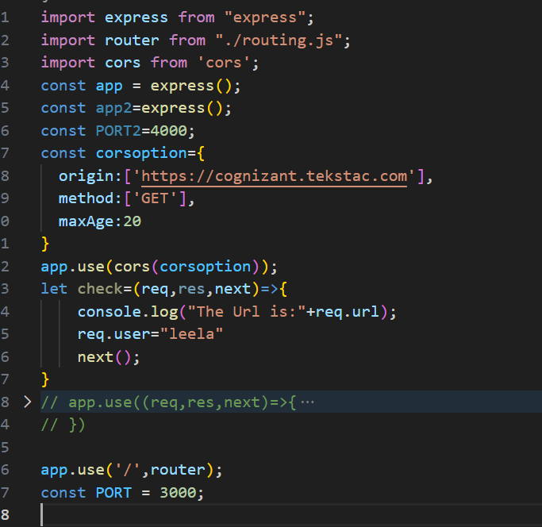
-configurating obj:
1.origin:
-Tells who can access this server api’s
-takes string (only 1), array, boolean(true indicates allowed to all …false ->no one), function is for custom allowings
2.methods: type of methods api…only delete,put,patch is checked..for post,get..it wont check
3. maxAge: time for browser in secs..telling to browser no need to ask me for next n secs
But server cors for every req…only brwser stops checking if we use maxAge
4.allowedHeaders: allows req if it has specified headers..takes [headers]
But it allows defaultly in built headers without restriction

Note:
Access-Control-Allow-Origin/Headers/Methods—is a prefix used by server to tell browser that I allows these methods/headers/origins
-So that browser compares requester data and returned data by server and then allows js to have it…else throws returned data
Prority->origin > methods> headers
3.cookie-parser
-use cookieParser in import
-app.use(cookieParser());
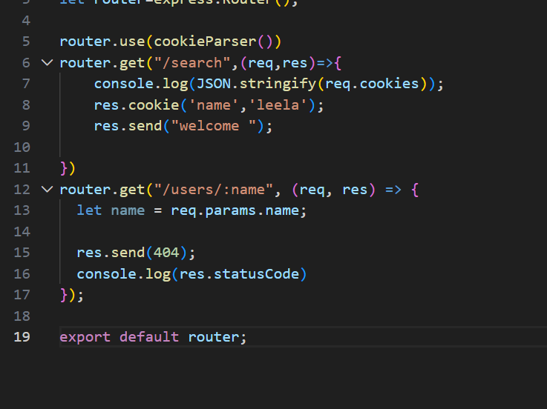
-used to parse cookies and allows us to access req.cookies
-req.cookies gives us an object where cookies are stored as key value pairs
-res.cookie is a method of expressjs built in
-res.cookie allow us to create cookie via server side
-res.cookie(keyname,value,options)
-value can be object too
Options:
signed:true:
-it modifes cookie to non editable coookie value
-usually it makes this cookie into signedCookies object
-signedCookies is an object which holds non editable cookies by user
-cookieParser() makes this work
So signed:false -> req.cookies and signed:true->req.signedCookies
-secure data is stored in signedCookies only
-when user edits cookie..it goes to req.cookies from req.signedCookies since we are destorying the usage ..internally cookieParser() does this.
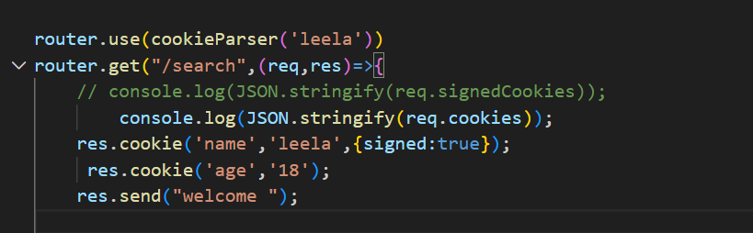
Name would be in signedCookies and age would be in req.cookies
Secure:bool
-true->send this cookie in req only if it is https request protocal
-false -> send this cookie in req even in any protocal
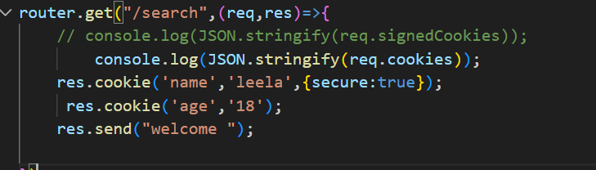
httpOnly:bool
-only allowed to access/set/edit in server side
-document.cookie is unable to access it
maxAge: n
-By default cookies are session storage
-automatic deletion
-takes ms
-starts from cookie arrival to browser untll n miliseconds
clearCookie(cookiename):
-clear cookie using key
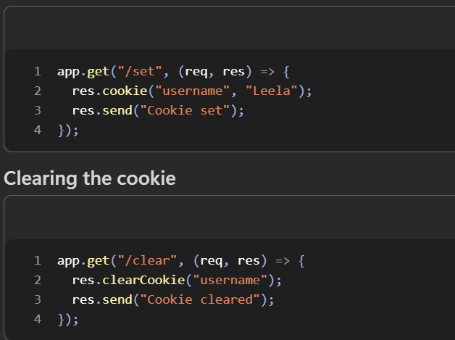
4.express-session
-cookies browser side
-express-session allows data to stored in server side
-high secure since user unabel to edit
-use ‘session’ to import
-only returns a id to browser…
-allows to have req.session which is js object to store data
-req.sessionID is a sessionID for specific user
-only req.session not …res.session
-cookies are path based and sesssion is user based
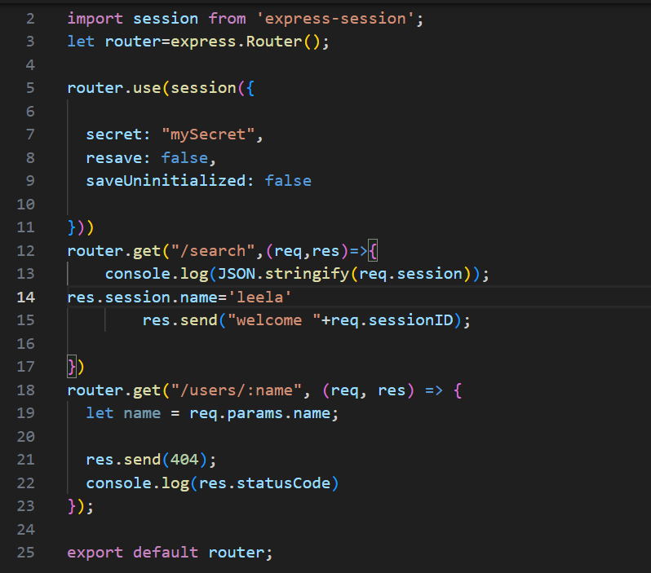
-session takes object to run
-configuring session:
1.secret: string used to create sessionID
2.resave: for every req ..update session data
True->update for every req even no change
False->update only when change
3.saveUnintialized: to save
False->create a session even server did not add any data explicitly
True-> creates when server adds data to session obj explicitly

5.body-parser():
-used in older versions..
-latest verison embedded directly in inbuilt
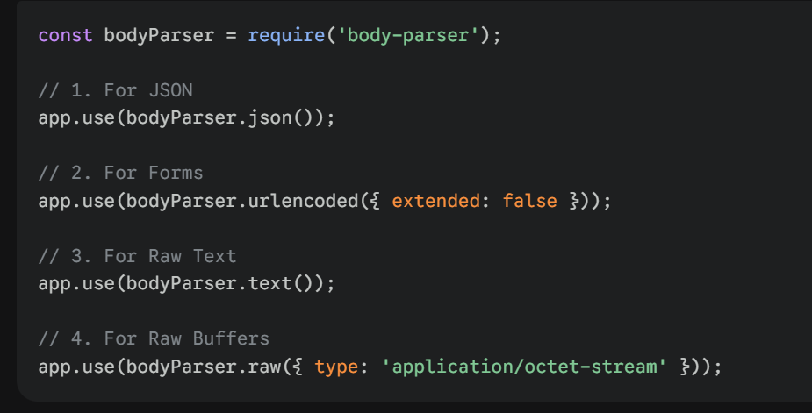
Just like express built in middle ware for data reading…
Templating and Rendering:
-SSR
-create webpage in server and send to browser
-uses view engines to do in express
View Engine: Allows us to create templates and render to browser from server
-EJS is a view engine that we are going to use
EJS:
-Embedded Java script
-it is a view engine
-npm install ejs
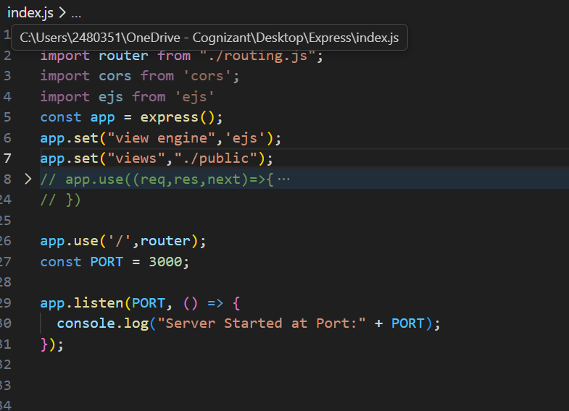
-app.set() used for configuring server instance
-app.set(“view engine”,”ejs”)-> sets view engine as ejs
By default no view engine for express
-app.set(“views”,path)-> tells where template files present
Path end should be folder with template files
By default app.set(“views”,”currentdirctory+./views”)…
Templating:
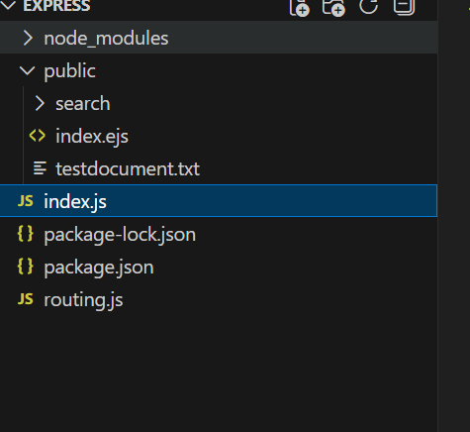
-fileext should be .ejs
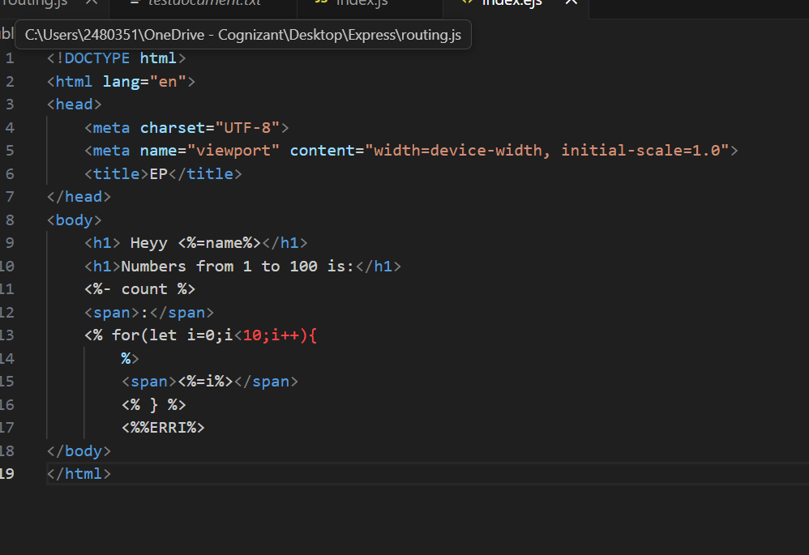
-just a normal html with some tag functionalites
EJS tags:
<%= %> -allows dynamic content that we pass on rendering //called as escaped tag/output tag
<% %>-allows js code //called as scriptlet tag
<%- %>-takes dynamic html content // called as unescaped tag
Rendering

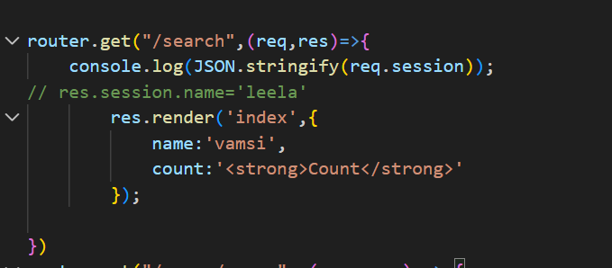

-in url, we send html file using .render()
-.render() takes 2 args
-1st arg ->filename and 2nd arg ->dynamic content values object
-.render() also ends response like send(),json()
Note:
-Template is a file which we write html code or ejs code...view is a template which rendered and forwared to browser
-To add css,js files..you speficy in ejs file with path filename directly
-Because…we need to put all files in a folder
-make folder as express.static(folder)
-after rendering..browser takes look at filename.css specified in view…and assings to it

Form-Data:
-Data that goes with normal fields and files
- x-www-form-urlencoded takes only normal text kind of data and encodes in url and allows those data In req.body as js object
-But form-data takes normal data also with files,images etc
-content-type is multipart/form-data
-Express cant read form-data directly..
Multer:
-3rd party middleware
-usefull for form-data parsing
-fields -> non-files data
-files->files sent by user
-req.body will have fileds
-req.file will have file that user sent
-req.files will have arr of multiple files
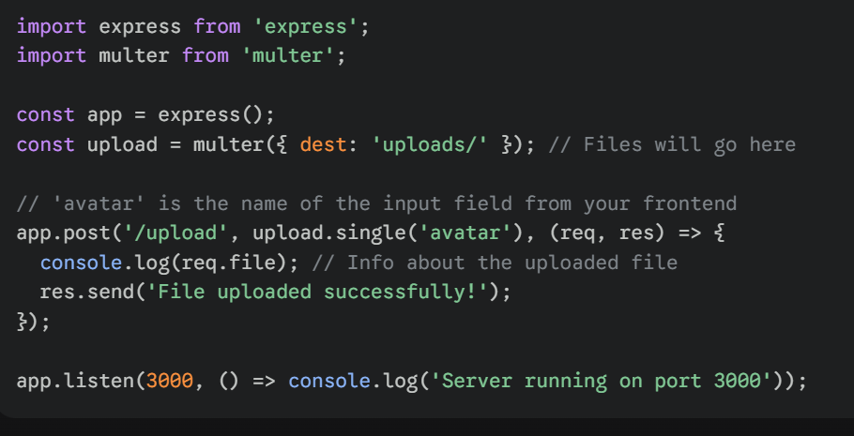
-uploads holds multer instance
Methods in Uploads:
1.single(‘fieldname’) : only one file can be sent
-name attr should have this same fieldname
2. .array(fieldname,maxcount): same fieldname but multiple files sent at a time.
-name attr is same but multiple files sent at once
-internally it enables req.files which is an arr with [file1,file2….]
-maxcount->max files…creates error if exceeds
-req.files woould have arr
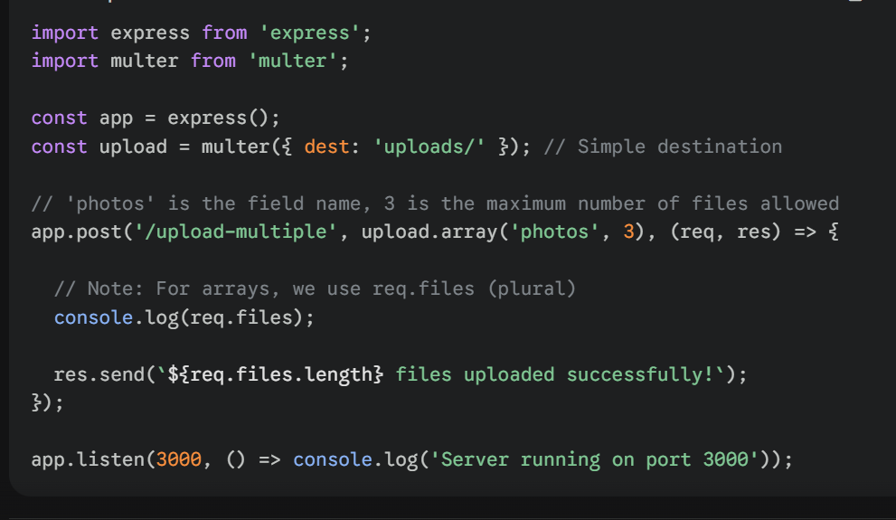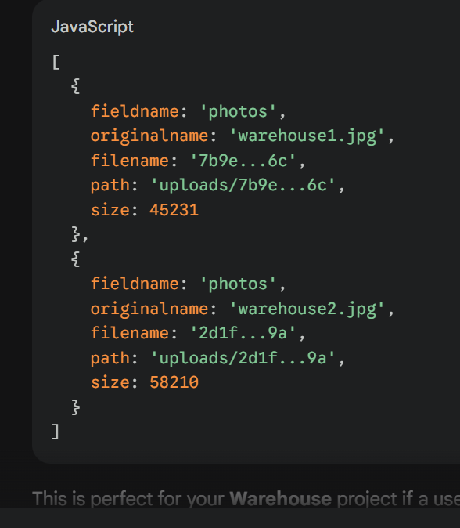

3. fields([{name:filedname,maxCount:count},{}]):
-Allows different fieldname along with multiple files for each fieldname
-creates arr of each filedname internally
-req.files would have object here
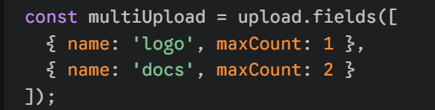
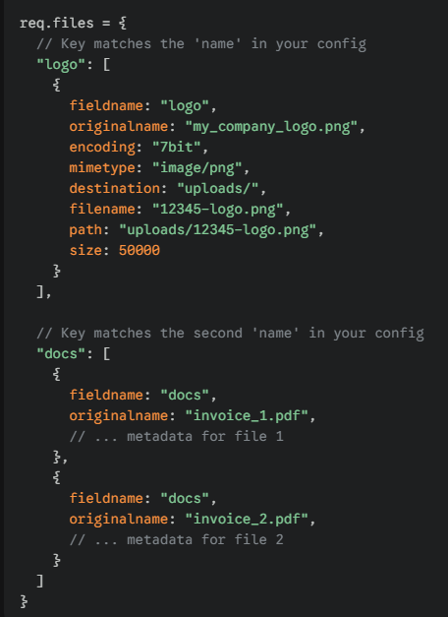
Configutring Multer :
1.storage:
-uses multer.diskStorage method
-takes object
-two properties destination and filename
Destination:
takes a req,file,cb
-file is object that contains file meta deta
.originalname // fileoriginal name of user’s data
.fieldname //fieldname in frontend
.mimetype //type of file
-cb is fn which 1st arg is error, 2nd arg is path
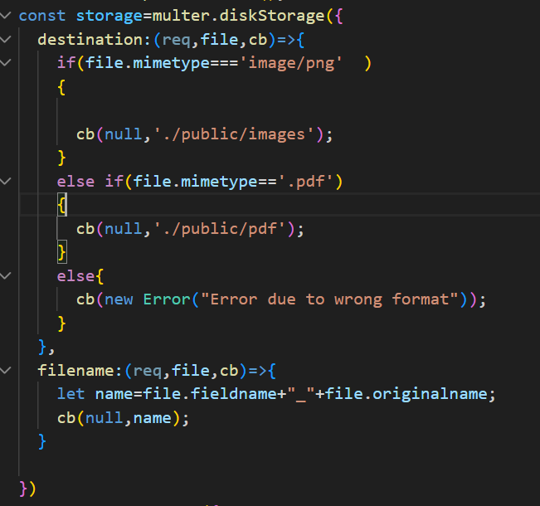
-null if no error
-cb intenrally handled and saves file in the particular path
Filename:
-same desgin but cb second arg is different -> it takes name of file
This data should be passed in storage property in multer instance creation….
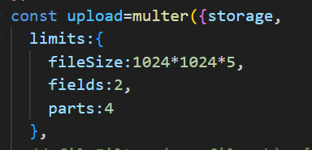
2. Limits:
-restrictions on data that we receieved
-fileSize in bytes…//filemust be less than specified
-fields:number // no of non file
-files :number //no of files
-parts: number // fields+files+1 ….1 is because..last part of data says no data left..
3.dest:path
-simple way for destination
-creates if no path exist but storage is not
4.fileFillter:
-Takes same req,file,cb
-cb 1st arg is err and 2nd arg is boolean
-boolean decides to allow to store or leave it
-false does not throw err…just stops storing it
-throw err if u filter hardly
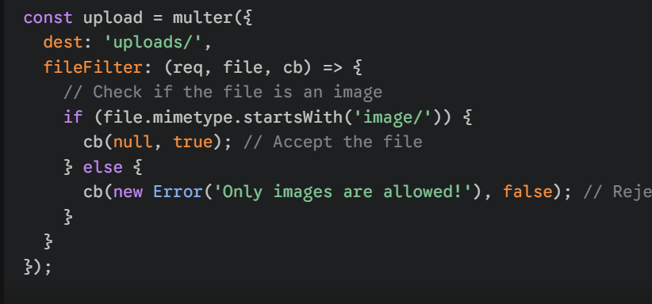
Global Error Handler:
-Error handler for any errors of particular file
-must be at bottom of file
-takes 4 args
-err,req,res,next
-err should be first
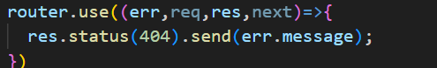
-any errors in multer…we can simple handle using this
Order of Execution of Multer:
Limits->fileFilter->storage

RestFull API’s:
-stateless …every req should get full data
-performing action on resources
-methods…get,post,put,patch,delete
-define path, middle ware, route handler
Status Codes:
Success codes:
1.200 – Req made and ok ….GET method should return this
2. 201- req created-> server created data ….POST should return this
3. 204 – req done but nothing to return ….PUT,PATCH, DELETE uses this
Client Side Error codes:
1.400: Bad Request…Server expects another content-type
2.401: UnAuthorized
3.403: Forbidden
4.404: Not found
5. 422: unprocessable entity -> invalid data but syntax and content type is right
Server Side Error codes:
1.500 : Internal server error…unhandled expections
2.502: Bad Gateway…issues related server to server communication
3.503:service unavailable…overloaded ..or …maintainence

Note:
-req.is() a method for checking available content type..
-req.is(‘application/json’) , req.is(‘image/*), req.is(‘text/plain’)
Error Handling:
-global error handler uses for error catches
-express may pass some error automaticlly
-some needs manual

Automatic Errors Handled by Exp:
1.sync errors …type error, manually reference error
2. Async errors….automatic promise errors ..not timeout
3. when you call next(err)
Manual Errors handled by Exp:
1. callback errors
2.logical errors
3.path errors
4. set timeout errors

3rd party Middleware for Error handling:
1. http-errors:
-npm I http-errors
-used to create simple http errors
-needs global error hanlder too..
-only 1 method…createError(status code, message)….
-message is customizable
-we can create error in 2 ways
1. new createError(404,’network issue’);
2.throw CreateError(404,’issue’);
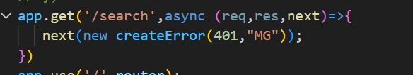
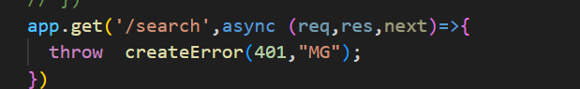
- status can be accessed by err.status
- messgae can be accessed by err.message
- only for http -errors
Catch All error handler:
- used for wrong paths
-catches and throws to global error
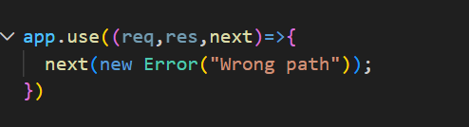
-should be at bottom upon global error hanlder

Scaffolding:
-Automatic generation of project structure for express js
-use express-generator package for scaffolding
-express-generator is scaffolding tool
Steps for Scaffolding:
-npm install express-generator -g
-cmd -> “express project_name”
-creates a folder with predefined structure
-install dependencies using npm i
-start using npm start
-can use nodemon just like how we use
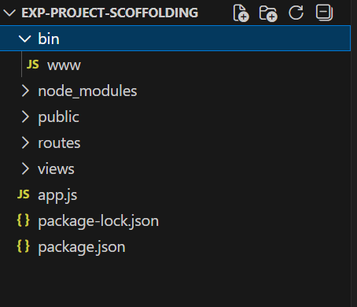
-gives structure like this
1.bin:
-contains start files
-creates and listens the server
-conatins lowerpart of app.js of our code
2.public ->static serving files
3.routes->route handling
4.views->rendering
5.rest are same
-we can folders below of package.json like controllers,middlewares
Express JS Server for Production:
-Express runs optimally in production
-Priortizes for performance and Security
Methods to follow for production server:
1. use env file for sensitive data
Dotenv:
-package which allows data of .env file for process.env by parsing
-bridge b.w .env file and process.env
-usually nodejs unable to execute .env file since we are not using exports and also it is not js file
-npm i dotenv
-in common js -> const dotenv=require(‘dotenv’).config()
-in esm-> import ‘dotenv/config’
-config() -> runs immediately which locates .env file and parses and gives to process.env
-searching done in root level by default
-mostly .env should be in root level such as level of package.json,nodemodules
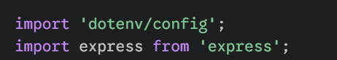
And this would be in app.js or www of bin
In env file ……..
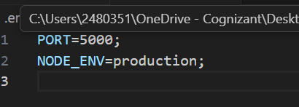
-stores in key -value pair
-key should be uppercase along with _ without spaces
-key=value and it is customizable except some varibale like PORT,NODE_ENV since express libraries use this key only
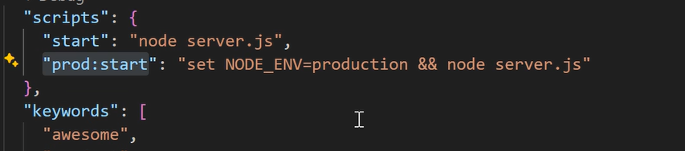
-2nd way for setting production level server
-use npm run prod:start …not npm start

2.use PM2 for production:
-pm2 is process manager 2
-used for managing server like node,nodemon
-node is terminal locked…i. e if we close terminal….server stops
-nodemon is also terminal locked but restarts If we had changes..
-These both used in dev mode
-But,,,,,,,,,,,,,,,,,, pm2 is a package which allows a server to run even it got crashes in it.
Benefits:
1.server got crashed->pm2 automatically restarts…node or nodemon need manual startup
2. closed terminal…still pm2 allows server to run in bg
3. uses cluster module internally…so no need of manual setup for optmization
4.provides usefull commands to control server
5.Internally maintains a table with all process it got allocated to…
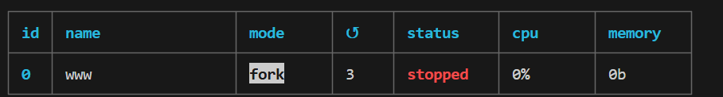
Commands:
1. pm2 start process_name : starts application
2. pm2 stop process_name :stops application
3. pm2 restart process_name : kills existing process and starts again with new process_id and cpu core…
-meanwhile killing and starting…if delay is 30 sec,..for 30 sec user gets sevrer error
4. pm2 reload process_name: creates new one and then allocates old to new one and then kills old one…so no problem in user experience
5. pm2 delete process_name: eraes from table and kills it
6.pm2 kill : Stops pm2 itself
Note:
-pm2 wont restart for code changes…manually use reload or restart

3.Gracefull shutdown:
-normal shutdown -> kills immediately and stops process even it is still working
..bad practice
-gracefull means compeleting current task and then execute it
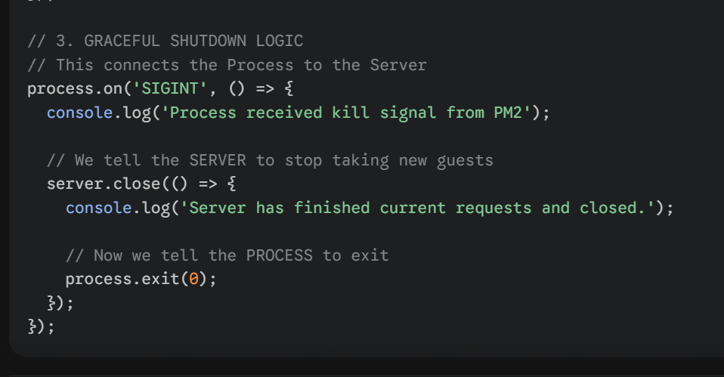
-sigint will be triggered when it got signal about to stop

When your code hits the line server.close(), two things happen immediately:
- The "Front Door" Locks: The server stops accepting new connections. If a new user tries to visit your site at that exact millisecond, they get an error.
- The "Wait" Begins: The server stays alive to finish the requests that were already inside the building.
-so we kill the process inside

4.serve static files correctly
5. Global error handling
Securing Express JS Server:
-usually express sends some automatic headers for every response
-That headers include server desgin and some other data..
-So hackers from browser can easy find ways to crack it
-So using helment middleware….it hides some headers, add new headers to tell browser to be strict..
-just install and use it as soon as possible
1.Helmet middeware:
-middleware to protect server
-It adds 15 layers of security headers that tell the browser to be extra strict.
-Those 15 are middlewares only used by helmet internally
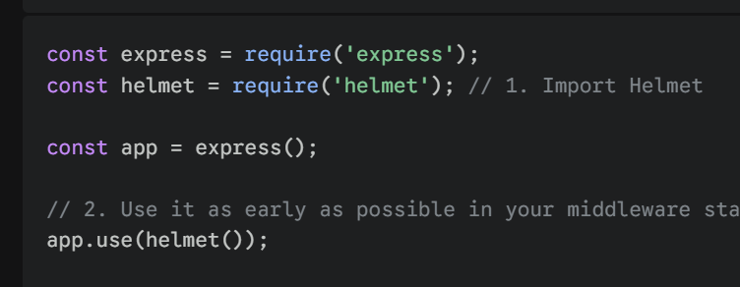
2.validate user input
3. use dotenv for sensitive data
Optmizing Express JS Server:
1.compression middleware

-used to zip the response so that it can travel fast in transmission
-then browser receives and unzip it
-fast transfer since size gets reduced.
2.minimize responses

PassportJS:
-a package which allows authentication effectively instead of writing code from scratch
-not only for authentication …also makes user stays in session
-npm I passport
-passport-local : Allows login using username and pass if these are like in local server
-passport-facebook: for facebook login
-passport-google-oauth20 : for google login
Flow:
-flow must be same
1.passport.initilize():
-allows passport to initialize
2.use app.use(session({}) ..since passport depends on session
3.use app.use(express.json()) and app.use(express.urlencoded({extended:true})) since passport has to parse data for login
4. passport.session()
5.passport.authenticate(‘name’,{}):
name is name of strategy
Options:
1.successRedirect:path
2.failureRedirect:path
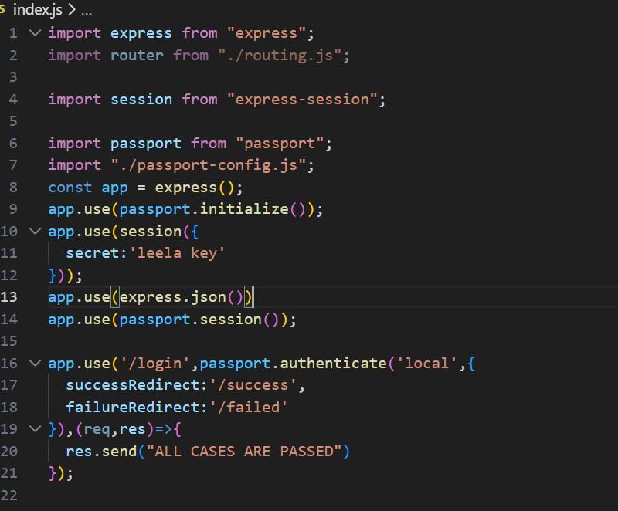
6.implementing strategy:
-import Strategy from passport-local
-strategy means how to validate user data
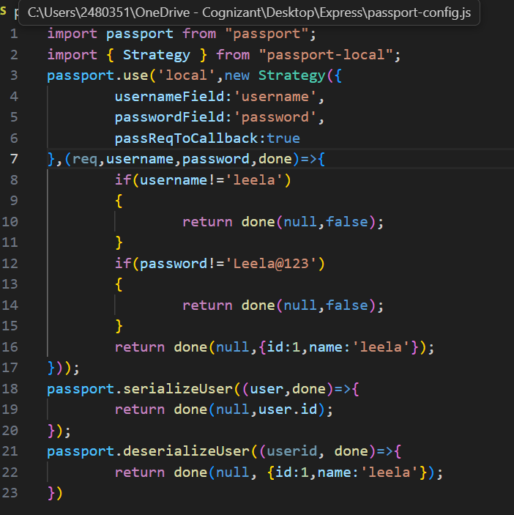
-here passport.use will be run when passport.authenticate got executed by express
-1st arg is name and 2nd is obj of Strategy
-Strategy takes 2 things …1st is options and 2nd is function
Options:
1.usernameField :value
2.passwordField:value
3.passReqToCallback:boolean //to pass req obj to callback or not

These values should be same as fields in query parmeter or body
Callback:
If passReqToCallback :true -> args would be (req,username,password,done)
Else -> (username,password,done)
-check password and username
-done(error,data)
-if u pass data as null…automatically it goes as error only
-always error wuld be null
Like data(null,null) if false and data(null,{id:1,name:’leela’})..
.serializeUser(data,done):
-runs for every succesfull login
-stores data in session
-uses as done(null,data.id)
-pass unique id …so that it can be used to retrieve later
.deserializeUser(data,done):
-runs for every request of user
-gets data and stores in req.user

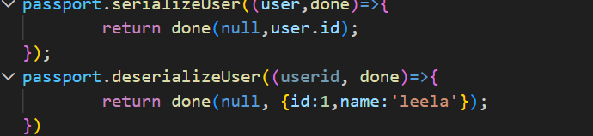
Req methods added by passport js:
-req.isAuthenticated() //bool value
-req.user // data from deserializing
-req.logout((err)=>{}) //usefull for deleting session of user login data from passport js and req.user=undefined
Note:
-if we use ‘local’ as name in passport.authenticate…it will directly usse full for LocalStrategy..
-also need to import Strategy as LocalStrategy
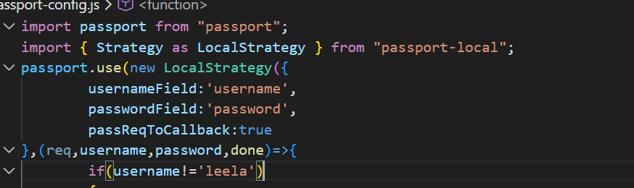
No need of ‘local’ path in 1st generation
CSRF:
-Cross-site-Request-forgery
-Evil site uses browser to send a request to any user-logged-in browser….
Hacker got data
Server thinks user sent a req and perform actions
Browser attach cookies automatically and sends cookies
Browser thinks user sent req since user has cookies and logged in
Website tries to access browser and sends req to any bank.com website
Any Evil website
User is using
-this is crsf attack
CSRF Protection:
-sends csrf token to client on first contact
Flow:
-user logs into website
-1st time-> server creates token and sends back to client in cookies form
-else -> checks csrf token on every request
-browser receives cookies and angular uses cookies and sets header if token is present for evry http req..because angular desgined like that
-Default cookie name is XSRF-TOKEN.. we can rename but config in angular..
-angular sends req along with token every time
-server compares header value and cookies value…
-But in hacker point of view…he can write his own req and sends req to bank.com
-Since no token is present server rejects…
-Why cant hacker access token>>>??
--hacker just take advantage of automatic cookies from browser but browser wont allow hacker to access cookies..so token missing…
-also hacker unable to access your angular code for req sending…so no attack…
Csrf-csrf:
-package for csrf protection
-needs session cookie-parser middleware
-has main methods doubleCsrf , generateCsrfToken, doubleCsrfProtection
doubleCsrf:
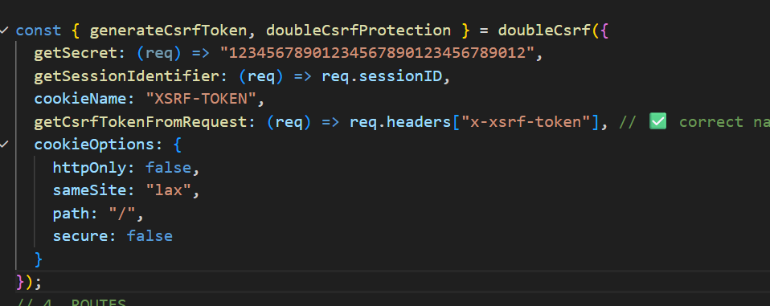
-used for configuring how protection should be
-takes object
-obj:
-getSecret -> used to create token
-getCsrfTokenFromRequest: telling package to look for a header with key
- getSessionIdentifier: requires sessionId of user to be more secure
-cookieName: key of cookie that send to browser later
-headerName: customizing header name that should match clientside
-cookieOptions: how cookies should be
{
sameSite:’strict’ || ‘lax’ // cookies will be sent if req from same site for strict..for lax…any site may send req,,,browser attatch cookies
httpOnly,secure
}
generateCsrfToken(req,res):
-used to create token for new user
-automatically adds cookies with token
-return token
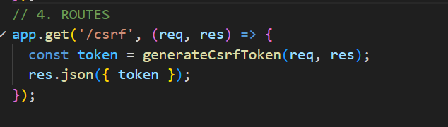
doubleCsrfProtection:
-middleware checks cookies and headerr value internally…
allows if both has same token
-must place for post,put,delete,patch

JWT:
-json web token
-created by server-> provides to client-> client send token every req->for every req it tells server who is using the resourse
-npm I jsonwebtoken
-use express.json() at first
-contains 3 parts -> header..payload…signature
-header deals with algorithm of hash
-payload is the main data that we stored about user and it is base64 encoded
-signature is used to avoid tampering the token and it is hashed
Methods:
1.sign(payload,secretkey,options):
-used for create token
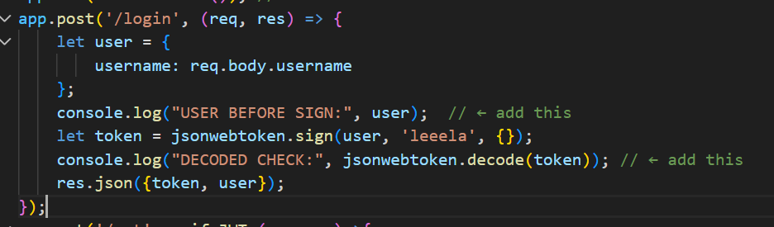
-options:
1.expiresIn: 60 | ‘1m’ | ‘1h’| ‘1d’| ‘1M’ | ‘1Y’
-expires the token and above is in order
2.issuer: ‘issuer name’
2.verify(token, secret, (err,data)=>{}):
-verifies token Is correct or not
-if not err triggers
-if not data comes
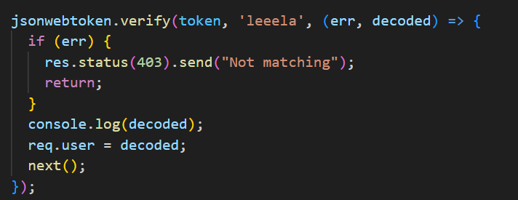
3. decode:
just returns payload of token
Passport js using JWT:
-we did using session last time
-now jwt
Flow:
1.passport.intialize()
2. Passport.authenticate(‘name’) directly skipping session
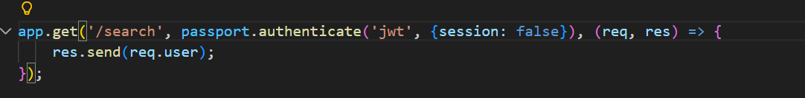
-no session needed right…so session:false and successRedirect, failedRedirect Is for session based passport
3.define strategy
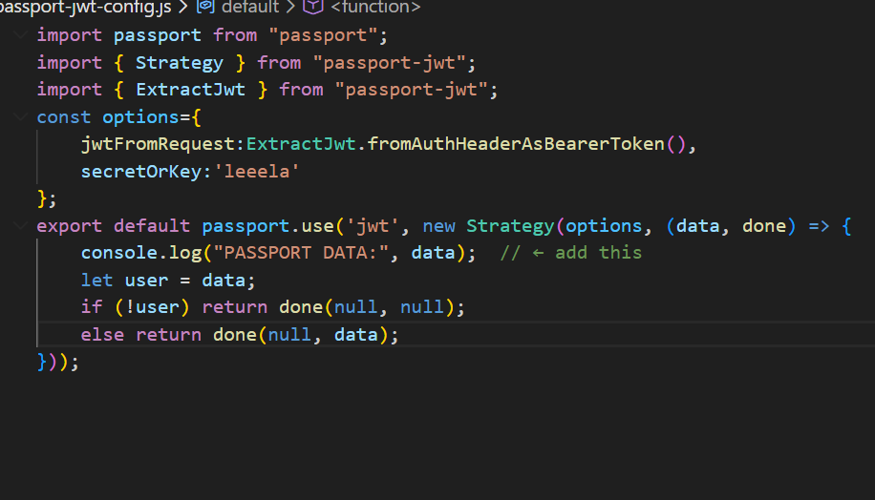
-ExtractJwt is used for extract token from request
-fromAuthHeaderAsBearerToken() is used when authorization has Bearer word
-fromHeaders(headername) …when no bearer is used
And it needs options like jwtForRequest and secretOrKey to verify
-in strategy , internally it uses jwt.verify() only…
-done(null,data) automatically sends data to req.user

Validation:
-express does not have inbuilt validation
-express-validator middleware is used
-import 2 things,….body, validationResult
-these are standard names
-just write logic in middleware place
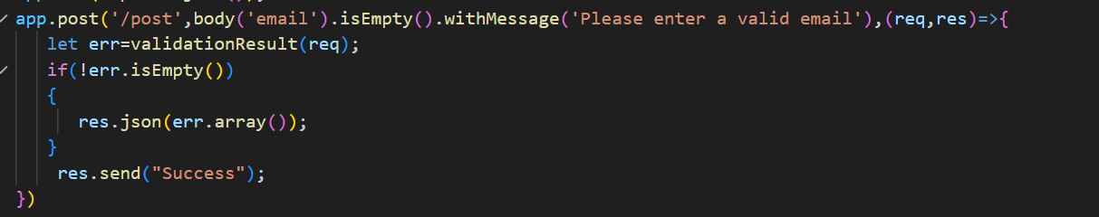
-syntax… body(‘name of field’).method().customerrormessageiffailed(‘’);
-body(‘’) takes field from req.body …so use express.json() before
-method() checks action..if true-> no issue
-if false-> stores error in validationRequest and also reads withMessage()
-withMessage() custom msg read only for error cases
-extract error and check errors exist or not
Validation Methods:
1.isEmpty() //true if empty else error
2.notEmpty() //true if not empty else error
3.isEmail() //perfect email validation
4.isInt() //only numbers not 3.55
5. isNumeric()
6.isAlphaNumeric()
7.isBoolean()
Error Methods:
1.error.isEmpty()
2.error.array() //returns array of errors
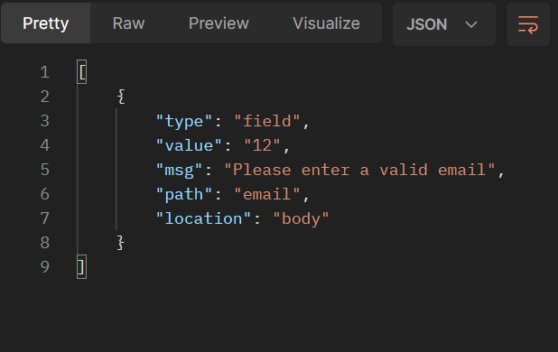
3. error.mapped()
-returns a object with key name and error
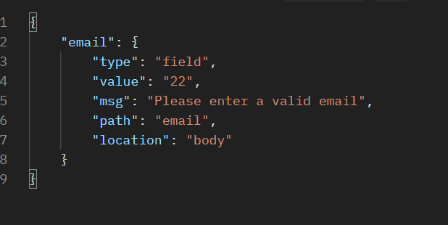
Custom Validators:
1.using .withMessgae() as above
2.using .custom()
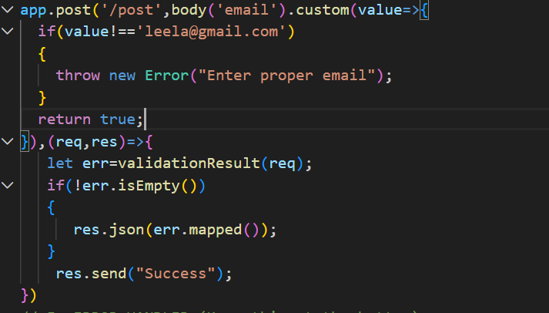
-if false throw new Error which stored in validatioResult
-if true-> no error
-return true or throw error
Testing:
-for basic…we can use supertest module
-npm test
Runs that u defined in package.json
-npm test –filename…runs only that file
Mocha:
-testing framework for js
-npm I mocha
-in scripts for paclage.json ..-> put “test”:’mocha’
-also include in devDependencies
-Mocha is test runner , not testing library which provides methods
-searches for test folder and executes automatically
SuperTest:
-Used for Basic Test cases
-Http response, status code
-Automatically sends request
-powerfull flexibilty
-asynchronous
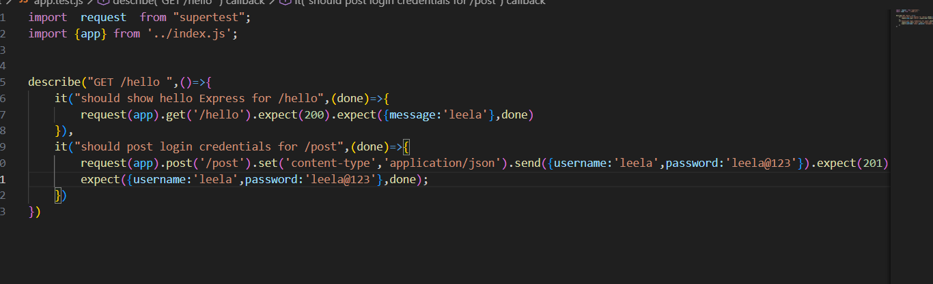
-request(app): provide server for supertest
-.get(‘/path) : just send path that u need to test
-post(‘/path),.put(‘/path’) etc
-.set(key,value): sets headers
.expect(statuscode): checks sttauscode of http response
.expect(final response, done): if res.response = final response ..done is true
Else error
Methods by Mocha:
Describe :
-came from mocha
-allows multiple test to run as group
It:
-single test case
-done is cb which tells mocha to end this case
Before():
-runs before all test cases
After():
-runs after all test cases
beforeEach():
-runs for every req before
afterEach:
-runs for every req after
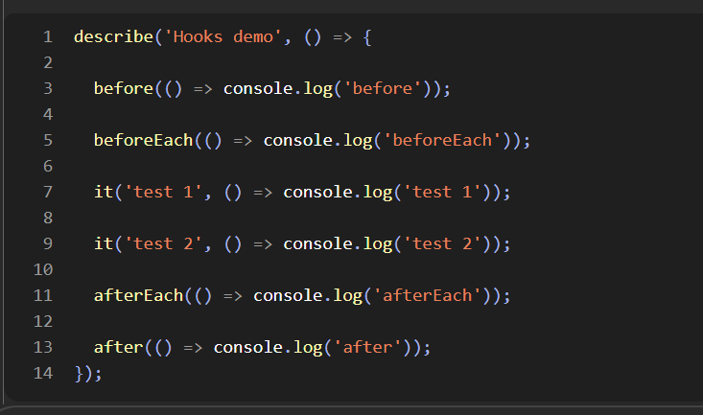

NOTE:

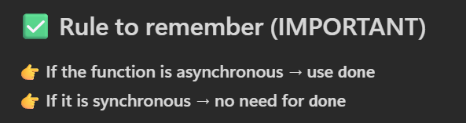
-before,after,etc can take done as parameter
Chai:
-Tool for read and compare data
-mocha just a tool that provides facility to test . but mocha cannot read data
-chai used here for functionality of expect() method
-expect automatcally throws error if it gets failed
Chai-http:
-a middleware used for fake http requests
-must put in .use()

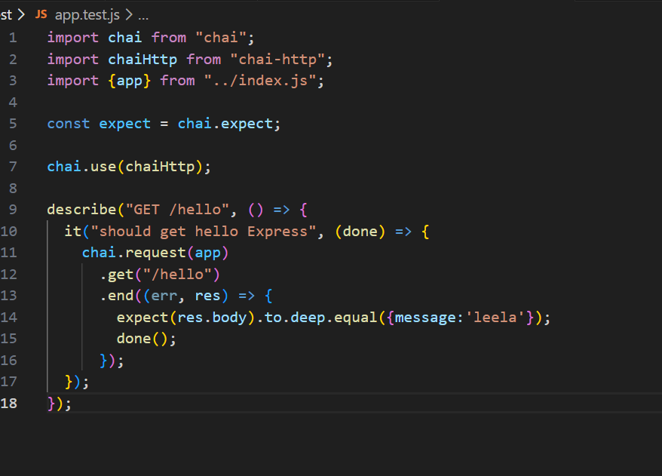
-instead of supertest…we are using chaihttp..
-chai is expect() and chai-http facility for request
-uses end(err,res) at last to handle response
-there are some methods
to.equal(val) for primitve
to.deep.equal(data) for non primitive
to.have.length(val)
to.include(data)
to.be.true
Sinon:
-used for spy functions and deal with functions
-works only for common js
Spy:
-checks func called or how many times called or with what values u have called
-the functions must be wrapped in obj..or in testing file export as object
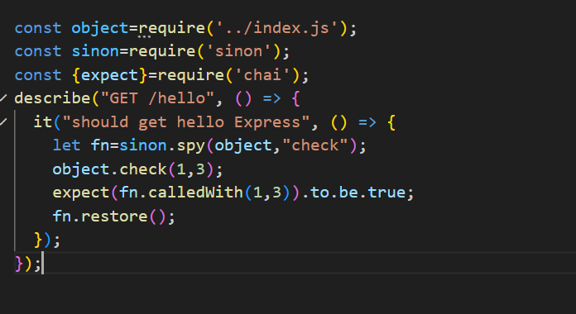
-spy takes 2 args…object and fn name
-execute fn..this executes real fn
-spy got attached and checks
-has methods like .called , .calledTwice, .calledThrice, calledWith(params)
- n times.. use .callCount with to.equal(n)
-must restore() else spy would be permenenant
-restore() unspies
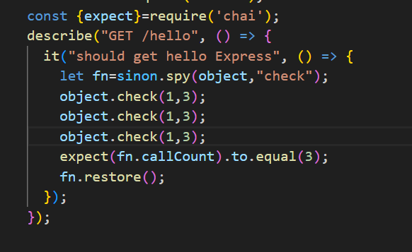
Stubs:
-replaces entire function with custom return value
-if a fn 1 need to run another fn 2 ….but fn2 has 1000 liness…but we return value
-simple stub allows us to replace 1000 line with return value , so that we can test fn1 optimally without testing and running fn2 ..
-optiml way of testing is main use of stub
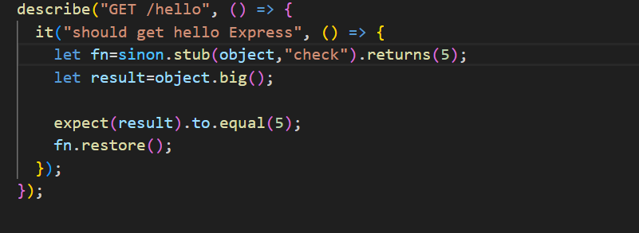
-big depends on check() internally
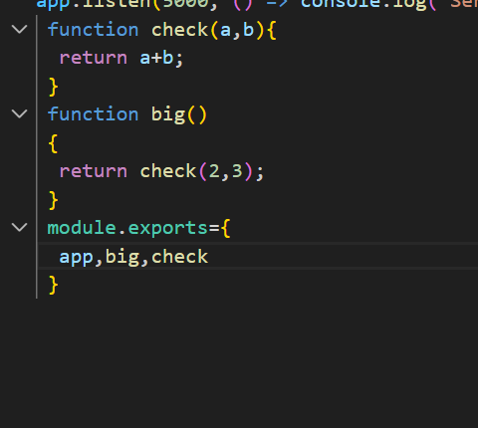
-stub also has same function as spy like called,calledOnce etc
Testing Functions:
-directly store result and check using expect
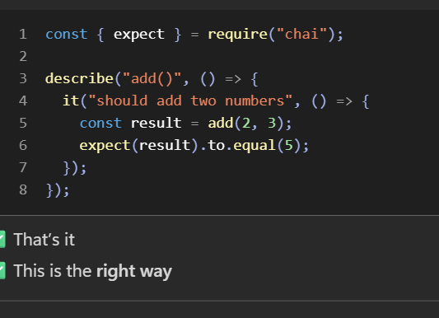
Testing callback:
just exeucte that higher order function and put expect in cb…and must put done() in cb
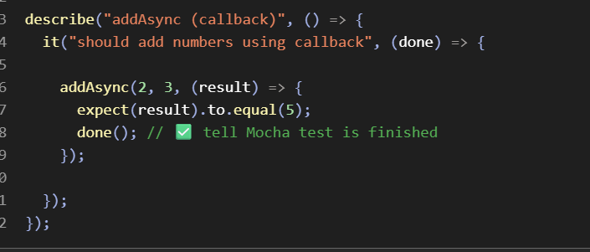
Testing promise:
-just use normally and check using expect
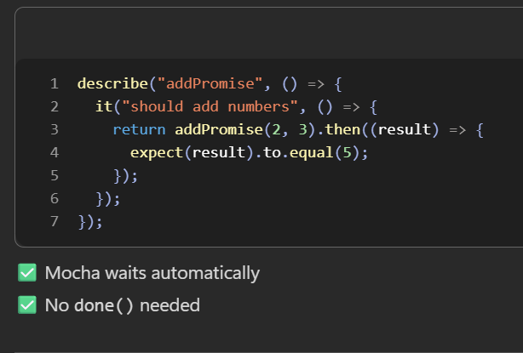

Jest:
-testing framework like mocha
-but mocha needs chai,sinon
-jest contains all tools internally
-same syntax of mocha only
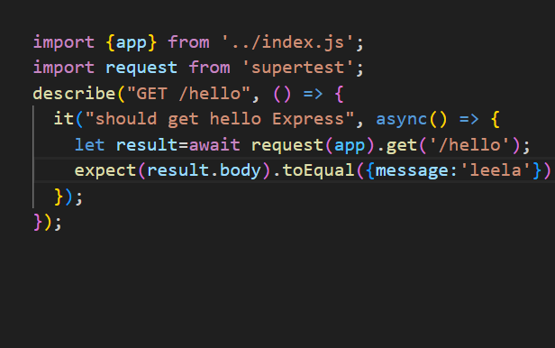
-replaces chai by providing inbuilt exprect() along with
-toBe // same as to.equal and to.be also
-toEqual //same as to.deep.equal
-toContains // same as to.include
-toHavingLength // same as to.having.length
-but jest cant replace chai-http…so use supertest

Testing Coverage for Jest:
-npm test -- --coverage
-works only for jest
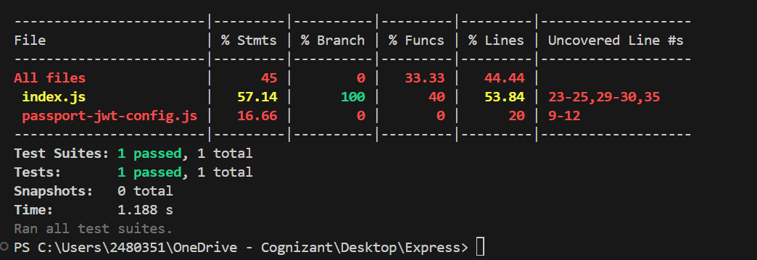
Stms-> executeable statements
Branch->if/else switch etc
-fun->functions
->lines ->total lines
Test coverage for Mocha:
-use c8 library
-npm I c8
-put “test”:”c8 mocha”
-run npm test
-runs testcases also generates coverage at a time
