Node JS
-Js runtime environment
-Nodejs is a engine to run js outside broswer
Architecture:
-same as js
-single thread, non-blocking, event-based(responds to events instead of waiting for result).
SetUp:
-npm init -> setup
Modules:
-uses commonjs module system .
require -> for import
module.exports -> for export
-uses esm in latest versions…same as angular/js
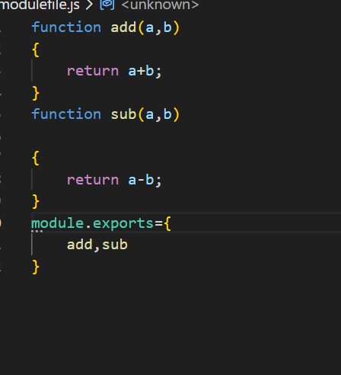
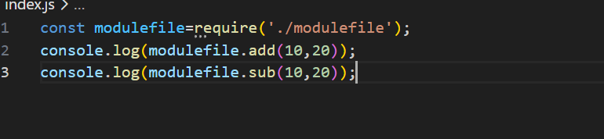
module.exports can hold any type and returns..
module.export= function ()=>{} can be possible.
module.export=[1,2,3] also possible
module.export=”leela” also possible.
To combine all,. We use object.

File System:
-readFile
-takes 3 arguments
-path, format, callback function (error,data)
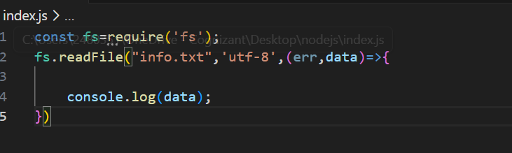
Err-> error object
Data->data from file
-readFile is non-blocking( i.e Asynchronous)
-readFileSync
-blocking and synchronous
-takes 2 things
-path and format
-returns data or throws error
-try catch is must
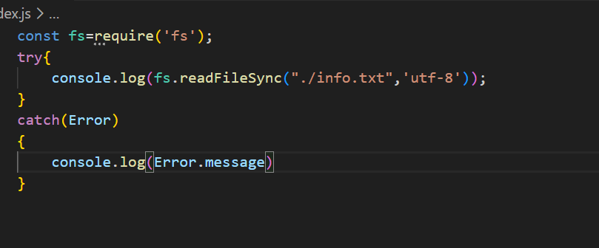

writeFile:
-takes 4 things
-path,content,format,callback function
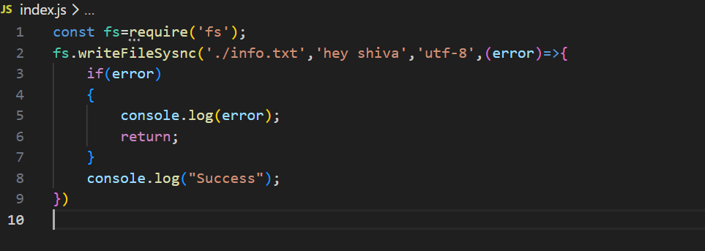
-creates file if no file
-callback function only have error
-non-blocking
writeFileSync:
-takes 3 things
-synchronous
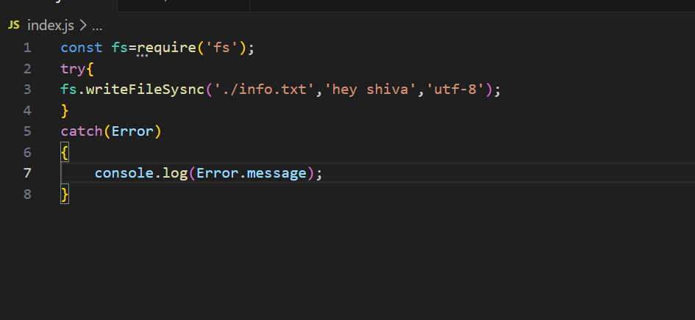
Update:
appendFile:
-takes 4 things
-same as writeFile
-use \n for new line
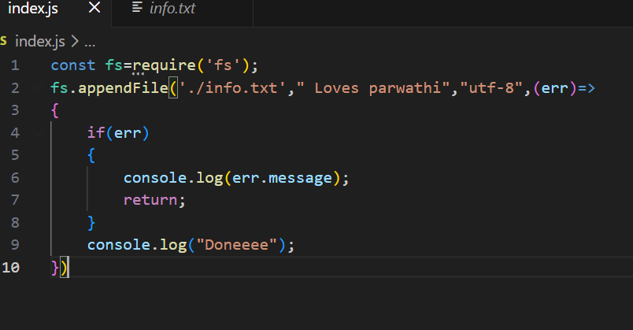
-appendFileSync also same but no callback function and use try catch
Deleting Files:
Unlink:
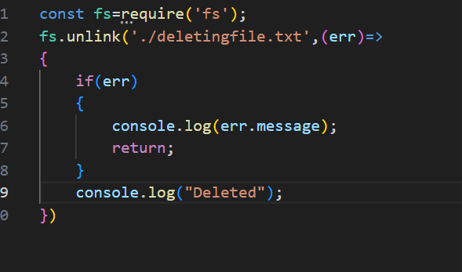
unlinkSync:
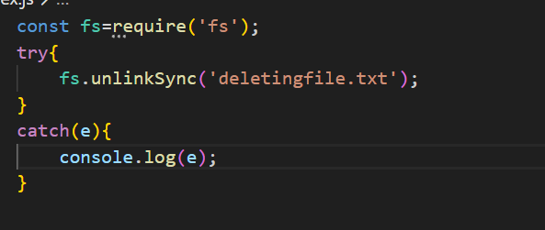
Truncate:
-Modifies file
-Keeps only 5 bytes in the file
-takes err callack fn

existsSync:
-Allows to check file exist or not
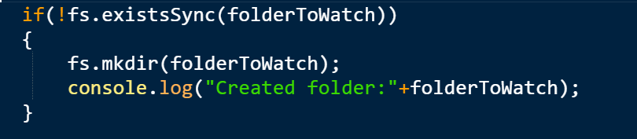

Handling Directory:
1.Making Directory
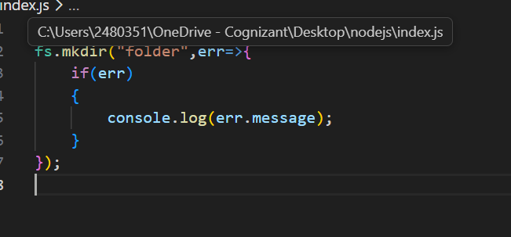
mkdir method allows to create a folder.
-takes foldername and callback fn
mkdirSync also available but without callback function
-creating same folder again gives error
-ReadDir:
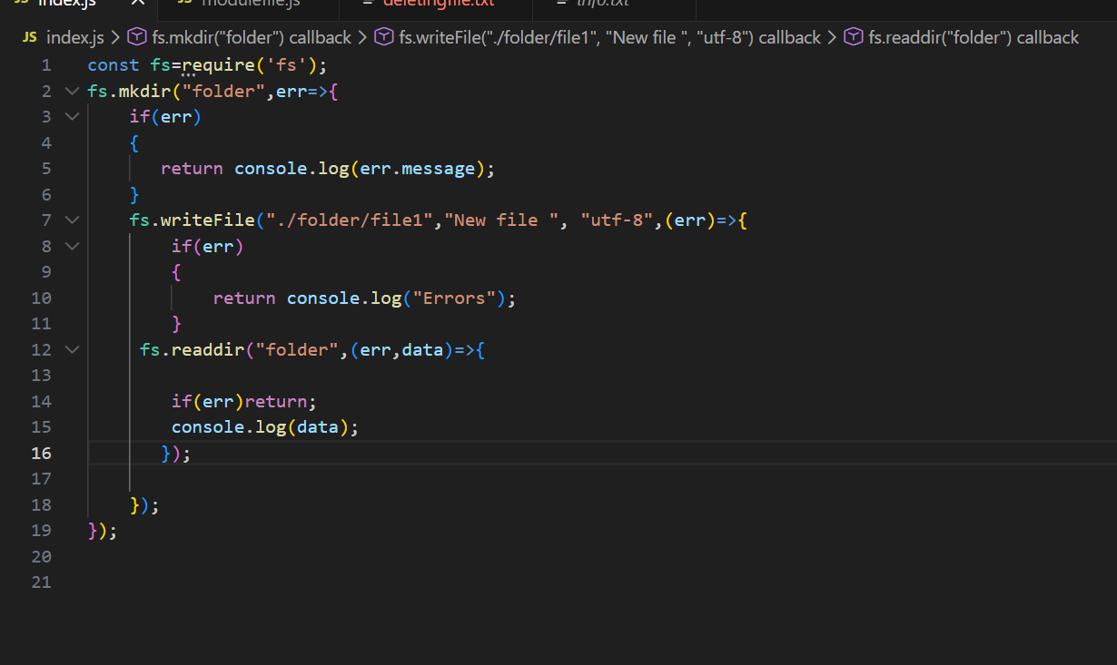
-readdir reads the files and returns array of file names
-takes callback with data and error.
Rmdir:
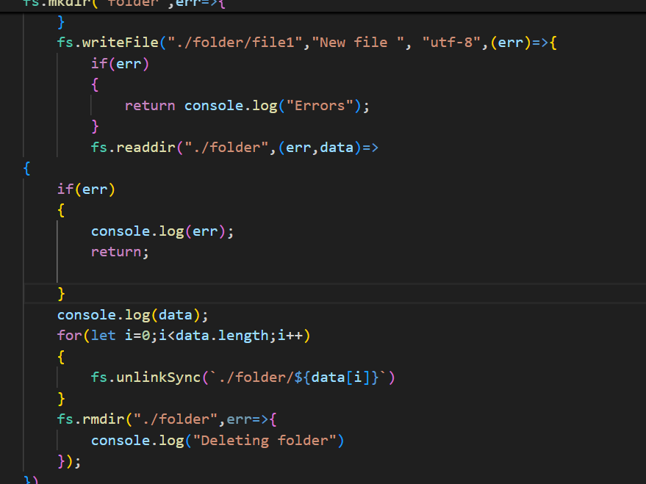
-used for remove directory
-dir can be removed after deleting all files.
-delete files first then remove dir.
Note:
-All above methods has sync methods without callback fn.
Watch:
-used to monitor file
-2 params
-eventType -> change,rename
-filename->name of file
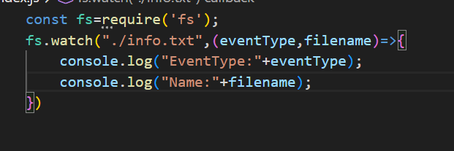
When u run this file and make changes in that watch file …here it will be visible
Rm:
-used to remove folder as well as files in it..even sub folders.
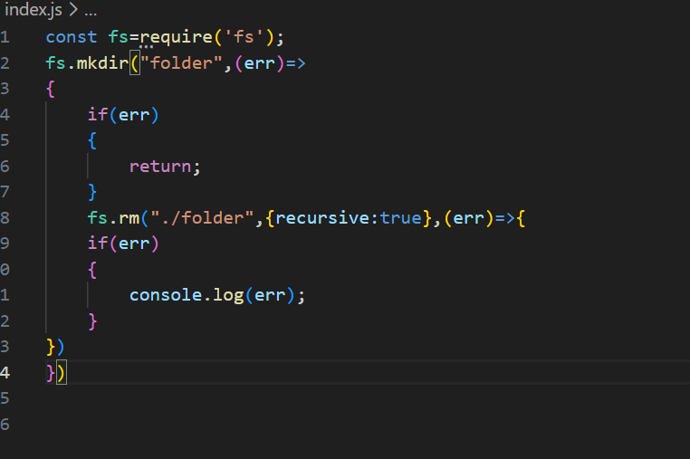
-here we use options object
-rm = unlink+rmdir
Open and close()
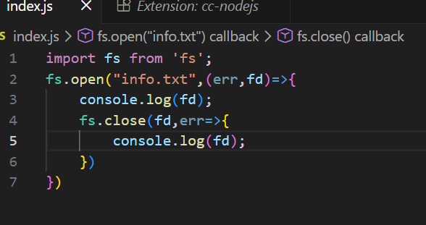
Fd is file descriptior
-fd is allocated by os starting from 3..because 0,1,2 reserved
-based on fd,.,internally process identify the file
`
Options Object:
-Mostly all methods take this options object..
-Extra info on how the operation should work
-last would be callback fn,,before it options would be
1.encoding
-tells format for operation
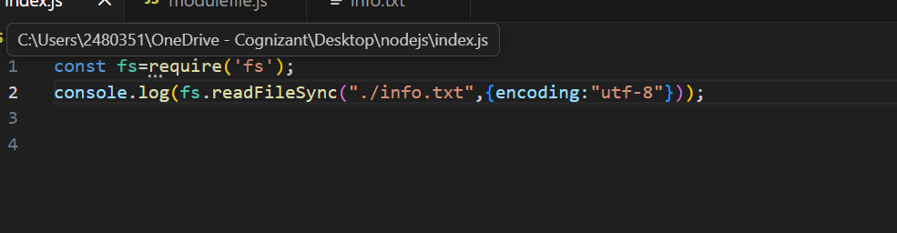
-just tells format
-even “utf-8” is appliable instead of object
-for better readability
2.Recursive.
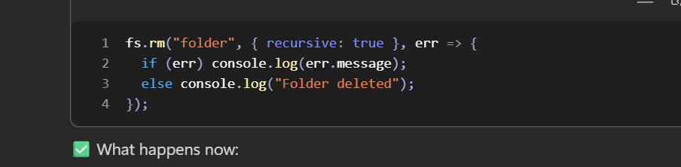
- Apply operation on it and as well as for inside folders too again and again..

3.force:
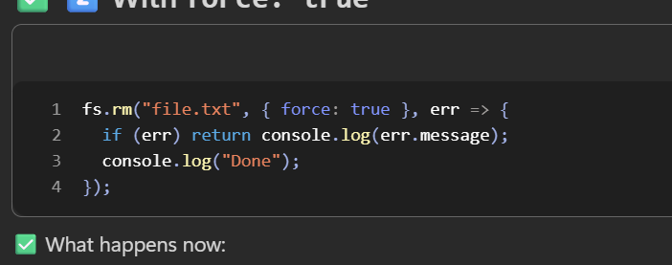
-forces nodejs to perform
-returns no errors
-makes code smoother and error free
-You should use { force: true } when you want to ensure a specific state (like a folder being gone) without writing extra boilerplate code to check for existence first

4.Flag
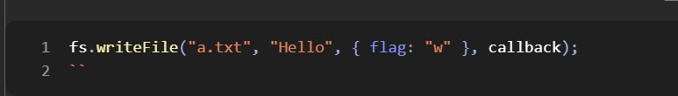
-flag allows to perform operations on read-write
-w=write only
-a=append
-r=read
-wx=write but fail if file exists

HTTP:
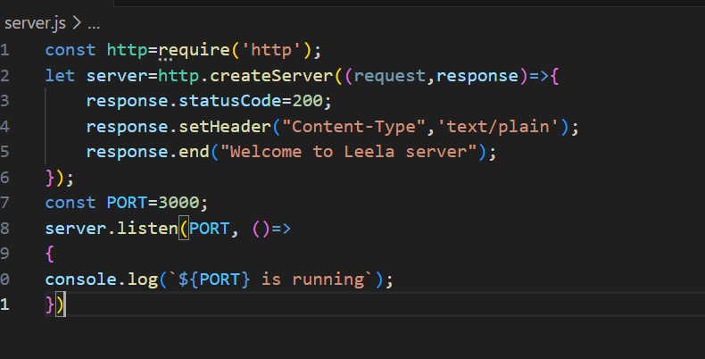
-response and request has methods
-response is configured here as server returns it
-response.end is a way to return data
Configuring Routing:
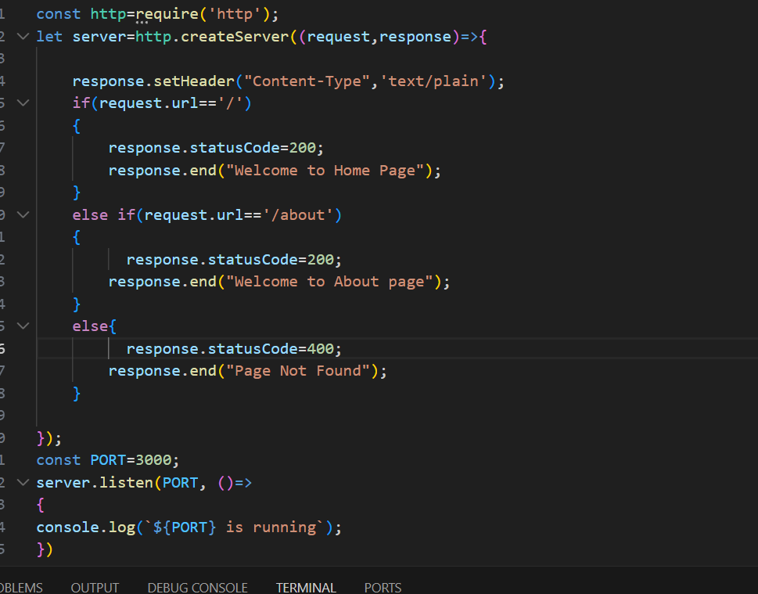
-must be if else
-response should be only once
Query Params:
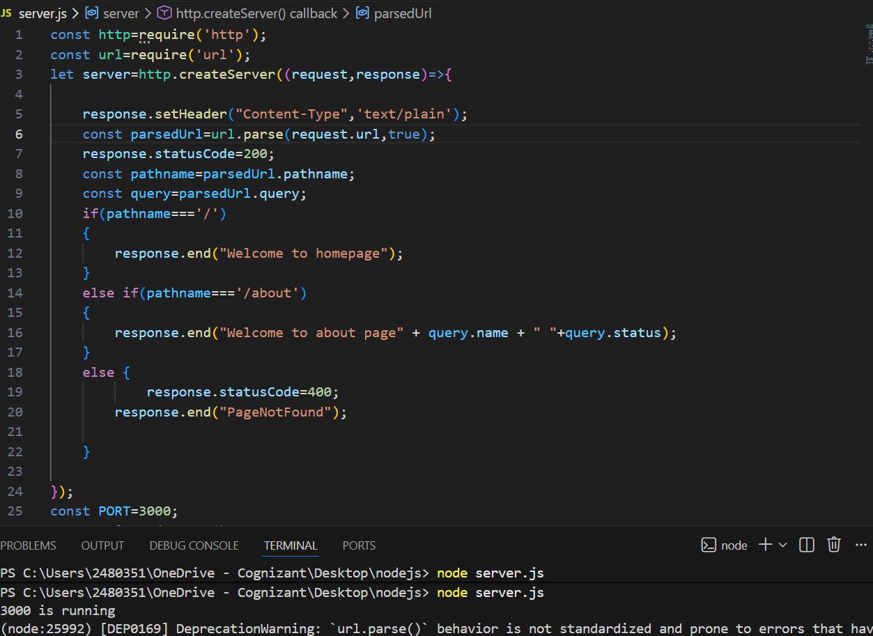
-url-> allows to access url and parse it
-parse->used for parse
-parse taks 2 things…req.url and Boolean
True->queryparams will become an obj
False->queryparams will be a direct string

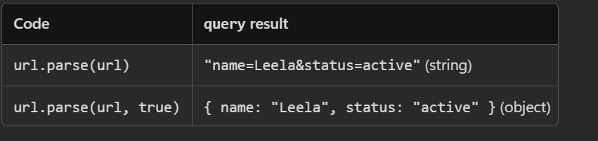
Parse->returns parsedUrl with 2 methodss
pathname->holds pathname
query->obj if true or string if false

Http Methods:
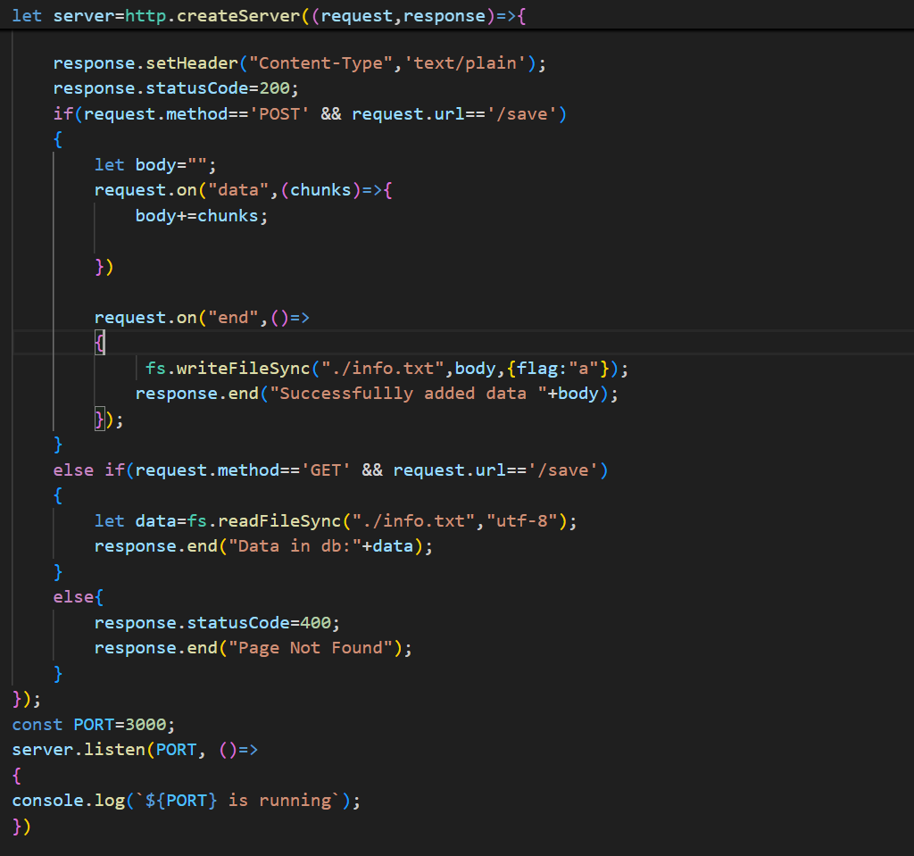
-use req.method and req.url to deal with conditions
-Unable to access body in nodejs….so use any variable and use events
-nodejs event based-> so use ‘on’ to attach event listener
-2 main events
-Data->runs when req got any data
-end->when req got whole data and ready to send response

Note:
-request =>
request.method
request.url
request.on
request.header(object with lowercase keys)
-Response
-response.setHeader()
-response.write() // sends response but keeps connection
-response.end() // send final data and closes connecttion
-response.statusCode

Node js Built in Modules:
1.Events:
-EventEmitter is core class which allows nodejs to be event based.
-EventEmitter is used for custom events and also internally eventemitter used by nodejs for fs,http etc.
-we create object for eventemiiter and it can emit also it can listen
-For emit-> emitter.emit
-for listen->emitter.on() ..emitter.once ()
-emitter.on runs for every emit
-emitter.once runs only once
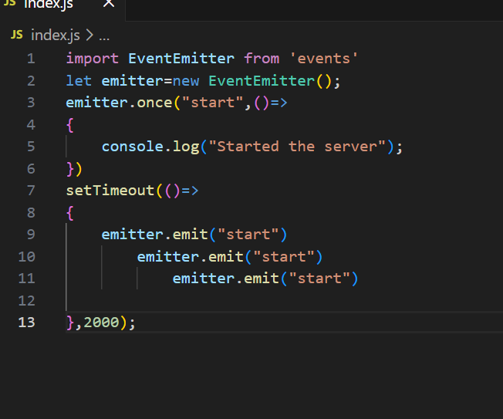

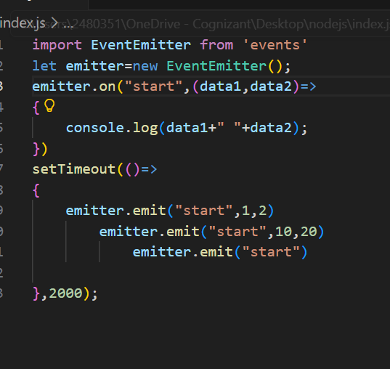
-we can modify the callback fn
-even we can pass error
-event emitter methods:
1.on
2.once
3.emit
4.off
-removes specific listener

5.removeListener
-same as off
-just old name of off
6.removeAllListeners()
-removes all
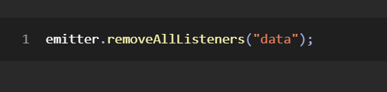
7.listenerCount
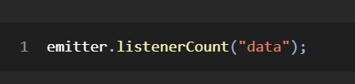
8.setMaxListener
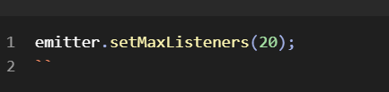
-default is 10
-only warning ..no error

Built In Events:
-we cannot modify callback fn for built in
1.request
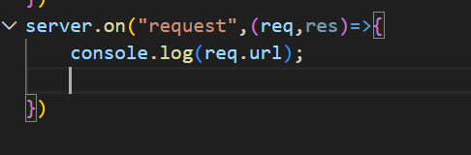
-runs when server gets request

2. end
-it may be both sides server and client
-for server..it triggers when user has no more data to send
-for client.. it tells that server sent final data and connection is about to close.
-no callback fn params
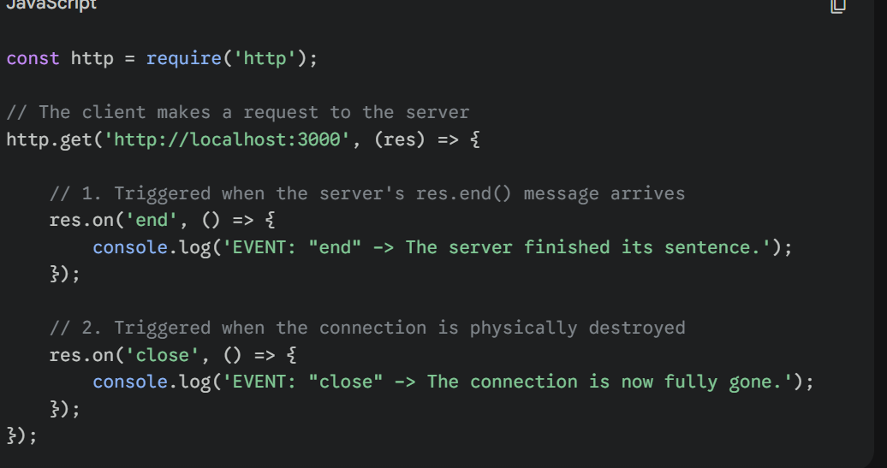
3.close
-runs when server closes connection
-no callback fn params
4. error
-when server gets error
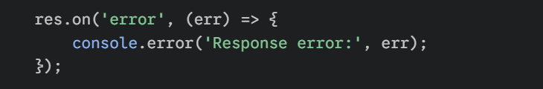
5.data
-runs when data is received by server
-have a callback fn with chunks param
-chunk is type of buffer
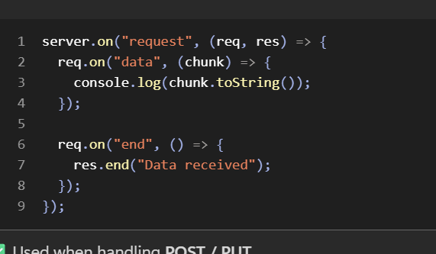
6.finish
-the flow is
Finish-data has sent to client
End-after finish, no more data to send..so this is final ( but in client pov, not server)
Close-after end..closes the connection
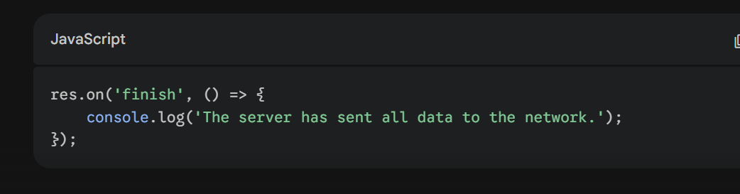
7. connection
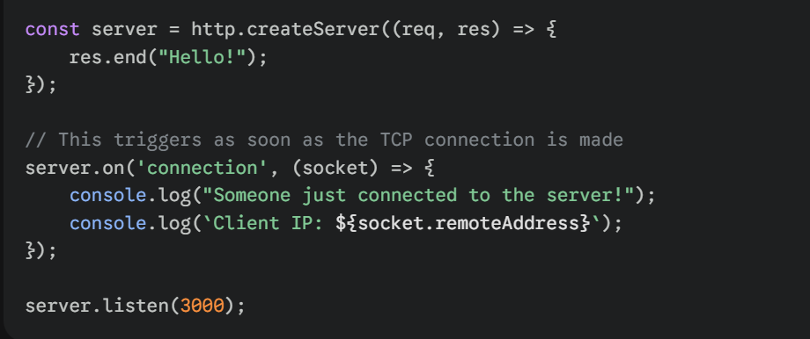
8.open
-runs when file gets opened
-takes fd as callback fn parameter
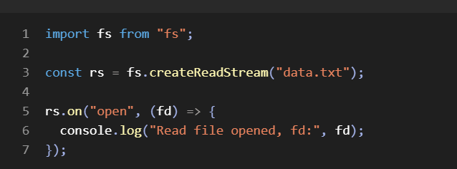
9. ready:
-runs when stream is ready
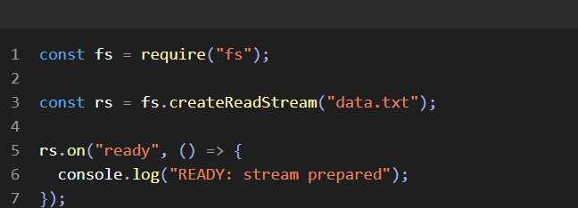
-ready -> stream setup is ready
-readable->stream accessed data and ready to send
-here..ready is independent on data but readable is depenedent

Path Module:
-used to deal with paths
-cant create folder,files…just to have access with paths.
1.join()
-used for create path joining
-can have any no of args
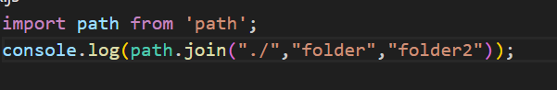
2.resolve()
-gives abs path
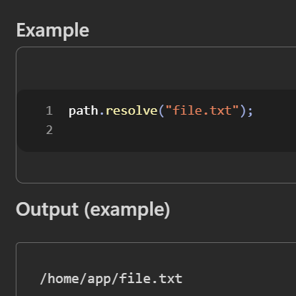
3.basename
-gives only file name
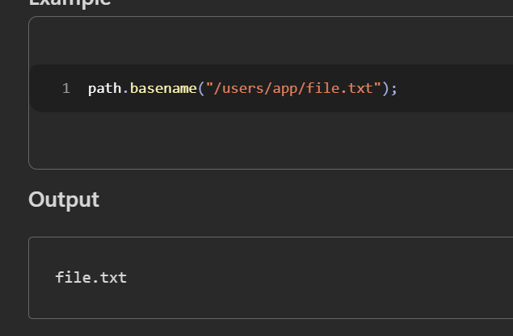
4.dirname
-returns folder path
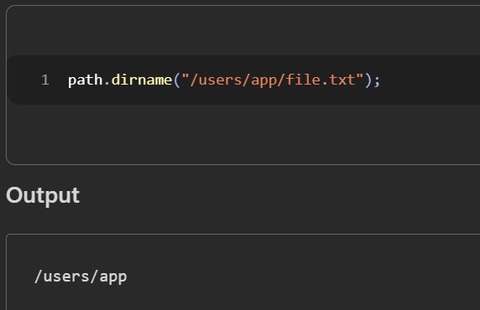
5. extname
-returns file extension
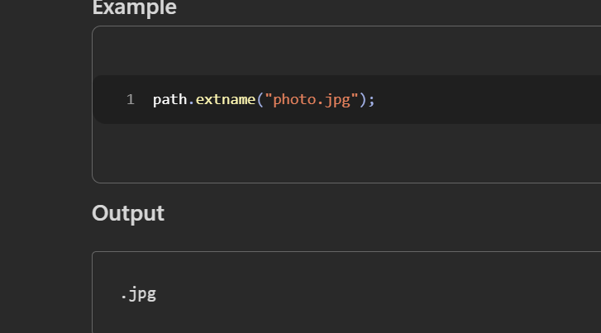
6.parse
-gives entire details of file in obj type
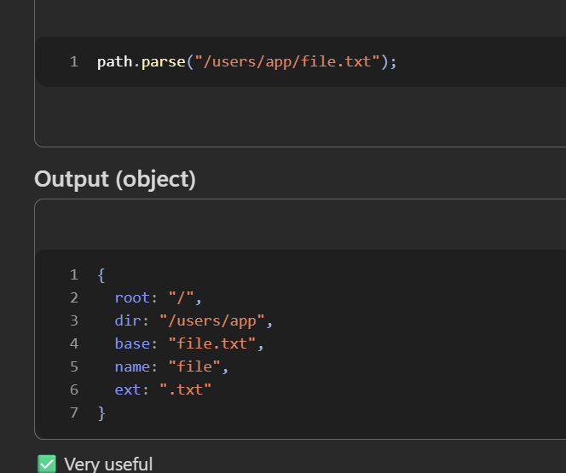
7.path.format
-exact opp of parse
-takes obj and creates path
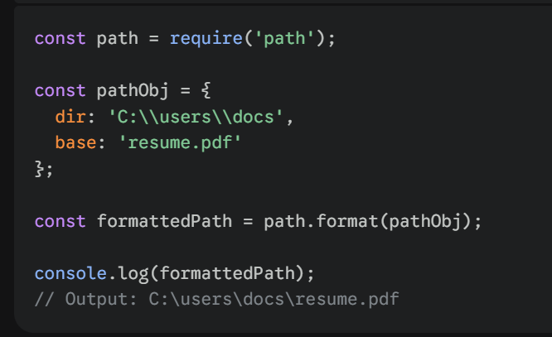
8.isAbsolute
-returns true if it is abs path
-abs path starts with C:\\ or \\ in windows
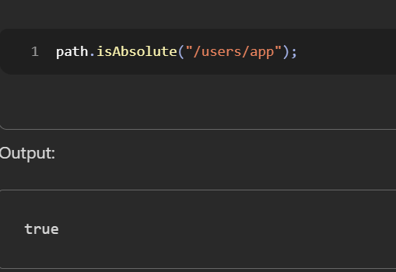
Streams
-stream of data
-reads chunks at a type instead of whole data
-mainly useful for large files
-even http request is one of child of streams
1.createReadStream
-creates a reading stream to read data
-it has 2 modes
-Flowing mode and Advanced mode
Flowing Mode:
if we use data event..automatically stream goes into flowing mode

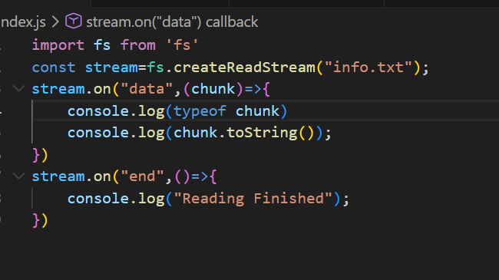
-it is automatically gets data
2.Pause Mode
-Here we use ‘readable’ event
-readable-> triggers when there is a data ready to read
-using stream.read() we go manually
-this is not automatic
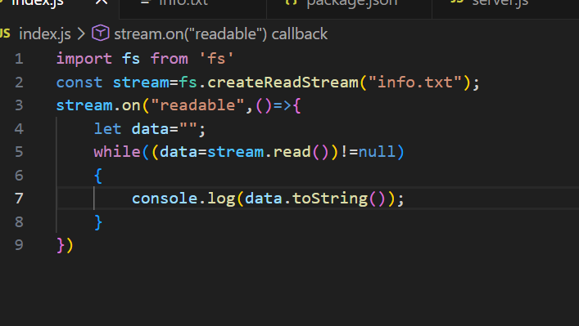
2. createWriteStream
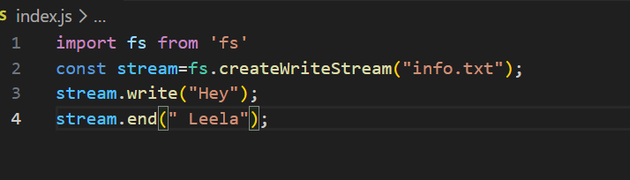
-has 2 methods…write and end..just like http response

Note:
Pipe:
-Performs tasks automatically and calls events internally..
-used for transferring data
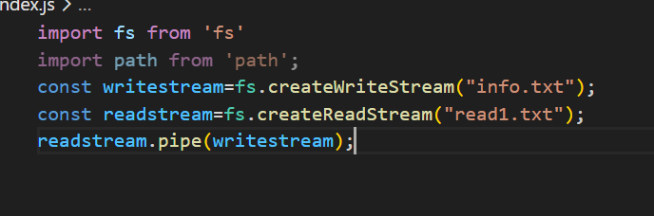pipe() needs:
- Left side → must be a Readable stream
- Right side → must be a Writable stream
Pipeline:
-instead of pipe chaining->use pipeline
-Takes readstream->n no of transforms->writestream
-No need of explicit call of parameters…node internally handles
-pipe must explicit error handling…pipeline doesnot
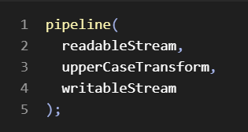

3.Duplex
- two way data
-we can read and write
-both are independent
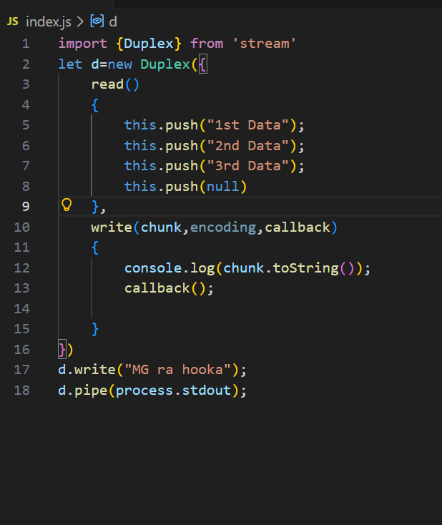
-Duplex is not fn like readCreateStream, readWriteStream…it is a class
-It takes option object which has read() and write().
-In Duplex..we are not dealing with files.
-read() executes when reading
-write() executes when writing
-final(callback) act as flush of transform
Read():
-push helps to send data when we read
-must push null at end..so nodejs comes out of read()
-nodejs triggers this and gives to read listeners.
-on(“data”) triggers read()
Write():
-takees 3 args
-chunk is data, encoding and callback is standard..internally nodejs handles
-method definition should be same
-only we call with data that we want
-callback() must be called at end so that nodejs comes out of it.
Note
-The .pipe is used because we need data from readstream to write..here d reads and send data to process.stdout which is terminal…that’s it..so that we can see data on terminal.
Diff b.w push(null) and callback:
-push(null) closes read stream permentely and stops allowing to read again
-callback() tells ended purpose with this input…go to next input
-The above Duplex is customized Duplex
-Real life example is Socket
4.Transform:
-takes data->modifies->return
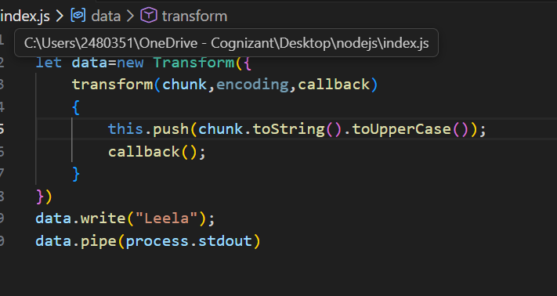

-we use callback() and fn definition is same.
-we call it as duplex stream only.
-we also flush(callback) along with transform which allows to send data last leftover one
Note:
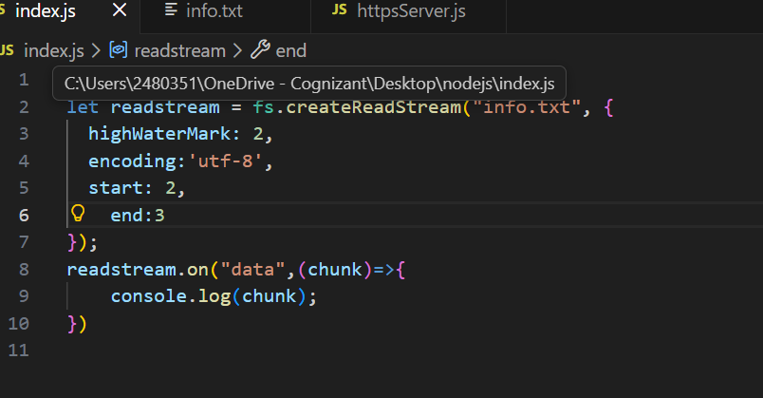
-highWaterMark->allows n bytes to read at a time
-start->start pos to read
-end->end pos to stop read
-encoding-format of read
Here start and end are inclusive and file content starts with 0 position
4.Util
-A module provides helper functions for formatting and async operations.
1.util.promisify
-converts a callback async to promises internally and let us use async and await
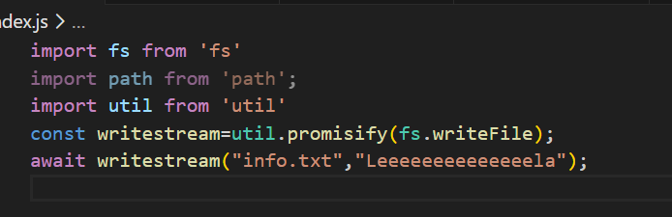
-we must a pass a async method that would have callback fn in it
2.util.inspect
-To get data of deep nested objects
-usually after 3 levels..we may not see the nested objects.
-to access, we use this along with depth option object
-depth:null allows to have infinite deep
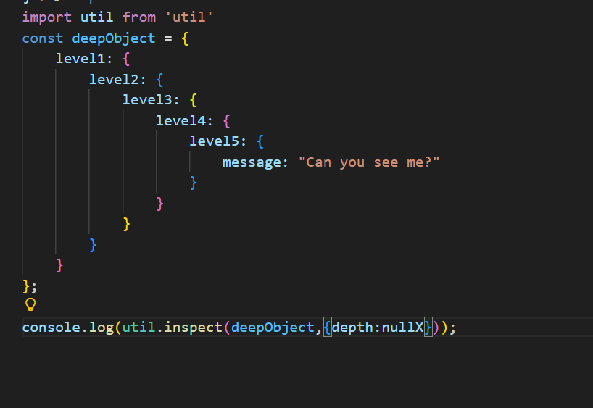

3.util.format
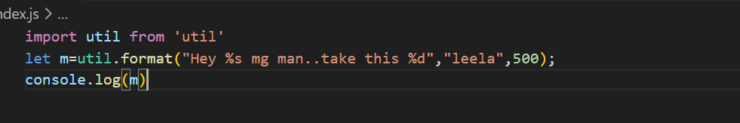
-allows c program kind of formatting

4.callbackify
-converts promise based ->callback based
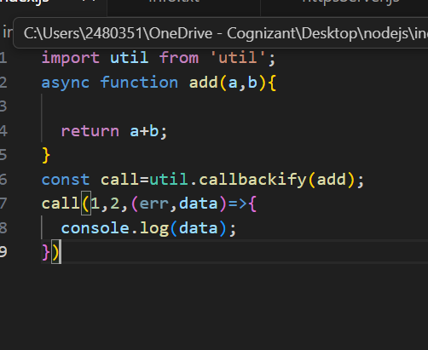
-always callback fn would be (err,data) form only

5.Process
-gives info about current node js running application
1.argv:
-allows to access command line arguments
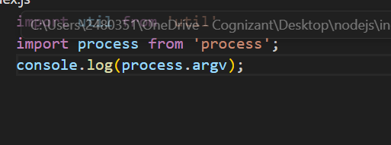
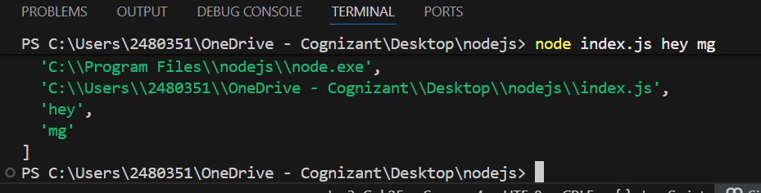
2.env
-allows to access environment of current running application
-environment means bridge b.w os and code
-gives a big object with all os details
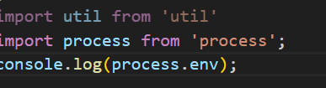

3.process.exit()
-stops program
- process.exit() and process.exit(0) are same
-it can take numbers as args
- 0=exit with success
-1=exit with errors
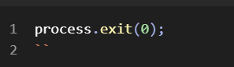
4.exit event
-runs when process is terminated
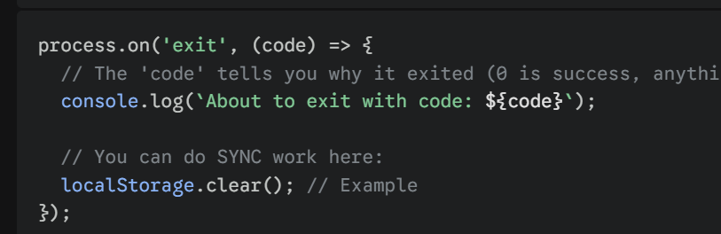
5. SIGINIT event
-runs when user presses ctrl+c
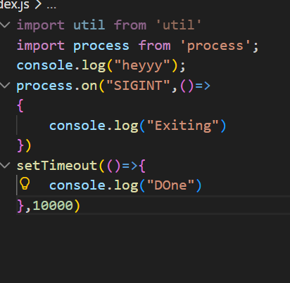
6.process.nextTick
-takes a c bfn
-runs after callstack empty and before callback queue execution
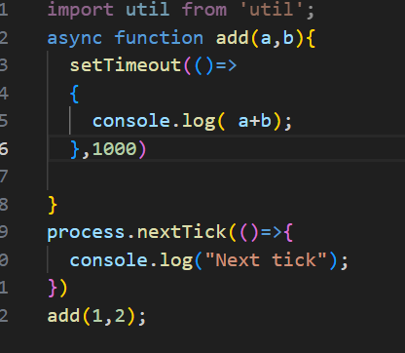

7.Process.cwd:
-gives current working directory of file
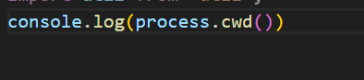
-no file name included
6. Error

-Same as in js
-But in nodejs..with some extra features
-in js-> error like type,reference..but in node js ..it is filesystem , network,stream errrors
-also in nodejs-> we have error first callback fn and error events
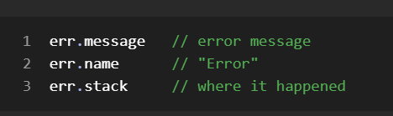
7.Global
-A object presents everywhere in the application
-in js->window..in nodejs->global
-no need of any imports for global methods
-few list of global methods…
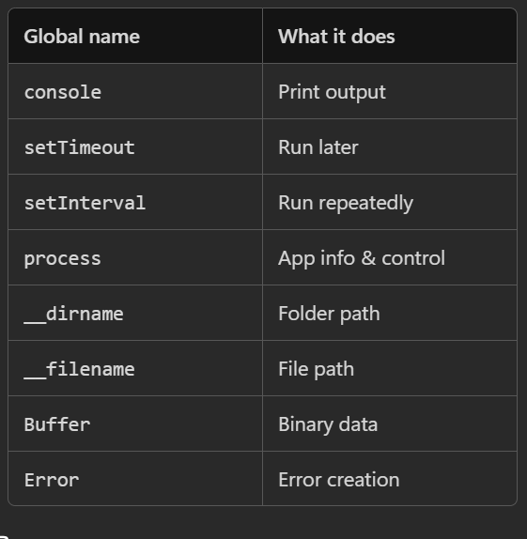

8. Clusters:
-Node js runs on single cpu core
-cluster allows to run on multiple core to efficiency
-creates child process and gives work to it
-Each worker/child process will re run the application after creating
-Each worker/child will occupy the each core of system to work optimally
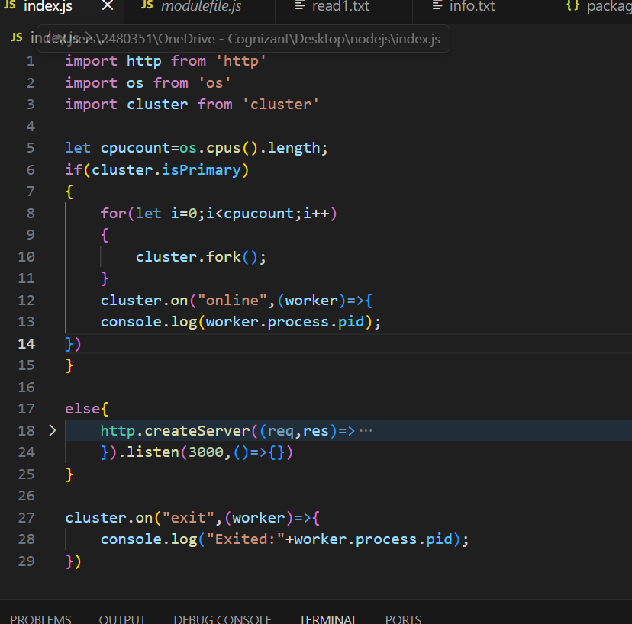
-cluster.isPrimary->true if master ..else false
-cluster.fork() ->creates child/workers process
-cluster.on() ->event listener
-online event-> triggers when workers are created and ready to work
-exit-> runs when a worker process ends.(worker killed or destroyed)
-worker.process.pid…gives process id of worker.

OS Module:
1.platform:
-gives os platform
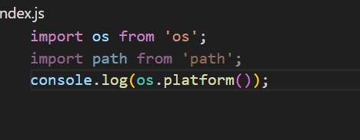
2. arch()
-gives architecture of system
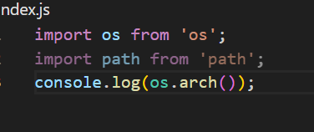
3. cpus()
-gives cpu cores of system
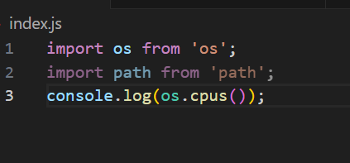

4.totalmem():
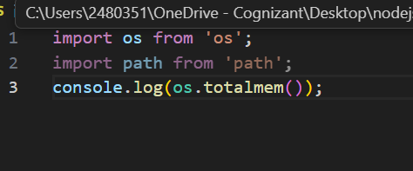
-returns total memory in bytes
5.freemem
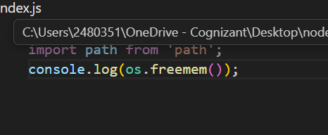
-returns available memory

Promises:
-same as js
-to use promises->import modules as promises
In commonjs->
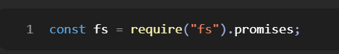
In ESM:

Normal import->callback approach
Promise import->promise way
-Async and await also same as js
Debugging Nodejs:
-using VS Code:
1. Add breakpoints
2. run->start debugging

-using node inspect filename.js cmd
-add debugger keyword in script
-run “node inspect filename.js” In ternminal
-goes into debug mode
- click c->for next debugger keyword/end of script
-click n-> for next line of code
Profiling:
-Checking performance
-checking time, cpu,memory of our program
1.Time Profiling:
-console.time(“name”) and console.timeEnd(“name”) allows to get execution time of block b.w those 2 ..and “name” is kind of key which prints later with time…name:0.2ms…
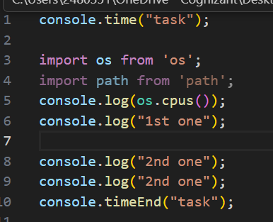
2. Memory Profiling:
-use process.memoryUsage()
-returns obj
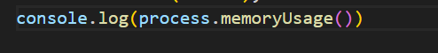
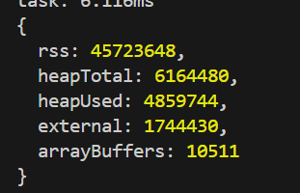
-rss =total memory of Nodejs app including js,c++lib etc
-heapTotal=total memory allocated for only js
-heapUsed = Total memoery used for js
External=used by file outside js

URL Class:
-used for access url
-url.parse is old..using URL class is modern
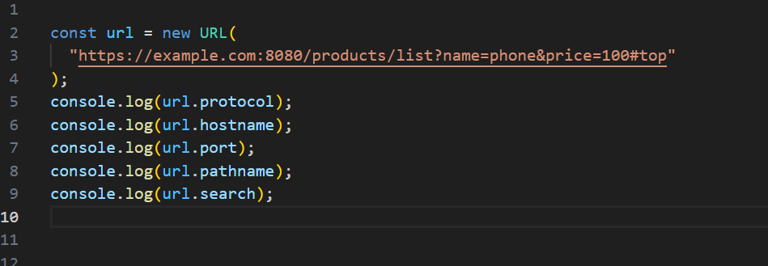
-expects full path
-search returns query string
SearchParams:
-allows to access query params
-map like structure
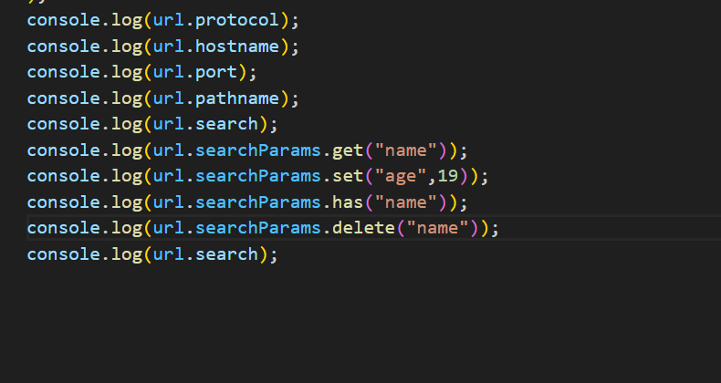
-has methods like map

__dirname and __filename
-only available in common js
Implementing in ESM:
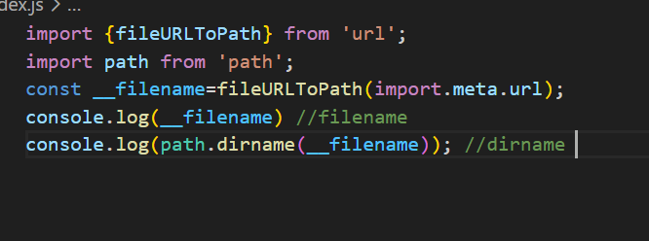
-import.meta.url is a property provided by node js which gives fileurl(not filepath)
-file url is like starts with file://users/leela etc
-to convert into path -> fileURLToPath is used

-Then it gives path

Fetch API:
-No fetch api before nodejs 18 version…so we use external libraries
-we use node-fetch or axios library for fetch api
-after version 18 fetch api is inbuilt
-node-fetch provides fetch api that works same as browser api
Axios:
-Allows to perform http request like fetch but..it has interceptor kind of technic and allows global declarations
-Axios checks for response type..if json->gives js object directly ..if it was different than json->gives same data
-Axios can be used mostly as fetch and angular http syntax
-we can use then and catch
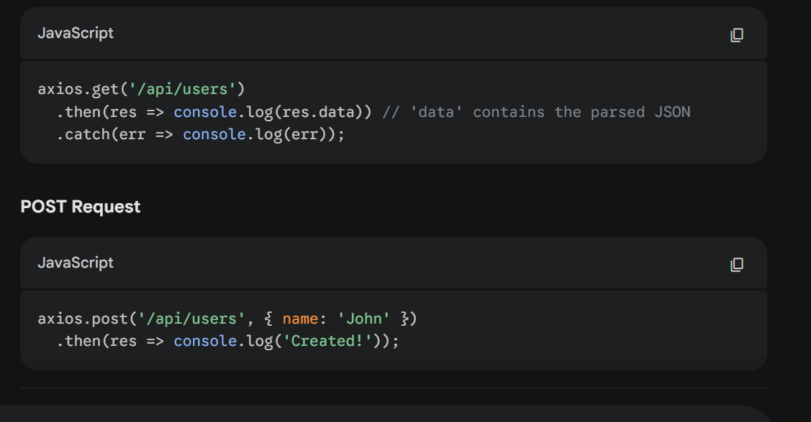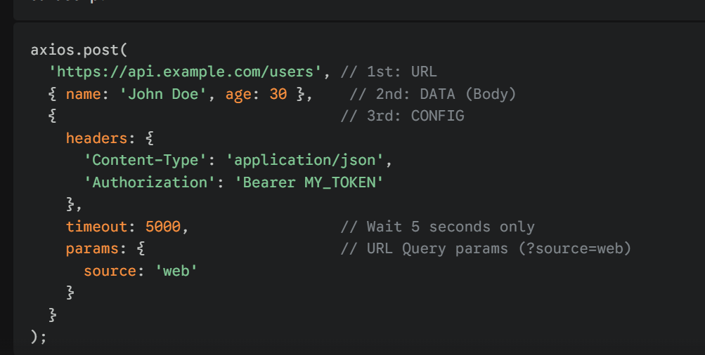
-we can have those options in config
Querystring:
- module to deal with query strings
-has two methods like JSON
-parse() and stringify()
-parse() makes query string into js object
-stringify() is opp of parse

-it is old…modern Is url class
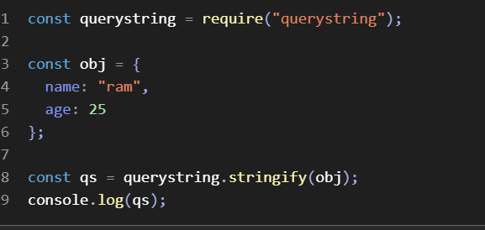
Crypto Module:
-used for hashing/encrypt/decrypt
Methods:
1.Hashing:
1.1 createHash(algo):
creates hash using algorithm
Uses sha256 ,sha512
1.2 update(value):
Takes value for hashing
1.3 digest(format):
-format after hashing
-uses hex,base64
2.encrypt:
-used for encryption
2.1 randomBytes(n): gives n bytes buffer in return
-use .toString() to convert into string
-use .toString(‘hex’) to convert into hex string
2.2 createCipheriv(algo,key,iv):
-iv is initalisation vector is a random string which will get added along with key inorder to avoid consistency for same data encryption result
• algorithm → string ✅
• key → Buffer ✅
• iv → Buffer ✅ (IMPORTANT)

2.3 update(DATA,cur_format,req_format):
-takes and sets data
2.4 final(format)
-require format
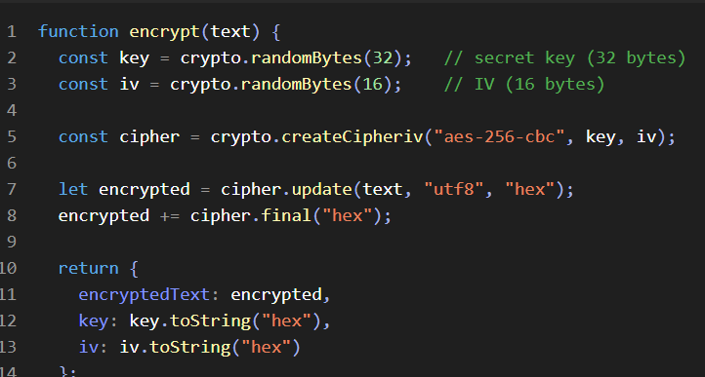
Decryption:
-createDecipheriv()
-update also same
-final also same
Note:
-Algorithm always would be lowercase
-to convert back to buffer-> Buffer.from(data)
-to convert back to buffer from hex->Buffer.from(data,’hex’);

bcrypt:
-used for hash passwords and compare it
-has two main methods hash and compare
-takes salt round
-salt round-> takes random data and performs 2^n times hashing using same salt data
.hash(data,salt rounds)
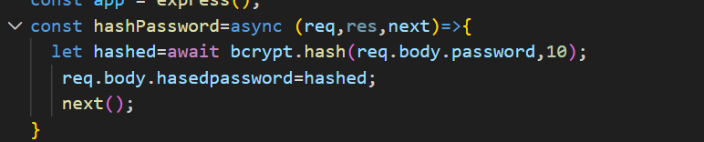
.compare(password,hashedpassword):
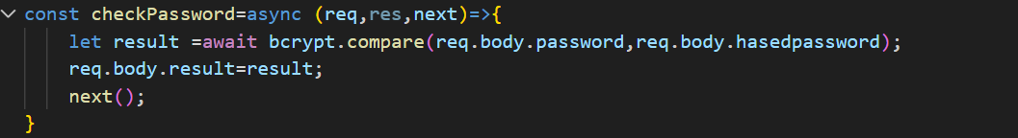
-no salt rounds needed..,,internally it knows

Testing:
-both mocha and jest same as express but…
-In nodejs we test functions, methods, values…not http and server
-we use jest here also..but only for functions testing
-Same syntax and same working
-done() also included

Mocha:
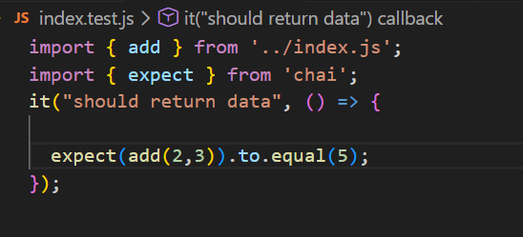
Jest:
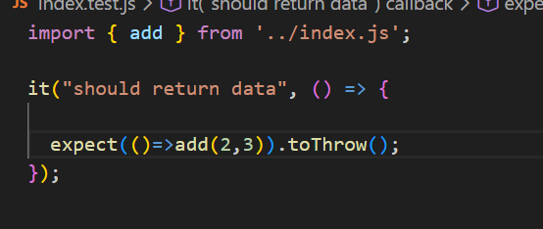
-toThrow() used to check whether a fn throws error or not
-throwing fn must be inside a nested fn…since it expects function error
Unit testing:
checks each testing without any dependencies
Integration Testing:
checks a fn which internally uses another fn…checking connection and result of depencies is correct
Deploying Node js server:
-use dotenv
-use pm2

