**Architecture**

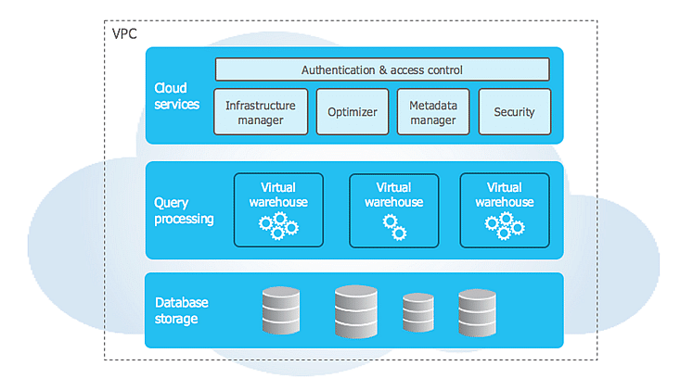

I’ve learned and implemented the Snowflake data warehouse architecture, exploring how it stands out from traditional data warehouses. Using this knowledge, I built a data warehouse for business applications, leveraging tools like SnowSQL and QuickSight. I also experimented with bulk data loading through the web interface, SnowSQL, and Amazon S3. I specifically focused on loading data from an S3 bucket to Snowflake using a data pipeline. Detailed steps for the project are provided in the README file.

**Resources Used:**

* IAM
* S3 Buckets
* Quicksight
* Snowflake and SnowSQL