**Hive**

Hive is a platform used to develop SQL type scripts to do MapReduce operations. It is a data warehouse infrastructure tool to process structured data in Hadoop. It resides on top of Hadoop to summarize Big Data, and makes querying and analyzing easy.

Initially Hive was developed by Facebook, later the Apache Software Foundation took it up and developed it further as an open source under the name Apache Hive. It is used by different companies. For example, Amazon uses it in Amazon Elastic MapReduce.

**Architecture of Hive : -** 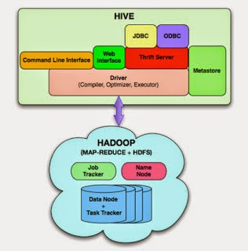

Following are the components of hive architecture :-

**1) User Interface :** Hive is a data warehouse infrastructure software that can create interaction between user and HDFS. The user interfaces that Hive supports are Hive Web UI, Hive command line, and Hive HD Insight (In Windows server).

**2) Meta Store :** Hive chooses respective database servers to store the schema or Metadata of tables, databases, columns in a table, their data types, and HDFS mapping.

**3) HiveQL Process Engine :** HiveQL is similar to SQL for querying on schema info on the Metastore. It is one of the replacements of traditional approach for MapReduce program. Instead of writing MapReduce program in Java, we can write a query for MapReduce job and process it.

**4) Execution Engine(MR) :** The conjunction part of HiveQL process Engine and MapReduce is Hive Execution Engine. Execution engine processes the query and generates results as same as MapReduce results. It uses the flavor of MapReduce.

**5) HDFS or HBASE :** Hadoop distributed file system or HBASE are the data storage techniques to store data into file system.