Automated Cross-Browser Testing:

Using Selenium and BrowserStack for the OrangeHRM Demo Application

Name | Leelavathi Chundu
Education | Software tester
Examiner | Staffan Åberg
Date of submission | 2025-12-14

Summary

This thesis report presents a work focused on building an automated cross-browser testing framework for the Orangehrmlive demo website. Cross-browser testing is fundamental part in modern software quality assurance. Web applications are expected to run smoothly on many different browsers, devices, and operating systems. If websites behave differently across browsers, users can experience errors, broken layouts, or missing features. To avoid this, companies need reliable ways to test their websites automatically. This project was carried out as part of a technical thesis to investigate how tools like Selenium in combination with BrowserStack can improve efficiency of cross-browser testing.

The work involved investigate existing testing methods, creating automation test with Selenium and running it on multiple browsers using BrowserStack’s cloud platform. The Orangehrmlive demo application was used because it has features which is suitable for academic testing. The focus was on creating simple login test and running it on different browsers such as Chrome, Firefox, Edge and Safari.

The results show that automated cross-browser testing is effective even with limited resources. The test was able to run successfully on different browser and operating system combinations. BrowserStack made it easy to access many browser versions without installing them locally. The framework built in this project was stable, reusable, and easy to extend for new tests.

The main conclusion is that automated cross-browser testing can greatly improve testing speed, reduce manual work, and help catch browser-specific problems earlier. Using cloud tools also makes it easier to add more tests and run it more often.

Contents
Summary 2
1. Introduction 4
1.1 Background 4
1.2 Purpose 5
1.3 Problem formulation 5
1.4 Boundaries and Focus 5
1.5 Method / Approach 5
2. Theory 6
3. Results 7
4. Discussion 8
5. Conclusions 9
5.1 Recommendations 9

Introduction

This report explains how I built an automated cross- browser testing setup for the Orangehrmlive web application using Selenium WebDriver and BrowserStack. The main idea is to check if a website works the same way in different browsers such as chrome, Firefox, Edge and Safari. Today people use many types of devices and browsers, so it is important to make sure a website behaves correctly everywhere.

Cross-browser testing is becoming more important because developers make changes to code faster to adapt to new requirements so there is a need for reliable automated tests to keep up with fast development and continuous updates. Manual testing is not enough to check that a website works correctly in all the different browsers people use today. Using tool like Selenium with a cloud-based platform such as BrowserStack removes the need to install and maintain many browsers on a local computer. This project shows how cross-browser testing can become more accurate, faster, and efficient to handle more tests.

This work was done as part of a technical thesis. And the Orangehrmlive website, which is a public demo website, was chosen for testing because it has realistic features and is good
for learning and experiments. The project brings together learning, practical testing, and checking the results to show how automated cross-browser testing can work in real life and improves efficiency.

1.1 Background

Web applications are used on many different browsers and devices, and each browser can display or handle a website in slightly different ways. This creates a need for cross-browser
testing to make sure that all users have the same experience, no matter which browser they use. As websites grow more complex and update more often, manual testing becomes too
slow and unreliable to keep up. This has created a strong need for automated testing tools that can check functionality quickly and consistently.

For the IT industry, reliable automated testing is important because companies must ensure that their web applications work correctly for all customers. When websites look or work differently in different browsers, users can get confused or frustrated. This can cause companies to lose customers and spend more money fixing problems later. Automated cross-
browser testing helps developers spot these issues early and makes it easier to keep updating the website without breaking things.
This project focuses on using Selenium WebDriver to create automated browser test, and on running the test in BrowserStack, a cloud platform that provides access to many real browsers and operating systems. The work is carried out using the Orangehrmlive demo banking application, which offers realistic features that make it suitable for testing and experimenting with automation tools. The scope of the project is limited to functional cross-browser testing, with a focus on running the test on different browsers.

1.2 Purpose

The purpose of the work is to build and test a framework that can automatically check how the Orangehrmlive website works in different browsers using Selenium and BrowserStack and to show how this approach can improve testing efficiency

1.3 Problem formulation

- How can automated testing be designed to verify that a web application functions correctly across multiple browsers?
- How does automated cross-browser testing improve testing speed and efficiency compared to manual testing?
- What challenges arise when running automated tests on different browser and operating system combinations and how can they be addressed?

1.4 Boundaries and Focus

This project focuses on testing the Orangehrmlive website automatically on different browsers, it does not cover
- Extensive browser/device combinations: Only the most used browsers such as Chrome, Firefox, Edge and Safari and desktop configurations are tested due limitations of trail subscription.
- Performance and security testing are outside the scope because the focus is on functional cross-browser compatibility.
- Mobile apps are not tested.

1.5 Method / Approach

The work begins with investigating what Browserstack is and how it works as a cloud-based testing platform and how it can be integrated with Selenium WebDriver to run automated tests. Firstly, understands why testing in a local computer is not enough and then understands how BrowserStack helps solve this by giving access to many browsers and devices without needing to install them. After that looked at BrowserStack’s useful features like videos and logs which help debug issues faster.
With this understanding developed automated login test for Orangehrmlive web application by creating Selenium WebDriver for chrome and using assert statement. Then pom.xml has updated to add dependency for browser-stack-sdk. And then add configuration file called as browserstack.yml to “target” directory which controls how and where the tests run on BrowserStack.
The browserstack.yml is used to store all the settings needed to run test on BrowserStack. It contains information about:
- Username and access key which allows you to access the BrowserStack
- Which browsers and operating systems to use to run the test.
- With which name build will be created in BrowserStack.
Using setting defined in browserstack.yml file local selenium test connects to BrowserStack devices through remote WebDriver as per flow chart shown below.

The tools used are IntelliJ IDEA as development environment, Selenium WebDriver for automating test, Junit for running tests and BrowserStack for cloud-based browsers access and GitHub for version control.

2. Theory

Cross-browser testing important because websites must work on different browsers, devices and operating systems. Users may open same websites on Chrome, Firefox, Edge or Safari and they expect everything to look and work same on everything. This is why cross-browser testing has become a standard part of modern web development.

In the past, cross-browser testing was mostly done manually. Testers must install different browsers on their computers and repeat same steps repeatedly. As websites became more complex manual testing became very slow and required too much work. So, industry reports suggests that manual testing alone is no longer enough.

To solve this problem, automated tools such as Selenium were developed. Selenium is widely used because it can control a browser just like a human would do. It can click buttons, type text and check if things appear correct on the screen. Many technical tutorials suggest Selenium as one most of reliable tool for web automation.

However, running tests on many browsers still requires a lot of setups if everything is done locally. Each browser needs its own driver and not possible to run of different operating systems. This is where cloud-based services like BrowserStack are useful. BrowserStack provides access to many real browsers and operating systems over the internet. Instead of installing everything one can run automated tests directly in the cloud.

Industry research shows that cloud testing saves time and reduces need for installing various browsers with less hardware resources. BrowserStack allows to run tests in parallel meaning several tests can run at same time on different browsers. This makes the testing process much faster and more efficient.

3. Results

The aim of this thesis is to create an automated cross-browser testing set up for Orangehrmlive website and check how one login test works on multiple browsers using Selenium, Junit and BrowserStack. The test was successfully run on the following browsers.

Browser | OS | Status | Comments
Chrome 142.0 | OS-X Monterey | Passed | Test ran smoothly
Chrome 142.0 | Win 10 Laptop | Passed | Observed some delay in page loading
Edge 142.0 | Win 10 | Passed | Test ran smoothly
Firefox 145.0 | Win 10 | Passed | Some delay in page loading
Safari | iOS18.6 iPad 9 | Passed | Test ran smoothly

Browerstack.yml configuration file allowed to switch to another browser and operating systems easily by changing the details in “platform” section.
For every build, browser stack provides summary of tests run and passed/fail status as shown below. Here one test run on five devices so it showed in summary as 5 tests.

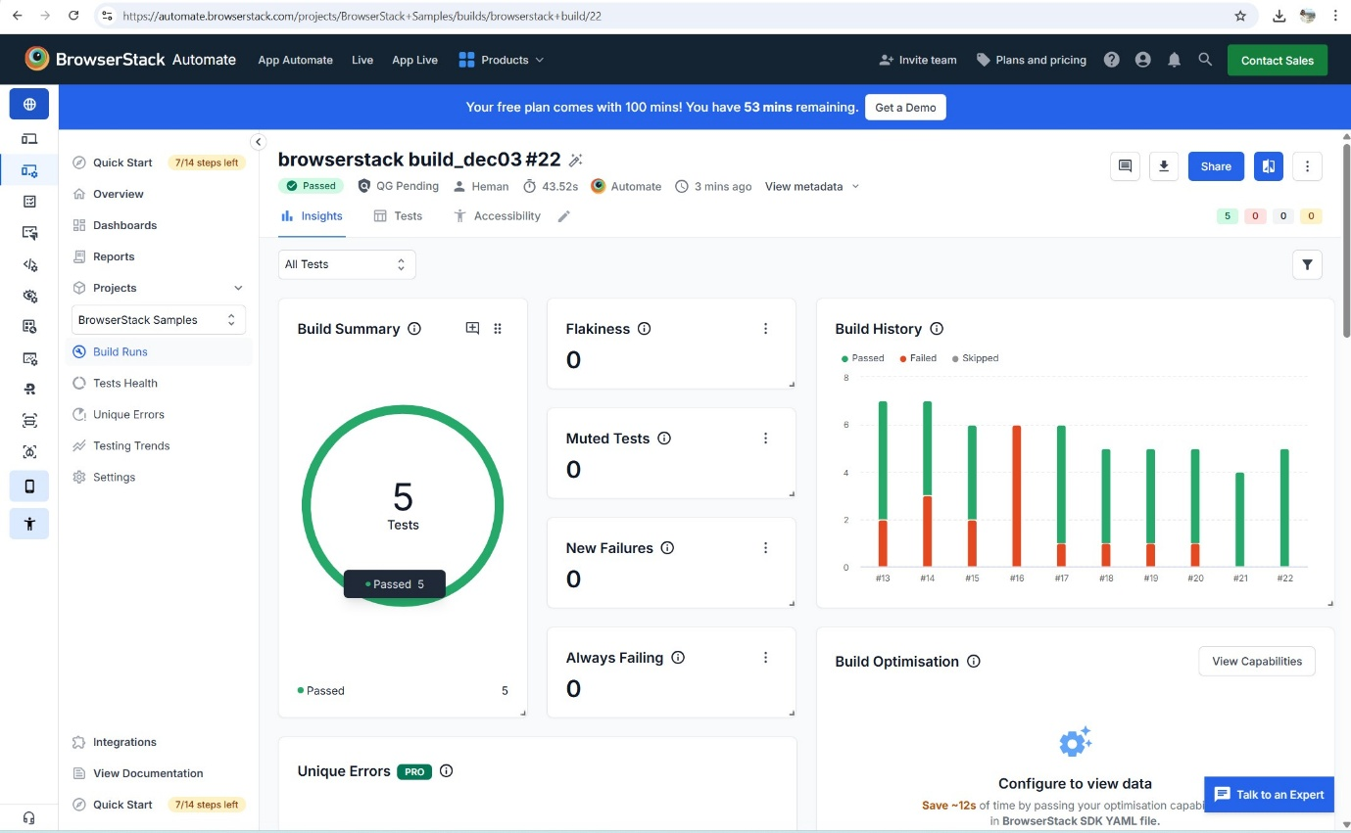

BrowserStack also provides video recording of test execution and network logs. I am attaching video for test run on browser Chrome on Apple MacBook. Click on video to see the test run.

Overall, results show that automated cross-browser testing saves time by running test on multiple browsers parallel, reduces manual work and there by improving efficiency.

4. Discussion

The results showed that how automated cross-browsers testing using Selenium and BrowserStack improved efficiency. It showed that same test run across multiple browsers without changing the code. This answered first question by showing that automation can work smoothly with limited resources.

The results also clearly shown that automation is much faster and effi5.cient. Manual testing would require repeating same steps repeatedly on different browsers. With Selenium and BrowserStack, same test can be run on multiple browsers, which saves time and reduces chances of human error.

However, there were also some limitations. The free BrowserStack plan has restricted usage time and fewer device options which limits how many tests could run. Another issue observed that some tests failed randomly due to certain browsers not fully supporting CSS Selectors. This did not happen all the time, but only occasionally which made the failures hard to understand.

Overall results shows that automated cross-browser testing is effective and easily extend for more tests as needed. It supports modern development needs and helps teams deliver better quality web applications with less manual efforts and less hardware or software resources.

5. Conclusions

5.1 Recommendations

